Account Numbers (ACCN)

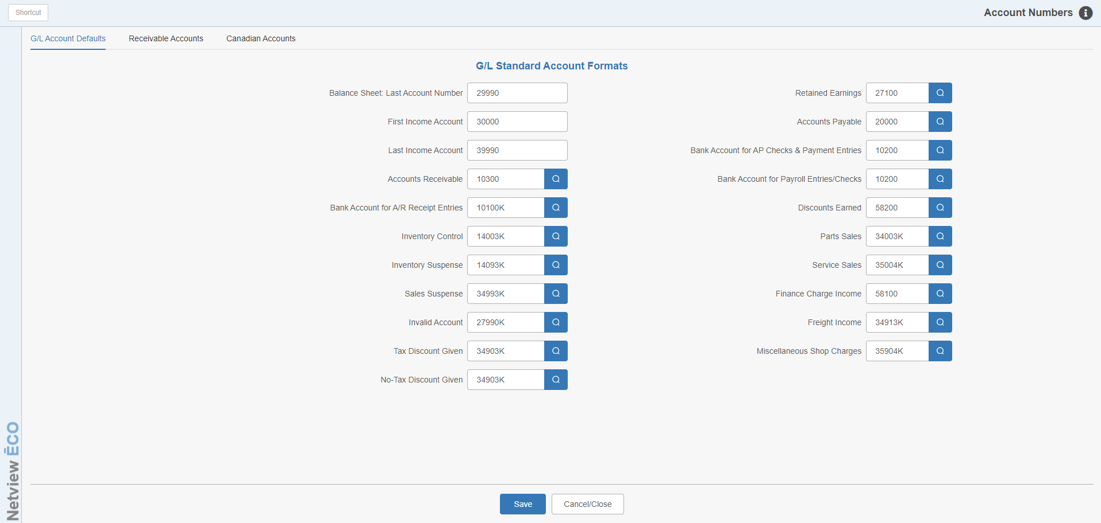

Account Numbers (ACCN) is one of the key elements in the “behind the scenes” set-up of the G/L system. Here a variety of account numbers are specified that control much of the automated system activity in many routines. The account numbers shown in the above example are merely examples of account numbers that could be used for the function defined, except in the cases noted.

To access this function, you can either:

- Select “System Maintenance” from the menu. Choose the “Company File” submenu and click “Account Numbers.”
- Type “ACCN” in the Shortcuts Bar.

G/L Standard Account Formats Screen

Balance Sheet Last Account Number: This is the last account number found on the balance sheet (the last liability account). This field is used for financial statement formatting. The standard setting is 29990.

First Income Account: The account number here represents the first sales account in the chart of accounts. This field is used for financial statement formatting. The standard setting is 30000.

Last Income Account: The account number here represents the last sales account in the chart of accounts. This field is used for financial statement formatting. The standard setting is 39990.

Accounts Receivable: This field holds the account number used by the system for accounts receivable transactions. The standard setting is 10300.

Bank Accounts for A/R Receipt Entries: This field is used by the Cash Applications feature of the Accounts Receivable module to indicate where cash received will be “debited.” The standard setting for this field is 10100 (Cash on Hand).

Inventory Control: This field holds the Parts Inventory account number (14003) used by the Parts Inventory and POS programs.

Inventory Suspense: This field should hold the Parts Suspense Inventory account number (14093) to capture stray or misplaced entries resulting from incorrect overrides in the POS program.

Sales Suspense: This field should contain the system defined sales account for stray, misplaced, or miscoded POS sales transactions (34993).

Invalid Account: This field holds the liability account number designated for invalid entries. This account number (27990) is used by POS to catch any transactions that are coded with improper tax or sales codes. It is also used as a default for various programs when a “blank” or unanticipated account number is encountered.

Tax Disc Given: This field shows where a discount given in the POS program should be posted. In this case, the field holds the discount given that is part of a taxable sale. It is derived from entering “D %,” “LD %,” or “CD %” on a ticket. This is typically an Other Income account number.

No-Tax Disc Given: This field shows where a discount given in the POS program should be posted. In this case, the field holds the discount given that is part of a non-taxable sale. It is derived from entering “D %,” “LD %,” or “CD %” on a ticket. This is typically an Other Income account number.

Retained Earnings: This account number is used by the GL Fiscal Year End program and receives the net profit or loss from the year being closed.

Accounts Payable: This is the account number reserved by the system to be used for all Accounts Payable entries when the Accounts Payable module is installed.

Bank Account for A/P Checks & Payment Entries: This account number is used by the Accounts Payable module and represents the offset for the disbursement entry when Print Checks (PC), Manual Checks (MC), or On Demand Checks (ODC) are run. This field holds the account for the checking or bank account where the checks are drawn.

Bank Accounts For Payroll Entries/Checks: This field is used by the Payroll module to indicate where cash received will be “debited.” The standard setting for this field is the account number for the primary checking account (likely 10200).

Discounts Earned: The account number in this field is used by the Accounts Payable Module to post any Discounts Earned identified in the payable transactions.

Parts Sales: This field holds the first Parts Sales account in the general ledger. The standard setting is 34003.

Service Sales: This field holds the first Service Sales account in the general ledger. The standard setting is 35004.

Finance Charge Income: This field holds the account number used to show any income from finance charges on unpaid accounts receivable transactions. This information is used by the A/R Month End and Statements program. This is typically an account number in the Other Income series (account numbers beginning with 58).

Freight Income: This is the account number used at the end of POS to record any freight charged to the customer. Typically it is one of the following account types:

Sale

Other Income

Expense

Miscellaneous Shop Charges: This income account number captures all the Miscellaneous or Miscellaneous Shop Charge entries from the POS program. It receives amounts from “M %” and “MS %” entries made on a POS ticket.

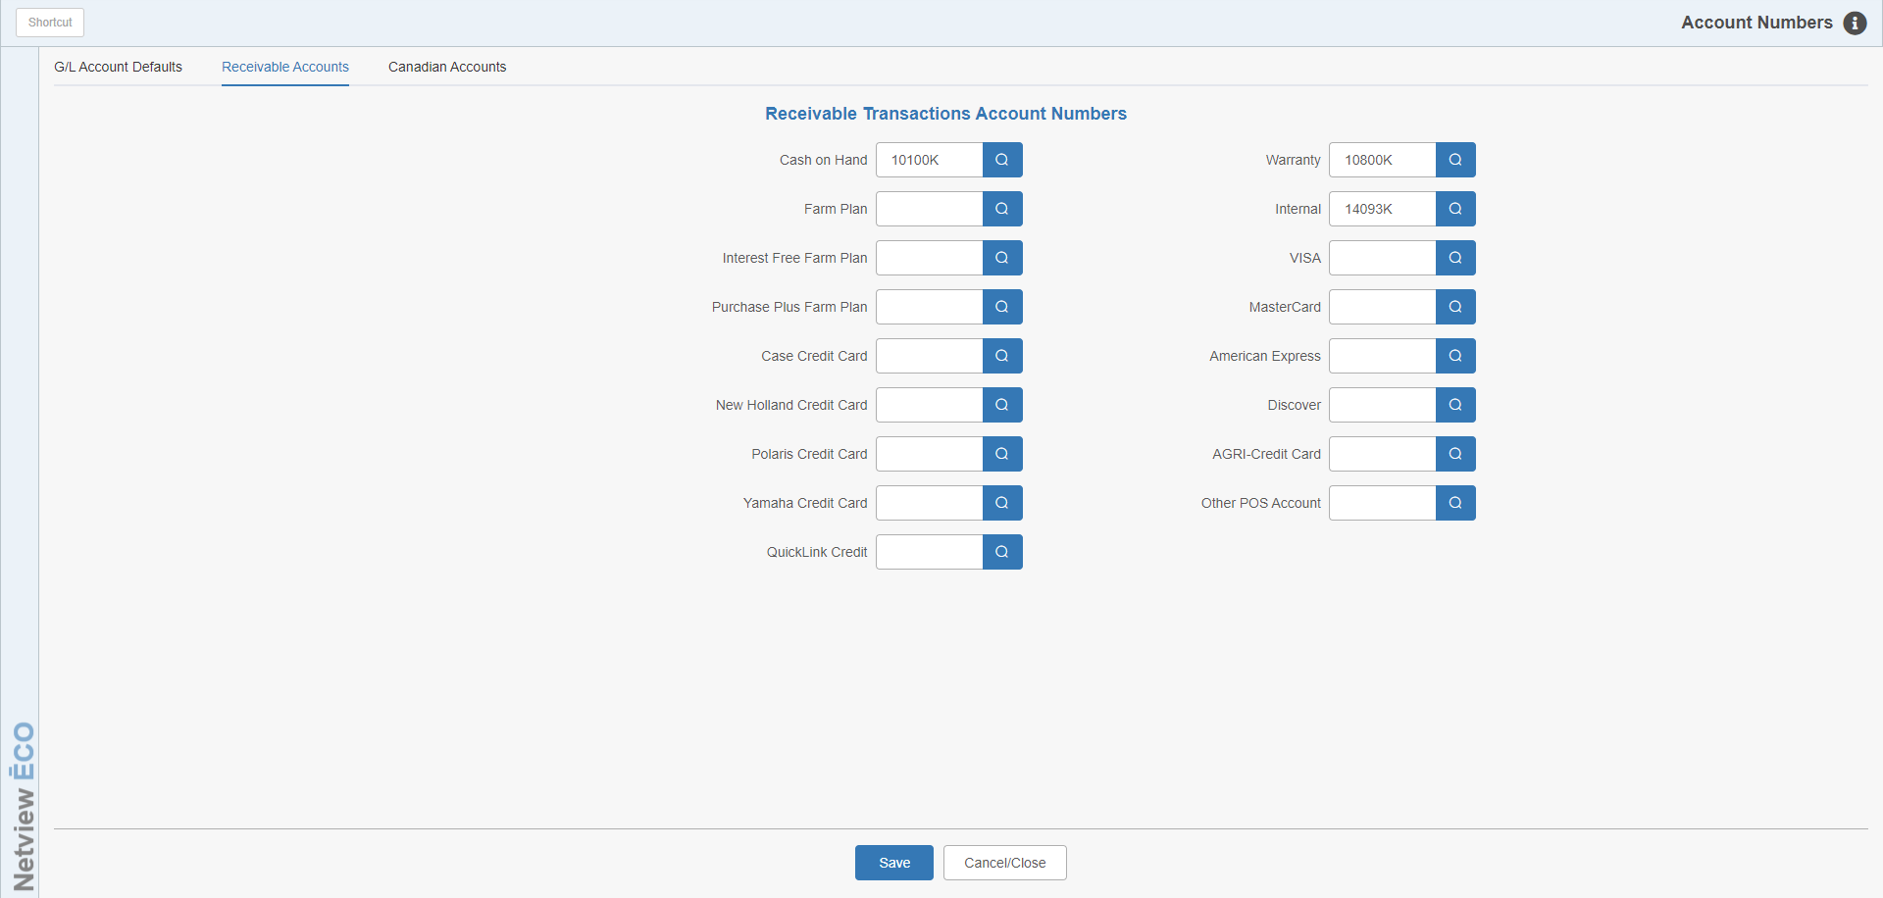

Receivable Accounts Screen

Cash On Hand: This field is no longer used. It previously held the account number used to direct the portion of a POS transaction shown as “Cash,” typically the Cash On Hand Account (10100).

Farm Plan: This field is no longer used. It previously held the account number for the Farm Plan Receivable account (usually 10350).

Warranty: The account number entered here indicates where any receivables for Warranty transactions will be recorded (those with a “W” type of sale from POS). The typical entries here are:

10800 (Warranty Receivables)

10300 (Accounts Receivable)

Internal: This account number is usually coded with the Parts Suspense Inventory Account (14093).

For the systems that do not have Units integrated or do not have Units, this field gets the “receivable” portion of the “I” type of sale from POS.

If the settings for Internal Repair Orders in Units are set to “Yes,” this field is not used.

The remainder of these fields are inactive at this point and have been replaced by settings in the Method of Payment screen (MOP).

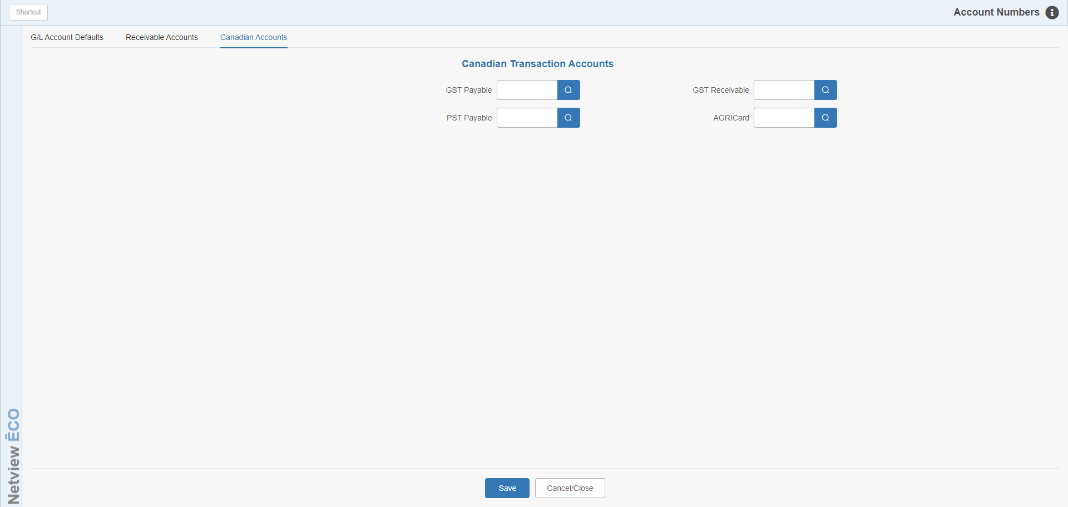

Canadian Accounts Screen

GST Payable: This field is only used at Canadian sites and holds the account number where the GST monies collected will be posted.

GST Receivable: This field is only used at Canadian sites and holds the account number where the portion of GST receivables due will be posted.

PST Payable: This field is only used at Canadian sites and holds the account number where the PST monies collected will be posted.

AGRICard (Canada): This is one of several accounts available to separate different types of charge card transactions. The account number used here indicates the receivable account where Canadian AGRICard (AGCO) transactions should be posted.

