Adjusment Report: The Adjustment Report in Rental Reports (RR) shows a list of all adjustments that occurred during a set time period. You can also filter the report to only show a specific type of adjustment.

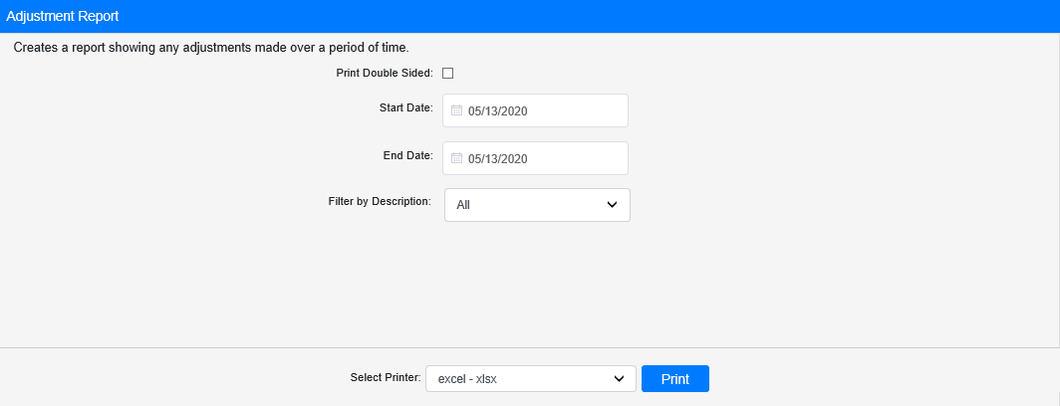

Field Definitions:

Print Double Sided:

- Check this box to print the report pages double-sided.
- Leave it unchecked to print the report pages single-sided.

Start Date: Enter the start date for the report here. All adjustments listed on the report occurred on or after this day.

End Date: Enter the end date for the report here. All adjustments listed on the report occurred before or on this day.

Filter by Description: If you only want to see a particular type of adjustment on the report, select it from this drop-down menu. The report shows all types by default. NOTE: The adjustment descriptions are created by the dealership in the Names & Definitions section of Rental Class Maintenance (RCM)

Select Printer: Select the printer to receive the report. Use the pdf printer to preview the report.

Click “Print” to print the report.

Sample Report:

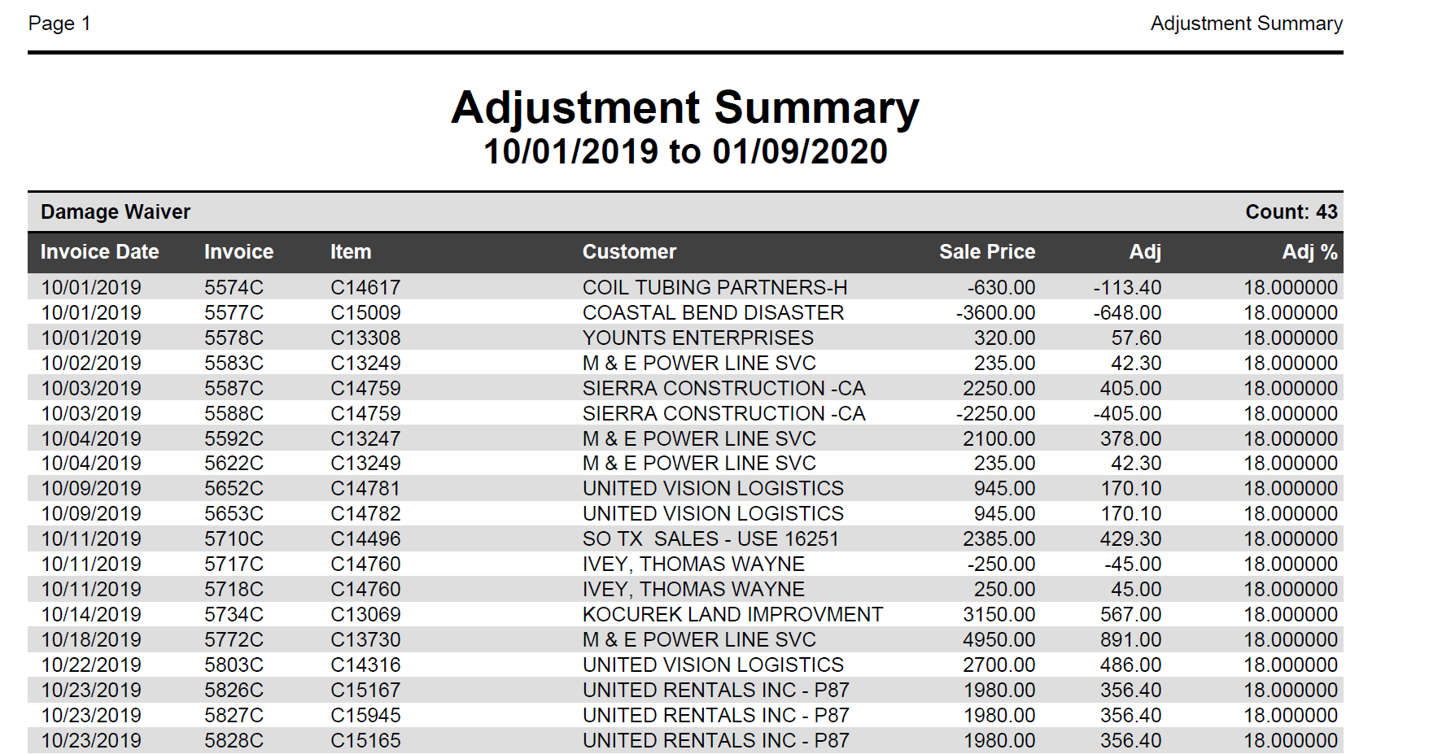

The adjustments are grouped by type/description and listed in order of invoice date and number. They also show the following:

- Relevant item number
- Customer name
- Sale price
- Adjustment value
- Percent adjustment

After each section, the report shows total dollar amounts for the section’s Sale Price and Adj columns.

