Finance Charge Rates and A/R Info (AIFC)

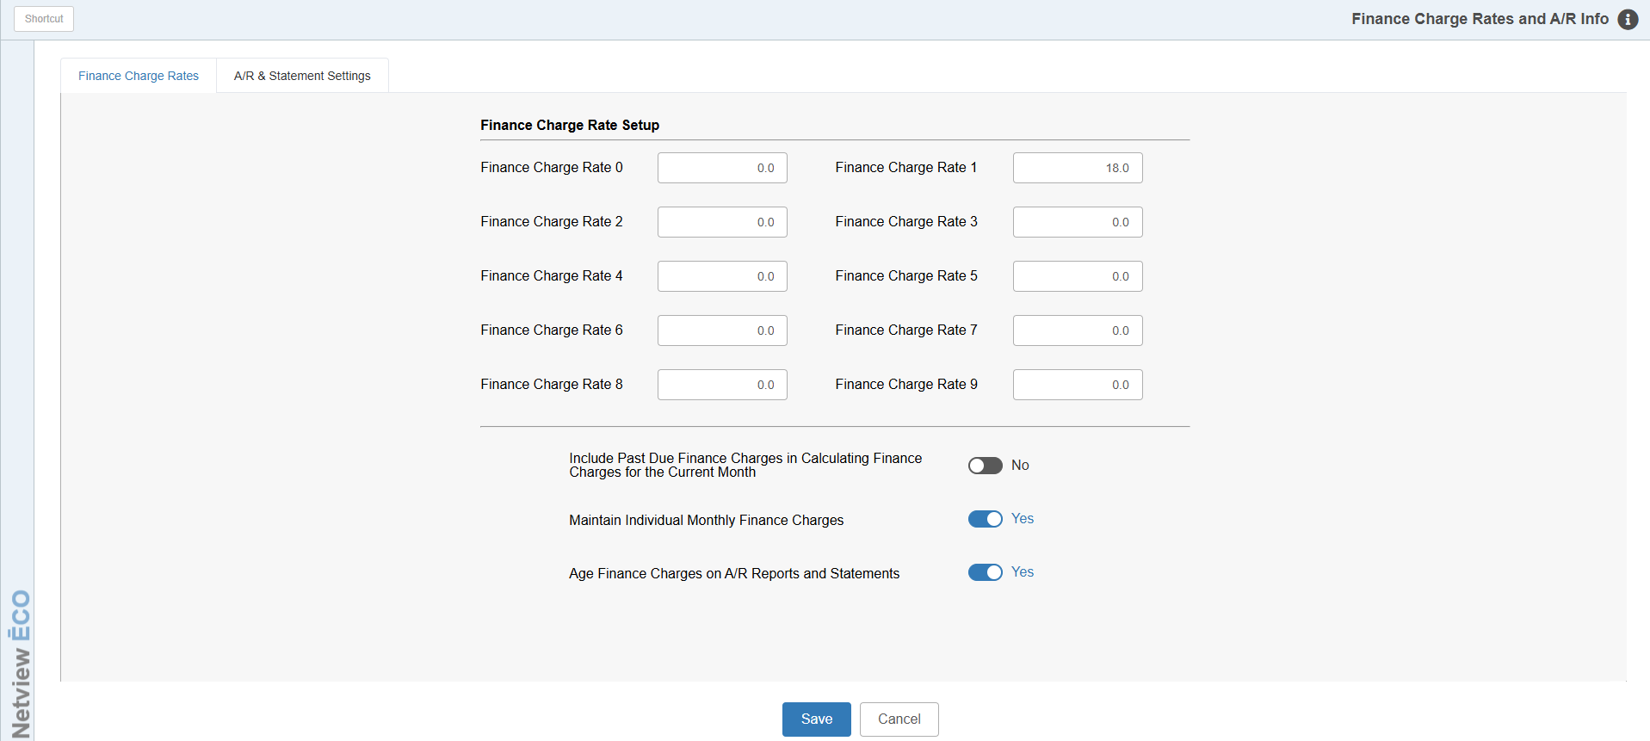

This area sets the defaults for many of the features in the Accounts Receivable program.

To access this function, either:

- Select “System Maintenance” from the menu, choose the “Company File” submenu, then click “A/R Info And Finance Charges.”
- Type “AIFC” in the Shortcuts bar

Finance Charge Rates Tab

Finance Charge Rate Setup (0-9): You may type in up to ten separate finance charge rates.

We suggest using Finance Charge Rate 0 when there are no finance charges.

The rate for Finance Charge Rate 1 is the one typically used for most customers.

The additional rates may be defined to handle any special interest rates that may apply.

Any percentage used should reflect the annual rate.

These rates are used by A/R Month End (ARME) to calculate finance charges.

Include Past Due Finance Charges in Calculating Finance Charges for the Current Month: Indicate your preference as to how finance charges are calculated.

Yes has the system calculate new finance charges on all outstanding invoices and earlier finance charges.

No tells the system to calculate new finance charges only on all outstanding invoices.

Maintain Individual Monthly Finance Charges:

- To have your finance charges appear as a new finance charge each month, select Yes.
- If you want the finance charges to accumulate as a lump total, select No.

Age Finance Charges on A/R Reports and Statements:

- If you want the finance charges to age and be included in the 30, 60, 90, and 120 day columns on the A/R reports and statements, select Yes.
- If you want them to report as current each month, select No.

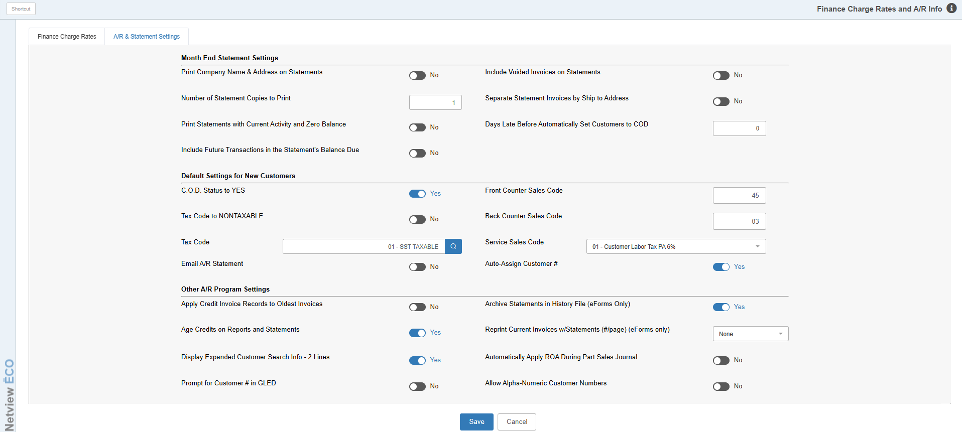

A/R Statement Settings Tab

Print Company Name & Address on Statements: This setting is used for dealerships who print on blank form (pre-printed forms that have NO company info). If you use this type, choose “Yes.” The typical response should be “No,” as most dealerships use pre-printed forms or e-forms.

Number of Statement Copies to Print: This field is used for laser printers. Choose the number of copies of statements to generate (i.e. 2 for 2 copies, 3 for 3 copies, etc.).

Print Statements with Current Activity and Zero Balance: Choose the kind of statement activity you want to print during the Statement Run.

Yes means that the system will print a statement if the customer bought and paid for items during the month and his account balance is 0.00.

No tells the system not to print balance statements of 0.00 at all.

Include Future Transactions in the Statement’s Balance Due: When statements are run, they include the detail for transactions up to and including the statement date. In the event there are future dated transactions on a customer’s account (any date later than the statement date—even one day), you decide if they should be added into the balance due for the statement. Whatever choice you make here, the total amount of future due transactions will always be included on the statement itself.

If you choose Yes, any dollar amount from these transactions will be added into the total statement balance.

No will still show the detail but will not add the amount of the transactions to the statement balance.

Include Voided Invoices on Statements: The question offers the ability to print any voided invoice information on the A/R statements.

Yes will print the voided invoice activity on the statements.

No will exclude voided invoices from the statement detail.

Separate Statement Invoices by Ship to Address:

- Answer Yes here to have the details on a customer’s statement separated by Ship To addresses.
- Answer No to have them print in invoice number order.

Days Late Before Automatically Set Customers to COD: This prompt gives the chance to automatically set a customer to COD if they are so many days past due on their account. Typical values would be in multiples of 30 days.

Default Settings for New Customers: This group of setting applies when you are adding a new customer.

You specify:

Default COD Status

Default Tax Code

Front Counter (Parts) Sales Code

Back Counter (Service) Sales Code

Service Sales Code (Labor - Netview Service).

Emailing Customer Statements

Auto-Assigning Customer Numbers

The defaults work hand-in-hand with the prompts selected for Custom Customer Maintenance (CCM). You can review your selections for these prompts in Customer Master Prompts (ARCP).

Apply Credit Invoice Records to Oldest Invoices: Choose how to apply credit invoices on customer’s accounts when taking payments in POS using the ROA option.

Yes tells the system to automatically apply credits to the oldest invoice amounts.

No tells the system not to apply credits to oldest invoices first. Credits are left as separate entries.

Age Credits on Reports and Statements:

- To have credits show as aging items instead of report as “current,” answer Yes.
- To have them to continue to report as a current lump sum, answer No.

Display Expanded Customer Search Info – 2 Lines:

- Answer Yes to have customer number look-up fields provide 2 lines of information about the customers. The information displayed includes:
  - Customer Number
  - Name
  - Phone Number
  - Average Credit Rating
  - Street Address
  - City
  - State
  - Zip Code.
  - If the customer is on COD status, this will be noted beside the Zip Code.
- Answer No to limit the information displayed to:
  - Customer Number
  - Name
  - City
  - State
  - Phone Number
  - A reference to COD status if appropriate

Prompt for Customer # in GLED: This setting defaults to “No” to prevent you from stopping in the Customer Number field for 10100 when making an entry in G/L Document Entry (GLED). You can have your cursor stop there for an entry each time by setting it to “Yes.”

Archive Statements in History File (eForms Only):

- Choose Yes to save eForms generated statements to a history file for future use.
- Choose No to bypass the saving option.

Reprint Current Invoices w/Statements (#/page) (eForms Only): Choose a number of current invoices to automatically reprint per page to include with the statement run. Select from 1 to a page or "Shrink-to-Fit" up to 8 invoices per reprint page. When you choose something other than “None,” the current invoices for that customer will print when the Statements print.

Automatically Apply ROA During Parts Sales Journal: This setting offers the option to have an ROA posted on a POS invoice to show as a SINGLE credit line on the customer’s account. It could later be manually applied to the preferred invoices in Cash Applications.

The setting will default to “Yes,” which will automatically apply the payment to any outstanding invoices and finance charges on a customer’s account.

You must change the setting to “No” to have it post only a single credit line to the customer’s account for the amount of the payment.

Allow Alpha-Numeric Customer Numbers: Use this setting to enable your system to generate alphanumeric customer numbers by selecting “Yes” from the drop-down menu. Otherwise, the numbers will remain composed of purely numeric digits.

