G/L Account Number Maintenance (ANM)

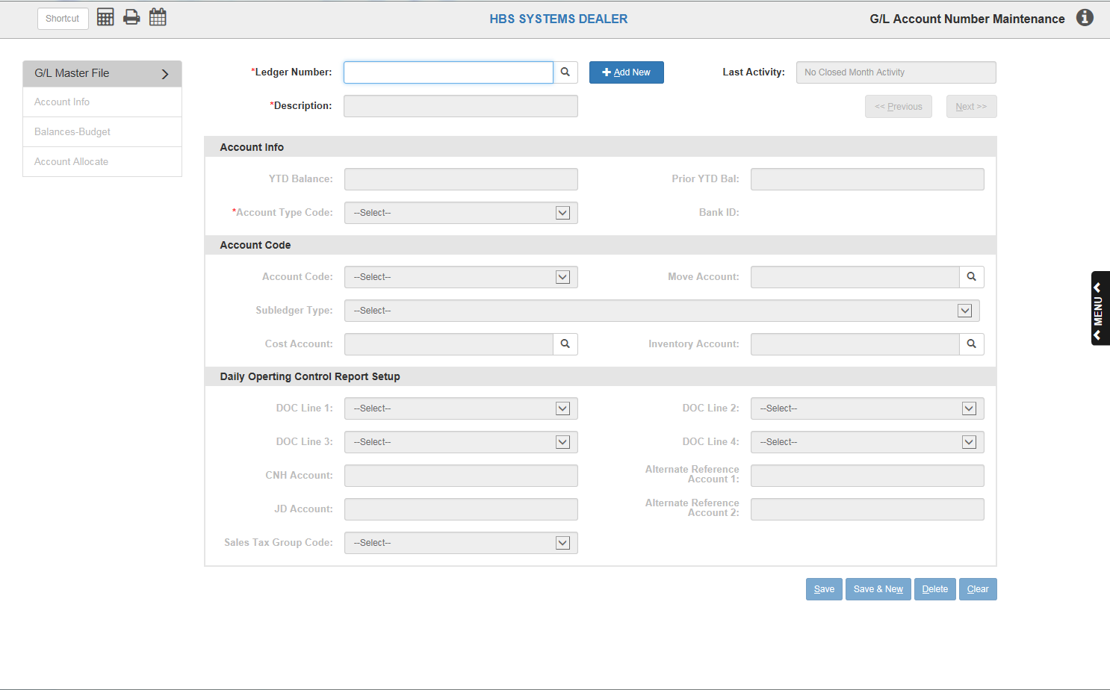

G/L Account Number Maintenance (ANM) contains a record for every account number in your system. The G/L system maintains this information and updates it when an accounting period is closed.

To access this function, you can either:

- Select “General Ledger” from the menu and choose the “Data Entry” submenu. Click on “Account Number Entry.”
- Type “ANM” in the Shortcuts Bar

General Fields/Buttons:

Ledger Number: This field holds the account number. Typically, this a five-digit number that sets up the master record for this account. The first (and sometimes second) digit indicates the account type:

- 0=Expenses
- 1=Assets
- 2=Liabilities
- 3=Sales
- 52-56=Cost of Sales
- 58-59=Other Income/Deductions

The fifth digit represents the account’s department code:

- 1=Units
- 3=Parts
- 4=Service
- 9=Dealership

Multi-location dealerships often have a sixth character that designates the individual store.

You can also look up an account by clicking the Search icon to the right of the field. A list like the one pictured below will appear in a new window.

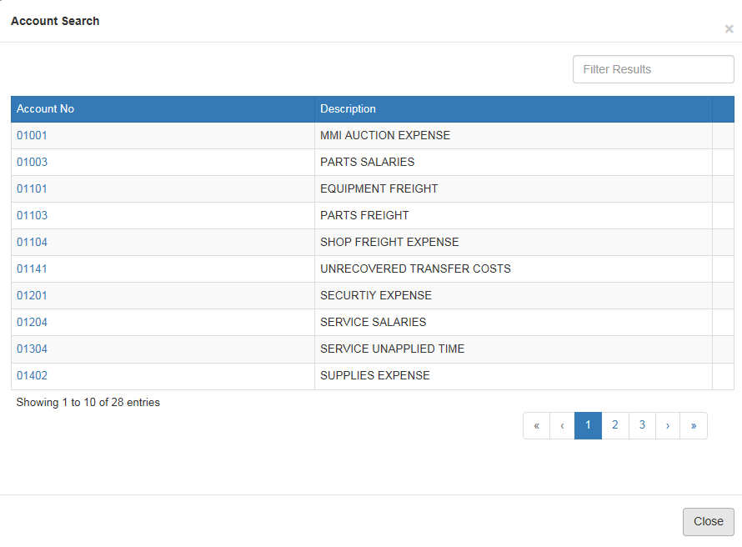

Select the account you want to edit by clicking on the account number.

Add New/Cancel Add: Click Add New to create a new account record. After you do so, Cancel Add will appear in its place. Click it to delete the newly added record.

Description: This area holds the title or description of this general ledger account number. It can be as detailed or descriptive as the space provided will allow. NOTE: If you are going to use abbreviations, it is a good idea to be consistent with abbreviations so the descriptions are in a similar format. For example, you could abbreviate Accounts Receivable as A/R, Accounts Payable as A/P, Notes Payable as N/P, Cost of Sales as C/S, etc.

Last Activity: This field holds the date this account was last affected by a month end closing process. The dates may vary from account to account. This variation is due to the fact that not all accounts have activity each accounting period and are only affected when there has been activity during the accounting period being closed. If there is no closed month activity previously, as in the case of a new account, the field is blank.

Previous: Click this button to move to the previous account record, as listed by account number.

Next: Click this button to move to the next account record, as listed by account number.

Save: Click this button to save any changes made to the account record.

Save & New: Click this button to save any changes made and open a new, blank entry.

Delete: This button is no longer active. You cannot delete accounts once they have been added to the system.

Clear: Click this button to clear the information fields in the onscreen record.

Account Info Tab:

YTD Balance: This field holds the balance as of the last month end closing process. This is a system-maintained field and is updated when an accounting period is closed. DO NOT modify it yourself.

Prior YTD Balance: This field, Prior YTD Balance, is used for the year-to-year comparison feature available on numerous reports. It contains the closing balance for the same accounting period as in the YTD balance field for the previous year’s business. It is a system-maintained field and is updated when the G/L Month End process is run. DO NOT modify it yourself.

Account Type Code: This field holds a code that places this account number in a specific area on the standard financial statement AND determines how this account will be handled when the fiscal year is closed. It is very important that you select an appropriate code for how it should be handled (balance cleared and rolled to Retained Earnings or balance kept because it is a Balance Sheet account) and its placement on the financial statement. The codes are also used by GraphXpress. A drop-down menu provides the different choices with descriptions. This is a required field, so you must select a value from the pull-down box when adding a new account.

Account Type Codes:

AcctType Range Description
A1 10000-10290 Cash/Bank Accounts
A3 10300-10390 Accounts Receivable
A4 not commonly used
A5 10600-10600 Contracts in Transit
A6 not commonly used
A7 not commonly used
A8 10400-11900 Other Receivables (Warranty)
B1 12001-12991 New Unit Inventory
B3 13001-13991 Used Unit Inventory
B5 14003-14993 Parts Inventory
B7 15004-15994 Work in Process/Other Inv
C 17000-17990 Prepaid Assets
E2 not commonly used
E4 18000-19500 Fixed Assets
F 19600-19990 Fixed Assets Total
F1 not commonly used
F4 not commonly used

G 20000-20190 Accounts Payable/Customer Deposits
H1 20200-20590 New/Used Unit Notes Payable
H3 20200-20590 New/Used Unit Notes Payable
H5 20600-20690 Parts Notes Payable
H8 20800-20990 Other Notes Payable
I 21100-22990 Accrued Liabilities
J 23000-23990 Long Term Liabilities
L 27000-29990 Capital/Net Worth

SA 30001-32991 New Unit Sales
SC 33001-33991 Used Unit Sales
SE 34003-34993 Parts Sales
SG 35004-36994 Service/Labor Sales
SI 35004-36994 Service/Labor Sales

TA 52001-52991 New Unit Cost of Sales
TC 53001-53991 Used Unit Cost of Sales
TE 54003-54993 Parts Cost of Sales
TG 55004-56994 Service/Labor Cost of Sales
TI 55004-56994 Service/Labor Cost of Sales

V 00101-09999 Controllable Expenses
V5 not commonly used
W 00101-09999 UnControllable Expenses
W5 not commonly used

Y 58000-58990 Other Income
Z 59000-59990 Other Deductions
Z5 not commonly used

Bank ID: This field is system-maintained. It is used by the Bank Reconciliation program to identify the accounts referenced in that program.

Account Code: This field helps you define and format your standard financial statement using the different codes. The different codes are:

H (Header): This may be used by the system to store codes that cause desired breaks, aka headings, in the account categories for the formatting of the financial statement. In this case you may see codes like T1 or T2 on selected accounts. These codes will appear in positions 1 and 2 of the 6-character field.

M (Move): See "Move Account" below. This feature is not commonly used.

S (Summary): This allows you to have numerous sublevel accounts summarized into a single account for reporting purposes. This feature is not commonly used.

T1-T5 (Level Total Lines): If used, these codes mean that the description in this account will appear on the financial statement as a Subtotal or Total, with the level line changing depending on the code chosen. Only Assets and Liabilities are coded as Subtotal Accounts. Accounts with these codes should never have an account balance or account activity during any accounting periods.

Move Account: This field setting actually cross references the monies directed to this account and passes those figures to another specified account number in this field. This feature is not commonly used.

Subledger Type: The system offers a feature to create an “audit trail” for accounts you specify. We refer to this as a Subledger of the account. Subledgers (or SLEDs) provide options to retain data in a specific format for an extended period of time. Subledger codes 0-9 are available, though only codes 5 and 8 are commonly used.

Common Uses of Sub-ledger Codes
Type of Account SLED Code Control Number
Unit Inventory 5 Stock #
Notes Payable (Equipment) 5 Stock #
Warranty Receivables 5 Invoice #/Document #
Contracts in Transit 5 Customer # or Name
Customer Deposits 5 Customer # or Name

Subledger Codes:

- 0—Balance Forward at Month End (sorted by Document Number)—The last month-end’s balance is subtotaled per document number (no previous month’s entry detail is brought forward). All current month activity is detailed and sorted in document number order. The document number detail is retained only for the current accounting period. The G/L month end condenses all dollar amounts not equal to zero into a balance forward line. Records with a zero balance are purged at this time.
- 1—Balance Forward at Month End (sorted by Control Number)—The last month-end’s balance is subtotaled per control number (no previous month’s entry detail is brought forward). All current month activity is detailed and sorted in control number order. The control number detail is retained only for the current accounting period. The G/L month end process condenses all dollar amounts not equal to zero into a balance forward line. Records with a zero balance are purged at this time.
- 4—Detail Preserved Through Month End (sorted by Document Number)—Even after the month end process is run, all entry detail is brought forward per document number. This style organizes the detail by paragraphs, each with its own total line. The only time detail is purged from this style of reporting is when the document number’s balance is zero. Items are sorted in document number order.
- 5—Detail Preserved Through Month End (sorted by Control Number)—Even after the month end process is run, all entry detail is brought forward per control number. This style organizes the detail by paragraphs, each with its own total line. The only time detail is purged from this style of reporting is when the control number’s balance is zero. Items are sorted in control number order. This style is used for the following accounts:
  - Unit Inventory
  - Unit Notes Payable
  - Warranty Receivable
  - Contracts in Transit
  - Customer Deposits
- 8—Register Format with Balance Forward at Month End (sorted by Document Number)—No entry detail is brought forward after the month end process is run. Only one balance forward total for the account number is printed, but all the current month detail is recorded in document number order (i.e. check # or deposit reference). This style is sometimes used for bank accounts as a check register.
- 9—Register Format with Balance Forward at Month End (sorted by Control Number)—No entry detail is brought forward after the month end process is run. Only one balance forward total for the account number is printed, but all the current month detail is recorded in control number order.

Cost Acct: This field is used only for Sale Accounts (those that have a first digit of 3). When the account number is a sale account, this field holds the corresponding cost account. For example, if the account number shown on the screen is 32001, the cost account field will show 52001.

Inv Acct: This field is used only for Sale Accounts (those that have a first digit of 3). When the account number is a sale account, this field holds the corresponding inventory account. For example, if the account number shown on the screen in 32001, the inventory account field will show the corresponding account.

DOC Line 1, 2, 3, and 4: This is a set of four fields used in the formatting of the DOC (Daily Operating Control) report. Each field holds the line number of the first appearance of this account number on the DOC report. Each account number may be included in up to 4 subtotals or totals on this report. The report itself may be up to 50 lines, and the numbers that are used in these fields refer to the actual line numbers in the report.

CNH Account: This field is used primarily for CNH dealers who submit their financial statistics to New Holland via their communications package. In this case, the CNH account number is placed here to cross-reference your chart of accounts to the selections available in the CNH chart of accounts.

JD Account: This field is primarily used by John Deere dealerships for mapping their chart of accounts for financial submission.

Alternate Reference Account 1: This field is currently not in use.

Alternate Reference Account 2: This field is currently not in use.

Sales Tax Group Code: This field is used to define Sales Tax groups for the Sales Tax Group Report (STGR). If this report is in use and this is a “sale type” account, a group code may be selected for it.

This coding is NOT necessary if the Sales Tax Report (STXR) is being used.

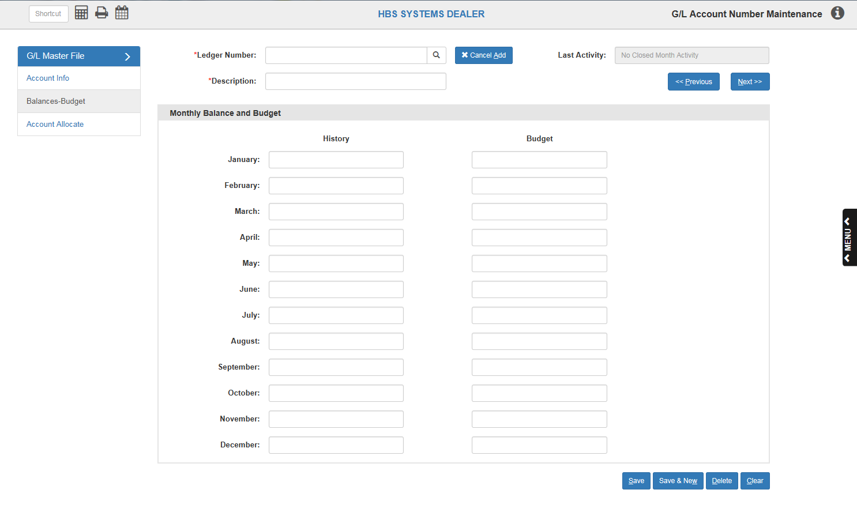

Balances – Budget Tab:

History Column: The first column on this tab displays the month-end closing balance totals for the last 12 months. This screen provides the beginning balance for printouts that show that amount.

Budget Column: The second column provides the areas where you may enter budget figures for the year. Budget figures are traditionally created or prepared for Sale, Cost, Income, Deduction, and Expense accounts. The entry of these figures provides the ability to compare current year statistics to planned targets as shown in the budget figures. To make use of the budget fields, it is advisable to make budget projections that are quite detailed and that affect virtually all accounts in the groups mentioned above. The entry of the budget figures is “sign” sensitive. In other words, if the account traditionally has a credit balance, then a credit number would be likely. The budget figures can be displayed on a Standard Financial Statement, DOC report, and on Custom Financials. A setting in CONA must be turned on for the numbers to show on the reports.

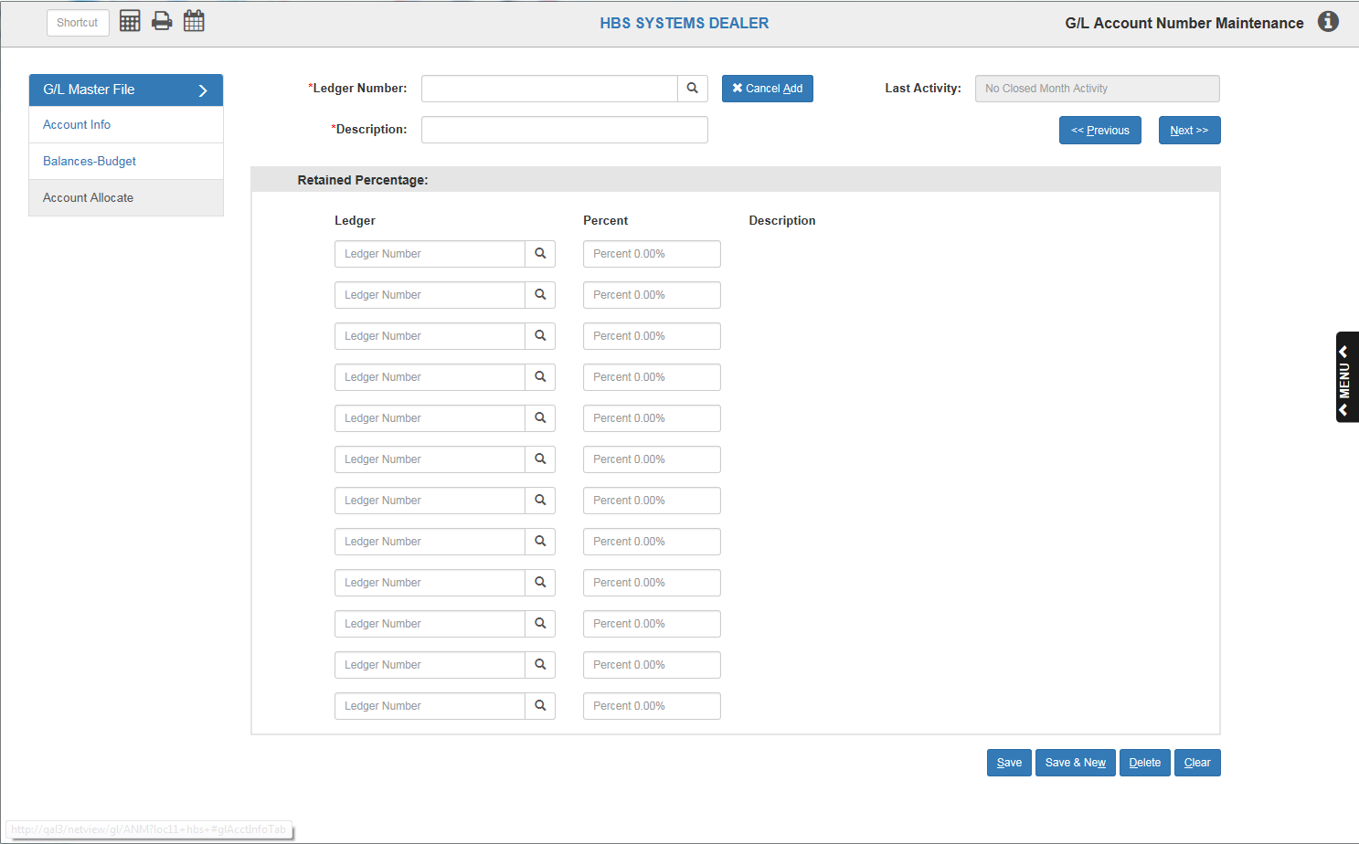

Account Allocate Tab: Here you may set-up specific, routine expense allocations. These are most commonly used for expenses that are divided among a set group of accounts. One example is the electric bill; in some dealerships this expense is divided between the departments by percentage. For instance, the bill could be divided so that the Sales Department gets 25%, Parts gets 20%, and Service gets 55%. If this expense is always divided this way, it can be created on this tab of ANM. NOTE: The allocations must add up to 100%, or they will not be accepted.

The ideal way to setup these allocations is to create an account number that is used only for this purpose. We suggest that you add an account number for each account series you want to automatically allocate with a department code of X. For example, if you are splitting up the utilities (account number 0380_) you would create account number 0380X to be used exclusively for expense allocation. You would also need to make sure that any of the departmental accounts you intend to pass a portion of the expense to also exist. For this example, you would also need accounts 03801 (Sales), 03803 (Parts), and 03804 (Service) to make the allocation work. On this screen you would enter the account numbers with an appropriate percentage for each, paying close attention to make sure that the total of your percentages equal 100%. You may use up to 12 accounts in each expense allocation.

The percentages are added ONLY to the X account in each number series. For example, when a bill or expense for utilities is entered in the system, then its total is directed to the X account. As the journals are run, the system will allocate the amount out to the identified accounts based on the percentages entered.

