A/P Aging Report (APA)

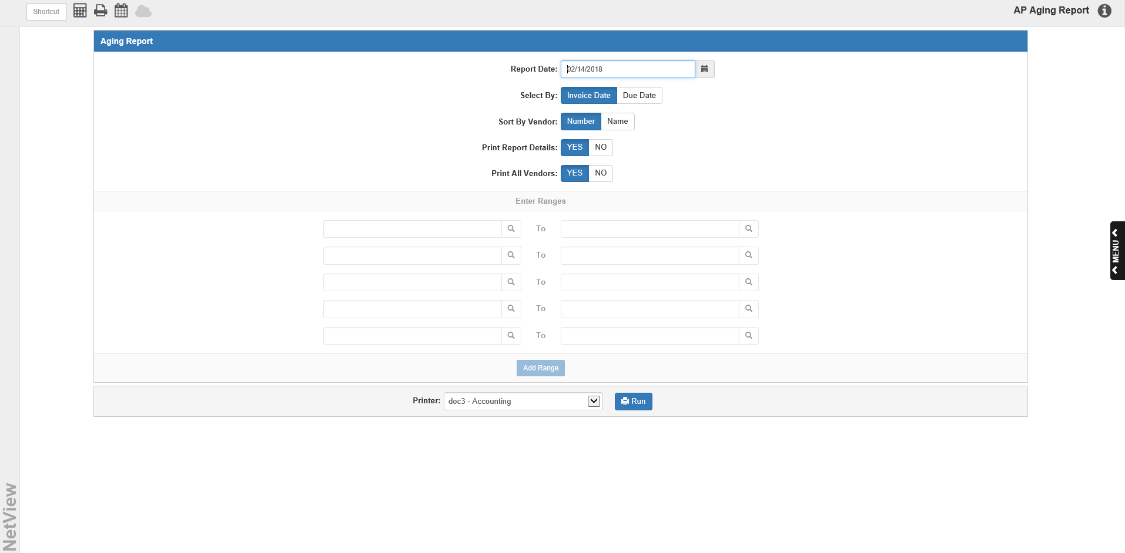

The A/P Aging Report (APA) tracks how long the unpaid invoices have been in A/P.

You may specify which invoices to include on the report, and whether to base the aging on the invoice date or the invoice due date. This report may be run anytime during the month, but it is particularly important to print it on the last day of the current month. For Month End purposes, the report provides the status of all of the open invoices up through the end of the period to be closed.

You can also use APA to re-create the A/P Aging Report for a date of your choice. This historical report is useful in reconciling A/P to the Trial Balance (TB).

To access this function, you can either:

- Select “Accounts Payable” from the menu and choose the “Memo Reports” submenu. Click on “Aging Report.”
- Or type APA in the Shortcuts Bar

Field Descriptions:

Report Date: The current date pre-fills here but you can change it as needed. This report includes all posted invoices that have either an invoice or a due date on or before this date.

Select By:

- Choose Invoice Date to base the report on the invoice date.
- You may also select Due Date if you wish to review all of the invoices that are due by or before the date you entered in the “Enter the report date” field.

Sort By:

- To sort the report alphabetically by the vendor name, choose Name.
- To sort it by vendor number, choose Number.

Print Report Details:

- Choose Yes to print invoice detail on the report.
- Choose No to print a summary report.

Print All Vendors:

- Choose Yes to print invoice detail for ALL of your vendor accounts.
- Choose No if you are only interested in a single vendor account or in a range of accounts.

Enter ranges: You may enter ranges of vendors to include. Type a vendor number in the starting range field, or type all or part of the vendor name to search for it. Enter an ending vendor number in the ending range field to set the range. If you require more than 5 ranges for the report, click Add Range to add more ranges of vendors.

Printer: A default printer is pre-filled but you may change it as necessary. Use the pdf-Display printer to display the report on your screen. The report can also be directed to a spreadsheet. A sample is shown after the printed copy.

Press “Run” to generate the report.

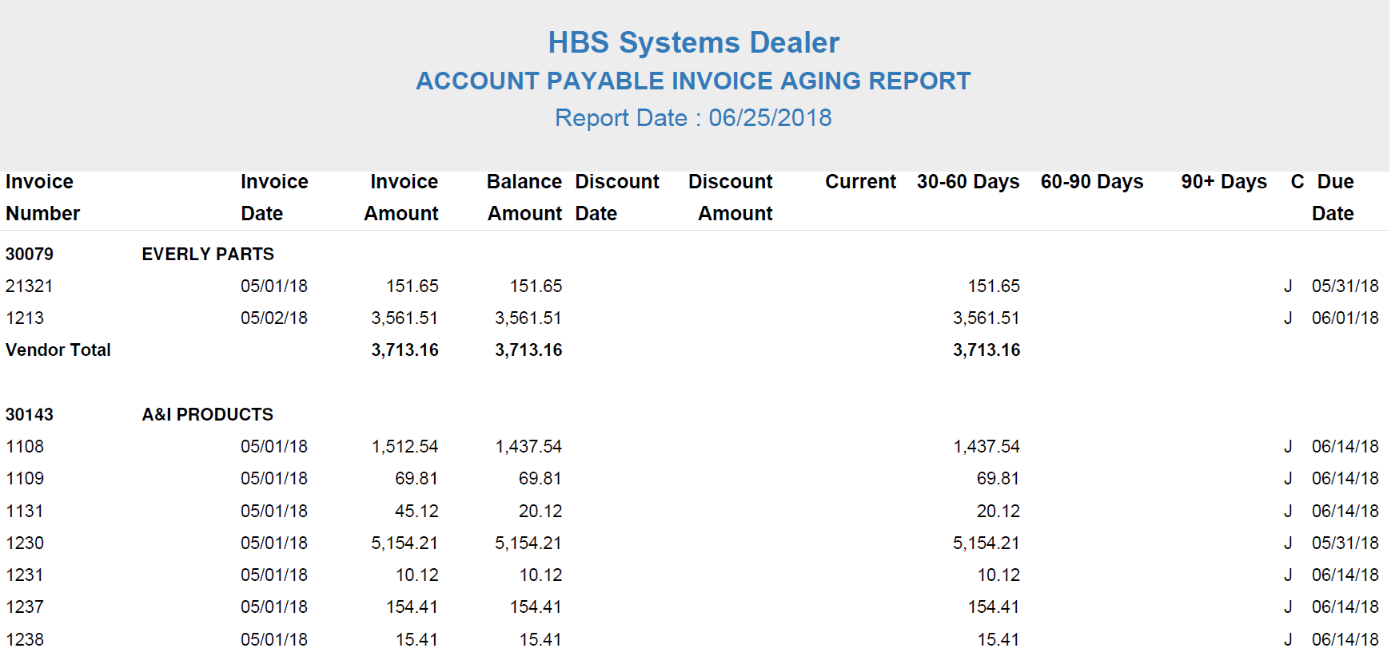

A/P Aging Report – Detail Report Printout: The A/P Aging Detail Report is divided by vendor and shows the aging for each of the vendor’s invoices.

Vendor: The vendor number and name print on this line.

Invoice Number: The invoice number is shown here.

Invoice Date: This shows the invoice date. If you chose “Invoice Date” in the Select By field, the report’s aging will be based on this date.

Invoice Amount: This is the original total amount of the invoice.

Balance Amount: This column prints the invoice’s remaining balance (original amount less payments).

Discount Date: This shows the discount date, if any.

Discount Amount: This is the discount amount, if any.

Current: The next few columns age the invoice’s remaining balances. The aging depends upon the report date and either the invoice date or the due date, depending on your selection. The program compares your chosen date to the report’s date. An invoice is current if the chosen date is less than 30 days from the report date.

30-60 Days: The balance is 30 to 60 days old (one to two months).

60-90 Days: The balance is two to three months old.

90+ Days: The balance is over three months old.

C (Code): The column displays the status of the invoice: J=Journaled.

Due Date: The invoice due date prints in this column. If you chose “Due Date” in the Select By field, the report’s aging will be based on this date.

Vendor Total: This line calculates the following totals for this vendor:

Total original invoice amount

Total remaining balance

Total discount amount

Total aging amounts

Grand Totals: This line calculates the following totals for all vendors listed on the report:

Total Original Invoices

Total Remaining Balance

Total Discounts

Total Aging for:

Current

30-60 Days

60-90 Days

90+ Days Past Due

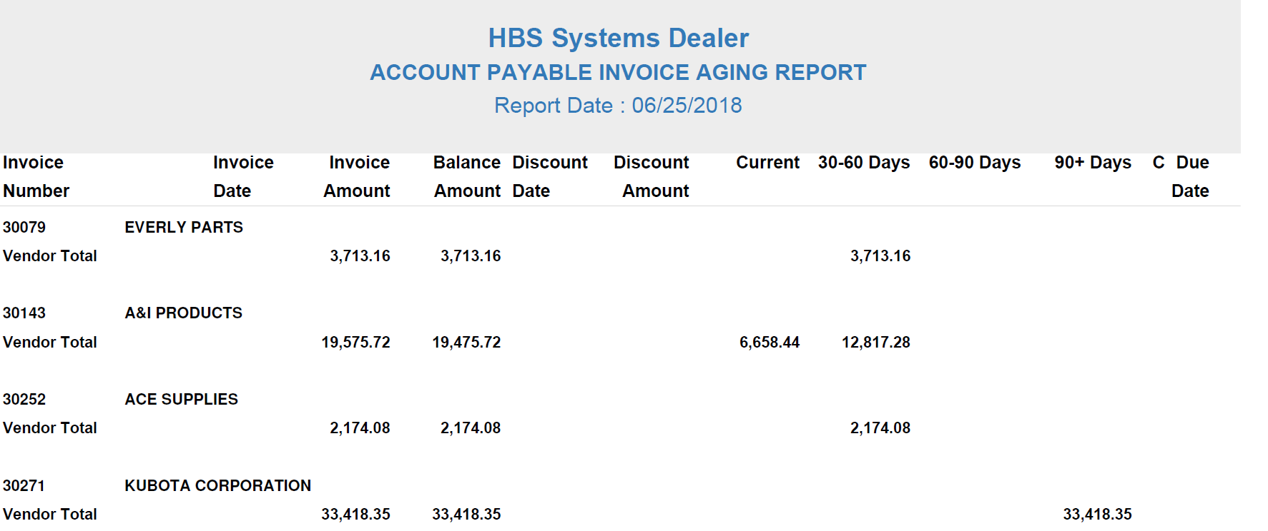

A/P Aging Report—Summary Report Printout: The A/P Aging Summary Report only shows the Vendor Total lines for each vendor, as well as the Grand Total line at the end of the report.

A/P Aging Report – Spreadsheet Sample: The report can be directed to a spreadsheet. This format includes BOTH a Summary version and a Detail version with each as different tabs in the spreadsheet.

A/P Aging Report – Spreadsheet Sample – Summary Version:

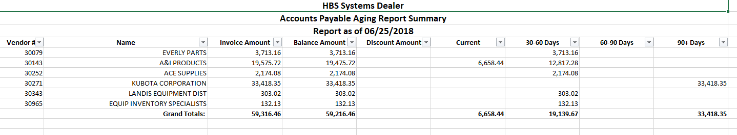

A/P Aging Report – Spreadsheet Sample – Detail Version:

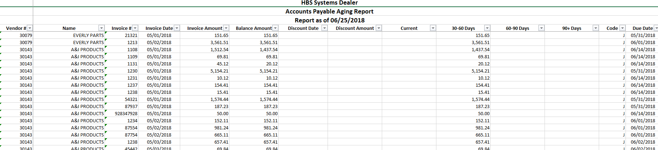

Print AP Accounts: If you have the Multiple A/P Accounts feature turned on in Information Defaults (ID), this report option will appear.

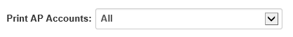

This field determines which invoices will print on the report based on their A/P account number. It defaults to “All,” but if you only want the report to show invoices for a specific account number, select that number from the drop-down menu. The account number will appear on the same line as the vendor name and number:

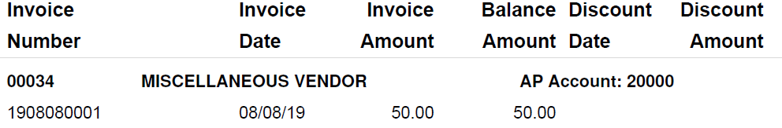

The report will also include a total line for the account, listed at the bottom of the report above the “Grand Totals” line.

If you print all accounts, the report will show a total line for each A/P account included on the report.

