A/P Purchase Journal (APPJ)

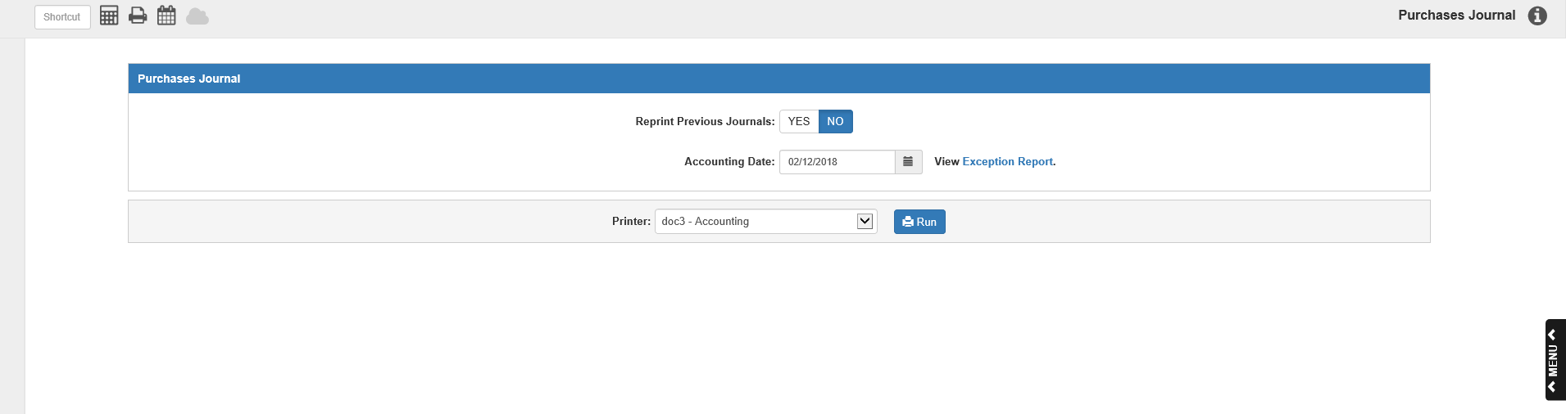

Purchase Journal (APPJ) is the final step in the invoice entry process. APPJ posts the entries to the General Ledger. The account numbers and their respective amounts in the invoice document are posted. Three areas are affected during the posting process:

- General Ledger—Creates entries to inventory, expenses, or income depending on the invoice.
- A/P Open Invoices—The list of open invoices, grouped by vendor. The open invoice total equals the A/P balance in the General Ledger.
- Unit Stock Number Records—If invoice or credit memo documents contain a unit inventory or Notes Payable account number and stock number (Reference), the journal process updates the A/P information in the Unit system for these stock numbers.

To access this function, you can either:

- Select “Accounts Payable” from the menu and click on “Purchase Journal.”
- Type “APPJ” in the Shortcuts Bar.

Reprint Previous Journals: This defaults to No. Select Yes to reprint the last Purchase Journal. You might use this option if the printer jams or prints the Journal incorrectly.

Accounting Date: This is the Journal’s posting date. Today’s date pre-fills but can be changed as needed. All pending documents for the accounting month will be posted, up to and including the date entered. You cannot post to a closed month.

View Exception Report: If you have any unposted invoices for a time period outside of the present (prior months, closed months, or future-dated), an Exception Report will be available, containing a list of those invoices. Click on the link to view the report. You will also get a warning will also appear when you run the Journal:

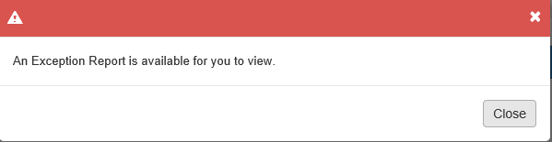

The Exception Report will appear as follows:

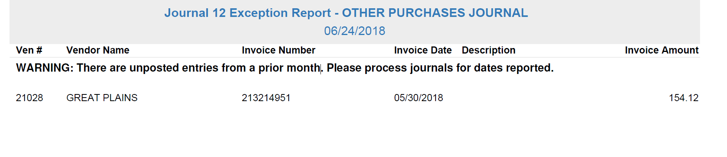

The report can be divided into three sections:

- Unposted future-date entries
- Unposted entries from a prior open accounting month
- Unposted entries for a closed accounting month

Report Columns:

Ven #: This column shows the vendor number for the invoice.

Vendor Name: This column shows the vendor name.

Invoice Number: This column shows the invoice number.

Invoice Date: This column shows the invoice date.

Description: This column shows the invoice’s header description from EAPI.

Invoice Amount: This column shows the invoice amount.

To post the entries listed on the report, return to APPJ and use either the last day of the accounting month affected or the dates listed for the entries on the report to post those invoices.

Printer Name: Identify the printer to receive your printout. A default printer is pre-filled, but you can change it as needed.

Click “Run” to run the Purchase Journal and receive the Journal Printout.

NOTE: If there are no pending Journal entries, Run will be disabled and the following message will appear by the button:



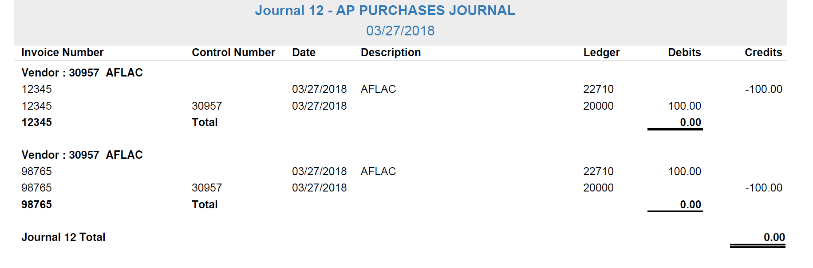

AP Purchases Journal (Journal No. 12) – Description: This printout is a permanent record of the entries and should be filed with other Journals. If there is an Exception Report for the Journal, it will appear at the beginning of this printout, before the actual Journal information.

Journal Date: The Journal Date appears right below the Journal Name in the header of each page.

Document Detail Section: Each invoice document is grouped first by Vendor Number, then by Invoice Number, and provides an invoice total at the end of each Invoice Number.

Vendor: This line appears at the beginning of each vendor section and shows the vendor’s name and number.

Invoice Number: This column shows the invoice number.

Control Number: Any info entered in the Reference field on the invoice line is printed in this column.

- If the account number is a subledgered account, you may see something here.
- For the Accounts Payable line to 20000, you will see the vendor number.
- If the invoice is tied to a unit, the unit’s stock number will appear here.

Date: This shows the invoice date. It may be different from the Journal Date at the top.

Description: This shows the vendor name or description entered on the line in Enter A/P Invoices (EAPI).

Ledger: This is the General Ledger account number associated with the line.

Debits: Typically, all lines for the entry are shown in this column. If you created a credit invoice, however, then the invoice entries would print under the Credits column.

Credits: Normally, the line for 20000 – Accounts Payable is printed under this column. However, if this is a credit memo, then this entry is located under the Debits column.

Invoice Total Line: This line appears as the last line for each invoice and shows the total journaled invoice amount. This amount should be “0.00,” showing that the invoice is in balance.

JOURNAL 12 TOTAL: This is the last line of the journal detail pages. It shows the total invoiced amount for all vendors on the report. As all invoices on the report should be in balance, the amount should be “0.00.”

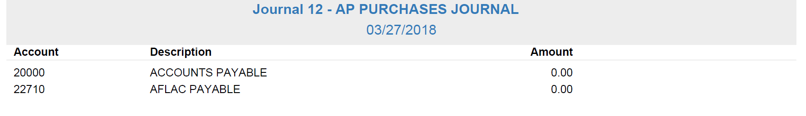

Account Summary Page: The last page of the printout contains a summary of all account numbers shown in the previous section.

Account: This lists the General Ledger numbers, sorted in numerical order.

Description: This is the account’s description.

Amount: This is the net amount of all entries to each account number listed.

