Void Check (APVC)

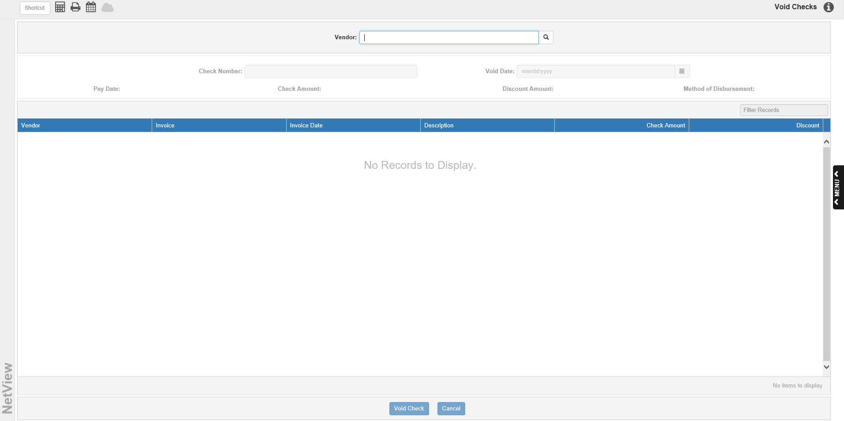

Void Check (APVC) makes it easy for you to void journalized payments from Print Checks (PC), Manual Checks (MC), or On Demand Checks (ODC). APVC automatically reverses the check’s accounting entries and places the invoice back on the vendor’s account in A/P to be paid. When you run the Disbursement Journal (DJ) at the end of the day, the void check entries are posted to the General Ledger for the check void date.

APVC even lets you void a payment that occurred in an accounting month that is now closed. Since the accounting entries for the void transaction automatically use the current date as the document date, it does not matter when the original payment entry occurred.

To access this function, you can either:

- Select “Accounts Payable” from the menu and choose the “Process Checks” submenu. Click on “Void Checks.”
- Type “APVC” in the Shortcuts Bar.

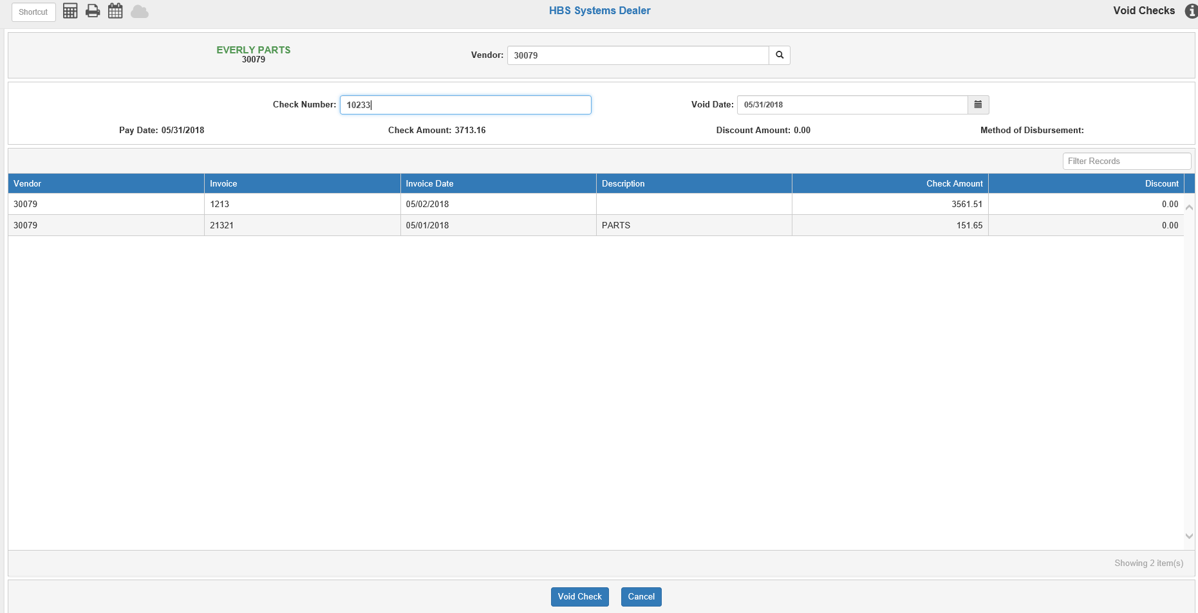

Field Descriptions:

Vendor: Type in a vendor number or search for it by entering part of the vendor’s name. Locate the vendor and click on it to select it. The vendor’s name and number will display to the left of the field. You can click on the vendor’s name to view their Vendor Insight (VI) page.

Check Number: Type the original check number or payment document number. The check or payment entry MUST BE JOURNALIZED in order for it to be voided. Hit the “Enter” key after entering the check number to populate the screen with its information.

Void Date: This field fills with the original check date provided that the date falls within an open accounting period. You may change that date to any time between the original check date and today if needed. If the original check date is not from an open accounting period, it pre-fills with the first day of the oldest open accounting period.

Pay Date: This pre-fills with the original check’s pay date.

Check Amount: This pre-fills with the check’s amount.

Discount Amount: This field displays the discount amount to the selected check or payment, if applicable.

Method of Disbursement: This field shows the bank info used to make the original payment. There will only be a value here if multiple bank accounts are in use.

Invoice Display Grid-Columns: The grid shows the invoices affected by the payment. You can sort the list using the column headers or filter it by entering specific information in the Filter Records field.

Vendor: This column shows the vendor number for the invoices, which is also the vendor for the check/payment being voided.

Invoice: This column shows the invoice numbers affected by the payment.

Invoice Date: This column shows the original invoice date.

Description: This column shows the invoice’s description.

Check Amount: This column shows the portion of the check amount assigned to pay off that invoice.

Discount: This column shows the discount amount for the invoice, if applicable.

Cancel: Click this button to cancel the void and clear the screen of everything except the vendor number.

Press “Void Check” to continue with the void when ready.

Void Check Warning: The following message will appear after you click Void Check:

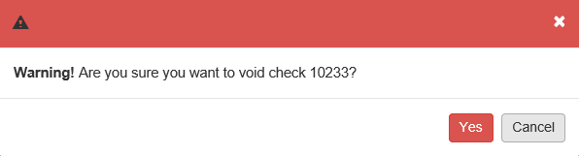

- Click Yes to continue with the void.
- Click Cancel to stop the void.

Void Check Confirmation Warning: You will need to confirm the void a second time:

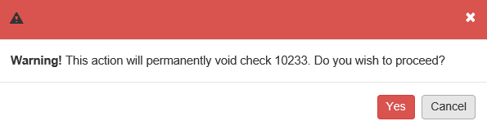

- Click Yes to proceed with the void.
- Click Cancel to stop the void.

Void Check Successful: If you clicked Yes at the second warning prompt and the void was successful, the screen will be cleared except for the vendor. The following actions have now occurred:

- Reversing accounting entries have been created. The checking account (and possibly discounts earned) has been debited and the A/P account has been credited.
- Vendor History has been updated to mark the payment line as a VOIDED CHECK and reset the invoice status to J (Journalized).
- The vendor will show these invoices back on the open balance list.

Posting Void Check Entries: Just as with check/payment and write-off entries, you have to run the Disbursement Journal (DJ) to post the Voided Check entries.

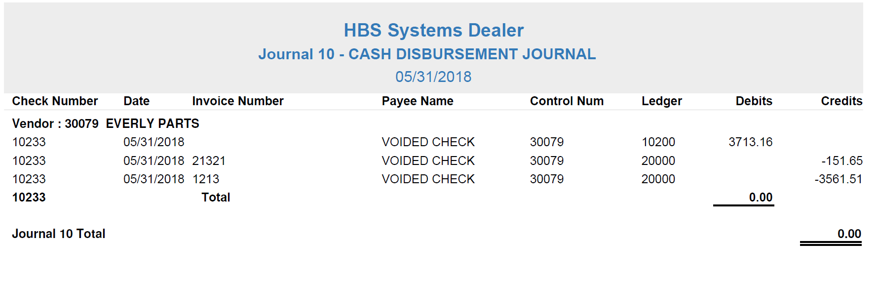

After you run Disbursement Journal (DJ), the printout shows all of the payment, check, write-off, and void entries made for that day (or since you last ran DJ). Notice the following items:

- The original check number is used as the Check Number for the void entries.
- The original invoice number is included in the document description.
- A line entry per invoice paid by the original check/payment entry is included on the printout, all of which list “20000” as their ledger account number, while there is only one line for the money being repaid to the checking amount, “10200.”
- If the original check/payment document included a discount amount, this amount is also reversed.

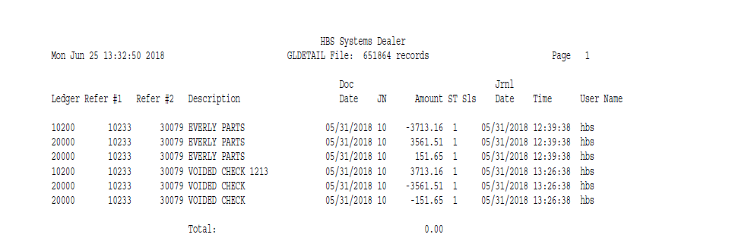

Above is a sample General Ledger Detail Inquiry (GLDI). This example shows the records for voided entries. Notice that Refer #1 contains original check/payment numbers and the voided entry Document Numbers.

