A/R Aging Report (ARA)

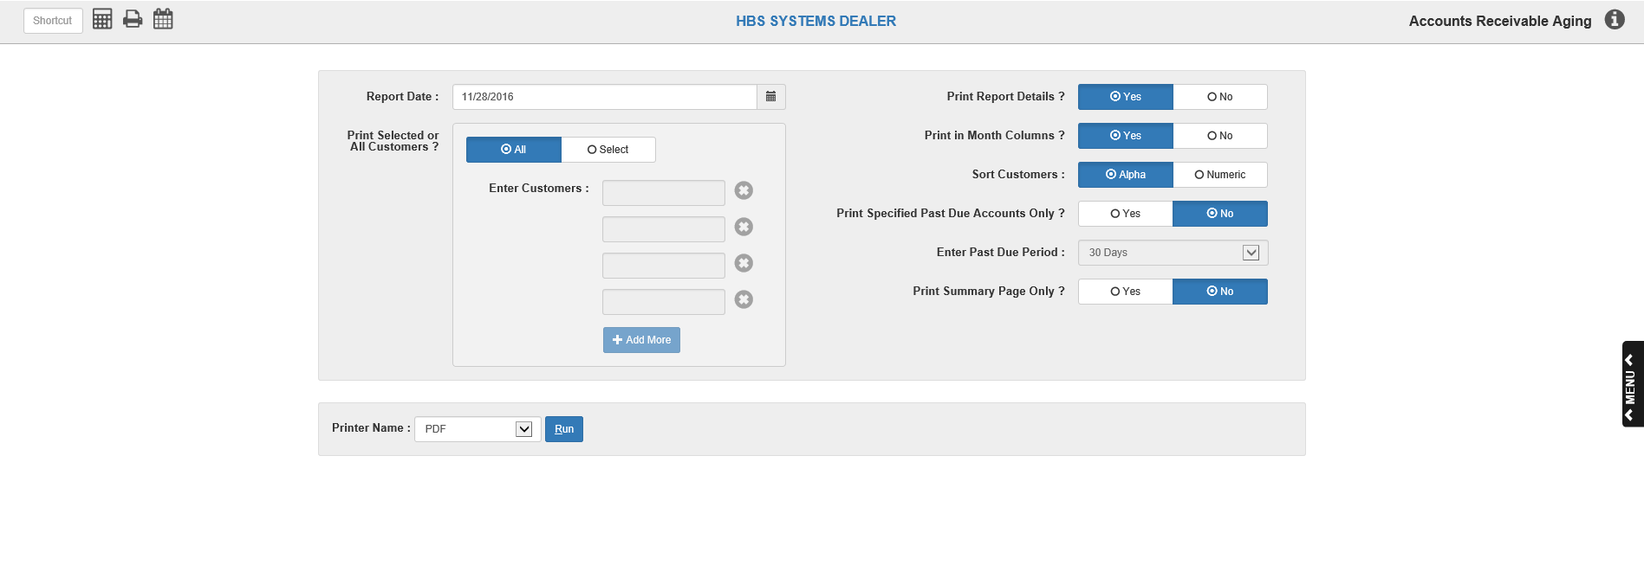

The Accounts Receivable Aging Report is the core of A/R reporting. It provides complete detail of Accounts Receivable amounts, amount totals without the detail, or just a summary page, depending on what options you select.

The details on this report will vary based on your selections in A/R Info and Finance Charges (AIFC). These selections apply to:

- Separation of finance charges
- Aging of finance charges
- Aging of credits.

We recommend printing this report on the last business day of the physical month (i.e. September 30). Keep the report with other printouts for that month.

- To access this function, either:
  - Select “Accounts Receivable” from the menu and select the “Memo Reports” submenu. Click on “Aging Report.”
  - Type “ARA” in the Shortcuts Bar

Field Definitions

Report Date: Type the report date in this field or click the icon next to the field to select it from a calendar.

Always use the current date when you run this report. This allows you to compare the Total Net Due to the Trial Balance amount for the G/L Accounts Receivable Account (typically 10300).

If you want it to reflect all invoices and payments up through and including the last calendar day of the month, then run this report THAT DAY.

Print Range or All Customers: Choose which customers to include on the Aging Report.

Select ALL to include all customers.

Choose Select to have the report cover only specific customers.

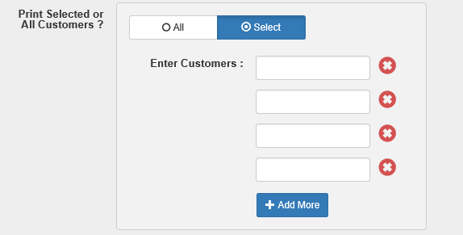

Enter Customers: If you choose Select, enter the selected customer numbers in these fields. You may run a report for a single customer or select as many specific customers as you want.

- There are 4 Enter Customer fields by default, but you can create more fields by clicking the Add More button below the fields.
- To remove Enter Customer fields, click the red “X” icon next to the field (you can remove all but one of the fields).

Print Report Details:

- Choose Yes to print the detailed version of this report. It lists all:
  - Outstanding invoices
  - New invoices
  - Payments
  - Credits
  - Finance charges per customer.
- Choose No to print the summary version of the report. It shows only the Net Due totals per customer. The “No Detail” style is ideal for a quick check of the largest and oldest balances, and includes the customer’s phone number for collection calls.

Print in Month Columns?: This option formats the report to print month names on the columns in lieu of the aging categories (example: Apr, Mar, Feb instead of 30, 60, 90 days). The Months version ages the A/R activity strictly by the date/month.

Choose No to print the traditional 30-60-90 days headings on the aging report.

Choose Yes to see the month names on the report.

Sort Customers: Choose the sorting order for your report.

Select Alpha to have the report sorted in alphabetical order based on the Alpha Sort field in the Customer Master.

Select Numeric to have the report sorted in numerical customer number order.

Print Specified Past Due Accounts Only?: Here you can limit the report to past due accounts or include all accounts on the report.

Select No to select all accounts.

Select Yes to choose a report of past due accounts.

Enter Past Due Period: This field only activates when you choose Yes for Past Due Accounts. Choose the lowest number of days past due to include on the report.

- Choose 30 Days to include customers who are 30 days or more past due.
- Choose 60 Days to include customers who are 60 days or more past due.
- Choose 90 Days to include customers who are 90 days or more past due.
- Choose 120 Days to include customers who are 120 days or more past due.

Print Summary Page Only?: This option deals with the summary page of the report. All report selections include the total page for that report run.

- If you just want the summary page, select Yes to print only the Net Totals.
- Select No to print a full-length report with the selections entered AND a summary page.

Printer Name: Select the printer to receive the printout. A default printer name is pre-filled, but can be changed as necessary using the drop-down menu. Use the PDF printer to view the report on the screen without printing a copy of it.

Run (Alt R): Press this button to start the report based on the selections you have made.

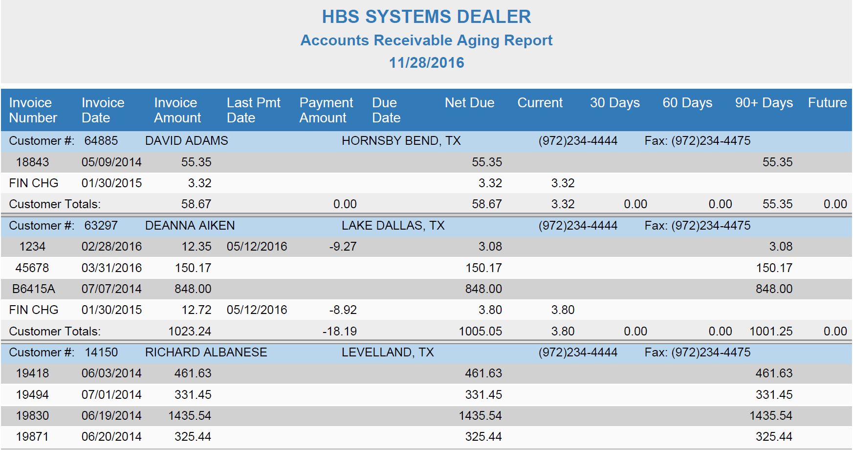

Report Sample – Detail Version with column headings of 30/60/90 days: For each customer that appears, you will see their:

Customer Number

Name

City

State

Phone Number

Columns Include:

Invoice Number: This is the invoice number on the customer’s account.

Invoice Date: This is the date the invoice was written.

Invoice Amount: This is the original amount of the invoice.

Last Pmt Date: This column shows the date of the last payment made on the invoice shown.

Payment Amount: This column shows the total payments made on the invoice shown.

Due Date: This column shows the due date of any invoices future billed to this account. There will only be an entry in this column IF the invoice has a future due date.

Net Due: This shows the net amount due on this invoice (original invoice amount less any payments).

Current: These invoices are tagged as current because they have been billed to the customer’s account since the last statement run and are less than 30 days old

30 Days: This column includes those invoices that are between 30 and 60 days old.

60 Days: This column shows invoices that are between 60 and 90 days old.

90 + Days: This column includes invoices that are 90 days older or more.

Future: This column shows the amounts of invoices with future due dates.

Customer Totals: Totals are provided for each of the following columns on the report:

Invoice Amount

Payment Amount

Net Due

Current

30 Days

60 Days

90+ Days

Future

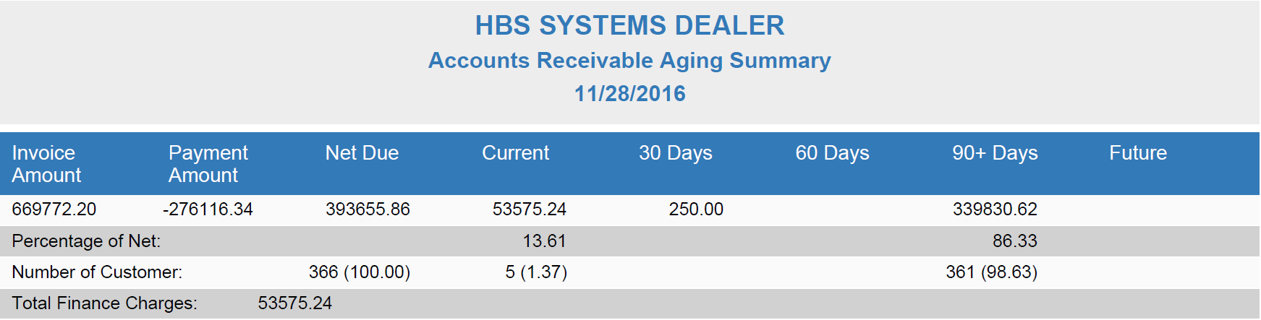

Summary Page: At the end of the detail report you will receive a summary report recapping totals for customers selected in this report (if relevant).

Totals: Grand totals are provided which includes all customers selected for this report:

Invoice Amount

Payment Amount

Net Due

Current

30 Days

60 Days

90+ Days

Future

Percentage of Net: Under the aging columns (Current, 30, 60, 90+, and Future) you will see a percentage that compares that column to the Net Due column.

Number of Customers: This total shows the number of customers represented in the total for each of the aging columns (Current, 30, 60, 90+, and Future) and the percentage of it to the total number of customers is shown behind it in parentheses.

Total Finance Charges: This is the total of all finance charges for customers selected for the report.

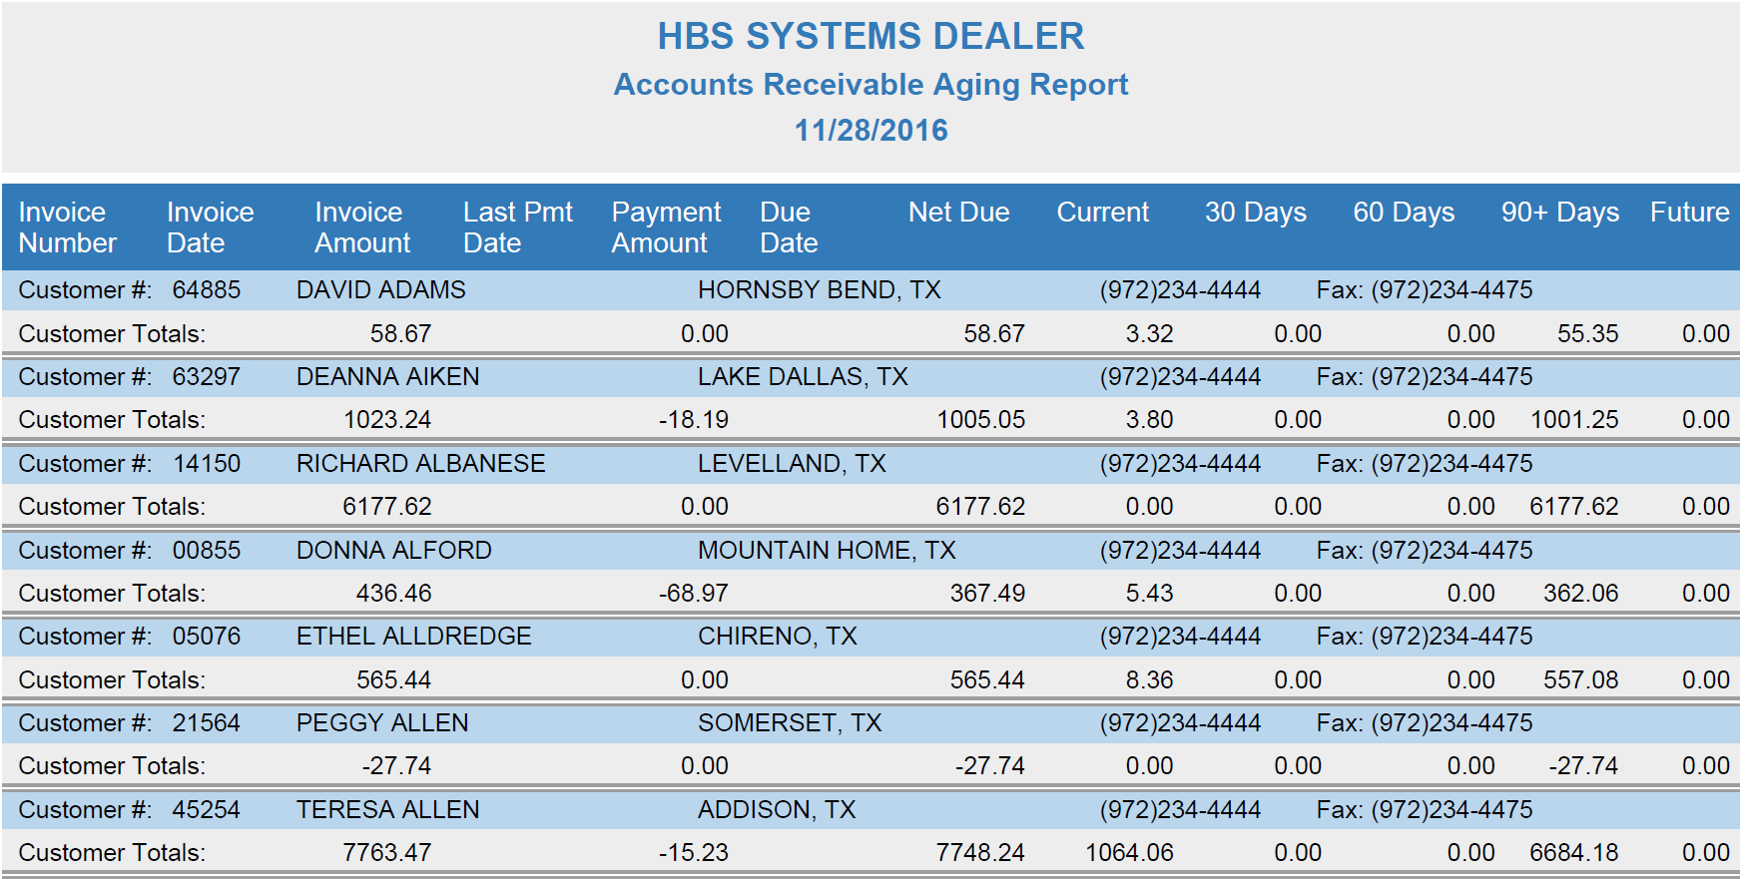

Report Sample – No Detail Version with column headings of 30/60/90 days: Notice how this style shows just the total for each customer for each of the aging categories.

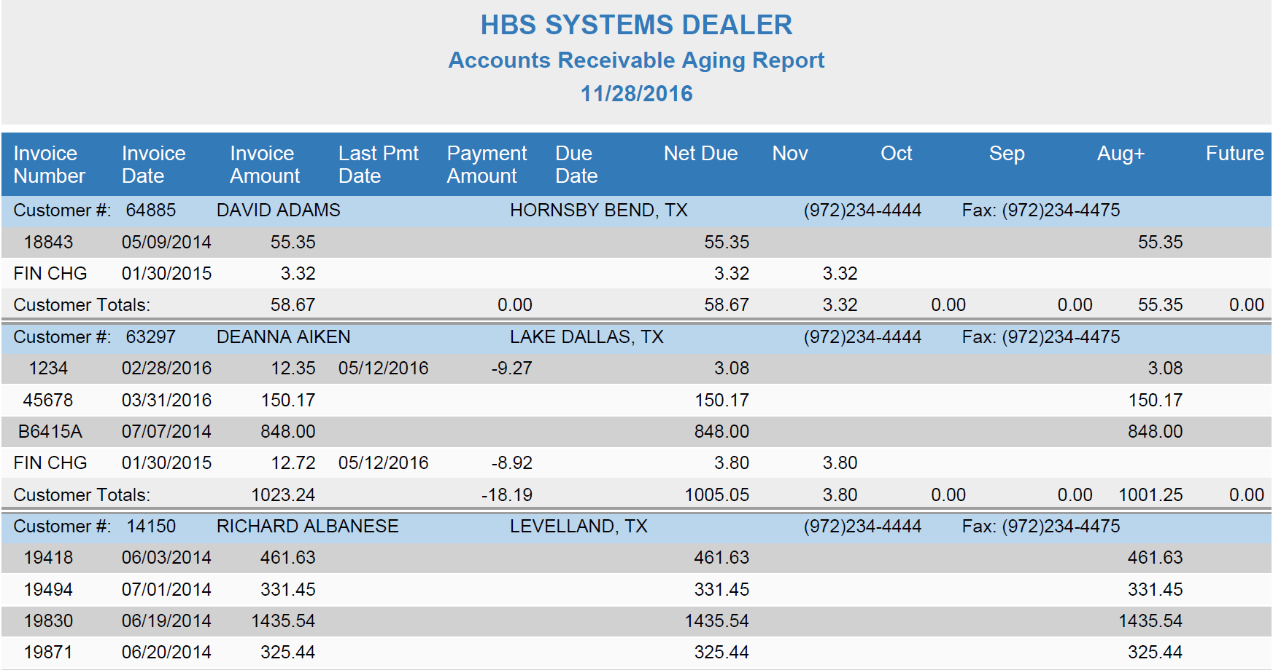

Report Sample – Detail Version with column headings of month names: The Months version of the report ages the A/R activity strictly by the date/month and places it in the appropriate column. The aging on this style of report WILL be different than the traditional style.

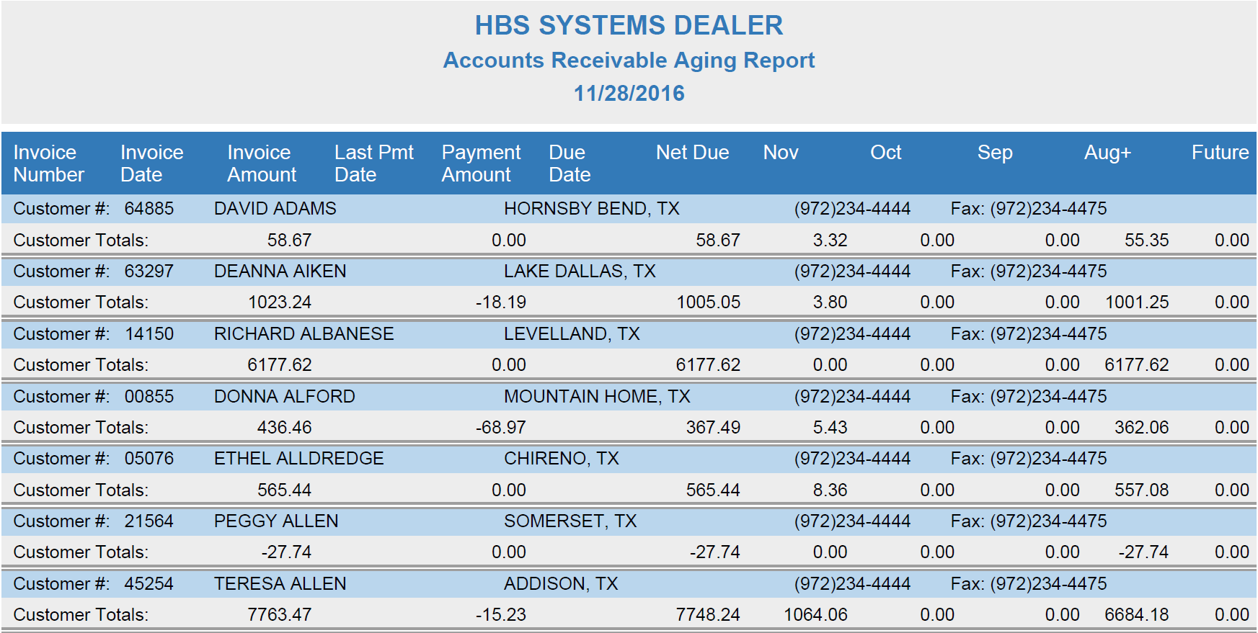

Report Sample – No Detail Version with column headings of month names: Notice how this style shows only the total for each customer for each of the aging categories. In the example, the Month names were chosen over the usual 30/60/90 day columns. This style of report shows aging strictly by the calendar month. The aging on this style of report WILL be different than the traditional style.

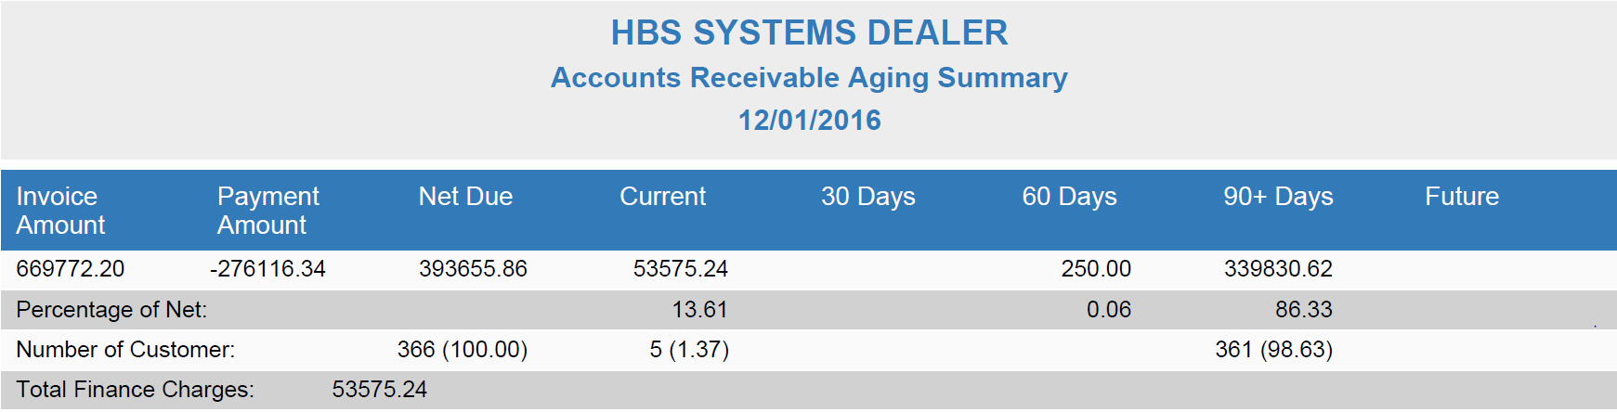

Report Sample – Summary Page Only with column headings of 30/60/90 days: This example shows the summary page only option. This quick report provides a grand total for Accounts Receivable as of the report date. It shows:

The total dollars by aging category

Percentage each represents of the total

The number of customers that make up each amount

The total amount of finance charges

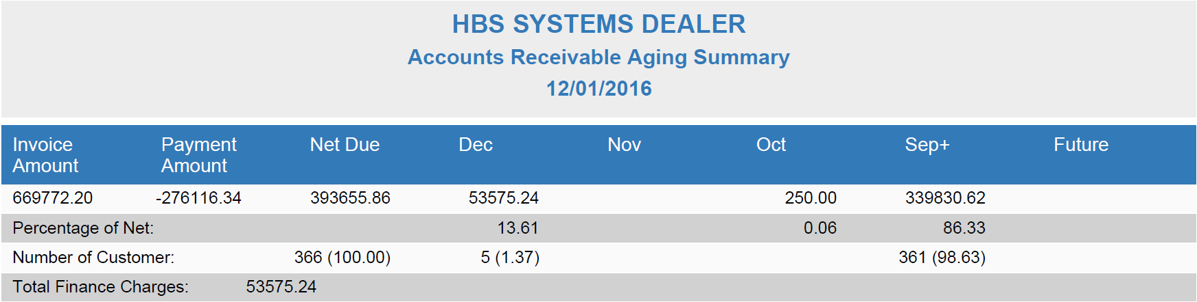

Report Sample – Summary Page Only with column headings of month names: This example shows the summary page only option with Month Names instead of the usual 30/60/90 Day columns. This quick report provides a grand total for Accounts Receivable as of the report date. It shows:

The total dollars by aging category

Percentage each represents of the total

The number of customers that make up each amount

The total amount of finance charges

