Automatic Reciepts/Cancel Order (ARC)

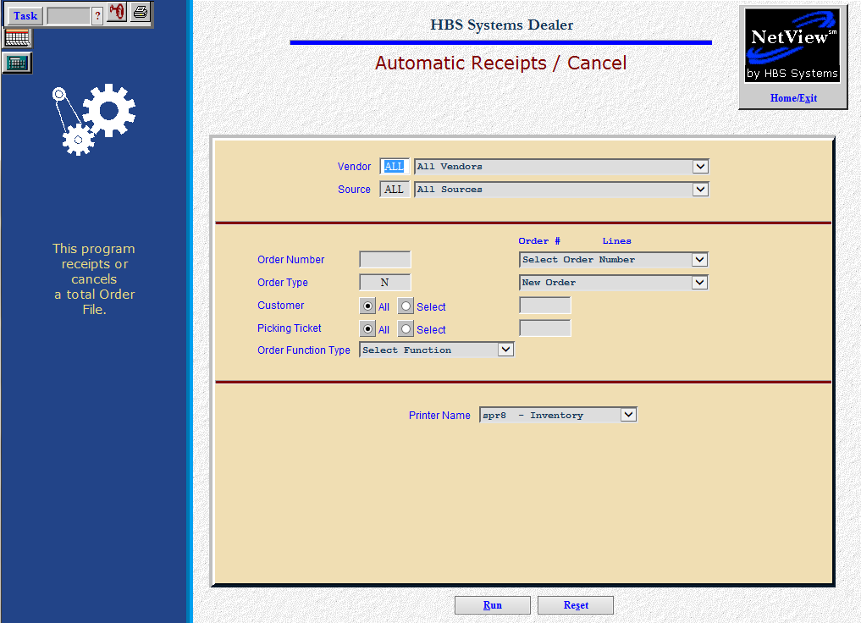

This easy-to-use screen offers two functions:
- Receipt the Order by receipting all parts on the current order in one sweep.
- Cancel the Order by clearing the order and canceling the on-order quantities on the affected part numbers.

To access this function, you can:
- Select “Inventory” from the menu. Choose the “Orders” submenu and click “Automatic Receipts/Cancel.”
- Type “ARC” in the Shortcuts Bar

Field Definitions

Vendor: Choose “ALL” or type/select one from the drop-down menu.

Source: Choose which source number to include. Select “ALL” to include all order records for all sources on this order. You can also choose an individual source from the drop-down menu.

Order Number: Type in the order number or choose one from the drop-down menu.

Order Type: This field pre-fills when you select an order. This choice could be:

N=New

C=Customer

B=Backorder

E=Emergency

T=Transfer

A=All

Customer: Select “ALL” to include the records for all customers on this order. You can also choose individual customers by clicking “Select” and typing in or looking up those customer numbers.

Picking Ticket: Select “ALL” to include the records for all picking tickets on this order. You can also choose individual picking tickets by clicking “Select” and typing in the picking ticket number.

Order Function Type:

- Select Receipt to receipt all or part of the order.
- Select Cancel to cancel all or part of the order.

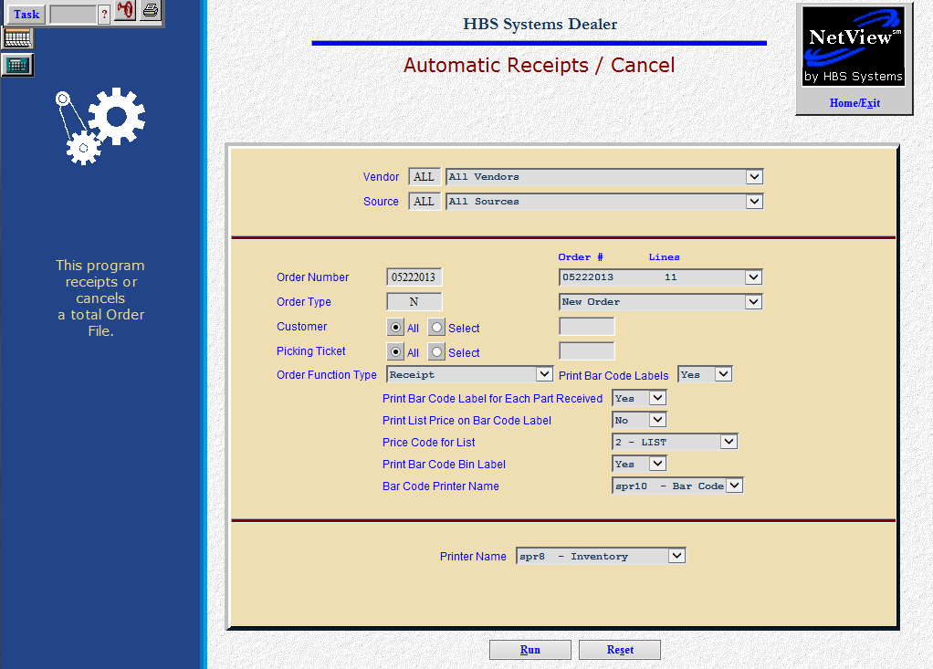

Print Bar Code Labels: Choose “Yes” here to print barcode labels for the parts receipted from the parts order. Pick “No” to bypass the barcode printing option.

Print Bar Code Label for Each Part Received: This option lets you print a barcode label for each part you are receipting on the order.

Select Yes to print a label based on the quantity received field. For example, if you choose “Yes” and you receipt 7 of an item on order, you will get 7 labels for that part number.

Select No to receive one label per part number receipted.

Print List Price on Bar Code Label: Choose here to have the List Price (factored selling price) print on the Barcode label(s).

Select Yes to have the List Price print on the label.

Select No to exclude the List Price from the label.

Price Code for List: This field pops up when indicate you want to print the list price on the label. It is pre-filled with the Price Code selected in the Bar Code Defaults but can be changed as needed.

Print Bar Code Bin Label:
  - Select Yes to have an additional label printed for the bin itself. This label will be over and above any other labels printed to satisfy the other choices you make.
  - Choose No here to bypass printing the barcode label for the bin.

Barcode Printer Name: The printer name for the bar-code printer will be pre-filled but can be changed as necessary.

Press the “Run” (Alt R) button to process your entries.

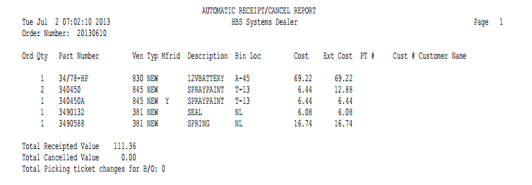

Report Detail: After making your selections, a report prints to show the receipt or cancel action taken on the order. It contains the following information:

Order Number: This is the order that was receipted or cancelled.

Ord Qty: This is the order quantity that was either receipted or cancelled.

Part Number: This is the part number on this order.

Ven: Here you will find the vendor number associated with this part number.

Typ: This field lists the part type for this part. This could be:

N=New

U=Used

C=Core

R=Reman

M=Memo

Mfrid: This is the manufacturer ID for this part.

Description: This is a description of the part number.

Bin Loc: This is the primary bin location of this part number.

Cost: Here you will find the cost of this part number.

Ext Cost: This is the extended cost of the part receipted in or cancelled.

PT #: If this part was placed on back order for a customer, this shows the picking ticket number or service repair order number it was ordered on.

Cust #: If this part was placed on back order for a customer, this shows the customer number that was referenced on the order.

Customer Name: Here you will find the Customer Name if this order was from a POS or Service back order.

Total Receipted Value: If you receipted this order, the total dollar amount of the order (extended cost) will appear here.

Total Cancelled Value: If you cancelled all or part of this order, the total dollar amount cancelled (extended cost) will appear here.

Total Picking ticket changes for B/O: This is a total of how many picking ticket lines were updated for the parts on this order were from POS or Service repair order backorders.

Barcodes: As the printout for your activity in Automatic Receipt/Cancel is printing, the barcode labels will print based on your selections.

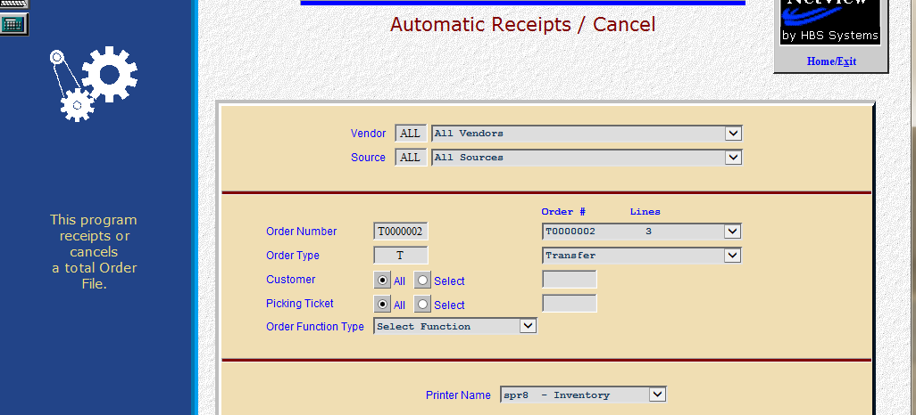

For multi-location dealerships, this screen can also receipt manual parts transfers from your other locations. These transfers have a “T” as the first character of the order number. Receipt them when the parts have arrived at your location.

