Customer Master Prompts (ARCP)

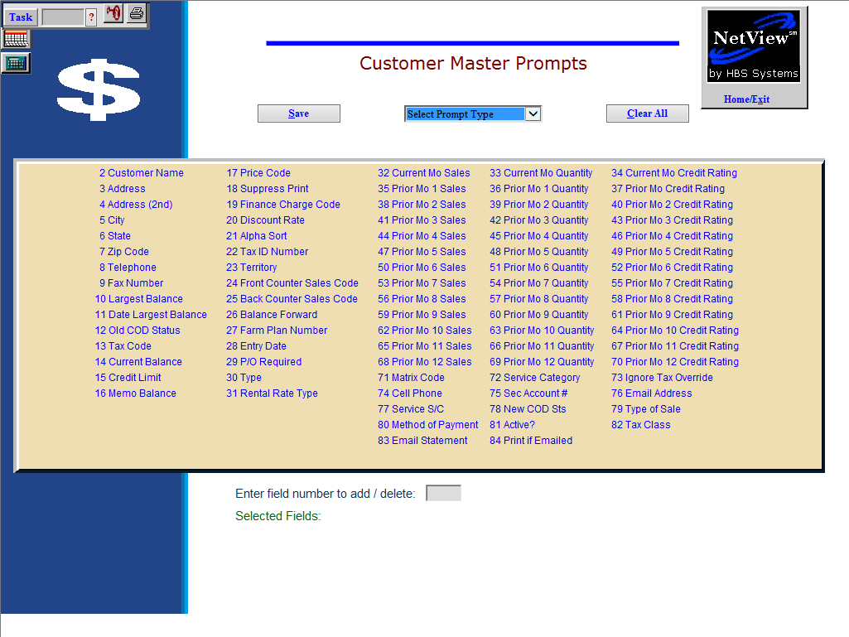

Customer Master Prompts lets you select the fields that you most often answer when setting up a new customer number. It prompts you only for the fields you select here, making the entry time for adding a new Customer Master much faster.

Another use for the program is to simplify the process of making repetitive type changes in a large number of Customer Masters. In this case, you set it up to prompt specifically for the fields you need to change. By being presented with a few selected fields to change, the time needed to make changes in a large number of records is dramatically reduced.

- To access this function, either:
  - Select “Accounts Receivable” from the menu and choose the “Data Entry” submenu. Click on “Select Custom Prompts.”
  - Type “ARCP” in the Shortcuts Bar.

Select Prompt Type

- New Customers: These prompts are selections to be used with Hotkey A. Often they are referred to as “the set for the office.”
- Add Customers from POS: These prompts are used when a new customer is added from POS, ROM, or Units Sales Invoicing.

Enter field number to add/delete: Use this field to enter choices from those displayed. You can choose the fields you want by number or you can use the mouse to click on them. The fields you select are shown below the list. To remove one from the selection list, type the number again or click on it again. TIP – Field prompts do NOT have to be selected in numerical order. This makes it convenient to group related kinds of information together when you are entering or changing customer details.

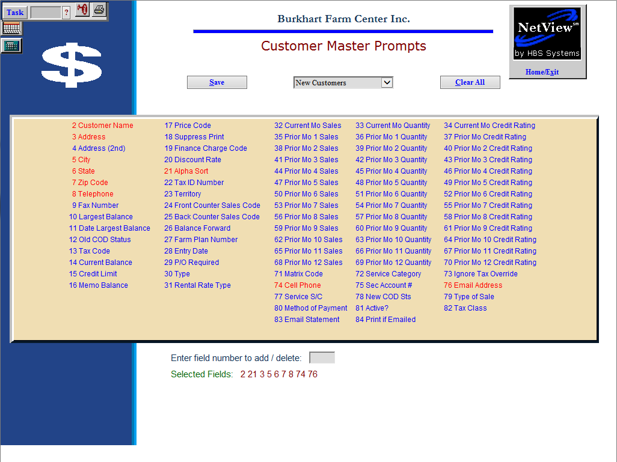

This is a sample for the prompts for New Customers. Notice how the fields are not arranged in numerical order.

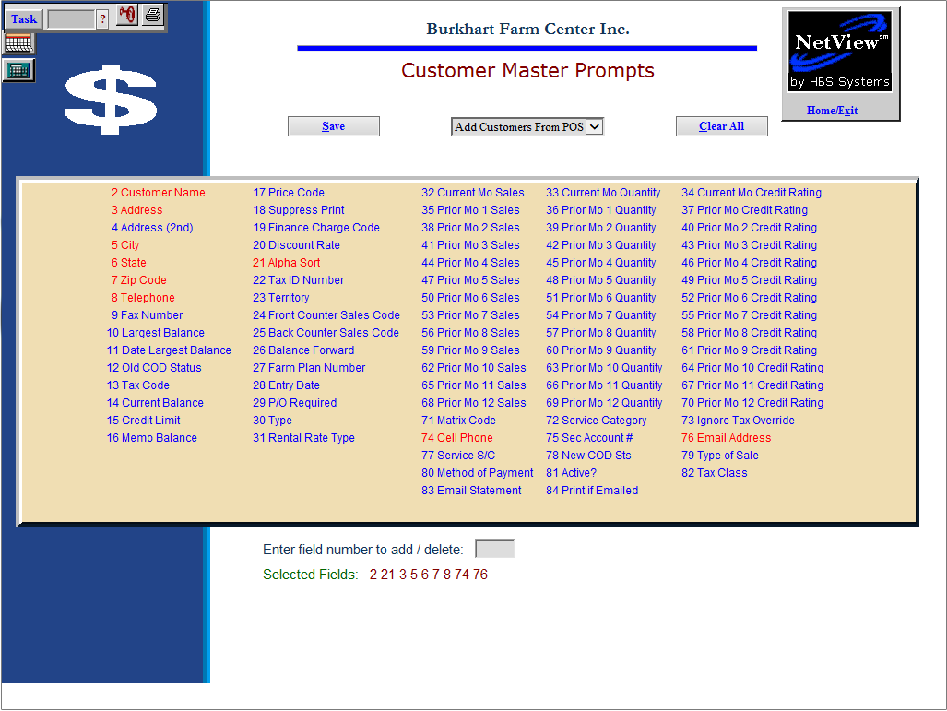

This sample shows the fields selected for Adding Customers from POS.

