Automatic Return/Cancel (ARET)

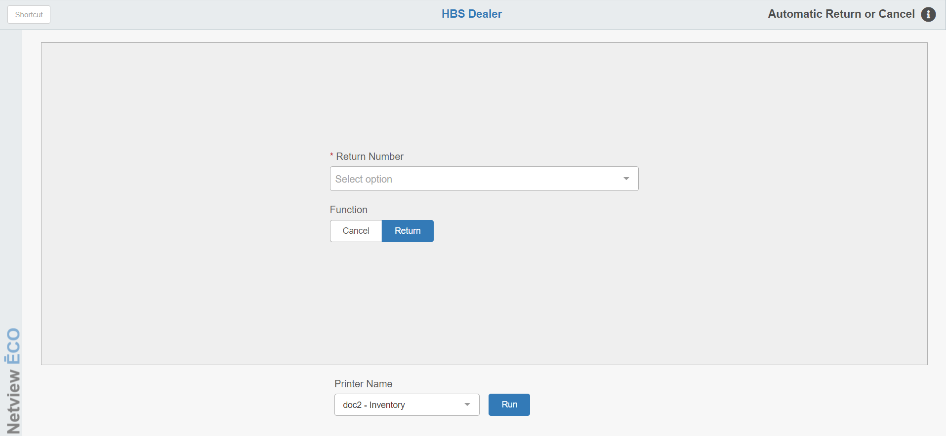

STEP 4—Send the Return to the Manufacturer: At this point in the process, send the return to the manufacturer.

Once you receive the vendor’s approval, Automatic Return/Cancel (ARET) lets you remove the Return part number quantities from your system in one quick step. ARET updates your inventory without posting the return part number by part number. Your only task is to pack up the parts and ship them to the vendor.

STEP 5—Receipt the Return through Automatic Return/Cancel: ARET has a dual purpose:

- To receipt the Return (reduce the on-hand quantities for the part numbers listed on the Return)
- To cancel the Return (remove the specified Return from the system without changing the inventory’s on-hand quantities)

To access this function, you can either:

- Select “Inventory” from the menu. Choose the “Returns” submenu and click “Automatic Return/Cancel.”
- Type “ARET” into the Shortcuts Bar.

Field Definitions:

Return Number: Choose the Return number here.

Function:

- Select Cancel to cancel a selected Return.
- Choose Return to remove or reduce the on-hand quantities of the parts for a selected Return.

Printer Name: Select the printer to receive the printout. A default printer name is pre-filled but can be changed as necessary. Use the pdf printer to view the report on the screen without printing a copy of it.

Run: This button receipts or removes the return.

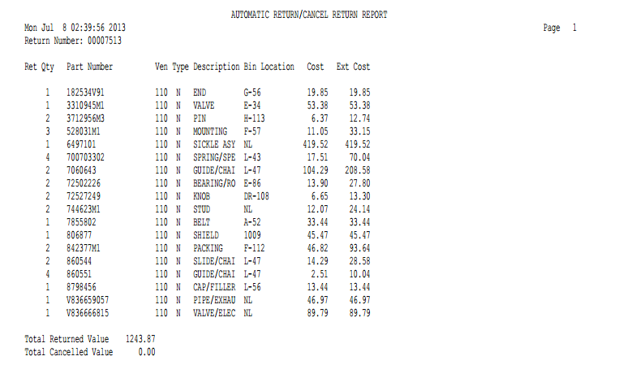

Report Columns:

Return Number: This field shows the Return number.

Ret Qty: This column lists the Return quantity of each part that was selected for return.

Part Number: This column lists the part number on the return.

Ven: This column lists the Vendor number for the part number.

Type: This column lists the part type for the part number:

- New
- Used
- Reman
- Core
- Memo

Description: This column lists an abbreviated description of the part number.

Bin Location: This column lists the primary bin location for the part number.

Cost: This column lists the individual cost for the part number.

Ext Cost: This column lists the Extended Cost for the part number shown (Return Quantity times the individual Cost).

