A/R History (ARH)

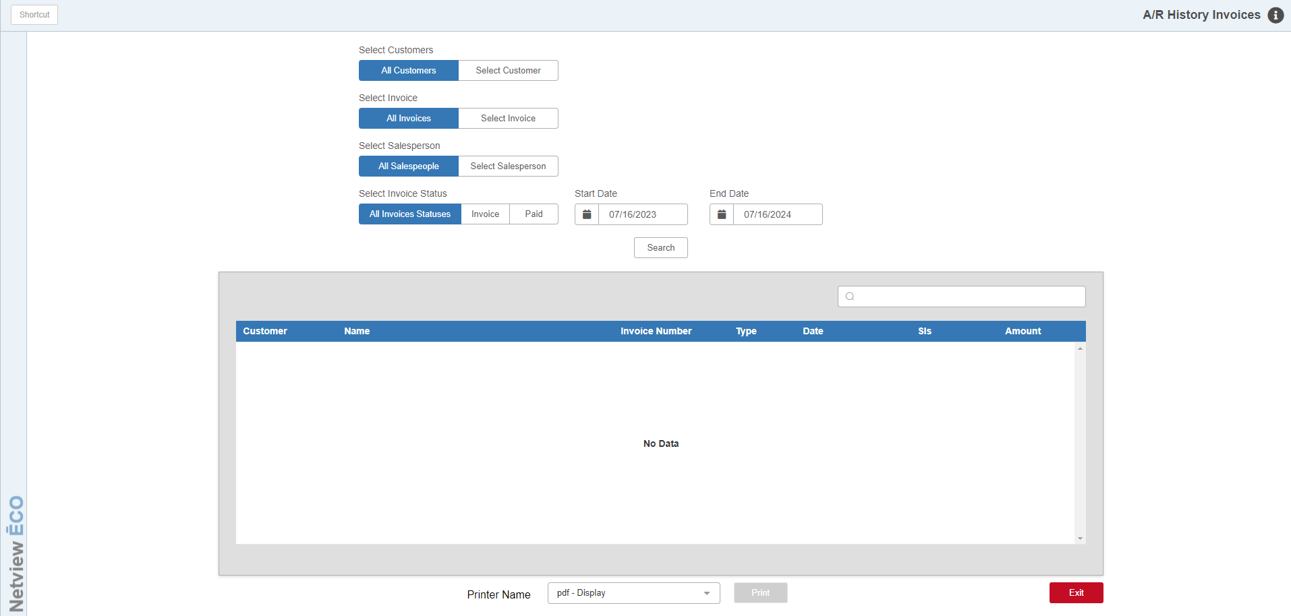

A/R History organizes and stores the accounting history of all transactions flagged as A/R Charges, Farm Plan, and Credit Card transactions per Customer number.

To access this function, you can either:

- Select “Accounts Receivable” and click “Customer History Invoices.”
- Type “ARH” in the Shortcuts Bar.

Through A/R History, you can track payment history on the AR Charge invoices (invoices that still have a balance other than 0.00). It provides the following information:

- Customer Number and Name
- Invoice Number/Document Number
- Ledger Number
- Receipt Number
- Salesman Initials
- Journal Number
- Status Code (I for Invoice or P for Payment)
- Invoice Date and Amount
- Paid Date and Amount
- Total Amount

Field Definitions:

Select Customers:

- Choose “All Customers” to look at the history of all customers.
- Choose “Select Customer” to select a specific customer to examine.

Customer Number: This field is active if you chose to select a customer. Type in the customer number or look it up.

Select Invoices:

- Choose “All Invoices” to look at the history of all invoices.
- Choose “Select Invoice” select a specific invoice to examine.

Invoice Number: This field is active if you chose to select an invoice. Type in the invoice number here.

Select Salespeople:

- Choose “All Salespeople” to look at the history of all salespeople.
- Choose “Select Salesperson” to select a specific salesperson to examine.

Salesperson: This field is active if you chose to select a salesperson. Type in the salesperson ID here.

Select Invoice Status: Choose to look at the history of “All Invoice Statuses” or select a status to examine:

Choose “Invoiced” to look at unpaid invoices.

Choose “Paid” for ones paid by the customer.

Start Date: This field defaults to one year prior to the current date. It works with the “End Date” field to create the range of dates examined by the search.

End Date: This field defaults to the current date. It works with the “Start Date” field to create the range of dates examined by the search.

Search: Press this button to start your search.

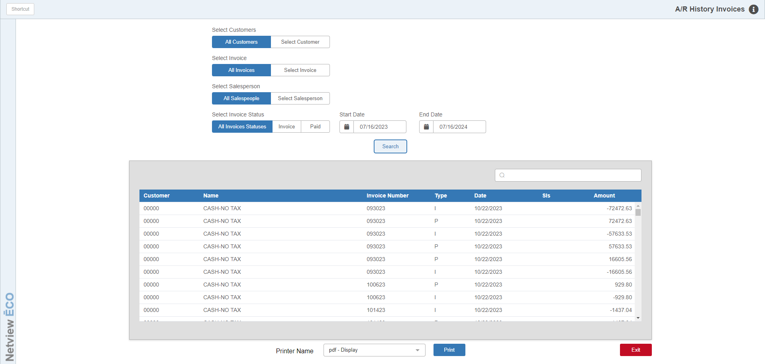

Once the screen is filled with the detail that matches your search criteria, you may click on any of the lines to see the invoice and payment information for that line. You can also use the Filter field at the top of the results grid to further specify what invoice you want to look at.

You can print out your search results by selecting a printer and pressing the Print button. You can also use the PDF printer to display the results on the screen without printing.

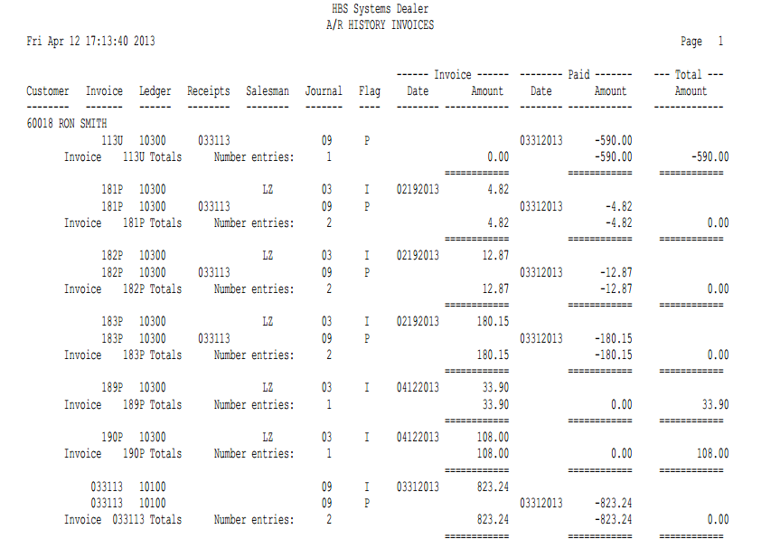

A/R History Invoices - Report Printout:

Report Columns:

Customer: This column shows the customer account number and name.

Invoice: This column shows the original Invoice Number or Document Number of a manually-entered invoice document.

Ledger: This column shows the account number affected:

10300 for A/R charges

Other account numbers for Farm Plan or Credit Card transactions

Receipts: This column shows the receipt number from Cash Apps (CA), Point of Sale (POS), or a manual entry for money received on account.

Salesman: This column shows the ID of the salesperson who wrote the original invoice.

Journal: This column shows the Journal Number where the invoice or receipt transaction was posted.

Flag: This column shows the Status Codes:

I=Invoice

P=Paid

Invoice Date/Amount: If the Status Code is “I,” the date and amount of the invoice print in these columns.

Paid Date/Amount: If the Status Code is “P,” the date and amount of the receipt transaction print in these columns.

Total Amount: Shows the Net Balance due per Invoice.

Total Lines: The report will also print Total lines for each Invoice and for each Customer.

