A/R Month End (ARME)

The A/R Month End process performs a number of important tasks:

- Assesses finance charges on past due invoices per the grace period defined
- Prints Customer Statements
- Ages the Customer Purchase History in the Customer Master
- Clears matching or paid invoices from each customer’s activity

Preparation for A/R Month End Statements

- Enter and journal all transactions that might affect customer statements.
- Change any statement messages, minimums, and finance charges as necessary. You can access this information from the Company Files area in System Maintenance.
- We STRONGLY recommend that you run Statements first thing in the morning. This gives you the extra security of the recent overnight back-up in case there is a problem with the statements.

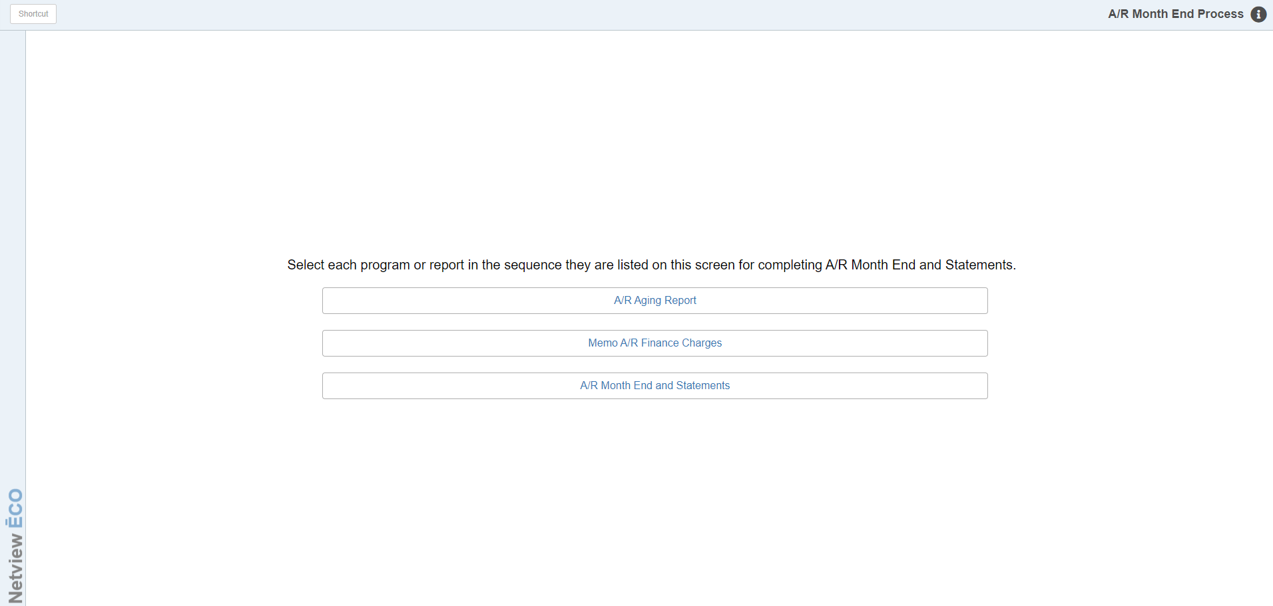

Use the A/R Month End Process Menu (ARME) to guide you through the process.

To access this function, either:

- Select “Accounts Receivable” from the menu and click “Month End Process.”
- Type “ARME” in the Shortcuts Bar

This menu provides a checklist for you to use. After you have completed each step, the process will return to this menu. It “checks” off each step completed as you go, adding a green checkmark to each item.

- Run an Accounts Receivable Aging Report (ARA). Do an overall check to see how the customer information looks.
- Run the Memo A/R Finance Charges (MFC) report. Set up this report EXACTLY the way you will for the statements you will soon print. If the report generates a finance charge for customers who should not be charged, check both the criteria for running this report and the customer’s account information. Make your corrections BEFORE continuing with the Month End process.
- Run the Month End and Statements (ARMES). In this step, the program assesses the finance charges, posts them, prints a journal, and then allows you to print the statements. See below for full details of this step. NOTE: If you are a multi-location dealership with a Consolidated location, you MUST run statements in the Consolidated location.

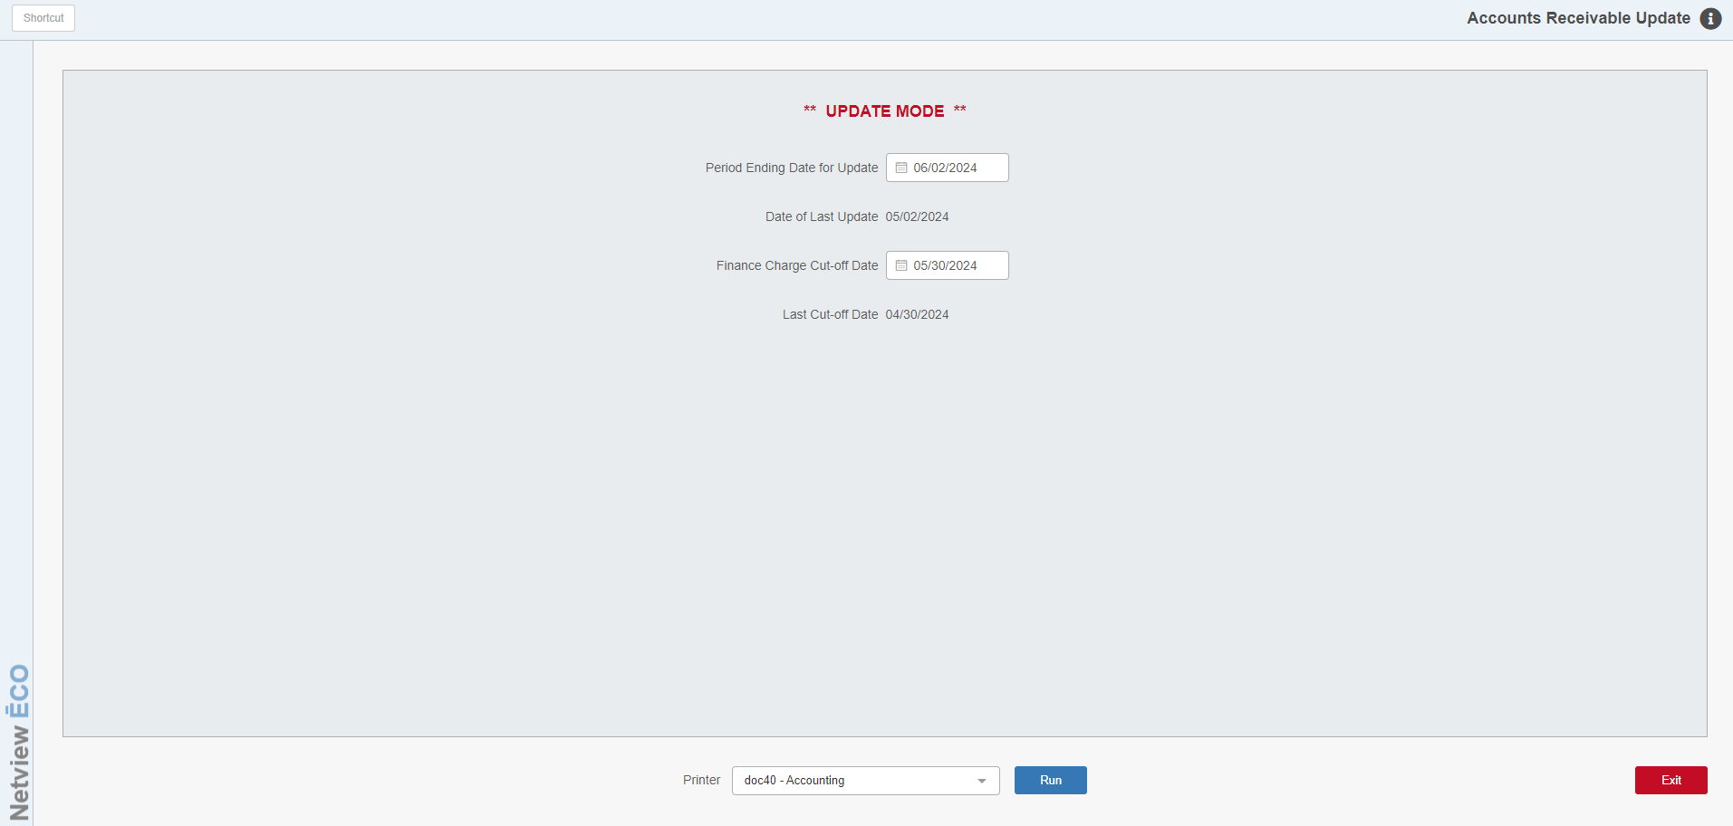

Field Definitions:

Period Ending Date for Update: Enter the Ending Date (or cut-off date) for the statements. The date you last ran statements shows on the line below as Date of Last Update. Typically, your cut-off date will be a month later than the Date of Last Update. Additionally, the date in the field will default to 1 month following your last statement process. It is very important to check your dates and correct as necessary. Otherwise, the statements produced could be incorrect.

Finance Charge Cut-off Date: Enter the cut-off date for finance charges, which tells the system that invoices older than this date are now eligible for finance charges (this date is usually the day after the last statement date). For example, if the statement date is 07/31/2016, then the date in this field probably should be 07/01/2016, based on a 30-day grace period before adding finance charges to old invoices. However, you can modify the grace period to match your dealership's requirements. Additionally, the date in the field will default to 1 month following your last statement process. It is very important to check you dates and correct as necessary. Otherwise, the statement produced will be incorrect.

TIP: Select the same day of every month as the Cut-Off date. This consistency safeguards against any finance charge assessment errors.

Printer Name: Select the printer to receive the Finance Charge Journal printout. A default printer name is pre-filled, but can be changed as necessary. Use the pdf printer to view the printout on the screen without printing a copy of it.

Run: Press this button to start the A/R Month End Process based on the selections you have made. If there are no system locks preventing you from running the process or statements, a pop-up like the following will appear:

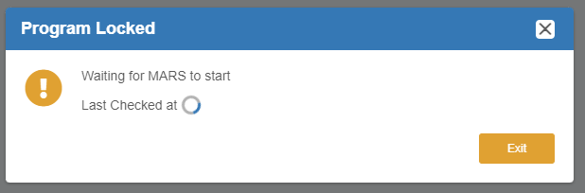

This notifies you that the process is running, no locks are blocking it, and that you will be redirected to the ARMES version of Memo A/R Statements (MARS) to print your statements.

As soon as the finance charges have been added to your customer’s accounts, the Finance Charge Journal will print. This is a record of the finance charges added to the accounts during the A/R Month End Process.

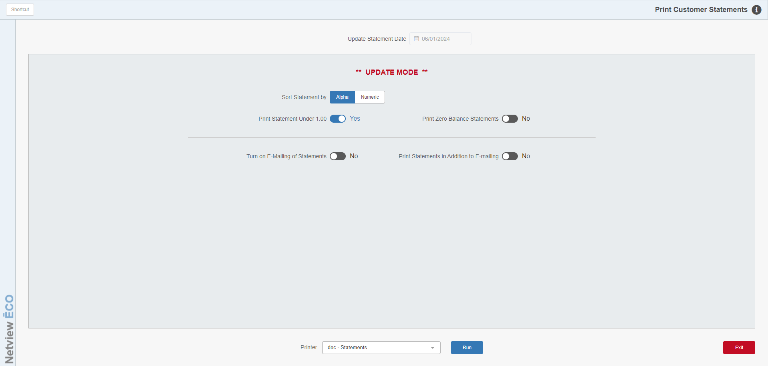

The process continues and takes you to the statement printing screen.

NOTE: If you CLOSE the program before printing statements, you will be able to assume the statement run as long as you log in using the SAME user ID as when you abandoned the run. The program will be LOCKED for all other users.

Statement Printing Field Definitions:

Sort Statements by:

- Select Alpha to have the statements sort alphabetically based on the “Alpha Sort” field in the Customer Master.
- Select Numeric to sort them numerically by customer number.

Print Statements Under [Amount]: This option is controlled by the “Minimum Statement Amount” setting in Tax Rates and Messages (TRM), which sets the minimum dollar amount for statements. The field title will change to show the dollar amount listed in that field.

- Set this option to Yes to print statements with a balance under the minimum statement value.
- Set it to No to print only statements with the minimum balance or higher.

Print Zero Balance Statements:

- Set this to Yes to print statements for customers who currently have a $0.00 balance, but have paid any outstanding invoices since the last statement run.
- Set this to No to skip statements with a zero balance.

Turn on E-mailing of Statements:

- Set this option to Yes to have the system email statements to your customer.
- Set it to No if no statements are to be emailed.

Print Statements in Addition to E-mailing:

- Set this option to Yes to print out hard copy statements as well as emailing the statements to the customer.
- Set it to No if no statements are to be emailed.

Printer Name: Select the printer to receive the statements. A default printer name is pre-filled, but can be changed as necessary using the drop-down menu. You will only be able to print to “.doc” type printers.

Run: Press this button to start printing the statements based on the selections you have made. If your printer jams or misprints some of the statements, you may use ARSH to review and reprint any missing statements.

TIP: If the printer should jam, DO NOT turn off the printer. Use the off-line or select button on your printer to take the printer off line and adjust your forms. If you are unsure of what to do or you’re not sure if the A/R Statement process is complete, contact HBS Support Express for assistance immediately.

Under no circumstances should you ever re-run the A/R Month End process!

