A/R Statement History (ARSH)

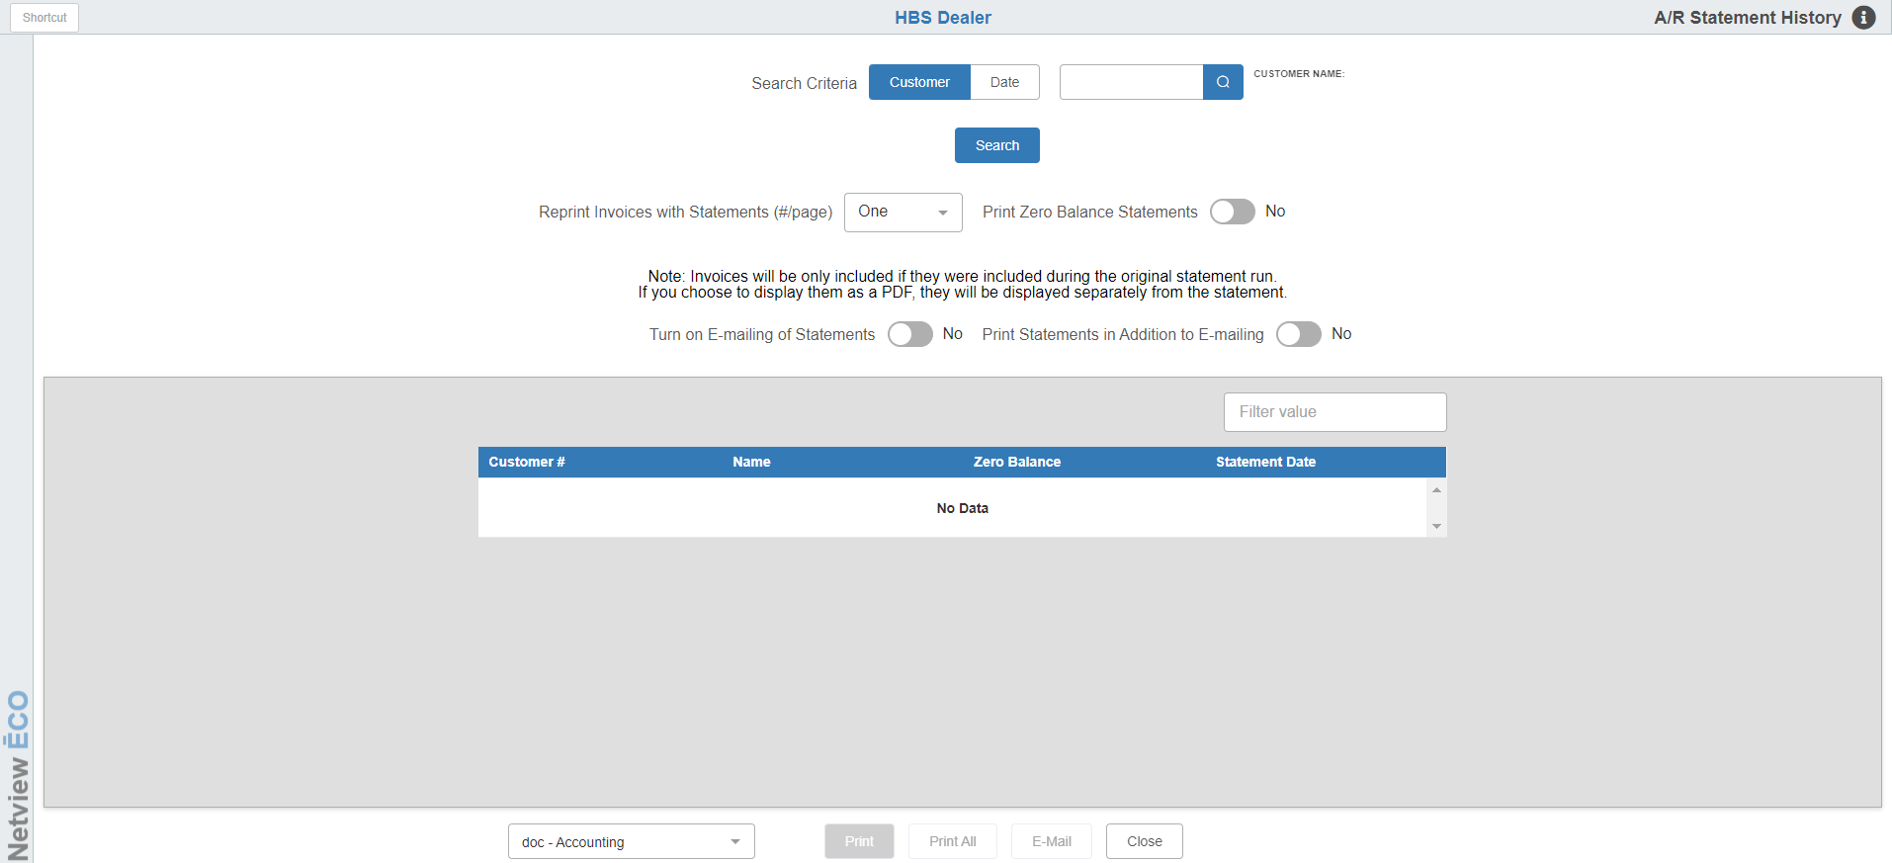

This program gives you access to A/R Statement History. Statements are stored here if you print eForms Statements and they are flagged to archive.

To access this function, you can either:

- Select “Accounts Receivable” from the menu and click “A/R Statement History.”
- Type “ARSH” in the Shortcuts Bar.

The archiving is controlled by a setting in AIFC. On the second tab, look for this prompt near the bottom of the screen.

This should be set to “Yes” for eForms Statements to be archived in history.

Customer Search: You can search for statements by customer or by date. When you fill in a customer number and click the “Search” button, a list of available statements for that customer will be shown. You will then be able to use the “Filter” field on the grid to further narrow down your results.

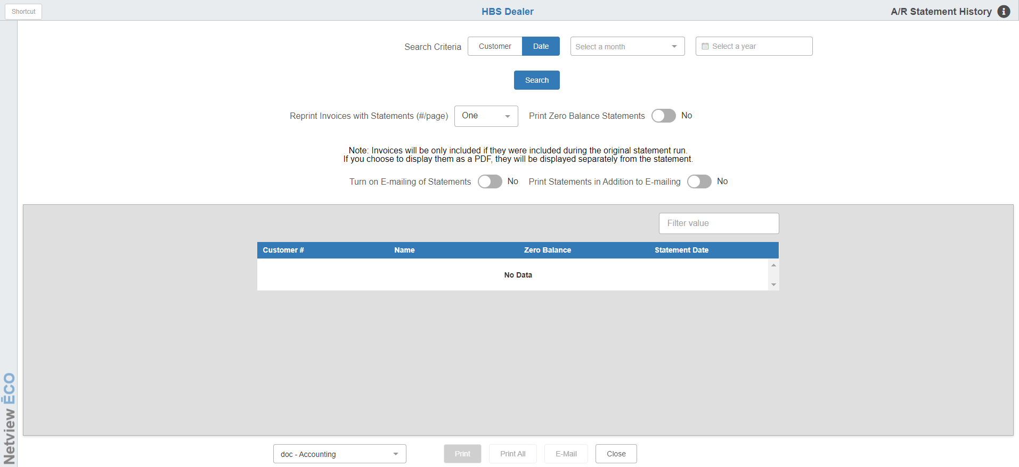

Date Search: For a date search, choose a month and/or year, then click the “Search” button. The screen will provide a list of all statements available for the date entered. You will then be able to use the “Filter” field on the grid to further narrow down your results.

Reprint Invoices with Statements (#/page): Invoice copies will be printed with the statements if they were originally printed with the statement selected. If you print the statement, any invoices printed with it will follow the format selection on the screen. Use this field to indicate how many of the reprinted invoices you want printed per page. We recommend “ONE” for the best readability, but you can put up to eight on a single page. NOTE: If you use the PDF printer option to display the reprinted invoices, the invoices reprinted will be shown on separate, individual pages.

Print Zero Balance Statements: If you wish to print statements with a zero-dollar balance, set this option to “Yes.” Otherwise, leave it set to “No.”

Printer Name: Select the printer to receive the statement(s). You can also review it on the screen by using the PDF printer. Once the PDF file is displayed, you can save a copy or email it from there.

Print: If you are only printing a single statement, select that statement and then click this button to print it out.

Print All: Click this button to print all statements display for the chosen customer or date range to your selected printer.

Emailing Statements: If your customer wants their statement copy emailed to them also, select “Yes” in the Turn on Emailing of Statements field. If the customer wants a hard copy along with the emailed version, select “Yes” in the Print Statements in Addition to Emailing field.

To email the statement, press the E-Mail button at the bottom of the screen next to the print options.

