Aged Subledger Accounts Report:

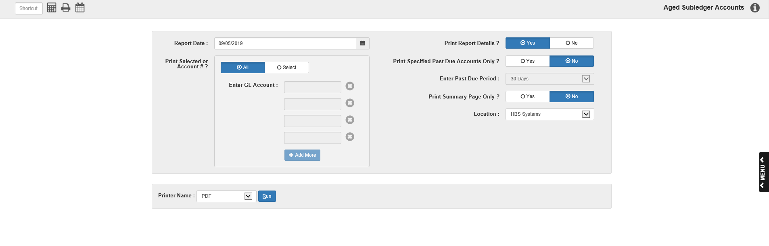

The Aged Subledger Accounts Report (ASR) generates an aging report for subledger accounts in the General Ledger. To access this program, type “ASR” in the Shortcuts Bar.

Field Definitions:

Report Date: Enter the report date or select it using the calendar. The field defaults to the current date.

Print Selected or Account #?: Choose whether you wish to run the report for “All” accounts or if you want to “Select” specific accounts for the report. The option defaults to “All.”

Enter G/L Account/Add More: If you choose the Select option, these fields activate. Enter the specific G/L subledger accounts you want shown on the report.

- If you want to select more than four accounts, click the Add More button to generate additional fields.
- If you don’t need all the fields, you can click the “x” icon to remove the field.

Print Report Details?: Select “Yes” to print the full aging detail on the report. Select “No” to print only the final account balance’s aging. The option defaults to “No.”

Print Specified Past Due Accounts Only?: Select “Yes” to only include accounts that are past due by a specific period. Select “No” to include all accounts. The option defaults to “No.”

Enter Past Due Period: If you select “Yes” for the previous field, this field activates. Select the past due period you want to show:

- 30 days
- 60 days
- 90 days
- 120 days

Print Summary Page Only?: Select “Yes” to only print the report’s summary page. Select “No” to print the full report. The option defaults to “No.”

Location: Select which dealership location’s accounts will print on the report. The default selection will be the first location listed in the Location drop-down at the top of the main Desktop screen.

Printer Name: Select which printer will receive the report.

Run: Click this button to generate the report.

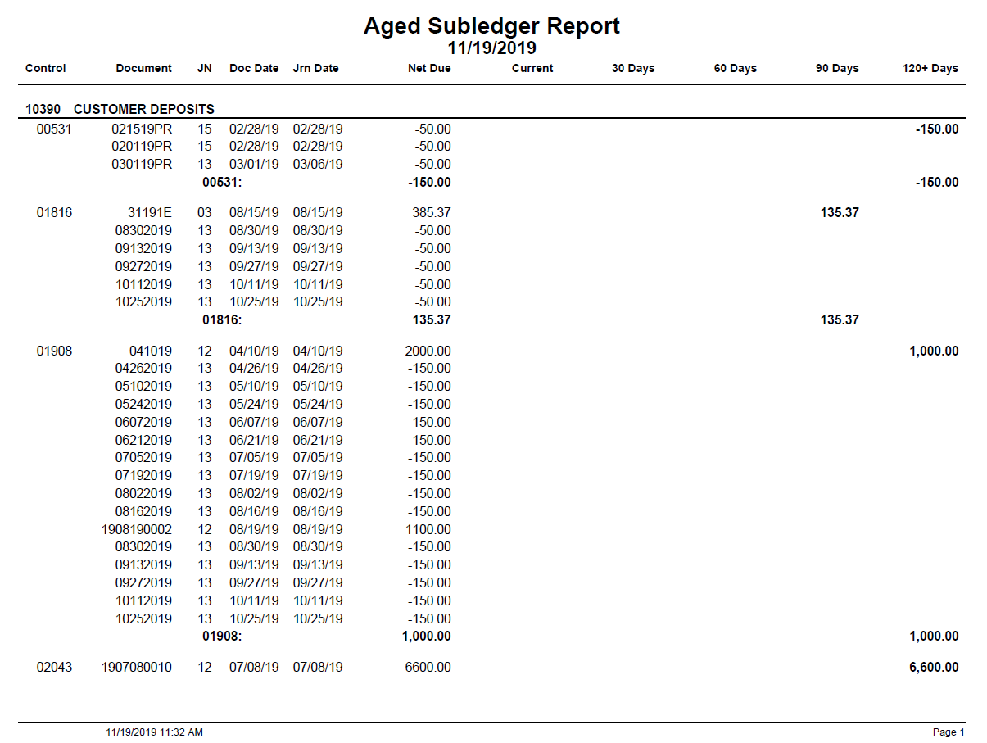

The report is always divided into sections by account (with an account total at the end of each section) and will always show a summary page at the end (which can be printed separately). However, depending on the “Print Report Details?” option selected, the reports will have different content.

Detail Report—Columns: The image above is an example of the Detail report, which generates when you select “Yes” for the “Print Report Details?” report option. This report lists out the details for every transaction recorded for an account (including individual invoice lines and the document’s total value). As such, it has extra columns to explain what each line represents.

Control: This column shows the subledger control number for the transaction line. The Detail Report will also include totals for all transaction lines with the same control number (listed after the final transaction for the number).

Document: This column shows the document number for the transaction line.

JN: This column shows the transaction line’s Journal number.

Doc Date: This column shows the transaction line’s document date.

Jrn Date: This column shows the transaction line’s Journal date.

Net Due: This column shows the net amount due for the transaction line. The total net due for a control number and for an account number will also appear under this column.

Current/30 Days/60 Days/90 Days/120+Days: The amount due for a transaction line will appear under one of these five columns, depending on if the amount is current or overdue by 30/60/90/120+ days. For the control and account number total lines, these columns will show how much of the number’s net amount is current or overdue by 30/60/90/120+ days.

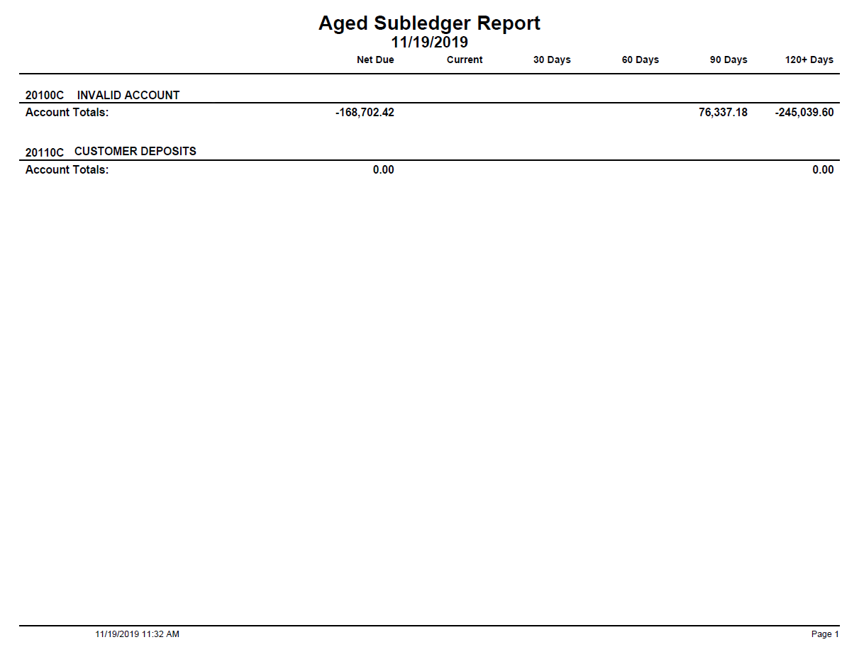

Non-Detail Report: The Non-Detail report generates when you select “No” for the “Print Report Details?” report option. This report only shows the total line for each account number, and as such has fewer columns than the Detail Report.

Net Due: This column shows the net amount due for the account number.

Current/30 Days/60 Days/90 Days/120+Days: These five columns show how much of the number’s net amount is current or overdue by 30/60/90/120+ days.

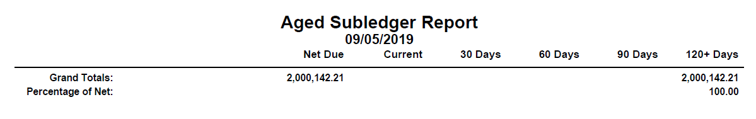

Summary Page: This page appears at the end of both Detail and Non-Detail reports, and provides total lines for the entire report. As mentioned above, this page can be printed by itself.

Grand Totals: This total line shows the total amounts on the report for the following columns:

- Net Due
- Current
- 30 Days
- 60 Days
- 90 Days
- 120+ Days

Percentage of Net: This total line indicates, by percentage, how the report’s net amount is distributed across the aging columns. For example, if the entire report’s amount appears in the 120+ Days column on the Grand Totals line, that means that 100% of the report’s net due amount is 120 days or more past due. As a result, the number “100.00” will appear for this line under the 120+ Days column.

