Appendix B: Writing of an Invoice with Manual Checks (MC)

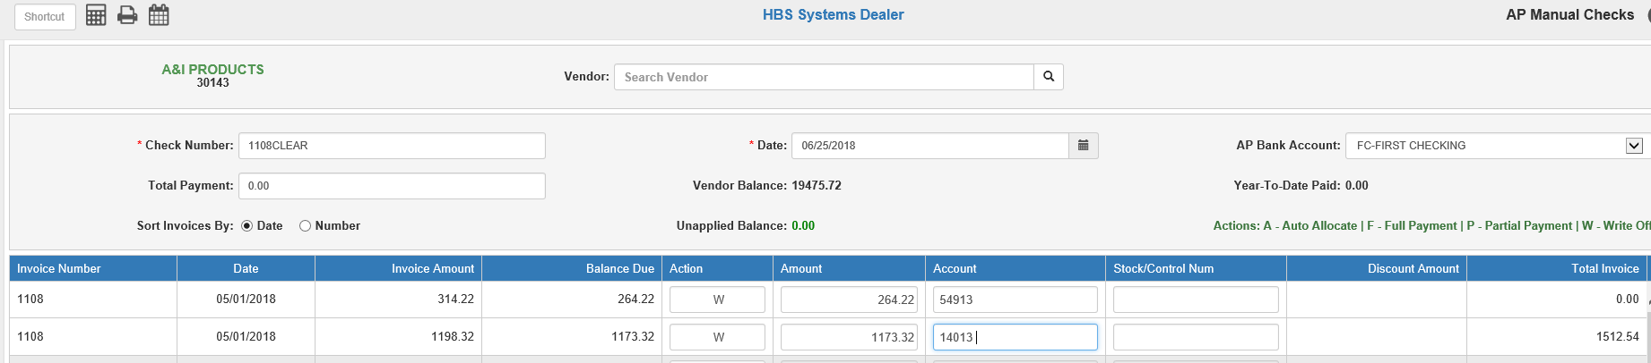

From time to time you may find it necessary to write-off an invoice from a vendor’s account in A/P. Perhaps you are correcting a double posting or maybe it is just correcting a mistake. Use Manual Checks (MC) to remove the invoice from the vendor’s account.

To access this function, you can either:

- Select “Accounts Payable” from the menu and choose the “Process Checks” submenu. Click on “Manual Checks.”
- Type “MC” in the Shortcuts Bar

- Select the vendor involved by entering the vendor number in the Vendor field. You can also use the Vendor Search to look up the vendor.
- Use the Check Number field as a document number/reference number for your write-off. It’s always a good idea to create a unique document number.
- Fill in the date of the write-off.
- Enter 0.00 for the Total Payment amount.
- Type W in the Action column of the invoice to be written off.
- The original amount of the invoice will appear on the line but can be changed as needed. The amount written off should be entered just as it is on the line: debit amounts are written off as debits, credits as credits.
- The original G/L account number for the invoice will appear on the line but can be changed as needed.
- The original stock Number/Control number for the invoice will appear on the line if it was entered on the invoice but can be changed as needed.
- Press Save to save the entry.
- Post the Disbursement Journal (DJ) now or at the end of the day to apply the write off to the General Ledger.

