Bank Setup (BANK)

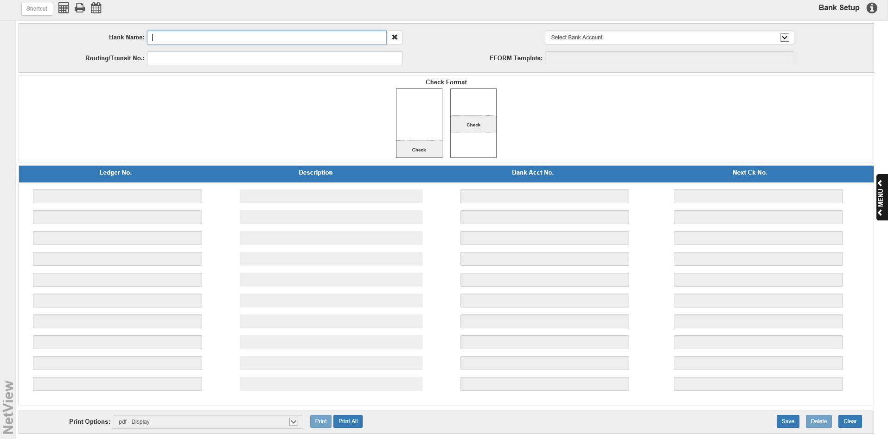

Bank Setup (BANK) is a one-time procedure, unless you have to add other bank accounts later. Setup requires creating the Bank Identifiers and entering outstanding entries. After you name the Bank Identifiers and the general ledger account numbers associated with them for reconciliation purposes, every journal posting through Accounts Payable, Units, General Ledger, and Payroll automatically update the reconciliation files.

BANK lets you identify as many Bank accounts as needed for reconciling account information to a regularly received statement. For example, if your company has three bank accounts, you should create three Bank Identifiers with the appropriate ledger numbers.

- To access this function:
  - Select “General Ledger” from the menu. Choose the “Bank Reconciliation” submenu and click “Bank Setup.”
  - Type “BANK” in the Shortcuts Bar
  - If BANK is password-protected in your program, the following box will appear:

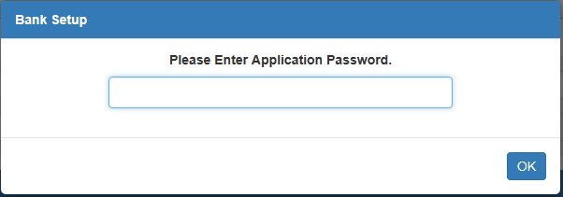

  - Enter the application password to access BANK.

Field Definitions

Bank Name: This field holds the identifier value for this bank account. Make this a simple name to type as you will have to enter it each time you use the reconciliation programs. You could use the name of the bank or something as simple as 10200, which is the GL account number.

Select Bank Acct: This field is used for the optional e-forms checking printing package. It holds the bank account number for the checking account.

The number is required only when e-forms checks are to be printed. In all other cases, the field should be left blank.

To display an account:

Press the arrow at the end of the field to reveal a drop-down menu listing all available accounts.

Click on the account needed.

Routing/Transit Number: This field is used for the optional e-forms checking printing package. It holds the routing/transit number for the checking account.

It is required when e-forms checks are to be printed.

In all other cases, it needs to have a unique value as it cannot be left blank.

EFORM Template: This field displays the eForm template used when printing checks for that account. This is an informational field only.

Check Format: Choose which check format you want the system to use for printing checks from this account, particularly for Accounts Payable or Payroll accounts. This is required regardless of whether you have eForm checks or pre-printed check stock.

Column Definitions

Ledger No.: This field holds the GL account number for this checking account.

- Account Search: You can search for the number by typing all or part of it into the field and hitting the “Enter” key. The search also activates if you type in all or part of the account’s description into the field and hit “Enter.” For example, if the account is identified as a Cash account in its description, type “Cash” into this field and hit “Enter.”
  - A box resembling the following image will appear:

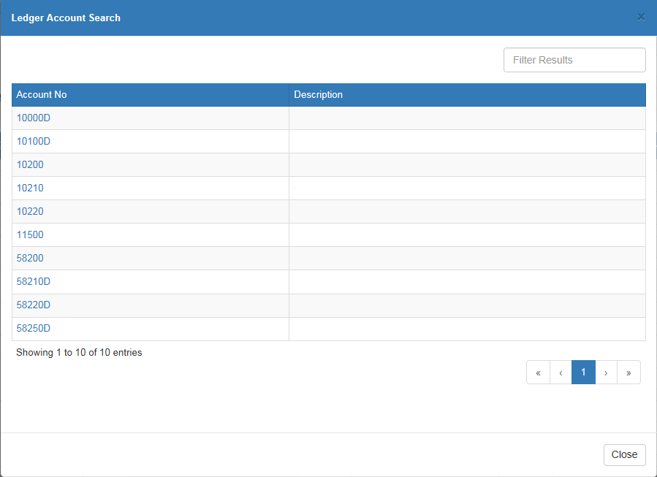

  - If you do not see the account number you want on the first page of results, use the page numbers and arrows at the bottom to look at the other pages.
  - You can use the Filter Bar in the top right corner to narrow down your results by entering in more information about the account, like words in its description.

Select the account number you want, and it will appear in the field on the main page.

Description: This field holds a description of the GL account.

Bank Acct No.: This field is used for the optional e-forms checking printing package. It holds the bank account number for the checking account.

It is required when e-forms checks are to be printed.

In all other cases, it needs to have a unique value as it cannot be left blank.

Next Ck No.: This field holds the next check number to be used in Accounts Payable or Payroll for the checking account.

