Bin Count Sheets Reprint (BCR)

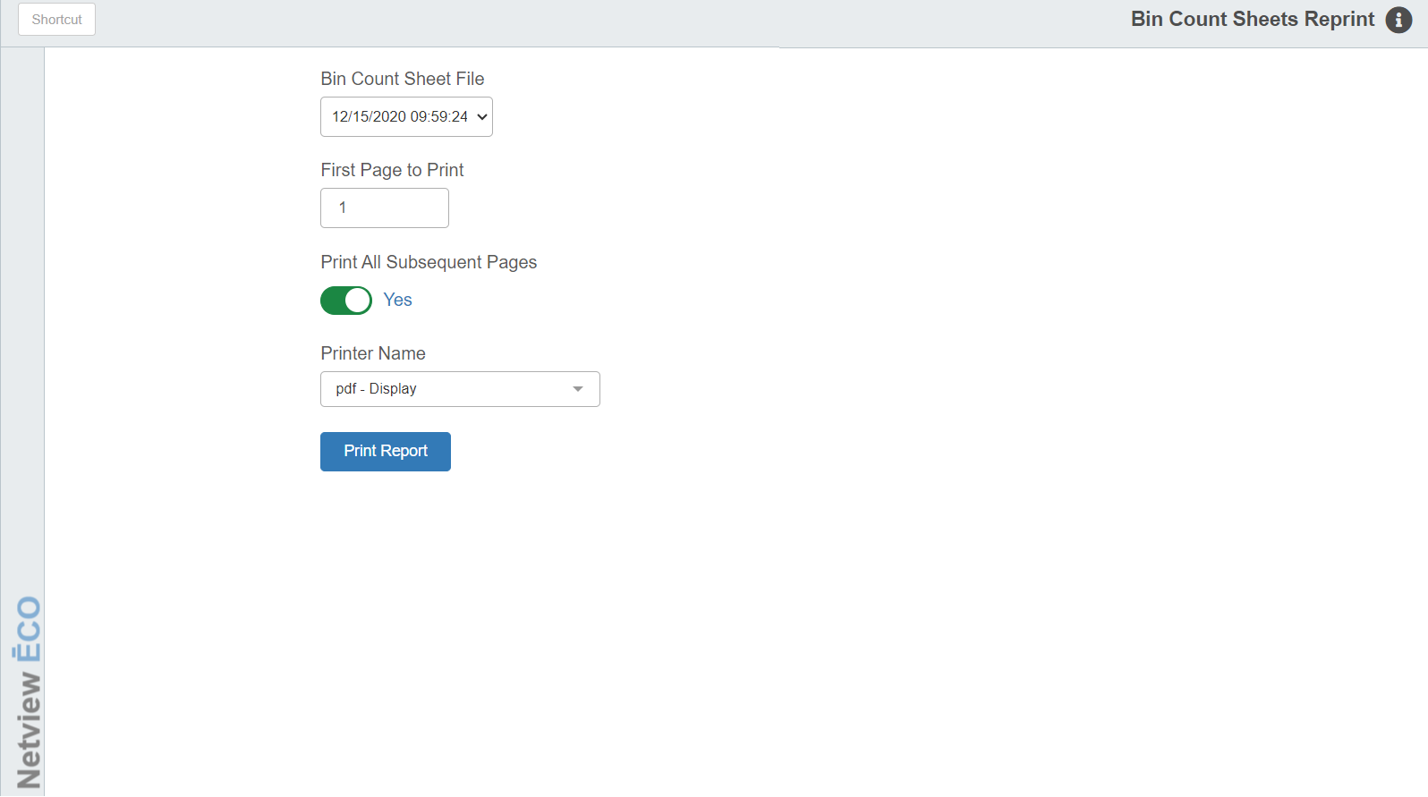

This Physical Inventory program lets you reprint any Bin Count Sheet(s) that may have been lost or destroyed during the inventory process.

To access Bin Count Sheets Reprint, you can:

- Select “Inventory” from the menu. Choose the “Physical Inventory” submenu and click “Bin Count Sheets Reprint.”
- Type “BCR” in the Shortcuts Bar.

Field Definitions

Bin Count Sheet File: Choose the Bin Count Sheet File to use.

First Page To Print: Enter the page number of the first page you want to reprint.

Print All Subsequent Pages:

- Select Yes if you want to print all the bin count sheets from the starting point that you specified as the first page.
- Choose No if you only want a range of pages to print.

Last Page To Print: This field only appears if you set “Print All Subsequent Pages” to “No.” Enter the last page number of the range you want to reprint.

Printer Name: Set the printer to receive the printout.

Print Report: Click this button to reprint your desired sheet(s).

