Step 6—Bin Count Sheets

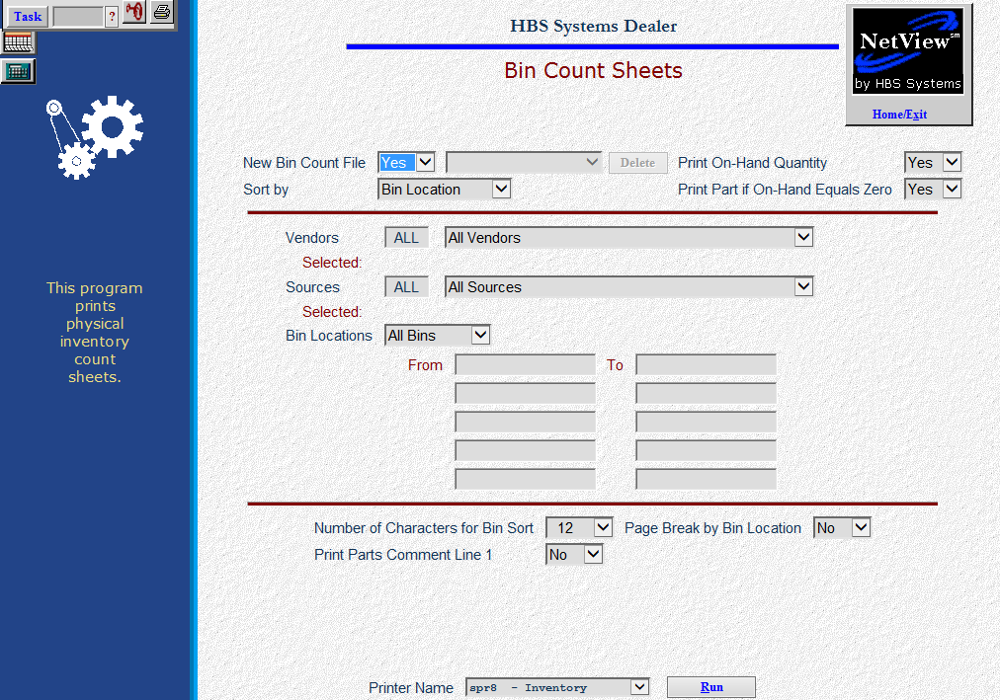

The Physical Inventory programs are flexible to accommodate full or partial counting processes. The first step in processing a physical inventory is to print the bin count sheets. Be sure to carefully read the options and their descriptions before printing the sheets. This is STEP 6 of the process for FULL physical inventory.

- To access this program, you can:
  - Select “Inventory” from the menu. Choose the “Physical Inventory” submenu and click “Bin Count Sheets.”
  - Type “BCS” in the Shortcuts Bar.

Field Definitions

New Bin Count File:

- Yes starts a new Bin Count file.
  - You can generate multiple Bin Count files for use.
  - Each is time-stamped with the date and time it was generated.
  - The files can be selected when entering counts and when posting the entered counts back to update inventory.
- No lets you access the existing bin count files.
  - Be advised that if you choose an existing file and select the same or additional bins, you WILL add those bins to the existing file. Adding more to an existing run may alter the record numbers of sheets already printed.
  - “No” on this screen should be used to delete unneeded files, not to modify files.
- If you need to reprint an existing bin count file, use BCR, NOT this screen.

Sort By: Here you can select the order in which you want the bin count sheets to print. Your choices are:

Vendor Number: This selection sorts by vendor and then bin location. Blank bin locations are printed first followed by actual bin locations.

Bin Location: This selection will print the bin count sheets in bin order and then part number order. Blank bin locations are printed first followed by actual bin locations.

Part Number: This selection will print the bin count sheets in part number order only without regard to bin location or vendor. Blank bin locations are not listed together.

Print On-Hand Quantity:

- Select No if you do not want the current on hand to appear on the Bin Count Sheets.
  - You may want to answer “No” if you feel that the employees may accept the current count in lieu of actually counting the parts.
  - We recommend using “No” here.
- Choose Yes to include the on hand column on the report.

Print Part # On-Hand Equals Zero (0):

- Select Yes to print all parts with an on hand of zero. Since the current count of zero may be incorrect, you should print these parts.
- Choose No to exclude parts with zero quantity.

Vendors/Selected: Select “All Vendors” from the drop-down menu if you want to include all vendors. You may also select up to 10 individual vendors. As you choose the vendors, they will display as selected.

Sources/Selected: Select “All Sources” from the drop-down menu if you want to include all sources. You may also select up to 10 individual sources. As you choose the sources, they will display as selected.

Bin Locations:

- Select Yes to print all bins.
- Choose No to select a range of bin locations.
  - You may specify up to 5 ranges of bin locations.

From: Type in the first bin number of the range of bins you wish to include.

To: Type in the ending bin number of the range of bins you wish to include.

Number of Characters for Bin Sort: Press “Enter” to accept the default of 12 characters. This lets you limit the length of the bin locations for the sheets. For instance, if you select a “4” from the drop-down menu, it would limit the run to all bin locations of 4 characters or less. We suggest using all 12 positions of the bin location.

Page Break by Bin Location:

- Select Yes if you want a page for every bin location.
  - You may want this kind of printout if you are assigning individual bin locations to each employee.
  - However, this may use more paper if you have bins containing only a few part numbers.
- Choose No to continue on to the next bin location without starting a new page.

Print Parts Comment Line 1:

- Select Yes if you want to print the Comment 1 line.
- Choose No to ignore the comment line.

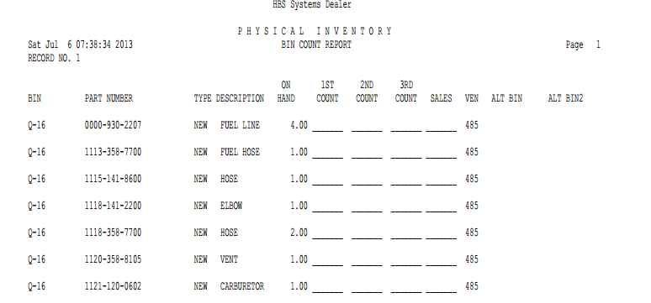

Bin Count Sheets: The Bin Count Sheets contain the following information:

Record No.: This is the record number of the first part number listed on this page. This is the number that you will enter when you begin the posting process.

Bin: This is the primary bin location for the part number listed.

Part Number: Here you will find the part number to be inventoried.

Type: This field identifies the part type, which can be:

New

Used

Core

Reman

Memo

Description: Here you will find a description of the part number.

On Hand: The On Hand field is the quantity currently shown on hand. This column only appears if you selected it.

1st Count: This column is to record the 1st count taken.

2nd Count: This column is to record the 2nd count taken, if a recount is necessary.

3rd Count: Here you can record another or 3rd recount, if necessary.

Sales: This is where you record any sales that we’re made during the time inventory was being taken. This step is NOT recommended at this time.

Ven: Here you will find the Vendor Number for the part number listed.

Alt Bin and Alt Bin 2: If you have more than one bin location for this part on the part master, up to two additional locations will show here.

STEP 7 – Count!

Take the inventory sheets and begin the counting process. They can be split up between the people you have doing the counting. As counting sheets are completed, they can be passed to the person(s) entering the counts into the computer.

