Appendix A: A/P Balance Forward Invoices (BFI)

Warning!!!

A/P Balance Forward Invoices (BFI) is used ONLY for setting up a new A/P System. Do not use BFI for every day use. Your entries in this program DO NOT create accounting records. It should ONLY be used with the guidance of the HBS Support Team.

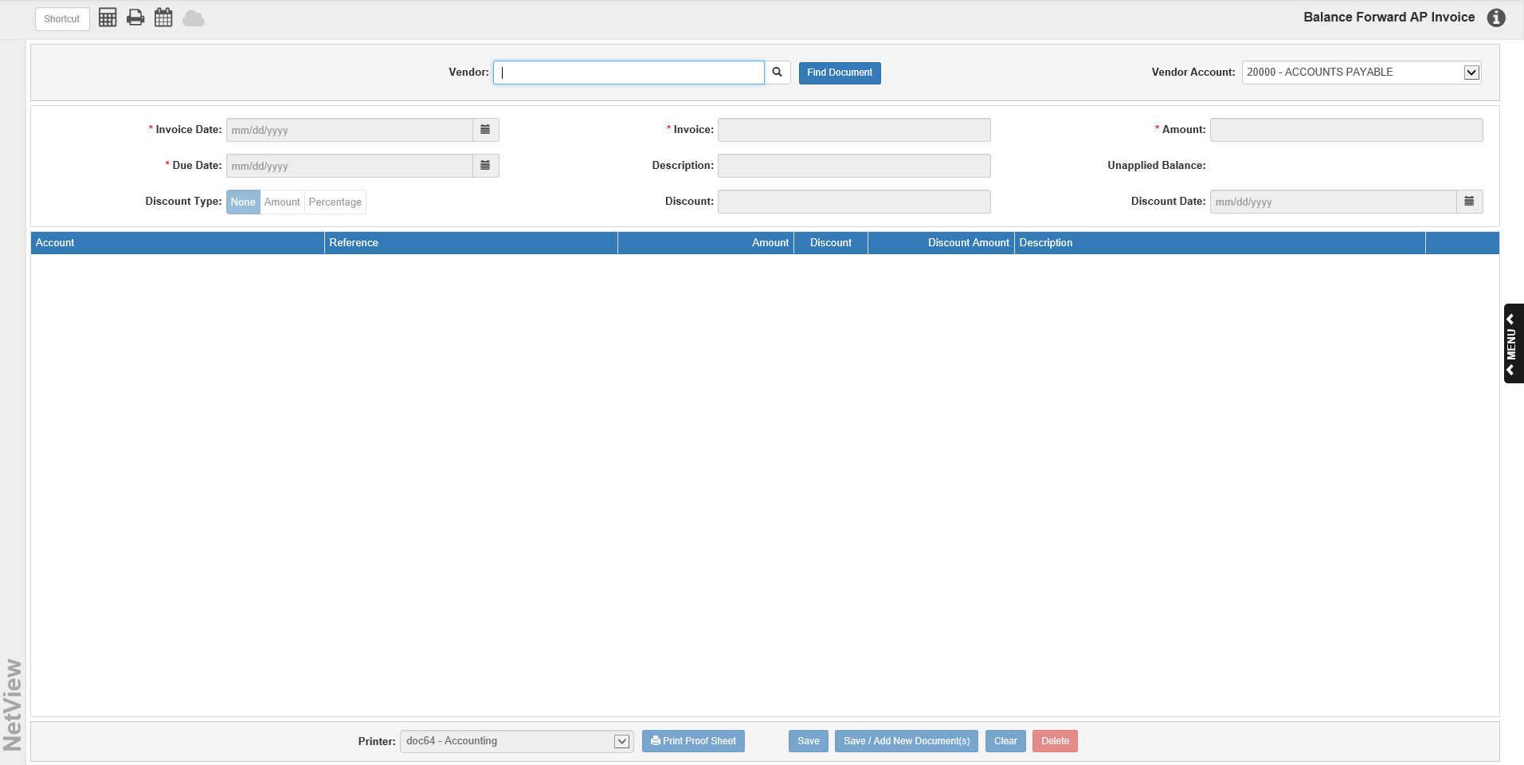

A/P Balance Forward Invoices (BFI) is designed for initial start up activities and Support maintenance. Entries made within this program do not update the G/L accounts. This program should ONLY be used with the guidance of the HBS Support Team!!

To access this function, you can either:

- Select “System Maintenance” from the menu and choose the “Data File Review” submenu. Open the “Accounts Payable” beneath that, and click on “Balance Forward Invoices.”
- Type “BFI” into the Shortcuts Bar.

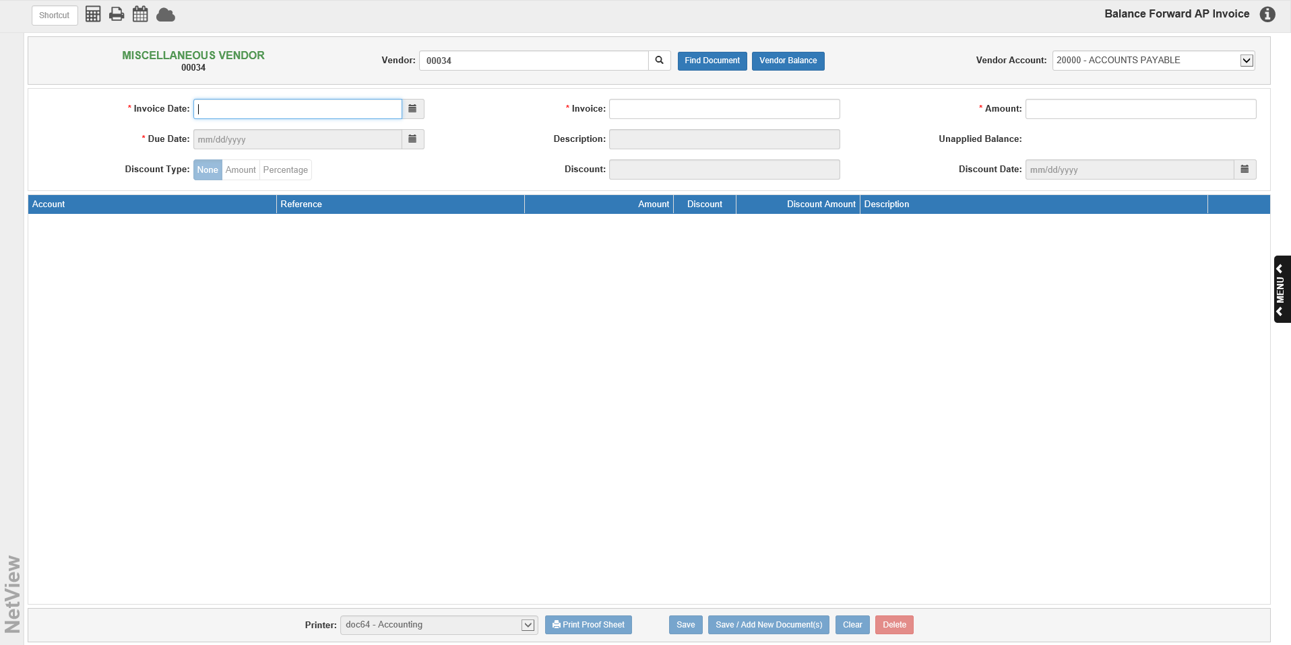

Vendor: Type in a vendor number or search for it by entering all or part of the vendor’s name in this field. The Vendor Search will appear if what was entered appears in multiple records, and will list all active vendors that match your search (you can look for inactive vendors as well by selecting the “All” option).

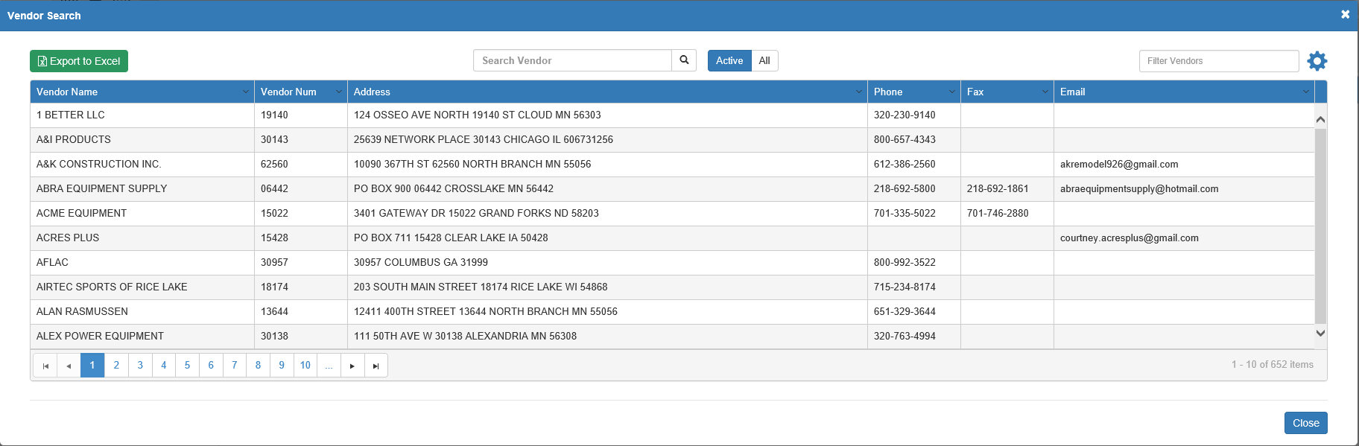

Locate the desired vendor and click on it to select it. The vendor’s name and number will also display to the left of the field. You can click on the vendor’s name to view their Vendor Insight (VI) page (see “Vendor Insight (VI)” for more information).

Vendor Balance: This button only appears after you have selected a vendor. It opens the vendor’s information in Vendor History (VH), so you can view the vendor’s current balance, year-to-date paid amount, and other related information.

Find Document: Clicking this button will show you a list of all open invoices currently in the system and their statuses. We do not recommend using this button in BFI.

Vendor Account: If you have the Multiple A/P Accounts feature turned on in Information Defaults (ID), you can use this field to select the specific A/P account you want to use on the invoice. The field will default to the account listed in the Vendor AP Account field on the vendor’s page in Vendor Information (VIM). If you do not have the feature turned on, the field will display the default A/P account (20000-ACCOUNTS PAYABLE).

Header Fields:

Invoice Date: Enter the date when the invoice was issued or select it from the calendar. This date determines the accounting period where the invoices will appear. Remember that you cannot enter an invoice into a closed accounting month.

Invoice: This field holds the invoice/reference number. If no number is available when entering a new invoice, create a UNIQUE document number. For example, you could use PHONE0518 for May’s phone bill or WATER0518 for May’s water bill.

The program will now also let you create duplicate invoice numbers. However, while the numbers can be the same, either the invoice date or the vendor must be different—you cannot create two invoices with the same number, vendor, and invoice date.

Amount: Enter the total amount of the invoice. The total should be a “pre-discount” amount. Type a positive (+) amount in this field unless you are entering a credit (-) memo.

Due Date: Enter the due date for this invoice. If this vendor has a setting in Vendor Information (VIM) for Day of Month or Number of Days, a suggested due date will show based on that info. If none was entered, then a due date 30 days past the invoice date will be suggested. The suggested date can be accepted or changed as necessary.

Description: This field can hold a description for the invoice header.

Unapplied Balance: This field displays the running invoice balance (normally a credit amount unless entering a credit invoice). Once you enter the invoice amount, this field will default to that value. As you specify the accounts where the invoice value is to go, this field will change.

Discount Type: This indicates what type of discount applies to the invoice. Click on:

- None
- Percent
- Amount

Discount Percentage/Amount: This field only activates if Percent or Amount is chosen as the discount type. Enter the relevant discount for your invoice here.

- If Percent is chosen, the title will read “Discount Percentage,” the field will hold a percentage, and the acceptable format will be “xx.x.”
- If Amount is chosen, the title will read “Discount Amount” and the field will hold a dollar amount (formatted traditionally).

Discount Date: This field only activates if Percent or Amount is chosen as the discount type. Enter the discount date here or select it from the calendar. If this vendor has a setting in VIM for Day of Month or Number of Days, a suggested discount date will show based on that info.

Invoice Details:

Account: This field holds the account where the invoice is being sent. A default number may appear here if it is specified in VIM. NOTE: You may need multiple lines to cover all aspects of the invoice. For instance, if you are billed for parts and freight from ABC Company, your invoice entry has two lines: Parts Inventory and Cost of Freight/Freight Expense.

Reference: This is an optional field and is not required, unless the account number for this line has a subledger or is related to a specific unit.

- In the case of a subledgered account, enter the necessary control number.
- For an account related to a unit, enter the unit’s stock number or look it up in the Unit Search by clicking the Search icon that will appear if a stock number is required. NOTE: You can also do a search by a partial number.

Amount: Type the amount for this line of the entry. The amount will default to the current Unapplied Balance amount, but can be changed as needed.

Discount/Discount Amount: When a discount percentage applies to the invoice, use the Discount field to determine which lines are eligible for this discount. A check will appear on the line if the discount applies to it. The Discount Amount field will then show the calculated discount for the line. Remove the check if this line does not qualify for the discount. NOTE: If the discount in the header is a flat dollar amount, the Discount field on the line will not be active and the line discount will remain at “0.00,” as the amount will be applied to the entire invoice instead of individual lines.

Description: This field pre-fills with the Vendor Name, but can be changed as needed.

Delete Line: Click the trash can icon on the far right of the invoice line to delete the line.

Tax Code: This field only appears on an invoice line when the selected vendor is Canadian. It will default to the tax code stored for the vendor in VIM. Edit the tax code as needed for the particular vendor and purchase.

Saving the Invoice: After all lines are entered, the Unapplied Balance should equal 0.00. Press the Save button to save the entry.

Alternatively, use the Save/Add New Document(s) button to both save the invoice and upload files to the invoice’s eDocs record. The following window(s) will appear:

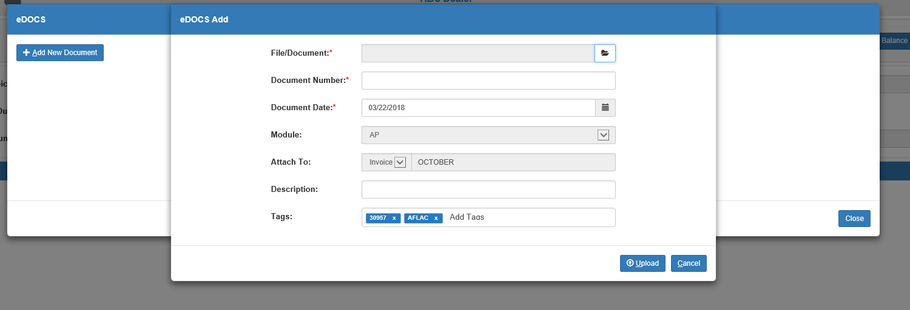

Upload the document using the File/Document field, then fill in the remaining required fields. The program will have automatically filled in the Module and Attach To fields with the specific invoice’s information, and will have also added descriptive tags specific to the invoice. Click Upload to finish uploading the document. It will then appear in the invoice’s main eDocs display once the Add window closes.

Importing a Kubota Invoice: If you are a Kubota dealer and have the Kubota Invoice Import feature set up in Kubota Connect (KUB), this button will appear in the header.

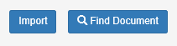

The button allows you to directly import downloaded Kubota invoices into the A/P system without having to manually enter the invoice data. Click it to view the Kubota invoices available for import.

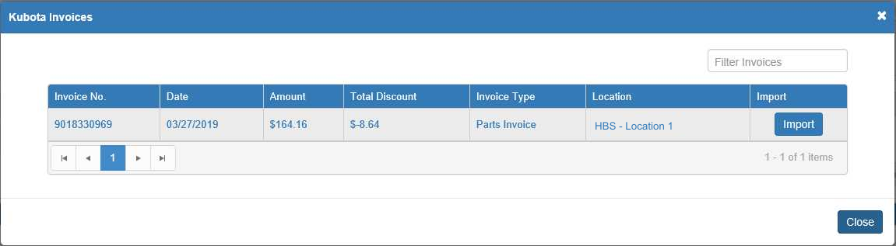

Each invoice entry lists the invoice’s number, date, amount, total discount, type, and what dealer location it belongs to. You can filter the list by using the sortable headers to reorder it or by entering specific information in the Filter Invoices field to narrow down your results. Additionally, you can click an invoice number to view a PDF of that invoice.

Once you find your desired invoice’s entry, click the Import button in the entry’s far right column to import the invoice. The program will return to the main screen and automatically populate with the invoice’s information, including automatically setting the vendor to Kubota. You can then make any adjustments as necessary before hitting Save to record the invoice. NOTE: You will not be able to change the Invoice Date field for imported invoices.

