Balance Forward Unit Purchase (BFP)

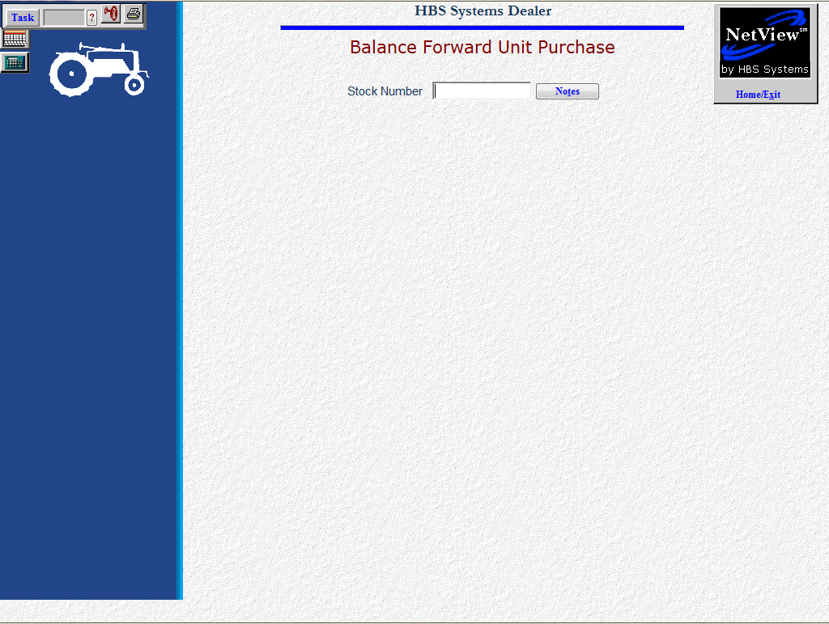

Balance Forward Purchases is a program used primarily for initial setup of units. It is NOT intended for everyday use as there is NO audit trail of any purchases made in the program. As such, no journal entries are created when units are entering via this method. Contact a HBS Support Team member before using this program.

