POS—Back Orders

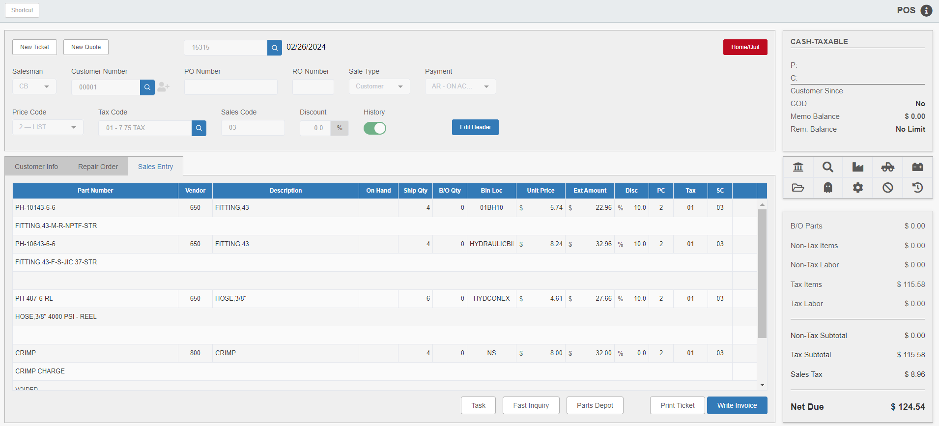

When parts are not available or not in stock, a back-order must be placed through POS using the Sales Entry tab. The Back-Order feature allows the dealership to set up, track, collect, and ship customer orders (back-orders) when the on-hand quantity of a part does not equal the quantity needed by a customer.

Duplicate Part Numbers: If a part number with two or more records in the inventory system is entered, the Part Search will open to display all duplicate part number records.

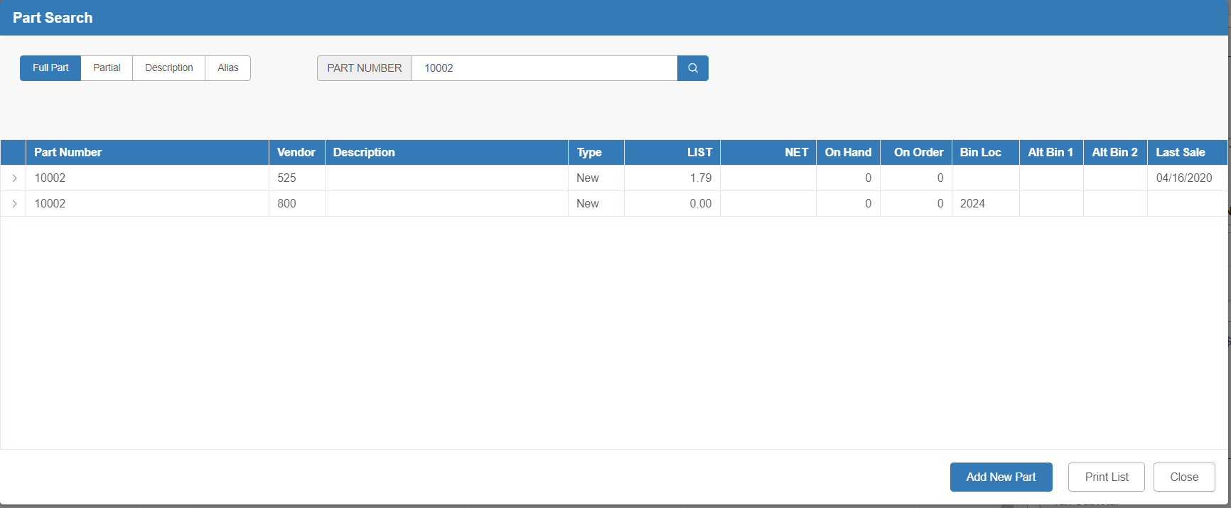

Setting Up A Back-Order: To begin setting up a back-order, add a part that has an on-hand quantity less than the quantity the customer wants to purchase (or is out of stock) to a picking ticket.

- With a part that is out of stock, record the Ship Qty as “0” in order to activate the B/O Qty field. Fill in the amount you need to order and finish filling in the line.
- With a part that is in stock, but the on-hand quantity is less than needed to complete a purchase, add the part to the picking ticket twice:
  - First to sell the on-hand quantity.
  - Second to back-order the additional amount required by the customer.

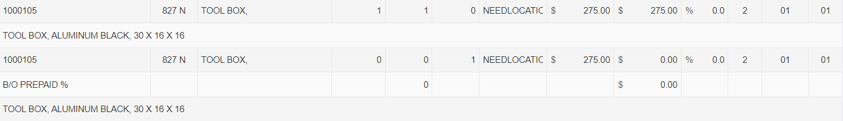

When the part is added with a B/O Qty, the Order Information screen opens showing the back-order number as an adjustment to a parts order. The current date auto-fills as the order number, but can be changed as desired, including to an existing part order number.

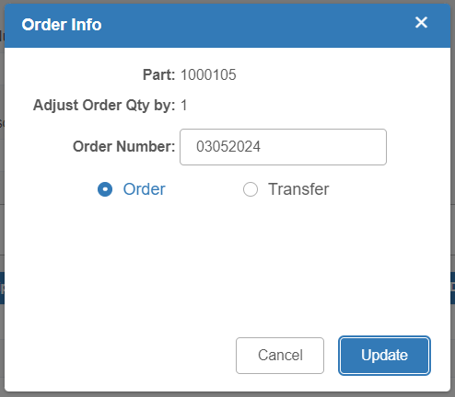

Press Update to accept or Cancel to eliminate the back-order posting to a part order.

Additionally, there is an option at the bottom of the screen to transfer the back-ordered part in from another store location. See “Multi-Location Parts Transfer” for more information. NOTE: This feature only works for multi-location dealerships.
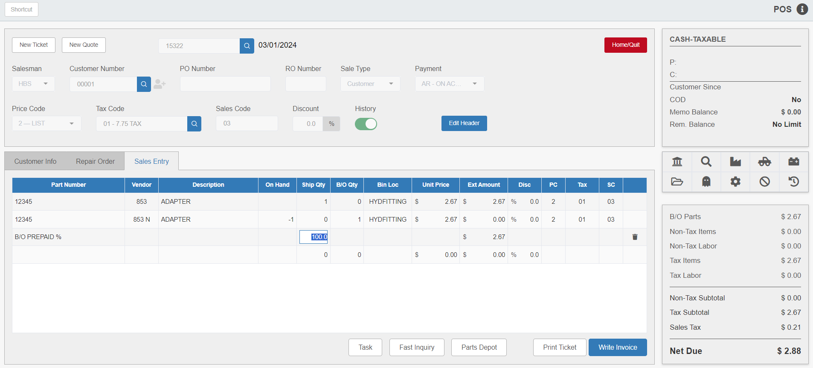

If the customer is to prepay all or part of the back-order amount for this part line, either:

- Press “Enter” to accept the default percentage (auto-filled based on the settings in Inventory Point of Sale Defaults (IPOS)).
- Enter an alternative percentage.
- Type “0” for no prepayment.

The back-order set-up is now complete.

Other parts may be sold or placed on back-order on the same picking ticket. Re-Use Picking Ticket with B/O Items must be set to Yes in IPOS in order for this to work. Other POS features, such as adding discount lines and accepting cores, may also be used on the ticket.

Quantities may also be changed on the back-order line(s). If back-order quantities are changed, the system displays the following prompt:

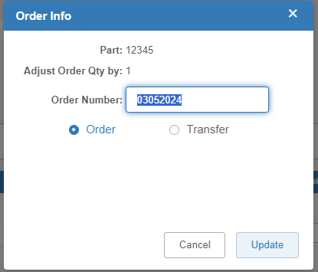

Select Update to change the quantity.

TIP—Voiding Back-Order Part Lines: As long as the INVOICE has NOT been written, back-order part lines may be safely changed or even voided. Store (quit) the picking ticket, return to it, and make quantity changes or void lines. However, as soon as an invoice is written from the ticket, DO NOT VOID THE BACK-ORDER PART LINES!

Writing the Invoice: When you are ready, click Write Invoice to open the Settlement screen. Choose the Shipping Info tab for adding freight charges, writing a freight description, determining if freight will be taxed or not, etc.

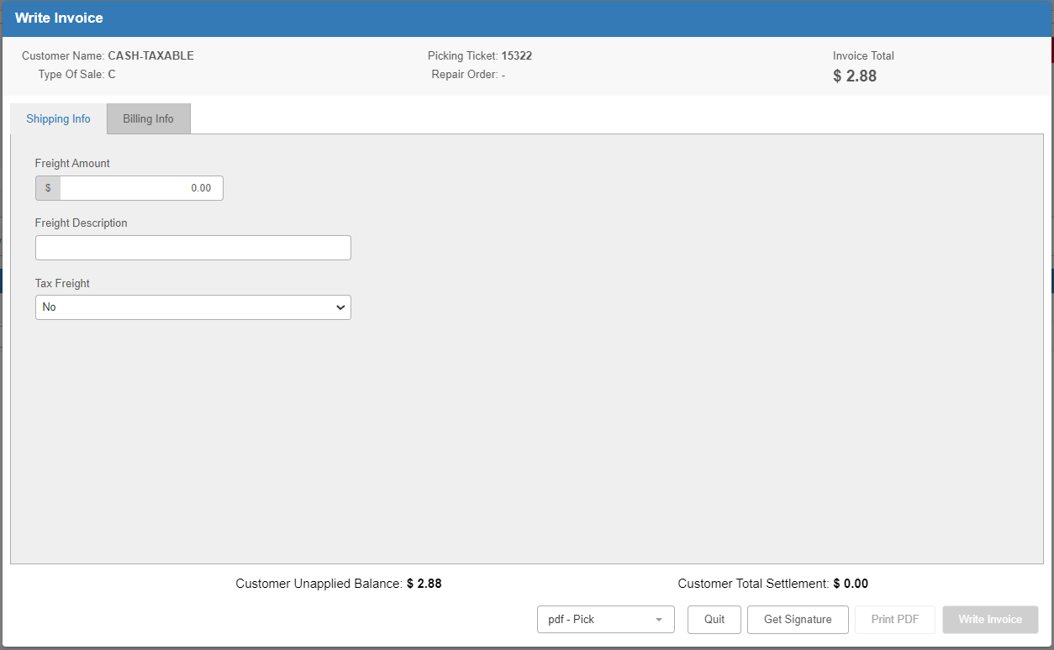

If a cash sale is made and there is change due a customer, the amount of change due will show in the “Customer Unapplied Balance” field as in the below example:

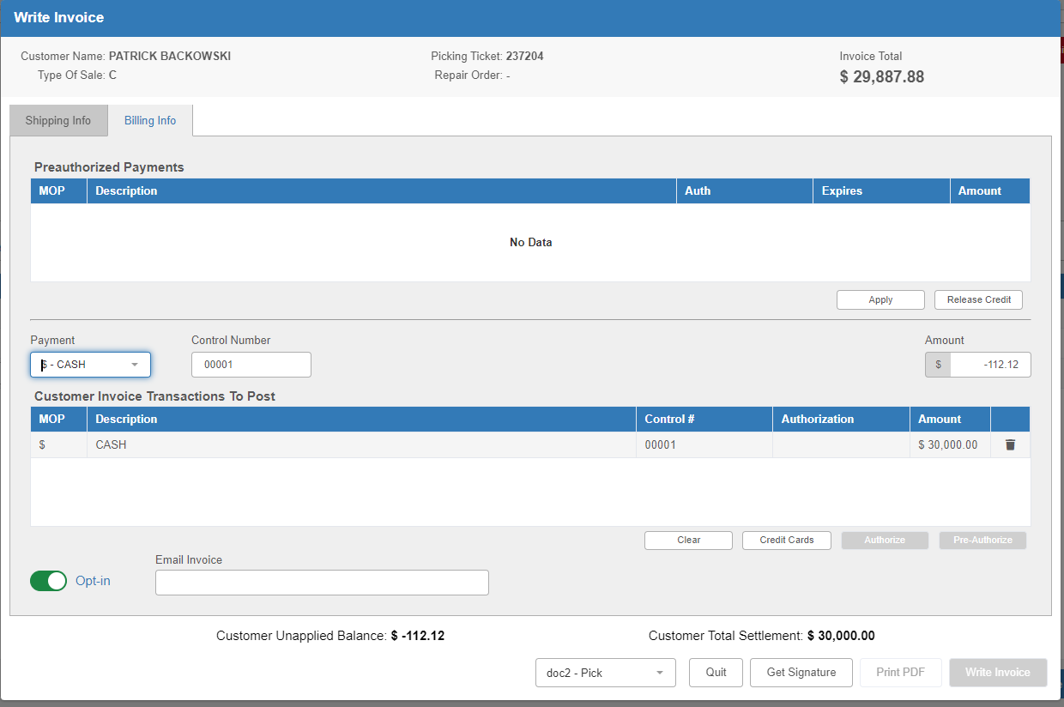

It is also possible to change sales type in this screen using the “Payment” drop-down.

NOTE: It is possible to leave a picking ticket containing the back-order open, even after invoicing the ticket. The picking ticket may remain open until the customer’s order arrives and is receipted into the Inventory system. Access the picking ticket and write a second invoice closing the ticket and showing all ordering and collecting activity.

Receipting the Back Order and Updating the Picking Ticket: When the back-ordered parts arrive, close the back-order picking ticket. Use Quick Receipts (QR) to update the inventory, ordering, and picking ticket files.

NOTE: Before using QR to update back-order picking tickets, the Re-Use Picking Ticket with B/O Items and Move B/O Quantity to SHIP Field When Receipted prompts must both be set to Yes in IPOS. If both prompts are set to No, the user must create a new picking ticket to receipt the back-ordered parts. If only the Move B/O Quantity to SHIP Field When Receipted prompt is set to No, the existing picking ticket must be manually updated.

Next, review and update the ticket as needed before writing the final invoice. Notice QR will move the back-ordered parts quantity from the “B/O” field to the “Ship” field.

Before writing the final invoice and closing the ticket, part numbers (even back-order part numbers) may be added, the sell quantities of parts not on back-order may be adjusted, additional prepayments accepted, and credit returned to the customer. The user may also add descriptive comments, apply discounts, or void lines, except those lines for back-order parts.

Warning!!!
Do not void Back-Order parts lines!!!
Do not void the Back-Order picking ticket!!!
It is NOT recommended to change the values in the “Ship Qty” and “B/O Qty” field on the back-order parts lines, if using Quick Receipts (QR) to receipt the parts back-ordered on this picking ticket.

Returning Back-Ordered Parts: If the customer no longer wants the back-ordered parts, move the cursor to a new line. Enter the back-ordered part number and, at the “Ship Qty” field, type a minus sign (-) followed by the back-ordered quantity (as shown).

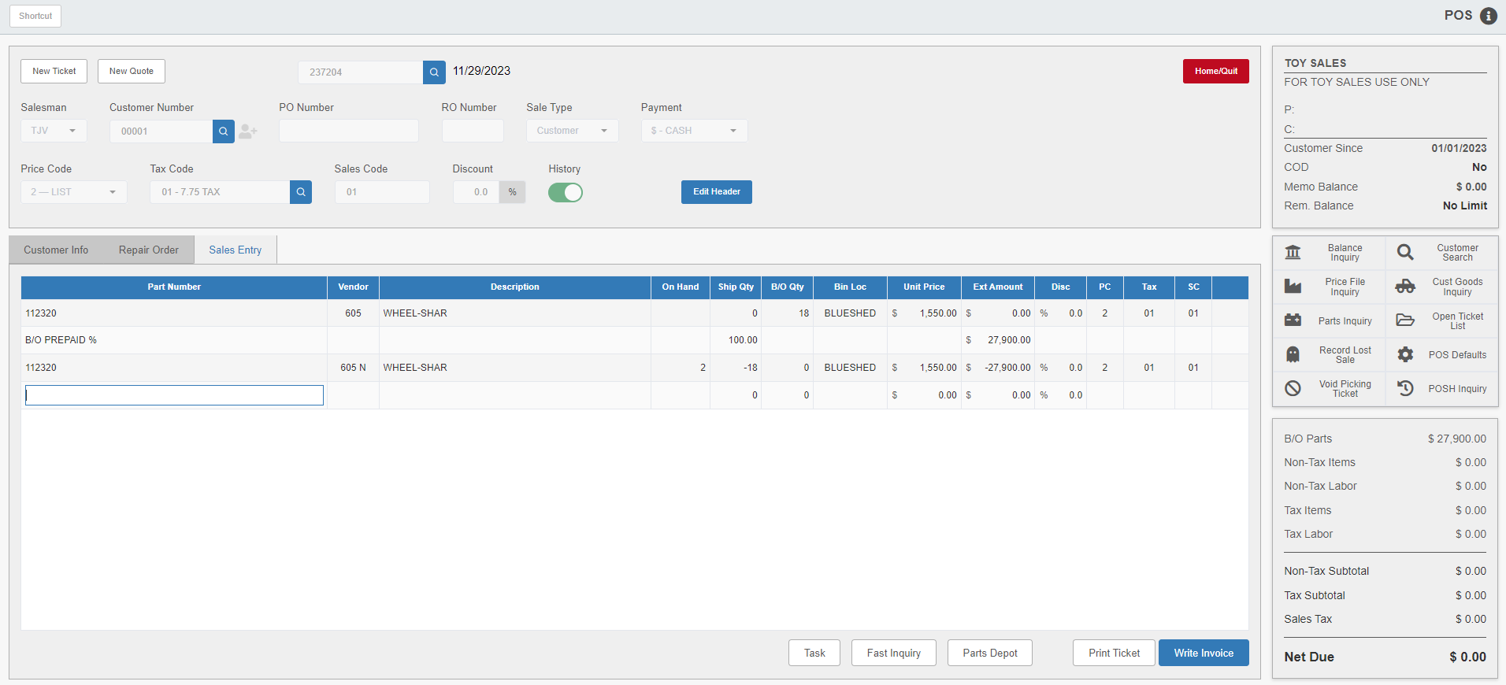

In this way, the Parts Inventory record for this part is corrected, increasing the quantity on hand by the amount returned. This line also credits the original sales amount. This function also handles the accounting side of this transaction, reversing the original posting entries made for the back-ordered part number, as well as reversing the prepayment.

Writing the Final Invoice and Closing the Picking Ticket: Now you can write and print the final invoice from the back-order picking ticket. To print the final invoice, click Write Invoice.

After the invoice prints, the system displays the Print Invoice-Confirmation screen.

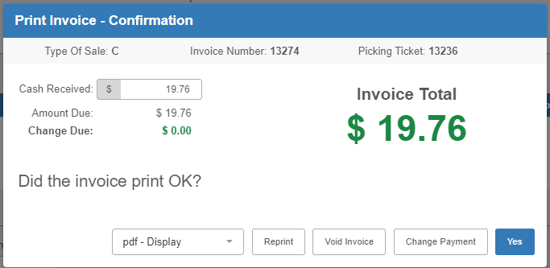

- If the invoice printed correctly, click Yes.
- If not, reload the invoice forms or fix any printer problem, and then click Reprint.

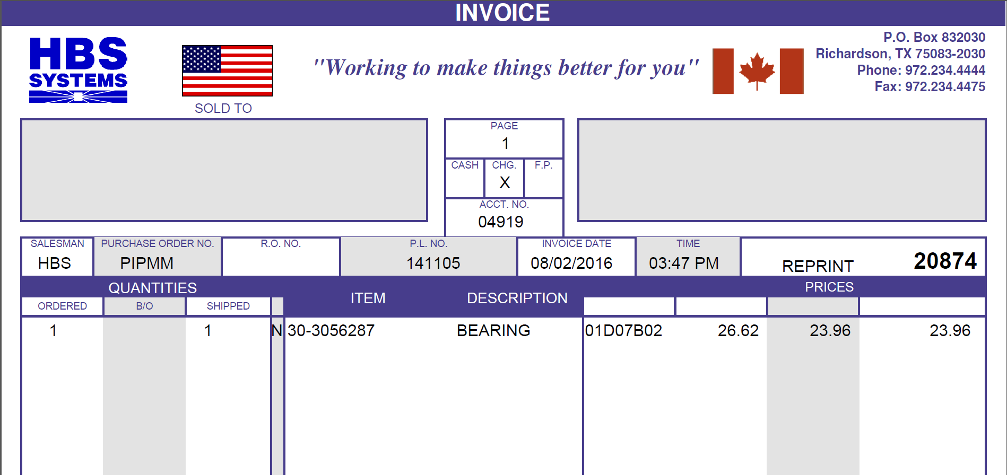

The invoice printout includes the comment lines from the picking ticket, showing the prepayment percentage, the amount, and the parts receipt information for the back-ordered parts. The invoice total shows any amount owed on the back-ordered parts (not covered by the prepayment), any additional parts lines, returned parts lines, etc.

