Balloon Payment Schedule (BPS)

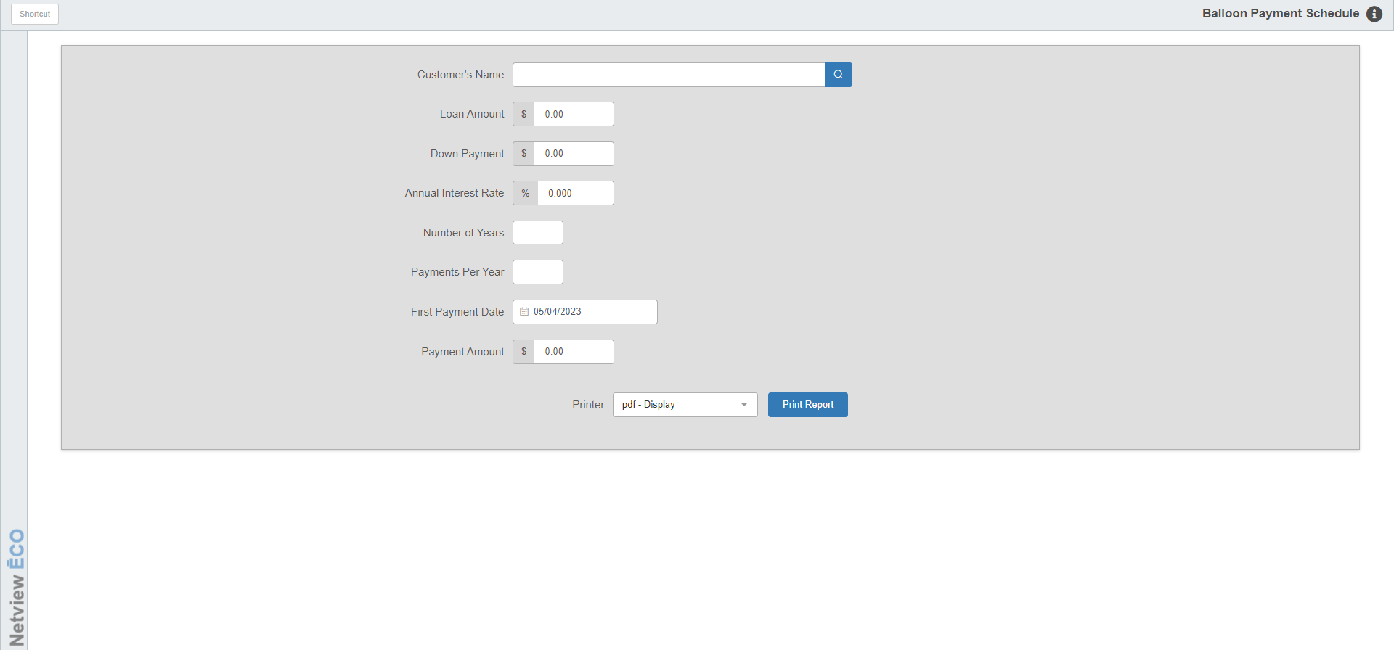

Balloon Payment Schedule (BPS) lets you generate, review, and print balloon payment schedules for dealership-financed loan amounts.

- To access this function,
  - Select “Units” from the menu. Choose the “Amortization” submenu and click “Balloon Payment Schedule.”
  - Type “BPS” in the Shortcuts Bar.

Field Definitions

Customer Name: Type a customer name. The name entered is used only for printout purposes.

Loan Amount: Type the amount of the loan, without a decimal point. For example, type “400000” for $4000.00.

Down Payment: Type the amount of the customer’s down payment on the unit, without a decimal point. For example, type “50000” for $500.00.

Annual Interest Rate: Type the amount of the annual interest rate on the loan, without a decimal point. For example, type “10000” for 10.000%.

Number of Years: Enter the number of years within which the customer will make loan payments.

Payments per year: Enter the number of payments the customer will make per year. Type 1 for annually, 4 for quarterly, 12 for monthly, etc.

First Payment Date: Type the date that the customer will make the first loan payment. For example, type “101511” for October 15, 2011. You can also use the blue arrow to select it from a calendar.

First Payment Amount: Enter the desired payment.

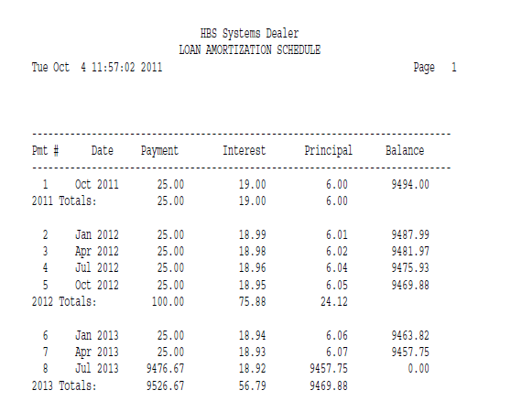

Field Definitions – Report: This page shows the detailed balloon payment schedule.

Pmt #: This column lists the numbers of the payments.

Date: This column lists the approximate dates of the payments.

Payment: This column lists the amounts of the payments.

Interest: This column lists the amount of each payment applied to interest.

Principal: This column lists the amount of each payment applied to the principal of the loan.

Balance: This column lists the remaining loan principal amount after each payment.

Year Totals: This line shows the following:

The total amount the customer paid the indicated year

The total amount of interest paid

The total amount applied to the loan principal

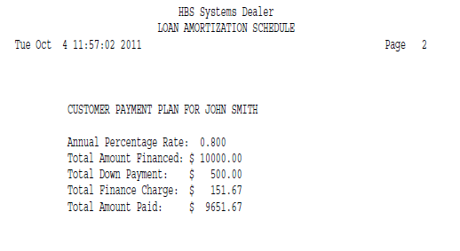

The final page lists the totals of the loan. Notice the amount of the balloon payment (last payment).

Annual Percentage Rate: This field shows the interest percentage rate selected.

Total Amount Financed: This field shows the amount of the loan (before the down payment).

Total Down Payment: This field shows the down payment amount.

Total Finance Charge: This field shows the total amount of interest paid over the duration of the loan.

Total Amount Paid: This field shows the total amount paid over the duration of the loan. It is calculated by taking the total amount financed minus the down payment plus the interest (finance charges).

