Step 9—Bin Variance Report (BVR)

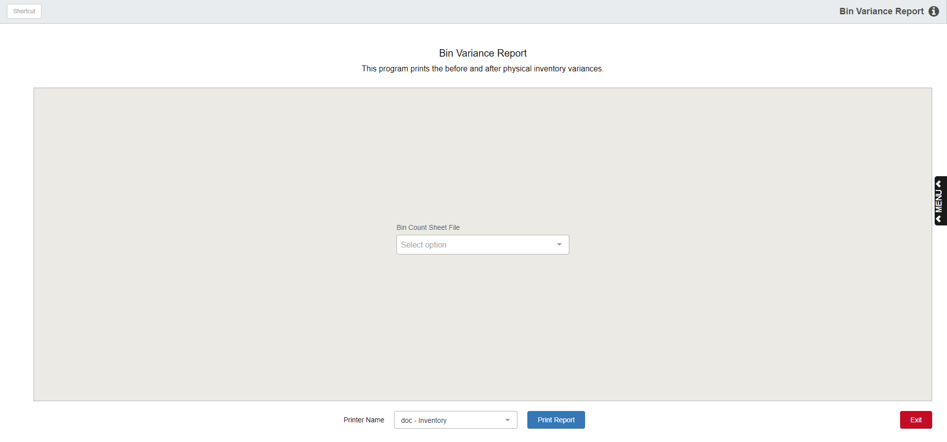

Print the Variance Report after entering all of your physical counts. To verify data entry and inventory count, large variances should be recounted. After corrections are made, print a new variance report to get an accurate dollar value variance. The bookkeeper/CPA may use this report to make any necessary accounting adjustments.

To access this program, you can:

- Select “Inventory” from the menu. Choose the “Physical Inventory” submenu and click “Bin Variance Report.”
- Type “BVR” in the Shortcuts Bar.

Bin Count Sheet File: Choose the Bin Count Sheet File to analyze.

Printer Name: Select the printer to receive the printout. A default printer name is pre-filled, but can be changed as necessary using the drop-down menu. Use the pdf printer to view the report on the screen without printing a copy of it.

Print Report: Press this button to print the Bin Variance Report.

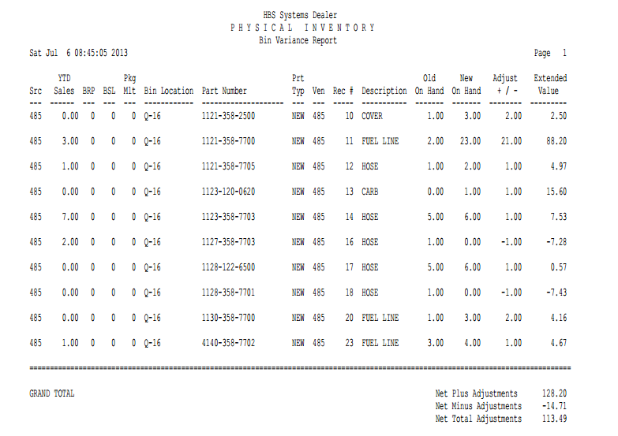

Report Detail: This report provides information about the differences in your physical counts versus the counts in the computer. The report shows:

Src: This field shows the Source Code for the part number.

YTD Sales: Here you will see the Year to Date Sales (quantity sold) for the part number.

BRP: This field displays the Best Reorder Point for the part number.

BSL: This column shows the Best Stocking Level for this part number.

Pkg Mult: This field prints the Package Multiple information for this part.

Bin Location: Here you will see the primary Bin Location for the part number.

Part No.: This shows the Part Number that was counted.

Prt Typ: This is the Part Type for this part number, which could be:

New

Used

Reman

Core

Memo

Ven: Here you will find the Vendor Number for this part number.

Rec#: The Record Number on the count sheets for this part is shown here.

Description: The description of the part as found in the Part Master is shown here.

Old On Hand: This field shows the quantity on-hand BEFORE the counting began.

New On Hand: This column shows the quantity you counted.

Adjustment +/-: The figure compares the New On Hand value to the Old On Hand value.

If the New Value is lower than the Old Value, the number shown will be negative.

Likewise, if the New Value is higher, the adjustment column will show a positive amount.

Extended Value: This column shows the value of the adjustments to the quantity on hand. It is calculated by multiplying the adjustment by the cost of the part.

A negative number here indicates a drop in value for the part.

A positive number here indicates an increase in value for the part.

Totals: Totals are provided for the following:

Net Plus Adjustments

Net Minus Adjustments

Net Total Adjustments

TIP: When taking an inventory, be sure to review the Bin Variance Report carefully. You might scan through it and look for quantity or dollars of a large amount. Review the parts with large variances, make changes as needed in the Post Inventory Count program, and re-run the Bin Variance Report. This time, review the report with a lower dollar or quantity variance. Check and re-count the parts with the variances, making any necessary changes in the Post Inventory Count. Re-run the variance report. Most dealers find that running several passes of the Bin Variance Report works best. Make sure you run a final Bin Variance Report before you proceed to the next step. This report can be passed to Accounting for adjustments if necessary.

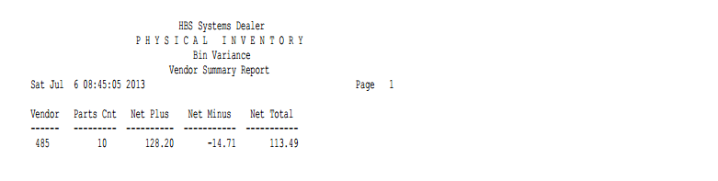

Vendor Summary Report: This additional report page summarizes the Bin Variance activity by vendor for all parts involved in the physical inventory process. The following information can be found on this report:

Vendor: There will be a line for each vendor that had parts in this round of physical inventory.

Parts Cnt: The parts count column shows the number of parts included on the report for the vendor. This is also the number of part numbers that actually had variances.

Net Plus: This shows the net total of plus adjustments (increases).

Net Minus: This shows the net total of minus adjustments (decreases).

Net Total: This column shows the value of the adjustments for this vendor.

A negative number here indicates a drop in value for the vendor.

A positive number here indicates an increase in value for the vendor.

