Cash Applications (CA)

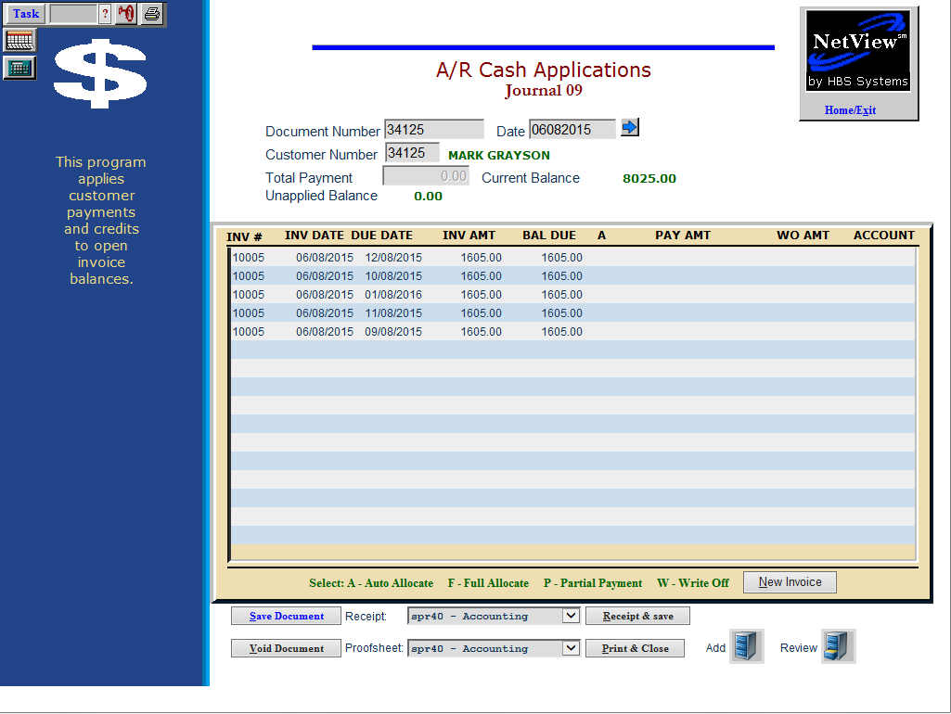

Cash Applications is an application where you can make customer’s payments on their accounts. Here you can see all existing detail on the account and apply the payments to specific invoices if needed. Cash Apps also supports write offs and the creation of new entries on a customer’s account. All entries for Cash Apps are made in Journal 09 (Cash Receipts Journal).

To access this function, you can either:

- Select “Accounts Receivable” from the menu. Choose the “Data Entry” submenu and click “Cash Applications.”
- Type “CA” in the Shortcuts Bar.

Date Validation: A setting in the company files helps you validate the dates entered. The Date Check Feature lets you limit the number of months back and forward from the current date that can be entered. When you set a limit (i.e. 1 month for both), the system will provide a message to have you check the date you entered and correct it if it is the wrong date. If you want to keep the date entered, you will have to enter the password to continue.

Date Check Feature Setup:

On the Company Defaults screen (CONA), choose the Future Date Limit field to limit the future dates in Cash Applications and the GL/AR journals. The field accepts the number of months into the future you want to allow before needing to enter a password.

We recommend that you use 1 for this choice. By limiting your future entries to one month, you can eliminate incorrect future dated payments in Cash Applications and limit the posting of future dated entries in the GL and AR journals.

A zero or blank in this field means there is no date limit set.

Choose the Back Date Limit field to limit the dates PRIOR to the current date. This limit applies to entries made in Cash Applications and the GL/AR journals. The field accepts the number of months prior to the current date you want to allow before needing to enter a password.

We recommend that you enter a number of months no larger than the number of accounting months you usually keep open. By limiting your prior dated entries to that number, you can eliminate incorrect prior dated payments in Cash Applications and limit the posting of prior dated entries in the GL and AR journals.

A zero or blank in this field means there is no date limit set.

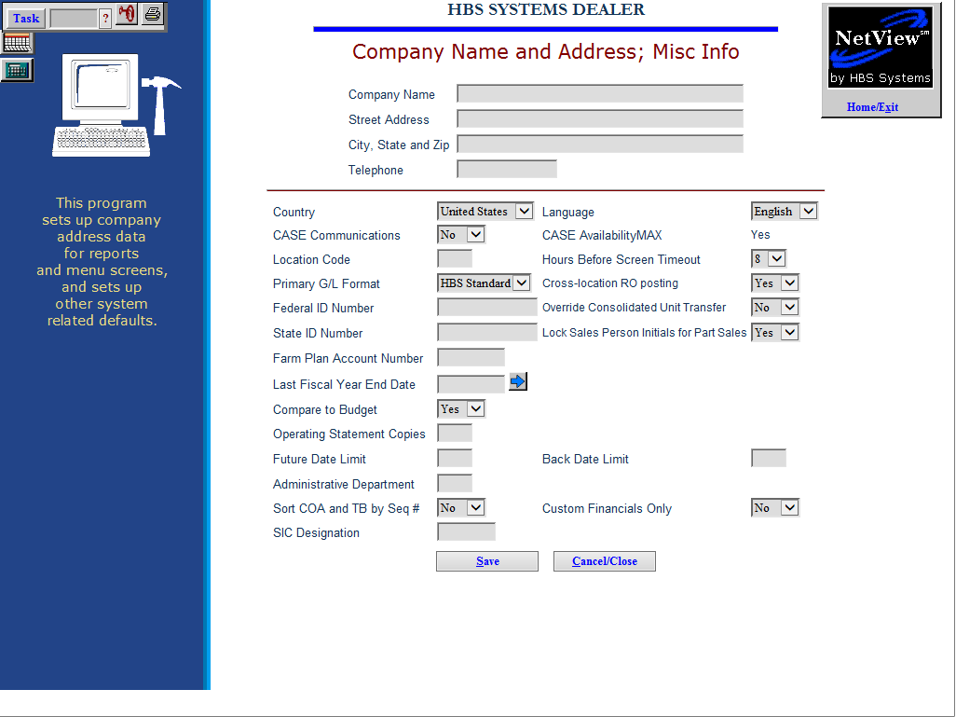

- If you want to activate the password portion of the date check feature, use Password Verification Maintenance.
  - Change the Date Limit Override. The first time you select this field, it will prompt you for the old password.
  - Press enter through the old password field and then enter the new password in the field provided.
  - The new password will remain in force until you return to this screen and change the password at a later time.

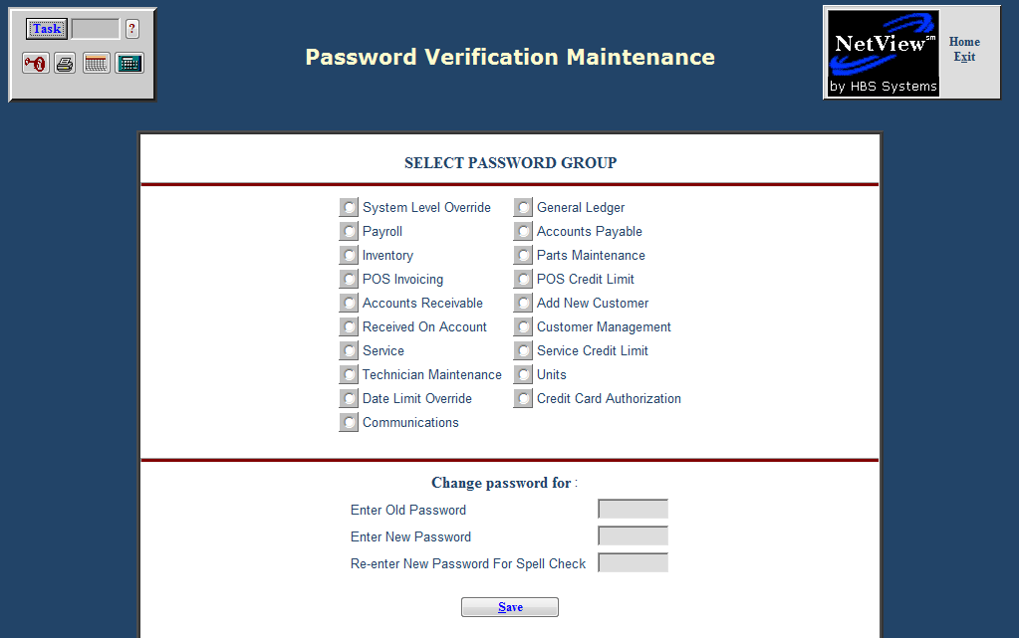

- With a date limit in place, you will see the following message in Cash Applications when you enter a date outside the range defined by the Back or Future Date Limit.

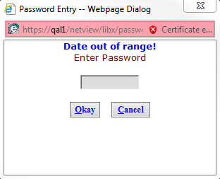

  - In Cash Applications when you type in a date outside the date limits you chose, you will receive the message “Date out of range. Enter Password.”
    - If you want to keep the date even though it is outside the limits, type in the appropriate password and press either the “Okay” button or “Alt O.”
    - If you want to correct the date, press either the “Cancel” button on the message box or “Alt C” and make your correction.
  - The same date check is run when you post the G/L Journal (GLPJ). You receive the same message and have to enter the password if you want to use the date entered.

Field Definitions

Document Number: Enter the check number or receipt/ticket number here.

Date:

- Enter the date of the payment or press “Enter: to accept the date shown.
- It pre-fills with the current date when you first enter the screen and then remembers the date you used on the previous receipt.
- Be sure to verify the date on each transaction.
- If you type in a date outside the date limits you defined in the Company Defaults, you receive the message “Date Out of Range. Enter Password.”
  - If you want to keep the date even though it is outside the limits, type in the appropriate password and press the “Okay” button.
  - If you want to correct the date, press the “Cancel” button on the message box and correct the date.

Customer Number: Enter the customer's account number. You can also search for the customer’s number by typing in the first few letters of the customer's last name. Scroll through the names displayed and click on the correct customer. Once this information is filled in, the customer's current invoices are displayed. The program will also provide a notification if the customer is on COD (see below image).



Total Payment: Enter the total payment amount (with or without the decimal point).

Current Balance: This field displays the customer's current balance owed.

Unapplied Balance: This field shows the amount of the payment that remains to be applied to the customer’s account.

Inv #: This field shows the unpaid Invoice Number.

Inv Date: This is the original invoice date.

Due Date: When the Future Billing option is used in POS, ROM or US, the due dates for those
invoices are now visible in this field when the payment is processed.

Inv Amt: This column shows the amount of the original invoice.

Bal Due: This column shows the net amount due on this invoice (original invoice amount less any payments).

Action: This column holds the Action Code you want to apply to the invoice on this line. The choices are:

- A=auto alloc
- F=full alloc
- P=partial alloc
- N=new inv
- V=void

Pay Amt: This field shows the amount of the payment made for the invoice on that line. It can be manually filled in or system-filled when you use Full or Auto Allocation payments.

WO Amt: This field is used when you need to write-off all or a portion of the amount on this line.

Account: This field holds the G/L account number where the write-off will be passed. Type in the G/L number or type a number or two of the account to look it up. Scroll through the choices and click on the account number to use.

Payment Application – Action Codes: You may apply a payment toward the customer's outstanding invoices. Credit invoices are listed first, followed by the Finance Charge(s), and then the oldest to newest invoices. Use the tab to move down the list and shift-tab keys to back up the list to select the invoices for applying the payment.

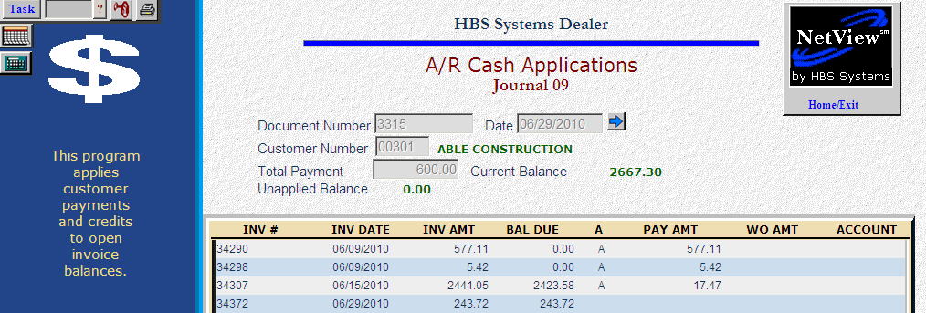

A-Auto Allocation: This code lets you automatically apply the payment to the account when no specific invoices are singled out. It applies payment to the first invoice selected and each of the following invoices until all invoices are paid or until all cash has been applied. Position the cursor at the first invoice to be paid and type “A” to spread any remaining money to the immediately following invoices.

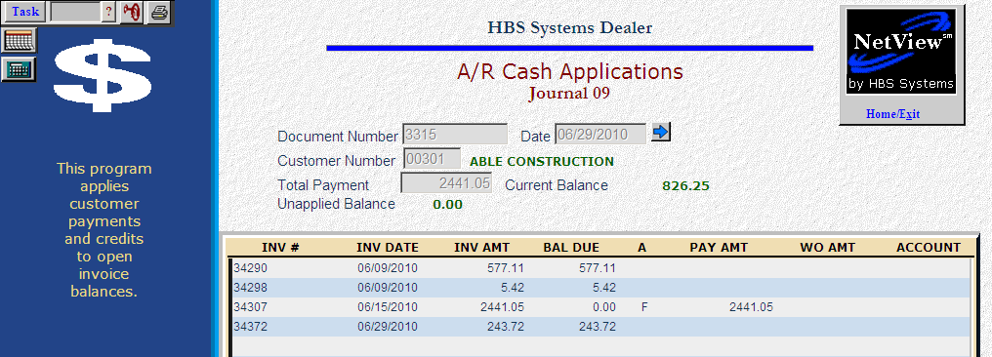

F-Full Allocation: This type of payment is used when the customer specifies a particular invoice or invoices to pay. Type “F” in the Action column next to each invoice that is paid in full.

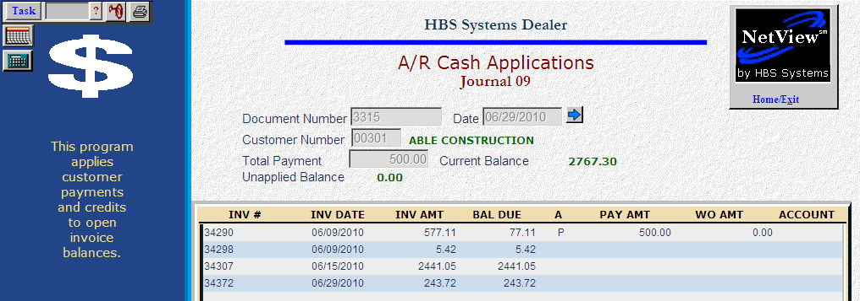

P-Partial Payment: This code is used when the customer makes a partial payment of one or more invoices. Type “P” in the Action Column to apply the partial payment to an invoice. Enter the payment amount in the Payment Amt column.

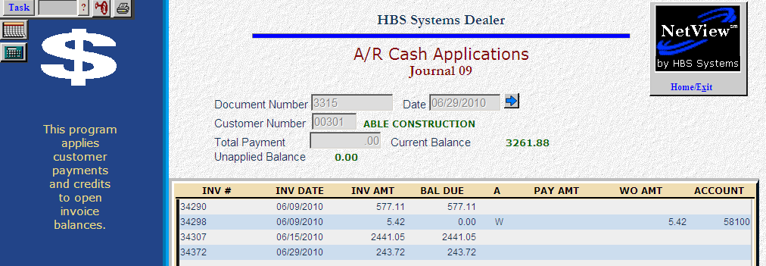

W-Write Off:

- To write off a full or partial invoice amount, put the cursor next to the invoice and type “W” in the Action Column. Then type the amount to be written off. Type the general ledger account number that will receive the write off money.
  - You may also type in the first number or two of the account number to look it up. Scroll through the list and click on the account number desired.
- This method can be used to write off finance charges from a customer’s account or other necessary adjustments.
- Remember that when writing off an amount, enter the dollar amount that is the same “sign” as the amount being written off. In other words, if you are writing off a positive (debit) amount, then your write off amount should be positive. Likewise, if you are writing off a credit amount, then your write off must be a credit amount, too.
- If you need to process a customer payment on an invoice AND write off part of that invoice, process the payment and post the journal for the payment. Then return to Cash Apps to the customer’s account and write off the necessary amount.
- We do NOT recommend that you write off amounts to an account with a subledger code!

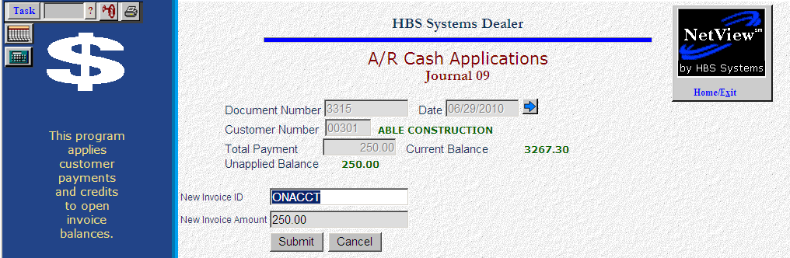

New Invoice Button: Press the New Invoice button if you need to apply payments to invoices not yet posted.

A pre-filled invoice of ONACCT is shown, but you can fill in your own invoice number in the New Invoice ID field.

The remaining amount will be pre-filled in the New Invoice Amount field or you can fill in an amount of your choice.

Press the Submit button to save the entry or Cancel to discard the entry.

The following screen illustrates how a new invoice looks on the customer’s account after you press Submit.

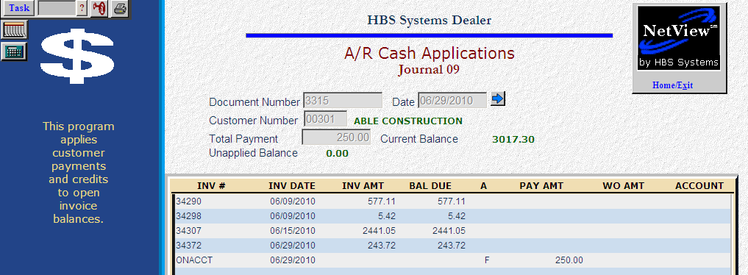

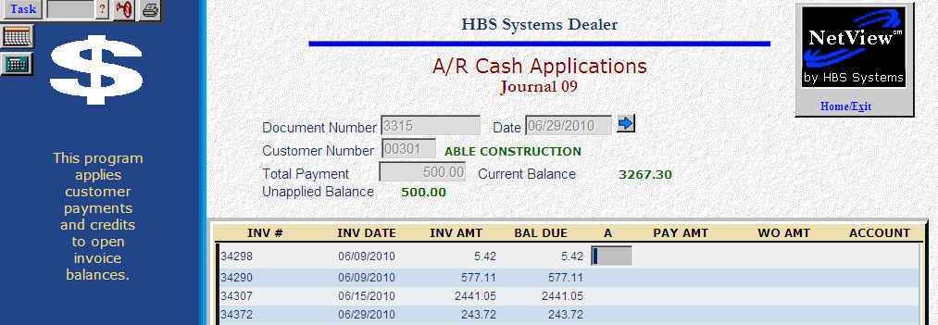

New Invoice – Multiple Invoices: The New Invoice field can be used more than once when you want to separate the payment received into multiple lines.

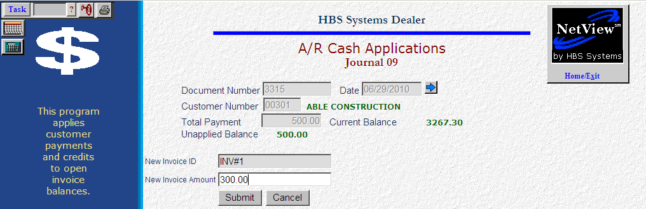

Fill in the first invoice number and amount and press “Submit.”

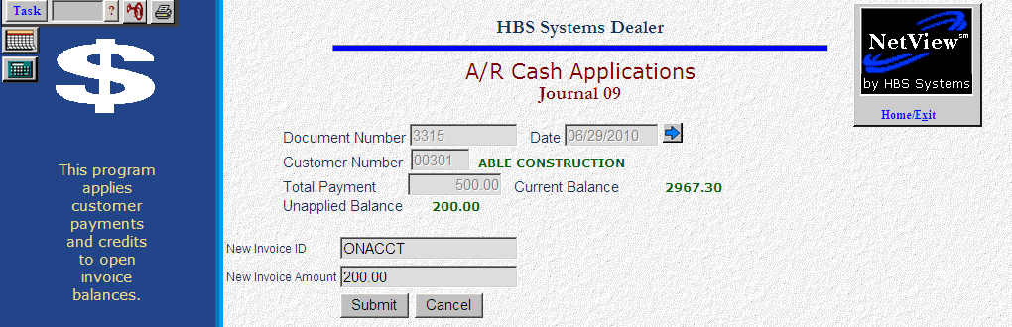

Then choose the New Invoice (Alt N) button again and fill in the invoice number and amount for the second invoice. Continue until all funds received are accounted for.

Void Document (Alt V): Use the “Void” button if you want to discard the transaction on the screen. You will be prompted to confirm that you want to abandon the document.

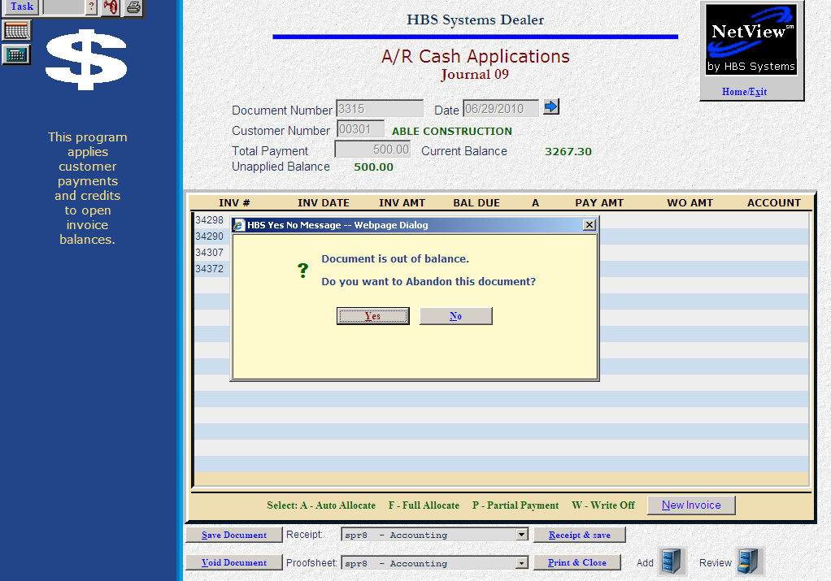

- Answer Yes or hit “Alt Y” to discard the document.
- Answer No or hit “Alt N” to return to the screen to make changes.

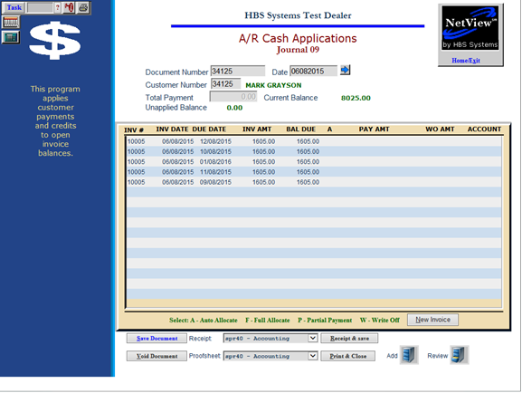

Finishing the Document:

When you have applied all the payment money, the Unapplied Balance will go to 0.

If your entries are correct, press the “Save Document” button or hit “Alt S” to save them.

You may continue to process more payments on account for other customers at this point.

Print & Close: Press the “Print & Close” button or hit “Alt P” to exit the screen.

Receipt & Save: Press the “Receipt & Save” button to generate a customer receipt for the payment.

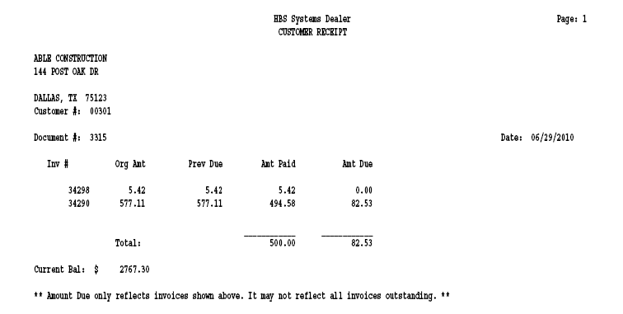

The receipt from CA shows the following:

- Customer
- Receipt document
- Date
- Amount of the payment
- Invoices paid by the payment

Editing Cash Applications Entries: You can edit previously entered payments in Cash Applications until they are journaled. To access an entry, type in the SAME document number, date, and customer number to see the entries as shown below. The box for Pending Cash Application Entries will appear. You have a couple of options at this point.

Change the Date: You may change the date on the pending transactions and then press either the “Save Date” button or “Alt S” to save the changes.

Void the Entries: You may void entries shown on the screen. Press either the “Void Entries” button or “Alt V” to discard them.

Close the Screen: You may keep the entries as they are. Press either the “Close” button or “Alt C” to leave the entries intact.

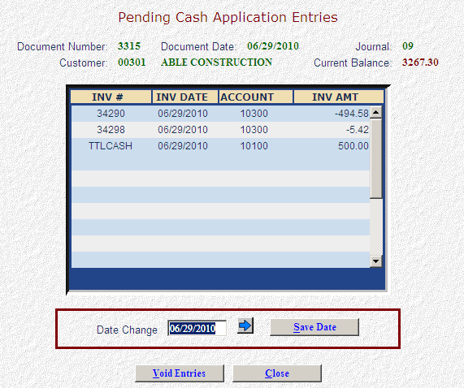
The line shown as TTLCASH stands for the total cash received.

Proof Sheet—Field Definitions: This proof sheet example above shows a transaction that was entered and later voided. Notice the lines where the description reads Voided.

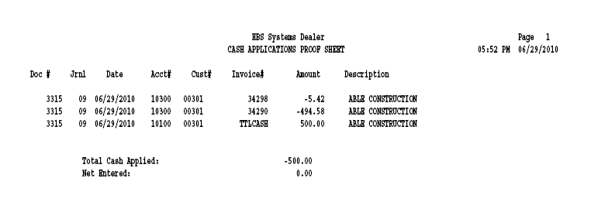

Doc #: This field shows the document number for the receipt.

Jrnl: This field shows the journal used for the cash application – 09.

Date: This field shows the date you entered on the transaction.

Cust#: This field shows the customer number used on the transaction.

Invoice#: This field shows the invoice number paid by the receipt. You may also see “TTLCASH” for the total cash applied for the transaction.

Amount: This field shows the amount receipted for this line of the transaction.

Description: This field shows the customer’s name for this line of the transaction. NOTE: If the transactions have been voided, this field will show “Voided” when the proof sheet is printed.

Printing Proof Sheets: To print a proof sheet, first save the document. Select the printer type you want from the drop-down menu next to “Proofsheet,” then hit “Print & Close.” The document will print and the program will close.

