Customer Address Labels (CAL)

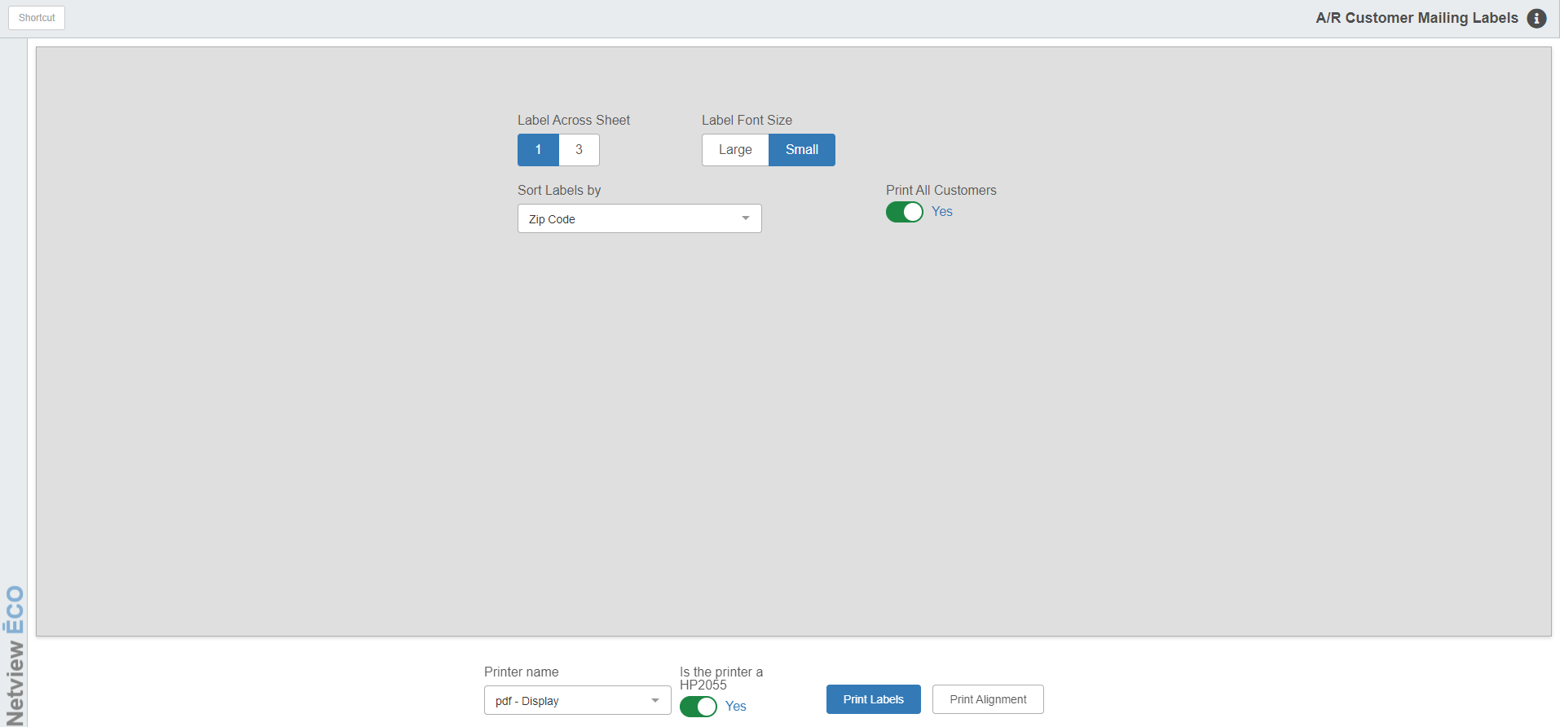

One of the ways your business can save money is to print your own mailing labels for direct mailers and correspondence to your customers. Customer Address Labels (CAL) is quite flexible and offers a number of ways to print the labels.

To access this function, you can either:

- Select “Accounts Receivable” from the menu and choose the “Memo Reports” submenu. Click on “Customer Address Labels.”
- Type “CAL” in the Shortcuts Bar.

You can use 1 up or 3 up laser labels (Avery 5160/5260). The label printing program also offers several options for sorting the labels that print. You may choose to print them by:

- Customer Name
- Customer Number
- State/Province
- Territory
- Zip/Postal Code (many post offices prefer if you bring bulk mailing items sorted by this)

Field Definitions:

Label Across Sheet: This is where you indicate how many labels run across the sheet you are using. Choose either the 1-across or 3-across style.

Label Font Size:

- Choose “Small” for condensed print.
- Choose “Large” for large print.

Sort Labels By: This question determines how the labels are sorted. Choose one of the following from the dropdown:

Zip Code/Postal Code (bulk mailings are often sorted in this order)

Customer Name

Account Number

State/Province

Territory

Print All Customers: Here you select which group of customers to print.

Choose “Yes” to print labels for ALL customers.

Choose “No” to select a group to print.

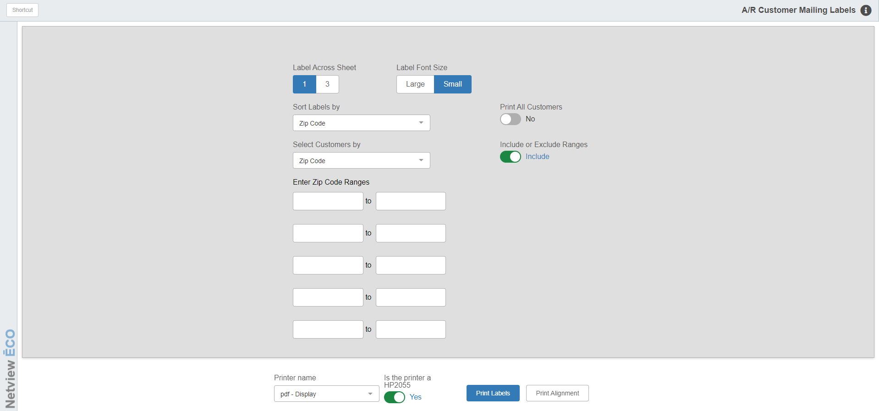

Select Customers by: This option becomes available if you select “No” on “Print All Customers.” You may choose the group to print the labels by the following:

- Customer Name
- Account Number
- State/Province
- Zip/Postal Code
- Territory

Include or Exclude Ranges/Enter Customer Ranges: This option becomes available if you select “No” on “Print All Customers.” Use it to choose what entries to include or exclude based on ranges of customers. You may enter up to 5 ranges to include or exclude from your selection of labels to print.

Printer Name: Select the printer to receive the printout. A default printer name is pre-filled, but can be changed as necessary using the drop-down menu.

Is the printer an HP 2055: Click this box if the printer is an HP 2055.

Print Labels: Press this button to start the report based on the selections you have made.

Print Alignment: Press this button to print a test alignment page to make sure your labels will print properly.

Sample Label Format—1-Up Style

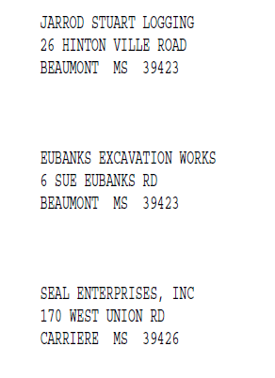

Sample Label Format—3-Up Style

