Customer Balance Inquiry (CB)

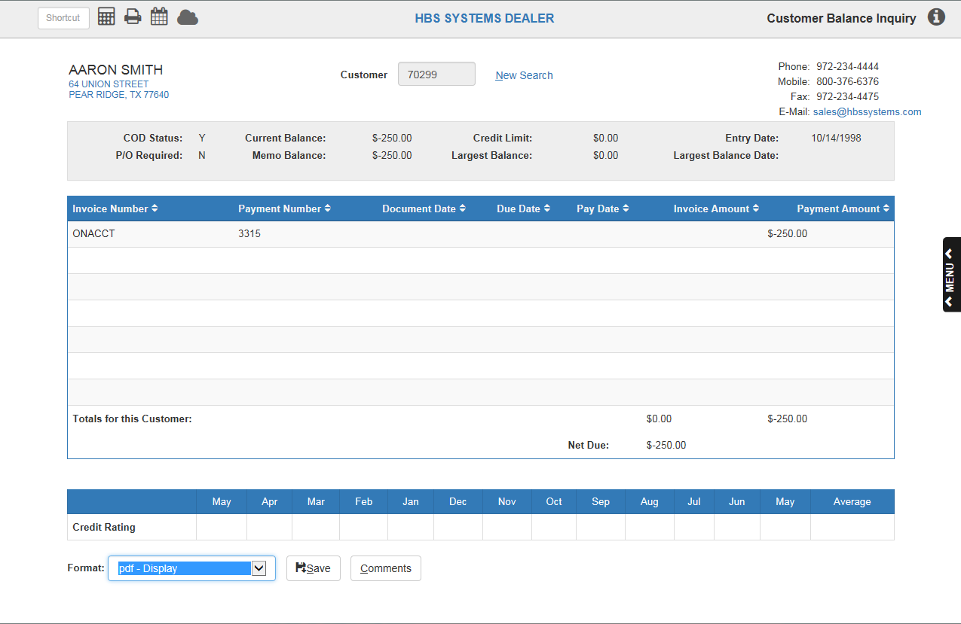

This inquiry screen provides general customer information and details of a customer’s outstanding A/R balance.

- To access this function, either:
  - Type the Hotkey B or “CB” into the Shortcuts Bar
  - Select “Accounts Receivable” from the menu and choose “Customer Balance Inquiry” from its submenu.

Field Definitions

Customer Search: Use the Customer Search field to find a customer’s entry in order to view their credit cards.

- Type either their customer number, name, or business name into the Customer Search bar above the information grid.
- Once you have found your desired customer’s entry, click on their name.
- The window will close and return you to the main screen, which will display the customer’s information.

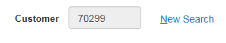

New Search: Click New Search to start a new customer search.

Customer Information:

The customer’s name and address will appear on the left.

The customer’s telephone number, mobile phone number, fax number, and email address will appear on the right.

If the customer’s email is highlighted in blue, then you can create a new email addressed to them by clicking on their email.

COD Status: This field shows if the customer has “charging” privileges for Accounts Receivable.

Y means CASH ONLY.

N means NOT on COD and has charging privileges.

P/O Required: This field shows if the customer requires a purchase order on an invoice.

- Y means they do.
- N means they don’t.

Current Balance: This is the customer’s Current Balance (posted/journaled total for the customer). It includes only transactions that have been posted from the Parts, Service, Units, and Rental invoicing routines and payments on account from Cash Applications and journal entries from GLED/ARDI.

Memo Balance: This is the customer’s Memo Balance. This up-to-the-moment balance includes the posted balance (Current Balance) plus the un-posted entries made through POS and ROM invoicing or Cash Applications.

Credit Limit: This field refers to the maximum amount of credit extended to this customer.

Largest Balance: This field holds the amount of the Largest Balance the customer has had on their A/R account. This amount is updated when A/R Month End (statements) is run.

Entry Date: This field holds the date that the customer number was added to your system (the date they began doing business with your dealership).

Largest Balance Date: The field holds the date that corresponds to the Largest Balance field. This date is updated when A/R Month End (statements) is run.

Field Definitions

Invoice Number: This column shows the Invoice number for the detail shown. If the invoice number is blue, click it to display a copy of the original invoice from Point-of-Sale, Service, and Rental.

Payment Number: This column shows the Payment number or Document number of a payment for the detail shown.

Document Date: This column shows the Document Date for the original invoice or the payment shown.

Due Date: This column may show a date if the Future Billing option was used.

Pay Date: This field shows the date of the payment referenced on this detail line.

Invoice Amount: This column shows the amount of the original invoice.

Payment Amount: This field shows the amount of payments to the invoice shown. Each payment made will appear on a separate line.

Totals for this Customer: This field shows the totals for amount paid and total charges for this customer.

Net Due: This field shows the balance due.

Credit Rating: This series of fields gives the monthly Credit Ratings over the past year and an average for the customer. The system uses an alphabetical rating system with A that stands for current standing, B as 30 days past due, C as 60 days past due, and D as 90 days past due. This information is updated by A/R Month End.

Format: Select the printer to receive the printout. A default printer name is pre-filled, but can be changed as necessary using the pull down menu.

Save/Print: This button’s appearance depends on the type of printer you have selected.

Save generates a printout for the information you see on the screen.

Print button lets you actually print the report.

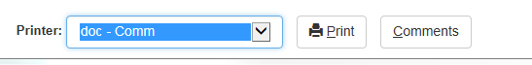

Comments: This button gives access to any comments entered about this customer. If there are existing comments for the customer on the screen, the button is darkened so you know this info is available.

