Custom Customer Maintenance (CCM)

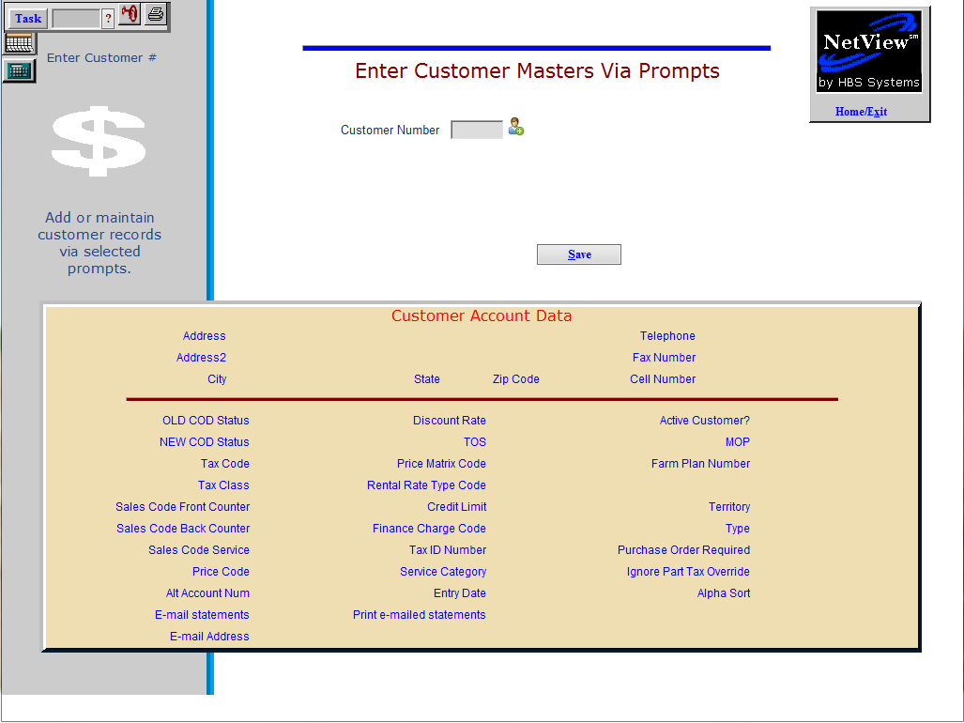

This Maintenance screen provides a fast way to add new customer numbers or edit existing ones. It works with the fields you select with Select Custom Prompts (ARCP).

- To access this function, you can:
  - Type “A” or “CCM” in the Shortcuts Bar.
  - Use New Customer add routines in POS and Unit Invoicing.
  - Select “Accounts Receivable” from the menu and choose the “Data Entry” submenu. Click “Custom Customer Maintenance.”

Field to Field Movement

- To move between fields, use:
  - The “Enter” key
  - The “Tab” key
  - The mouse.
- To return to the previous field, you can also use “Shift-Tab.”

Save (Alt S): This button and its corresponding shortcut keys save a new customer record or any changes made to an existing record.

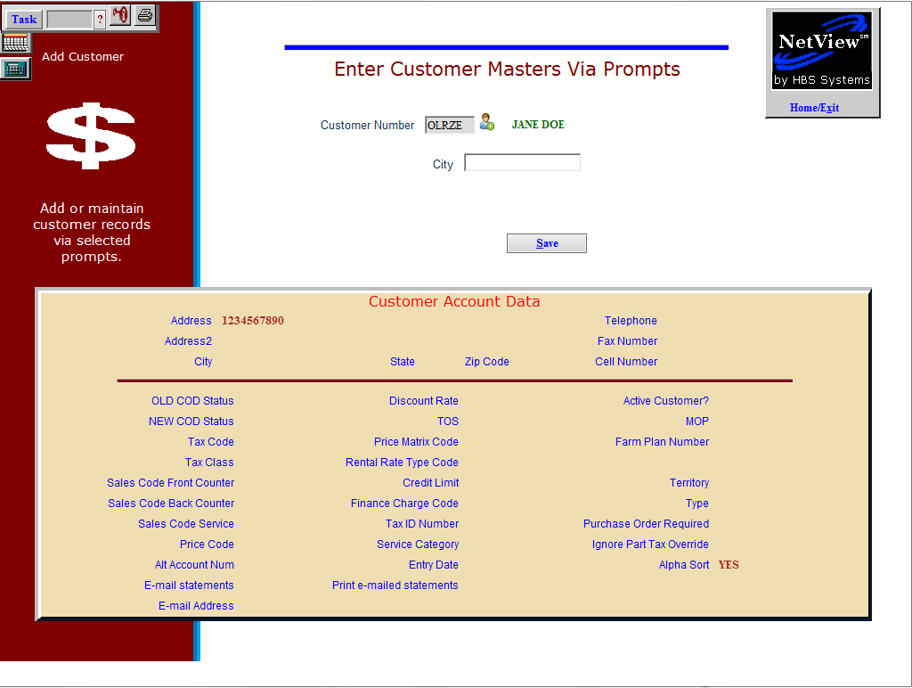

Creating Customers

Creating Customer Numbers: You can create a new customer number by either:

- Typing in the desired number in the Customer Number field.
- Clicking the “Add New Customer” icon to the right of the field.
  - This method ensures a unique number.
  - Click the icon again to generate a different number.
  - The number can be alpha-numeric, depending your system settings.

Entering Information: From that point on, you will be prompted for the fields selected in ARCP (Select Custom Prompts). As you fill in each field, the details appear in the box in the lower portion of the screen.

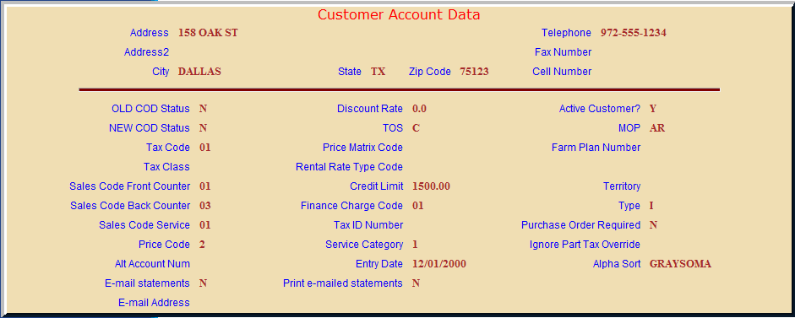

Editing Customer Entries: When you edit an existing customer number, the box is pre-filled from the information in the Customer Master. That information is brought up field by field for editing based on the selections made in ARCP (Select Custom Prompts).

