Customer Equipment Maintenance (CEM)

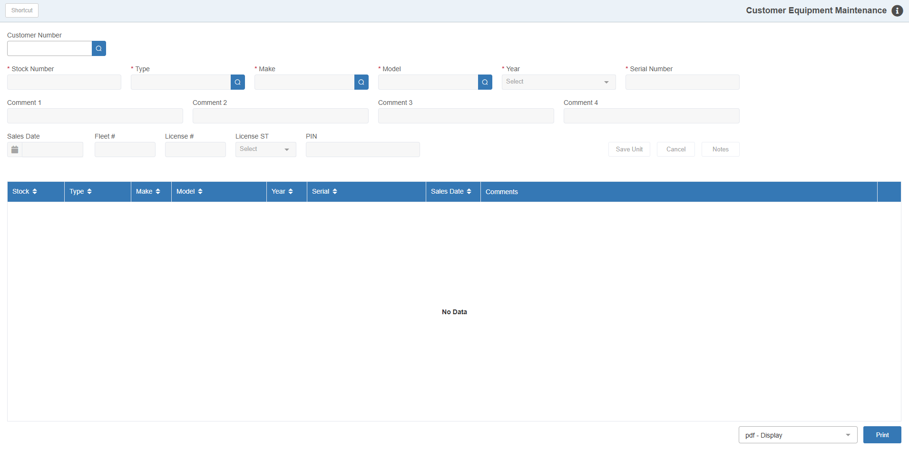

This application lets you track what equipment your customer base currently has. It will automatically be updated with all the units as you sell them through the system. The function stores and reads the information from the Units records on your system. It can access all the sales history records of units sold as well as the historical units entered here (“H” status in Units).

Other uses of and benefits to the application include:

- You can identify other equipment they have:
  - Units purchased from you before your current system
  - Units they have purchased elsewhere
  - Simply units they have
- When units are added in this maintenance program, a Units Master with Historical (H) status is created. These records become excellent sources of information about the inventory your customer base owns. If you would like to enter more information about any of the historical units entered, they can be accessed via Units Maintenance (UM).
  - If a customer decides to trade in one of these units, they can easily be taken as a trade in the typical Unit sales transaction via the Unit Sale (US) program.
  - You will already know model numbers and serial numbers when the customer comes to the Parts counter to make a purchase. You don’t need to ask them every time they come in what the specs are and you will always select the correct part number for the actual equipment they have.
  - When a customer brings the units into the shop for repair you can simply reference that stock number and build a full, detailed repair history for EACH unit they own.

To access this function, either:

- Select “Accounts Receivable” and choose the “Data Entry” submenu. Click on “Customer Equipment Maintenance.”
- Type “CEM” in the Shortcuts Bar.

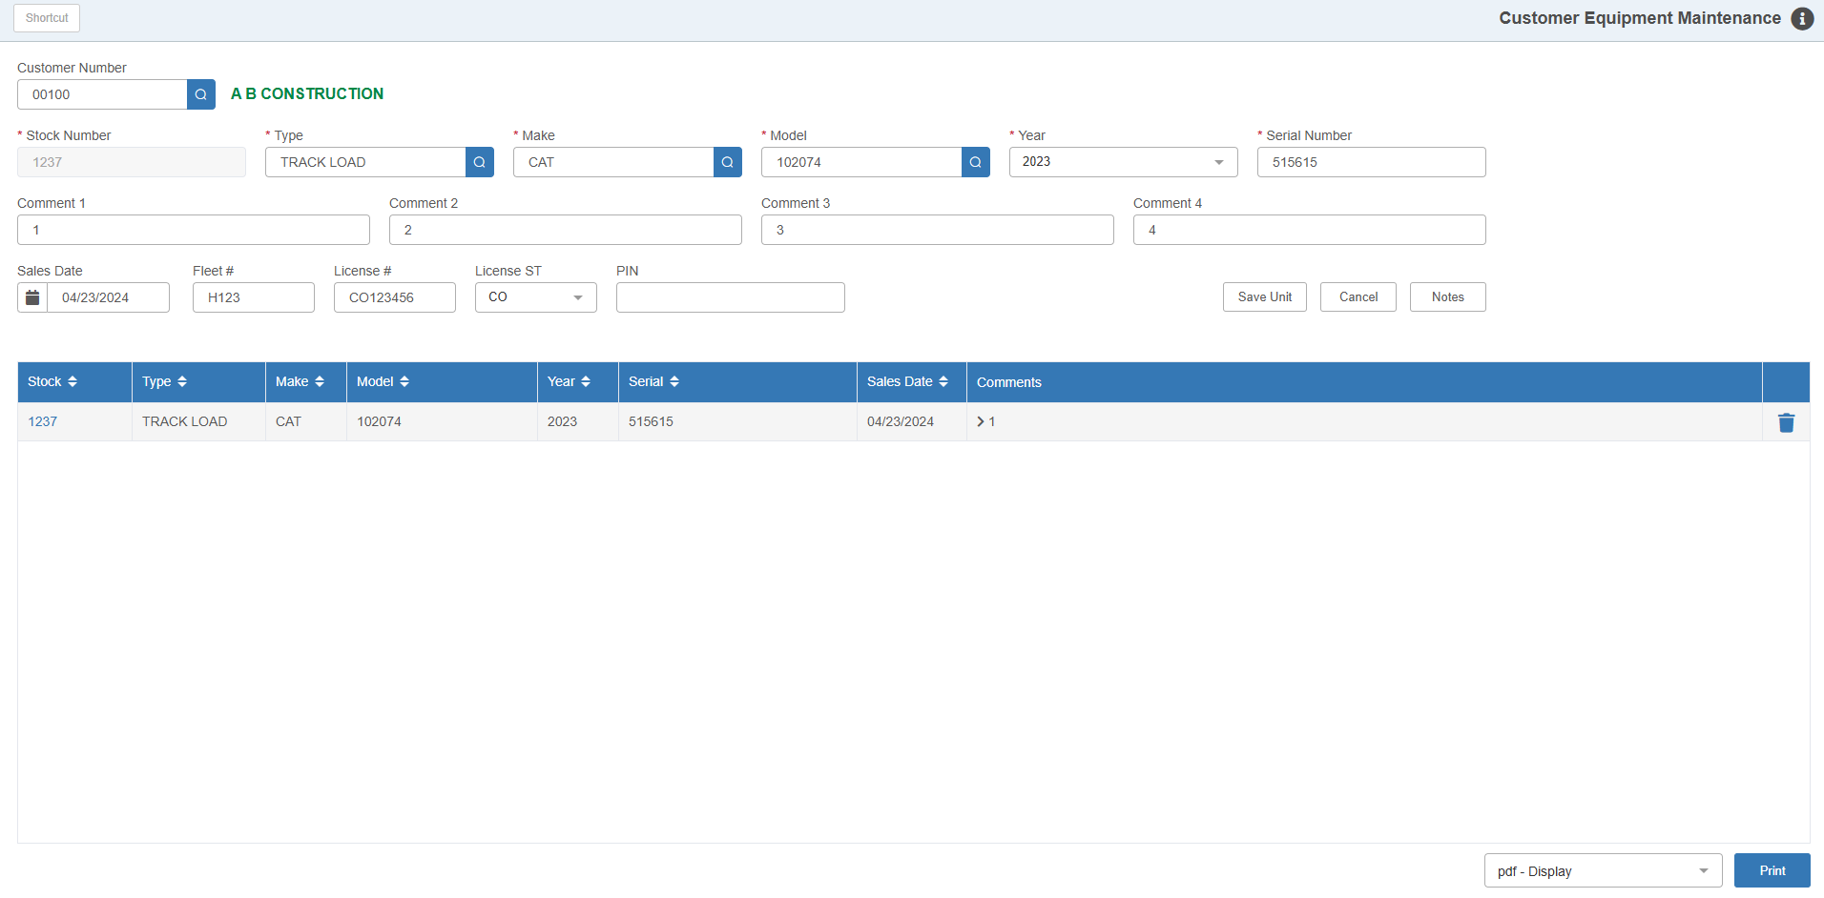

Field Definitions:

Customer Number: Type in a customer number or look it up using the Customer Search.

Stock Number: This field holds the stock number for this unit. The units shown here are units that may have been previously sold to the customer or those that the customer has acquired on their own.

Units sold to the customer through the system automatically appear here.

Other units that the customer has would have to be added on this screen.

Remember, any of these units can actually be taken as a trade-in on a Unit Sale.

System Stock Numbers: Some dealerships use the same stock number pattern for customer goods as regular inventory items. Others use the sequential number provided by the system. Press “Enter” to use the system-provided stock number for a new unit.

Type: This field lets you set the unit’s Type. Enter the type or use the Type Search to look up existing types recorded in the system. NOTE: You can add a new type in the Search window if the type you want to use doesn’t exist in the system.

Make: This field lets you set the unit’s Make, or manufacturer ID. Enter the make or use the Make Search to look up existing makes recorded in the system.

- You can add a new make in the Search window if the make you want to use doesn’t exist in the system.
- We recommend you keep your makes consistent with the manufacturer IDs used for your Unit Sources to align the pricing in the Sources with your actual units.

Model: This field stores the equipment’s Model number. Enter the model number or use the Model Search to look up existing model numbers recorded in the system. NOTE: You can add a new model number in the Search window if the type you want to use doesn’t exist in the system.

Year: This is the equipment’s Model Year. Enter the 4-digit year or select it from the dropdown. NOTE: If it is not known, you could use a consistent year like “0000” for all unknown years.

Serial Number: This field holds the unit’s main Serial Number.

Comment 1 – 4: Use these four optional lines for any special comments about the unit. This is a good place to add information that is helpful to you, like the customer preference in weight of oil, common oil, and fuel filters, repair preferences, characteristics of the unit, and so on.

Sales Date: This field is optional.

If a unit was sold through the system, it will show the date the customer purchased the unit from you.

If it is a historical unit, the date can be used to record any important date that relates to this unit or it may be left blank.

The arrow button to the right of the field offers a calendar for look-up.

Fleet #: This optional field can hold the customer’s fleet or ID number for the unit.

License #: This optional field can hold the license plate number of the unit.

License ST: This optional field can hold the state of the license plate. Enter the state abbreviation or select it from the dropdown.

Save Unit: Click this button to save the unit entry.

Cancel: Click this button to clear any unit information in the fields. NOTE: Any unsaved changes to a unit’s information will be lost.

Notes: Pressing this button opens Unit Notes (UN), where you can record comments on a particular unit.

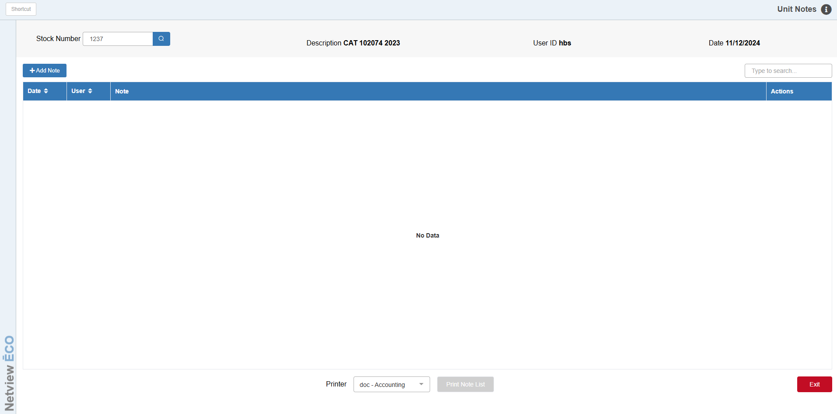

Grid Features: The grid lists out all the units belonging to the selected customer. Clicking on a unit in the grid will have its information fill in the fields above so that you can edit the unit’s information.

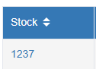

Stock # Links: If you click on the hyperlinked stock number, you can view the Unit Inquiry (UI) page for the unit.

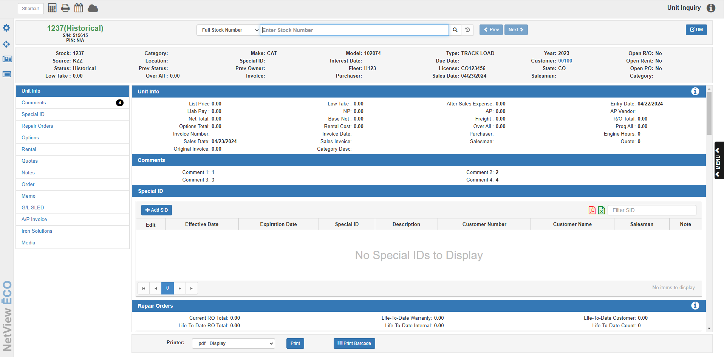

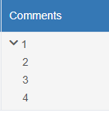

Comments: The “Comments” column will only show the Comment Line 1 by default. Click on the arrow in the column to view all 4 Comment Lines.

Delete: Click the 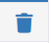 icon to delete the unit from the customer’s equipment record. An alert will appear asking if you are sure you want to delete the unit:

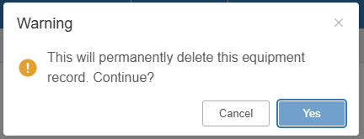

Click Yes to delete the unit. The alert will close and the unit will no longer appear in the grid.

Printing Customer Units: You can print a list of the customer’s units using the fields in the bottom right-hand corner of the screen.

Printer Name: Select the printer to receive the printout. A default printer name is pre-filled, but can be changed as necessary.

Print: Click this button to get a printout of this customer’s equipment.

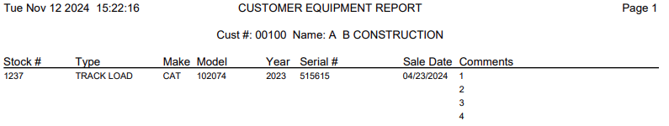

Field Definitions – Sample Customer Goods Printout:

Stock #: This field shows the Stock Number for the unit.

Type: This field shows the Type.

Make: This field displays the Make or Manufacturer.

Model: This field shows the Model Number.

Year: This field shows the Model Year.

Serial #: This field displays the main Serial Number.

Sale Date: This field may show:

The date the unit was purchased by the customer

Another date that is important to the unit

A blank

Comments: This area shows any comments entered for the unit.

