POS Screen-Customer Info Display

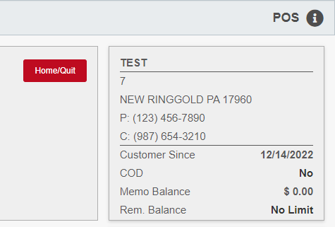

The Customer Info Display contains information about the selected customer. It appears in the upper right corner of the Point-of-Sale (POS) Screen.

Field Definitions:

Name: The customer’s name shows at the top of the display box.

Address: Two lines show the customer’s address, city, state, and zip/postal code.

P (Phone #): This field shows the customer’s primary phone number, it one exists.

C (Cell #): This field show the customer’s cell phone number, if they have one recorded.

Customer Since: This field shows the date the customer’s Master record was added to the system.

COD: This field shows if the customer is on COD (Yes) or not (No).

Memo Balance: This fields shows the customer’s current memo balance.

Rem. Balance: This field shows the customer’s remaining balance, if any.

