Customer ID Maintenance (CIDM)

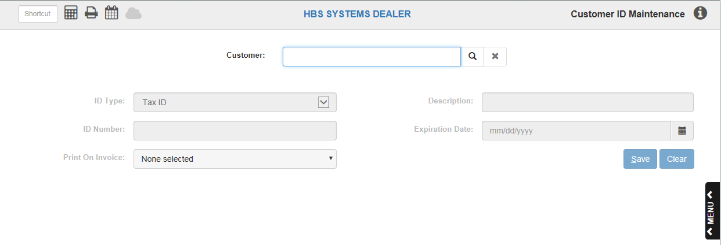

This maintenance screen, which is tied to the Texas requirement signatures for Ag & Timber tax exemption, stores additional Customer information:

- Tax ID
- Ag Certificate #
- Timber Certificate #
- Insurance Waiver
- Driver License #
- Other ID.

To access this function, either:
- Select “Accounts Receivable” from the menu, then choose the “Data Entry” submenu. Click “Customer ID Maintenance.”
- Type “CIDM” in the Shortcuts Bar.

Field Definitions

Customer/Search Customer: This field holds a unique five-digit number for this customer. You may type in a customer number or look it up.

To look it up:

Type in as many characters of the customer’s name or the business name. Any information you enter searches the Customer Name field for any matches.

The search results are sorted in Alpha Sort order. Here are a couple of examples of how the search works:

If you type in “Bruno” in the Customer Number field and there is only one customer named “Bruno,” the fields would automatically fill with that customer’s information.

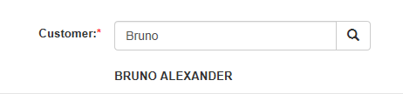

    - But generally, if you type in a name, like “ROGER,” in the Customer Number field, you will get all customers who have that name somewhere in the Customer Name field:

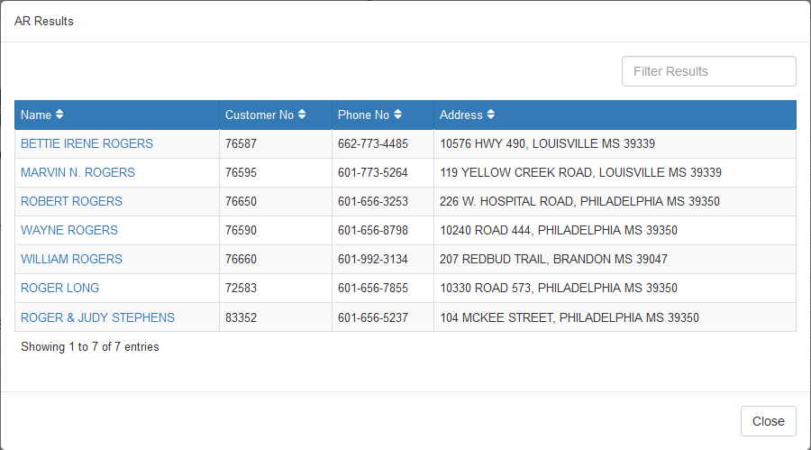

    - Similarly, if you type in “D &” (that’s “D<space>&”), you would get all customers who have either the letter “D,” the symbol “&,” or both in the Customer Name field:

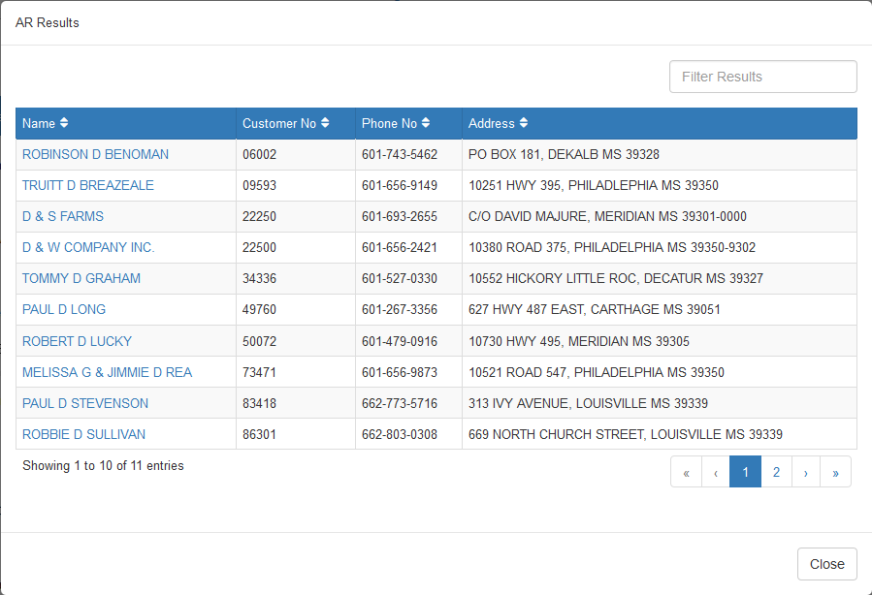

- A few words of advice: if you type in just a letter or two in the search field, you will probably see many more matches than you want because you will get all the names that contain the letter(s) somewhere in the Customer Name field, as with the example immediately above.

ID Type: Choose the type of ID from the drop-down menu. The choices are:

Tax ID

Ag Certificate #

Timber Certificate #

Insurance Waiver

Driver License #

Other ID.

Description: Fill in a brief description of the ID.

ID Number: Enter the number for the ID: driver’s license #, tax exemption #, etc.

Expiration Date: Enter the expiration date for the ID.

Print on Invoice: Choose which invoicing programs should print this ID on the invoice. Please note that these printing options are only available to dealerships located in Texas at this time. The active choices are:

POS

Service

Units

Save: Press this button to save the ID and any changes you have made.

Clear: Press this button to clear the entry.

