POS Screen-Customer Info Tab

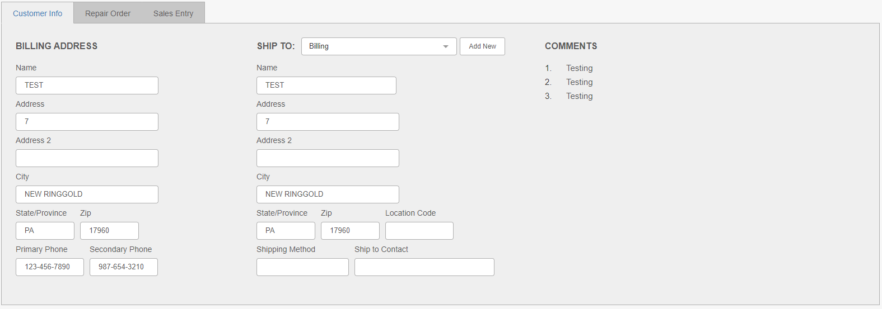

The Customer Info tab contains information about the selected customer, namely their billing (Bill To) and shipping (Ship To) details.

Field Definitions—Billing Address:

Name: This field shows the customer’s name.

Address: This field shows the customer’s address

Address 2: This field provides a second address line in case additional information is required, like a suite or apartment number.

City: This field shows the customer’s city.

State/Province: This field shows the customer’s state or province.

Zip: This field shows the customer’s zip or postal code.

Primary Phone: This field shows the customer’s primary phone number, if one exists.

Secondary Phone: These fields show the customer’s secondary phone number, generally their cell phone number, if one exists.

Field Definitions—Ship To Address:

Ship To: Select which Ship To address you want to use for the customer, if any. If you do not want to include a Ship To address on the ticket, leave the field set to None.

Add New: Click this button to open Customer Ship To Address Maintenance (ECSA) and add a new Ship To address for the customer.

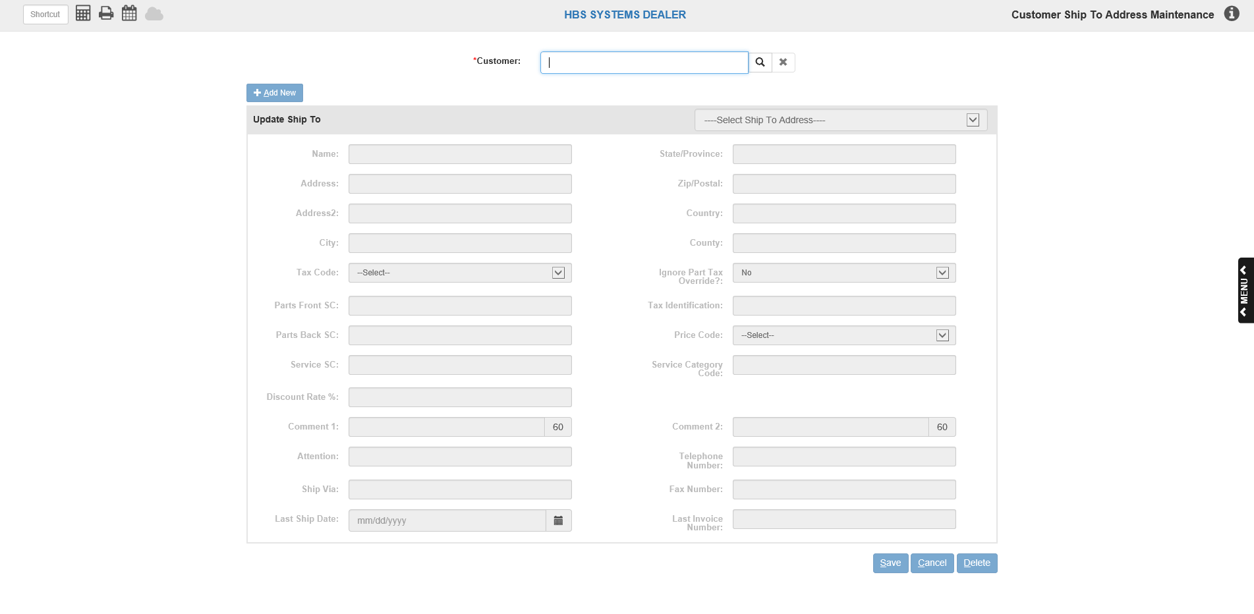

Once you save the new address and return to POS, it will be available for selection in the Ship To dropdown.

Ship To Name: This field shows the name of the individual identified with that shipping address (not necessarily the customer).

Ship To Address: This field shows the Ship To address.

Ship To Address 2: This field provides an additional Ship To address line in case more information is required, like a suite or apartment number.

Ship To City: This field shows the Ship To address city.

State/Province: This field shows the Ship To address’s state or province.

Zip: This field shows the Ship To address’s zip or postal code.

Loc Code: This field shows the Ship To address’s location code, if applicable.

Shipping Method: Here you can enter a shipping method preferred by the customer.

Ship To Contact: This field allows you to specify a contact name at the Ship To address. For example, if the address name is that of a company, the contact could be a specific individual at the company who is to receive the merchandise.

Comments: Any comments for the customer will be listed on the far right side of the tab. Additionally, the comments will appear in a pop-up box that will automatically display after you select the customer in the Header:

