Checked In with a Balance Due Report: The Checked In with a Balance Due Report in Rental Reports (RR) lists all rental contract segments that were checked in, but still have a balance due.

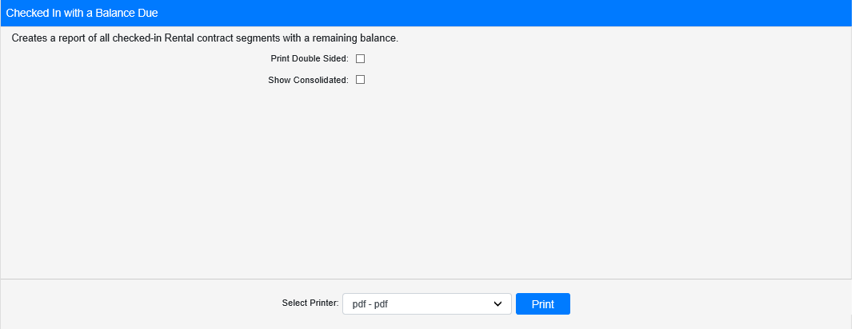

Field Definitions:

Print Double Sided:

- Check this box to print the report pages double-sided.
- Leave it unchecked to print the report pages single-sided.

Show Consolidated: If you are a multi-location dealership with a Consolidated location, check this box to include the Consolidated location’s information on your report. Uncheck it to only print a report for your individual location. NOTE: If running the report in the Consolidated location, you must check this box to receive a report.

Select Printer: Select the printer to receive the report. Use the pdf printer to preview the report.

Click “Print” to print the report.

Sample Report:

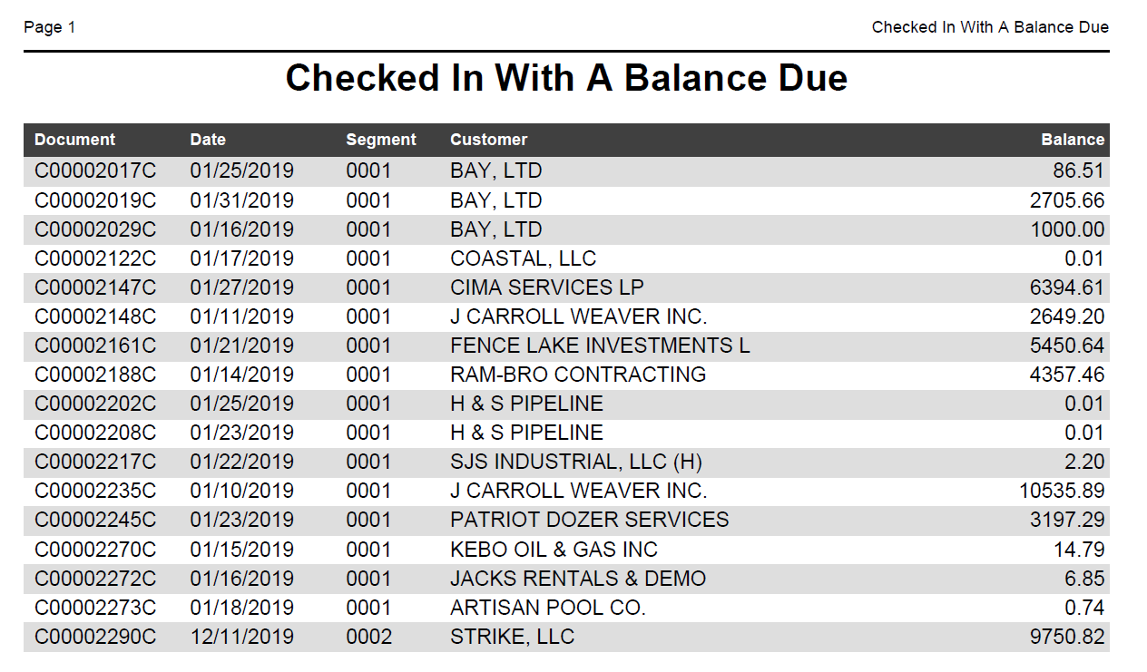

The report lists the following information for the relevant check-ins:

- Document number
- Date
- Segment number
- Customer
- Remaining balance

