Chart of Accounts (COA)

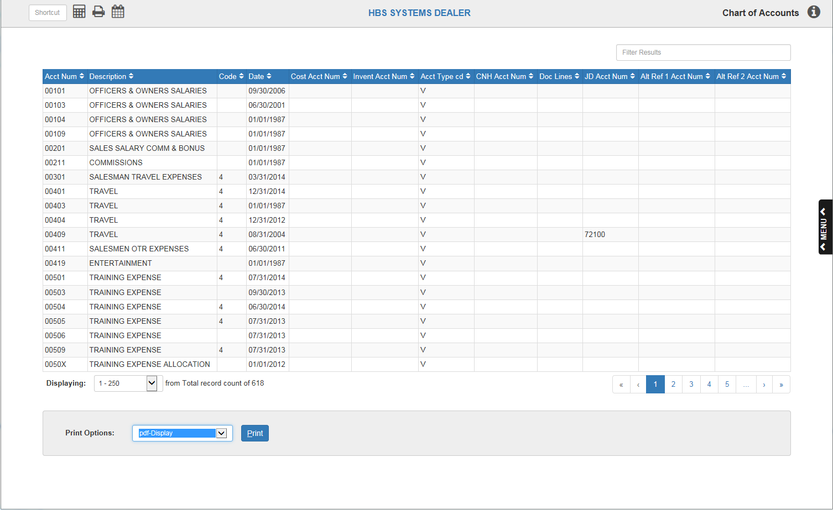

Print Chart of Accounts (COA) provides a printout or display of all account numbers defined in the General Ledger system.

- To access this function, you can either:
  - Select “General Ledger” from the menu. Choose the “Memo Reports” submenu and click “Chart of Accounts.”
  - Type COA in the Shortcuts Bar.

Application Features

Filter Bar: Use the Filter Bar to see a particular account entry by typing in information about that account indicated by the headers, like the account number or description. The Filter Bar will generate results for even partially-entered information, like half a date or a few letters.

Page Numbers/Scroll Arrows: Use the page numbers and scroll arrows to move between pages of entries.

- Click on a page number to jump to that page.
- Use the right and left single arrows to move forward or back a single page, respectively.
- Use the right and left double arrows to move to the first or last page of entries, respectively.

Displaying: Use the drop-down menu in this field to select the number of entries to display out of the total entries. The default allows to you look at only the first 250 entries.

Sortable Headers: Use the column headers to sort the entries in different orders. See the column definitions below for how the headers will sort the entries should you click them.

- Acct#: This column shows the account numbers.
  - Clicking the header once will sort the entries in ascending numeric order by account number.
  - Clicking the header again will sort the entries in descending numeric order by account number.
- Description: This column holds the descriptions of this general ledger account number.
  - Clicking the header once will sort the entries in alphabetical order by the first word of the description.
  - Clicking the header again will sort the entries in reverse-alphabetical order by the first word of the description.
- Code: This column shows any information entered. It could contain a code used by the system for formatting of the Standard Financial Statement or a Subledger Code.
  - The Subledger codes include:
    - 0—Balance Forward at Month End (by Document Number) - not commonly used
    - 1—Balance Forward at Month End (by Control Number) – not commonly used
    - 4—Detail Preserved Through Month End (by Document Number) – not commonly used
    - 5—Detail Preserved Through Month End (by Control Number)
    - 8—Register Format with Balance Forward at Month End (by Document Number) – not commonly used
    - 9—Register Format with Balance Forward at Month End (by Control Number) – not commonly used
  - Clicking the header once will sort the entries in ascending order by code.
  - Clicking the header again will sort the entries in descending order by code.
- Date: The Date column holds the date each account was last affected by a month end closing process. The dates may vary from account to account. This variation is due to the fact that not all accounts have activity each accounting period and thus are only affected when there has been activity during the accounting period being closed. You may also see “01/01/1987” in this field for accounts that have not been used.
  - Clicking the header once will sort the entries in chronological order by date.
  - Clicking the header again will sort the entries in reverse-chronological order by date.
- Cost Acct#: This data appears only for Sale Accounts (those that have a first digit of 3). When the account number is a sale account, this column holds the corresponding cost account. For example, if the account number shown is 32001, the cost account field will show 52001.
  - Clicking the header once will sort the entries in ascending order by cost account number.
  - Clicking the header again will sort the entries in descending order by cost account number.
- Invent Acct#: This data appears only for Sale Accounts (those that have a first digit of 3). When the account number is a sale account, this column holds the corresponding inventory account. For example, if the account number shown is 32001, the inventory account field will show the corresponding account (perhaps 12001).
  - Clicking the header once will sort the entries in ascending order by inventory account number.
  - Clicking the header again will sort the entries in descending order by inventory account number.
- Acct Type cd: This column holds a series of codes that are used to format the financial statement. These codes will vary based on the type of account and tell the system where to place this account on the standard financial statement.
  - Clicking the header once will sort the entries in ascending and/or alphabetical order by this code.
  - Clicking the header again will sort the entries in descending and/or reverse-alphabetical order by this code.
- CNH Acct#: This field is used primarily for CNH Dealers who submit their financial statistics to via their communications package. In this case, the CNH account number is placed here to cross reference your chart of accounts to the selections available in the CNH chart of accounts.
  - Clicking the header once will sort the entries in ascending order of offset account number.
  - Clicking the header again will sort the entries in descending order of offset account number.
- Doc Lines: This column shows four possible line numbers where this account appears on the Daily Operating Control report (DOC).
  - Clicking the header once will sort the entries in ascending order of the line number(s).
  - Clicking the header again will sort the entries in descending order of the line number(s).
- JD Acct#: This column is primarily used by John Deere dealerships for mapping their chart of accounts for financial submission.
  - Clicking the header once will sort the entries in ascending order by reference account number.
  - Clicking the header again will sort the entries in descending order by reference account number.
- Alt Ref 1 Acct#: This column is not currently being used.
- Alt Ref 2 Acct#: This column is not currently being used.

Printer Name: Identify the printer to receive your printout. A default printer is pre-filled, but you may change it as necessary. Use the PDF printer or the “see” printer to display the report.

Print: Click this button to print the accounts.

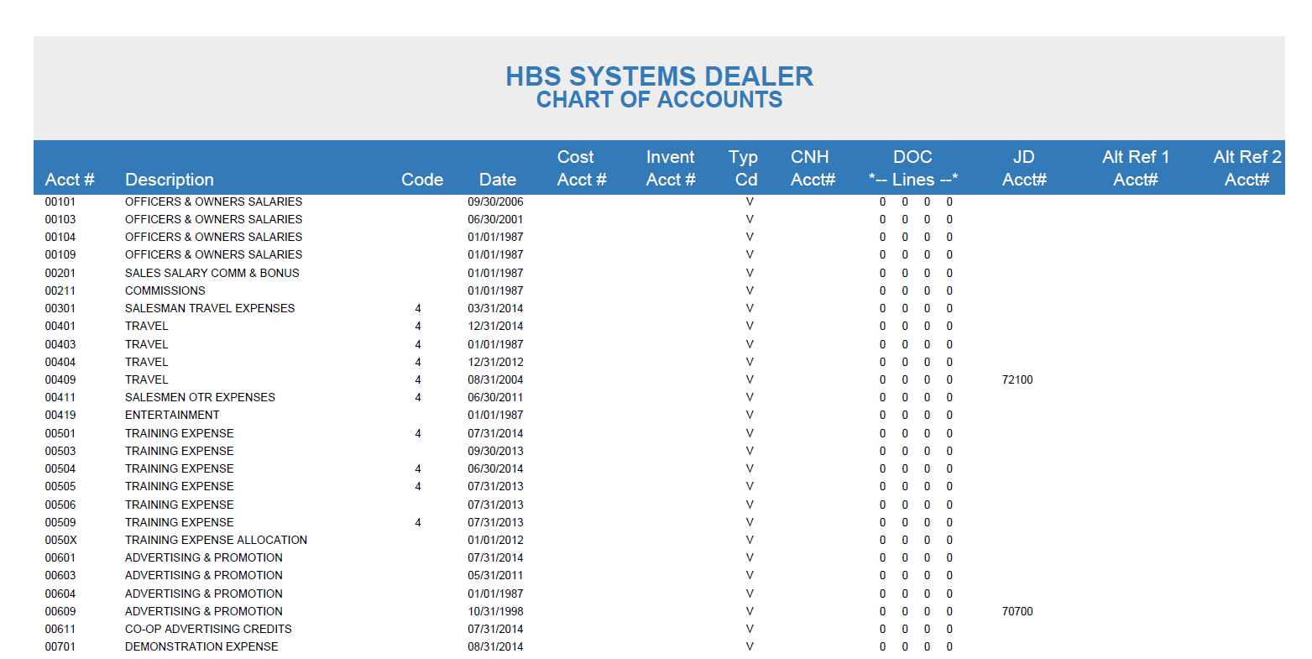

Report Entries

Acct#: This shows the account number.

Description: This area holds the description of this general ledger account number.

Code: This area shows any information entered in this field. It could contain a code used by the system for formatting of the Standard Financial Statement or a Subledger Code. The Subledger codes include:

- 0—Balance Forward at Month End (by Document Number) - not commonly used
- 1—Balance Forward at Month End (by Control Number) – not commonly used
- 4—Detail Preserved Through Month End (by Document Number) – not commonly used
- 5—Detail Preserved Through Month End (by Control Number)
- 8—Register Format with Balance Forward at Month End (by Document Number) – not commonly used
- 9—Register Format with Balance Forward at Month End (by Control Number) – not commonly used

Date: The Date field holds the date this account was last affected by a month end closing process. The dates may vary from account to account. This variation is due to the fact that not all accounts have activity each accounting period and thus are only affected when there has been activity during the accounting period being closed. You may also see “01/01/1987” in this field for accounts that have not been used.

Cost Acct#: This field is used only for Sale Accounts (those that have a first digit of 3). When the account number is a sale account, this field holds the corresponding cost account. For example, if the account number shown is 32001, the cost account field will show 52001.

Inv Acct#: This field is used only for Sale Accounts (those that have a first digit of 3). When the account number is a sale account, this field holds the corresponding inventory account. For example, if the account number shown is 32001, the inventory account field will show the corresponding account (perhaps 12001).

Type cd: This field holds a series of codes that are used to format the financial statement. These codes will vary based on the type of account and tell the system where to place this account on the standard financial statement.

CNH Acct#: This field is used primarily for CNH Dealers who submit their financial statistics to via their communications package. In this case, the CNH account number is placed here to cross reference your chart of accounts to the selections available in the CNH chart of accounts.

Doc Lines: This area shows four possible line numbers where this account appears on the Daily Operating Control report (DOC).

JD Acct#: This field is primarily used by John Deere dealerships for mapping their chart of accounts for financial submission.

Alt Ref 1 Acct#: This field is not currently being used.

Alt Ref 2 Acct#: This field is not currently being used.

