Company Name & Address; Misc. Info (CONA)

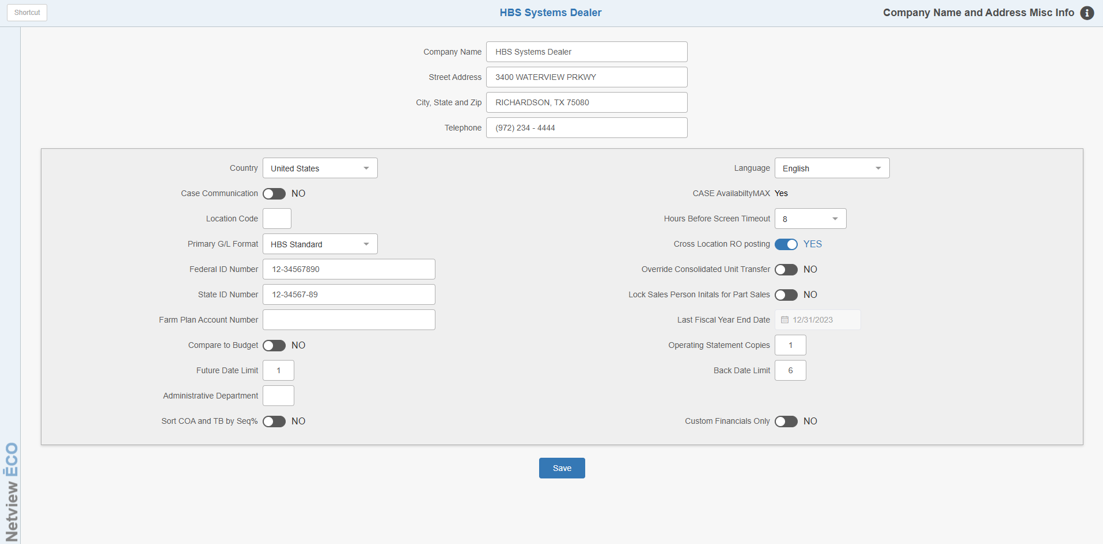

Company Name and Address; Misc Info (CONA) keeps a variety of information. Most of the data kept here impacts the business or system as a whole.

To access this function, you can either:

Select “System Maintenance” from the menu. Choose the “Company File” submenu and click “Company Name/Address.”

Type “CONA” in the Shortcuts Bar.

Screen Fields:

Company Name: In this field, enter the name of your dealership as it should appear on printouts and on the top of the menus. For a multi-location dealer, this should be the name of the specific location this version of CONA will manage.

Address: In this field, enter the exact street address of your dealership location.

City, State and Zip: In this field, enter the name of the city, state, and correct zip code where your dealership is located.

Telephone: Enter the company phone number. For a multi-location dealership, this may be the phone number for the specific location.

Country: In this field, choose United States or Canada. This field changes various field names and menus for Canadian dealerships.

Language: This field shows the language currently in use. English is the current available selection.

CASE Communications: This field was previously used strictly for Case communications. It should be set to No at this point.

Case AvailabilityMAX: This field indicates that the Case AvailabilityMAX interface to CNH is active for the dealer location.

Location Code: This field is part of the set-up for a multi-store system. In the case of a multiple locations, an identification code will be entered here to indicate the location. For example, a number or letter could be shown here to indicate the actual location.

Hours Before Screen Timeout: This setting is active for all NetView users. It holds the preference for clearing record and screen locks for idle screens on your system. You may choose any number of hours from 8 to 24. This choice tells the system to release the records held on idle screens once the number of hours specified is reached. The default setting is 8.

Primary G/L Format: This field defines any special accounting formats. Usually, it is set to “HBS Standard.”

Federal ID Number: This field holds the Federal Payroll ID Numbers for US dealerships.

State ID Number: This field holds the State Payroll ID Number for US dealerships.

Farm Plan Account Number: This holds the Farm Plan number assigned to your dealership if you accept Farm Plan cards from your customers.

Cross-location RO Posting: This setting offers a choice of how the accounting is handled for multi-location dealers that process repair orders for equipment that belongs to other locations.

- Choose Yes to allow Internal Repair Orders to post across locations (Store A does a setup on a unit for store B and closes the RO. It then “debits” store B’s inventory account while giving the credit for labor and parts sales to Store A.)
- Choose No to prevent Internal Repair Orders from posting across locations (Store A does a setup on a unit for store B and closes the RO. It then “debits” the Invalid account in Store A and gives the credit for labor and parts sales to Store A.)

Override Consolidated Unit Transfer: This is a multi-location setting. For most multi-location dealerships, this setting should stay No. Consult with a member of the HBS Support Team before changing this setting.

Lock Sales Person Initials for Part Sales: This option offers the ability to have the Salesperson ID in POS locked in to the ID associated with the user login, in the case that the dealership location has a salesperson database set up. This means that when you log in, your Salesperson ID in POS is pre-filled and unchangeable. To turn on and lock the Salesperson ID, choose Yes. Otherwise leave it as No. Once activated, it will read the Salesperson ID associated with the user login in Salesperson Maintenance (SLSM).

Compare to Budget: This field refers to the use of budget figures on various accounting reports. Budget figures are entered by individual account in the G/L Account Number Maintenance (ANM) program.

Select Yes to have any previously entered budget figures appear on selected accounting reports.

Choose No to leave the budget comparison off.

Last Fiscal Year End Date: This field indicates the last Fiscal Year End your dealership has closed. It is a system-maintained field that is updated when the G/L Fiscal Year End (GLYE) program is run. This field cannot be edited by anyone other than HBS Systems employees.

Operating Statement Copies: This field indicates how many copies of the Operating Statement you wish to print when closing an accounting month end. By using a number other than 1, you can save time by automatically printing copies for your CPA, department managers, Board of Directors, etc.

Future Date Limit: This field accepts the number of months into the future you want to allow before needing to enter a password.

We recommend that you use “1” for this choice. By limiting your future entries to one month, you can eliminate incorrect future dated payments in Cash Applications and limit the posting of future dated entries in the G/L and A/R Journals.

A zero or blank in this field means there is no date limit set.

Back Date Limit: This field limits the dates entered PRIOR to the current date. This limit applies to entries made in Cash Applications (CA) and the G/L & A/R Journals. The field accepts the number of months prior to the current date you want to allow before needing to enter a password.

- We recommend that you enter a number of months no larger than the number of accounting months you usually keep open. By limiting your prior dated entries to that number, you can eliminate incorrect prior dated payments in Cash Applications and limit the posting of prior dated entries in the G/L and A/R journals.
- A zero or blank in this field means there is no date limit set.

Administrative Department: This field is primarily used for International Truck dealers. It is used to indicate which department number is associated with the administrative department.

Sort COA and TB by Seq #: This question refers to the “Sequence Code” field in ANM (Account Number Maintenance).

- If values have been added to the field, then it is very likely that setting should be Yes so that the Chart of Accounts (COA) and Trial Balance (TB) sort by the provided sequence codes. This setting is most commonly used by International Truck dealers.
- If no special sorting is required, the setting should be No.

Custom Financials Only: The recommended setting here is No. This field primarily applies to International Truck dealers, who are likely to mark “Yes” because of their extensive chart of accounts. If there are no special requirements, the setting should be “No.”

