Custom Parts Maintenance (CPM)

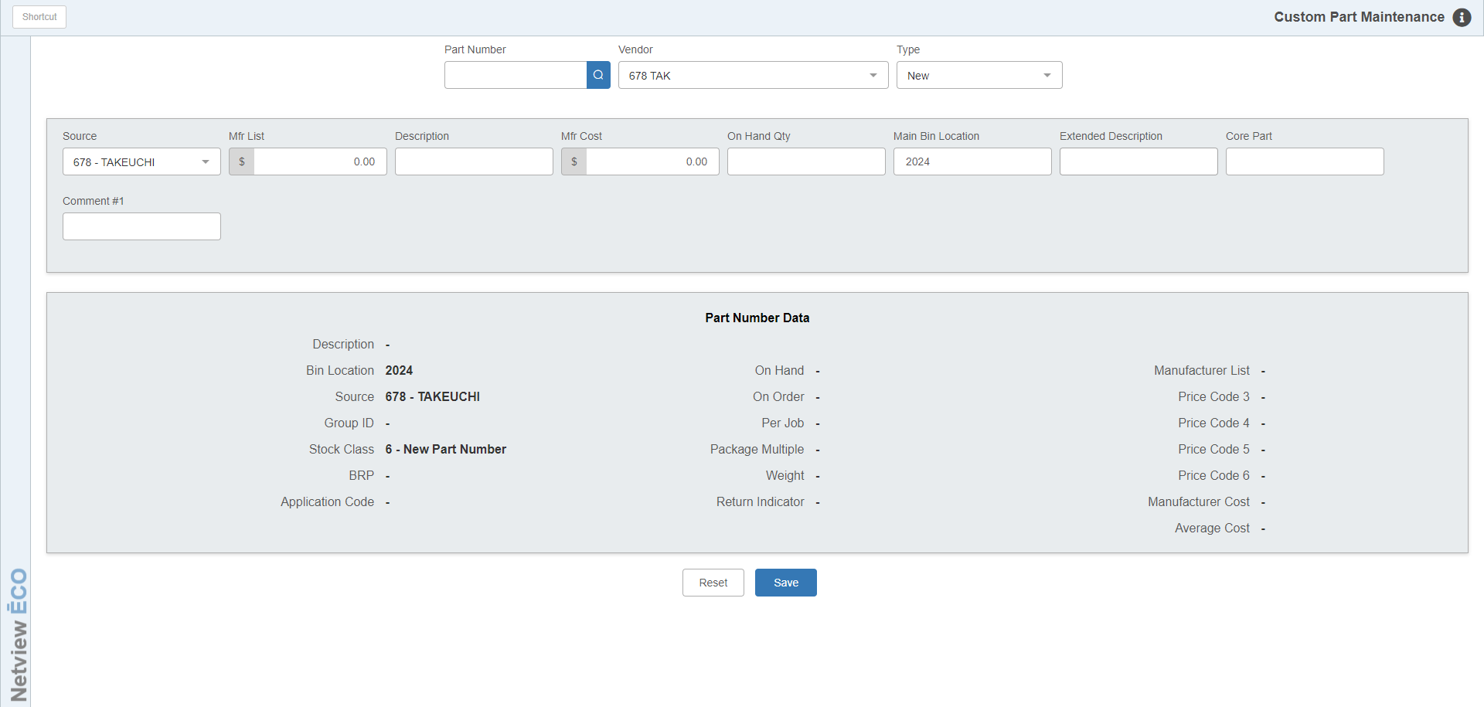

Custom Parts Maintenance (CPM) provides an easy way of adding new parts and maintaining existing parts. You may choose the data fields that best fit your inventory records from Select Custom Prompts (INCP). Once you have selected the fields you want to use when setting up new parts or editing ones, you may use CPM to add or maintain parts.

To access this program, either:

- Select “Inventory” from the menu and choose the “Parts/Source Update” submenu. Click “Custom Parts Maintenance.”
- Type “CPM” into the Shortcuts Bar.

Field Descriptions: The order in which the program’s fields display is set by you, the user, when you select them in INCP. The only fields that display automatically are:

- Part Number
- Vendor Number
- Type

Part Number/Vendor/Type Fields: Type in a part number and press “Enter.” If it is a new part number, you must select a Vendor and a Type for the part.

Selected Fields: The fields you selected with INCP appear next in the order you selected them. Fill in or modify the fields as desired.

Part Number Data: General information about the part displays on the lower portion of the screen as you work. If any of the fields shown here are part of your selected fields, then they will update along with any additions/changes you make in those fields.

Save: Press “Save” to add/save your changes.

Reset: If at any time before saving you realize that you need to undo something you’ve done, click this button to reset the part’s data to its previously saved state. Note that you must not save before trying to reset in order to restore the previous information. Once you save your changes, your prior saved data will be replaced.

