Order Merge (CPOR)

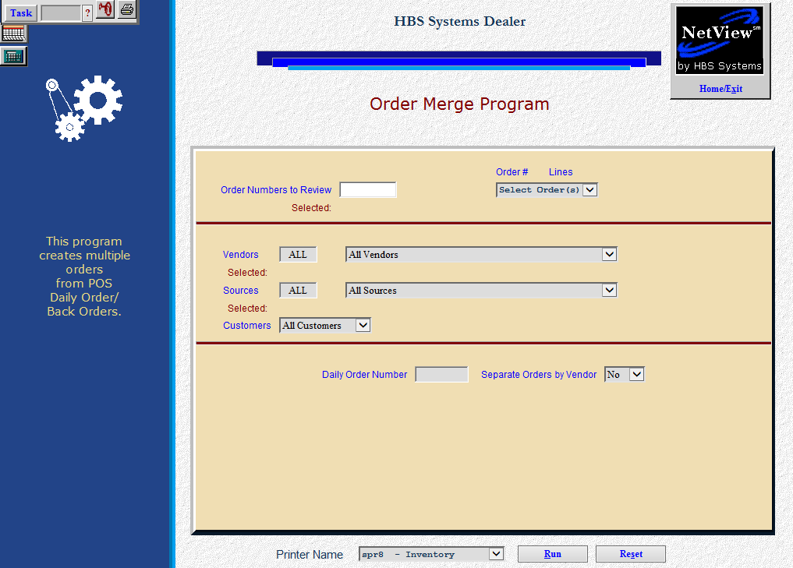

Customer POS Order Merge lets you merge up to 10 orders (orders from SSO, CSO, QOA, or customer orders from POS or ROM), change an order number, or separate those orders by vendor.

- To access this function, you can:
  - Select “Inventory” from the menu. Choose the “Orders” submenu and click “Customer POS Order Review.”
  - Type “CPOR” in the Shortcuts Bar.

Field Definitions

Order Numbers to Review: Type in the order numbers or choose them from the drop-down menu. Your selections will display as they are chosen.

Vendors: You can select “All Vendors,” or type in or select up to ten vendors from the drop-down menu.

Sources: You can select “All Sources,” or type in or select up to ten sources from the drop-down menu.

Customers: You can select “All Customers” or type in up to ten Customer Numbers to include.

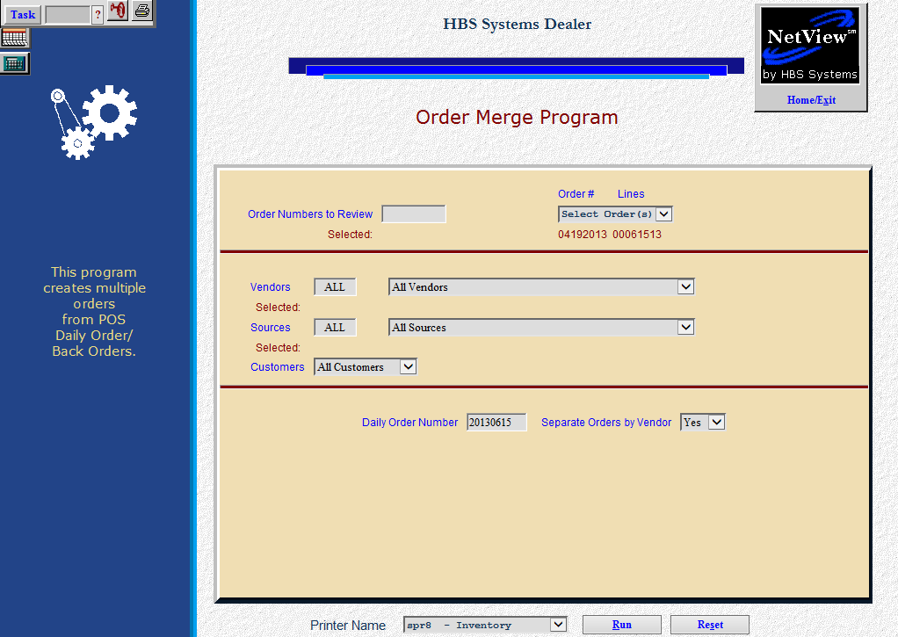

Daily Order Number: Enter the new order number that will replace the orders you specified. If you have several daily orders that have been entered from POS or ROM that used the same order number, such as the date of 06302013, you can separate those orders here by assigning them a new number such as 06301, 06302, etc.

Separate Orders by Vendor:

If you want the new order numbers separated by vendor, select “Yes.”
If you want all the vendor orders together on one order, choose “No.”

Orders Separated by Vendor

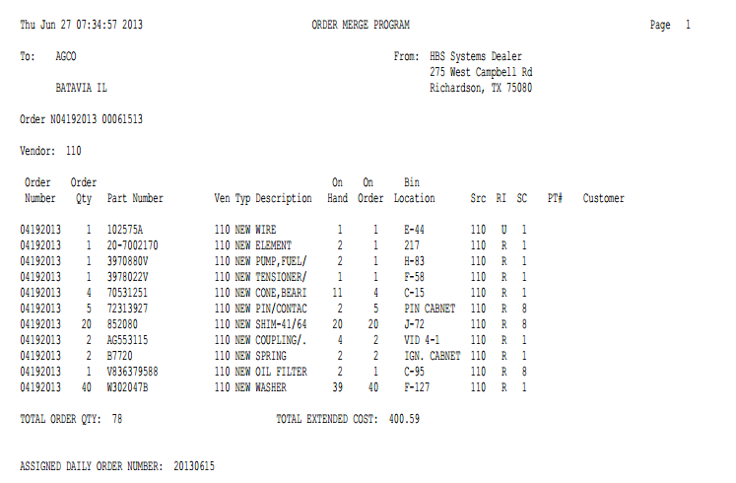

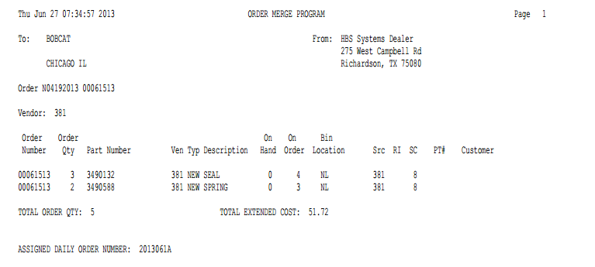

Above is the 2nd order pulled from the orders and below is the 3rd one pulled from the orders.

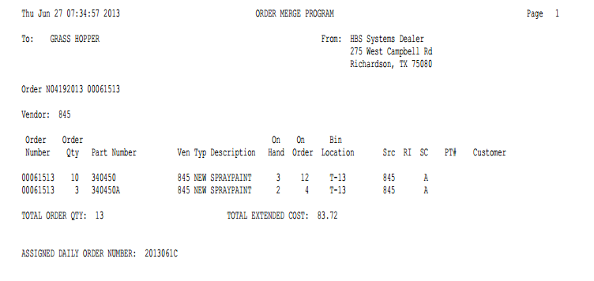

At the top of the new order you will see the specifications you selected from the setup screen, along with the vendor name, address, and vendor number, and your original order numbers. This report contains the following information:

Order Number: This is the ORIGINAL order number that was assigned in SSO, CSO, QOA, POS, or ROM. If you chose to separate the orders by vendor as shown above, only the original order numbers that apply to this vendor will be listed. Also, you will receive separate printouts for each vendor as shown.

Order Qty: This is the Order Quantity that was included in the original order.

Part Number: Here you will find the part number that was placed on the order.

Ven: This is the Vendor number for the part number on order.

Typ: This is the type of part for this part number from the part master. This could be:

New

Used

Core

Reman

Memo

Desc: Here you will find a description of the part from the part master.

On Hand: This is the current on hand quantity for this part number.

On Order: This is the total quantity of this part number on this order.

Bin Location: This is the primary bin location for this part number from the part master.

Src: Here you will find the Source Number for this part.

RI: This is the Return Indicator for this part from the part master.

SC: This is the Stocking Class for this part.

PT #: This is the Picking Ticket number from POS or the repair order number from SMS where the order was created.

Customer: Here you will find the name of the customer that the parts were ordered for when the order was created.

Total Order Qty: This is the total number of parts on this order (piece count).

Total Extended Cost: The total dollar amount of the order is shown here. It is the total of all the extended costs for all items on the order (order quantity times cost).

Assigned Daily Order Number: This number is the new order number that you assigned on the setup screen. It replaces the original order numbers.

Orders combined as vendor ALL

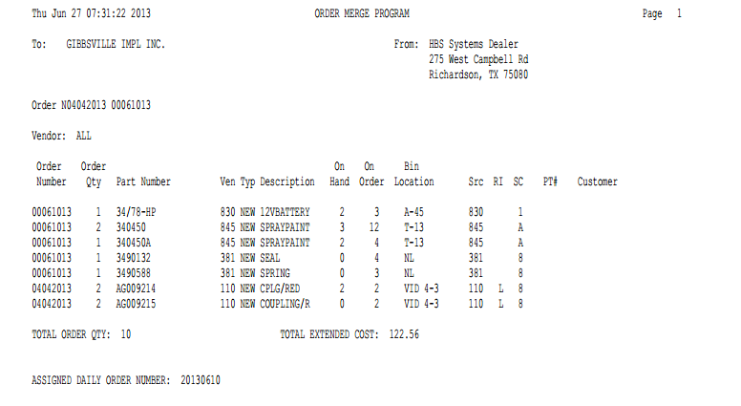

At the top of the new order you will see the specifications you selected from the setup screen, along with the vendor name, address, and vendor number, and your original order numbers. This report contains the following information:

Order Number: This is the ORIGINAL order number that was assigned in POS or SMS. If you chose to include all vendors as shown above, only the original order numbers that apply to this vendor will be listed and all orders will be combined in one printout.

Order Qty: This is the quantity that was included in the original order.

Part Number: Here you will find the part number that was placed on the order.

Ven: This is the Vendor number for the part number.

Typ: This is the type of part for this part number from the part master. This could be:

New

Used

Core

Reman

Memo

Desc: Here you will find a description of the part from the part master.

On Hand: This is the current on hand quantity for this part number.

On Order: This is the total quantity of this part number on this order.

Bin Location: This is the primary bin location for this part number from the part master.

Src: Here you will find the Source Number for this part.

RI: This is the Return Indicator for this part from the part master.

SC: This is the Stocking Class for this part.

PT #: This is the Picking Ticket Number from POS or Service where the order was created.

Customer: Here you will find the name of the customer that the parts were ordered for when the order was created.

Total Order Qty: This is the total number of parts on this order (piece count).

Total Extended Cost: The total dollar amount of the order is shown here. It is the total of all the extended costs for all items on the order (order quantity times cost).

Assigned Daily Order Number: This number is the new order number that you assigned on the setup screen. It replaces the original order numbers.

