Customer Parts Sales History (CPSH)

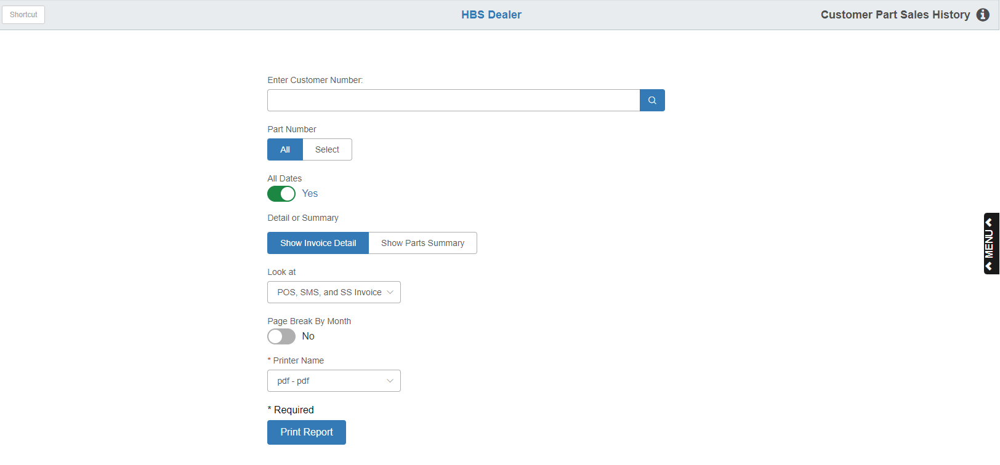

This report lets you track sales history per customer. You can choose:

- A Detail report which lists each part number per Invoice Number in the specified time frame.
- A Summary report that lists all the part numbers, quantity sold, and total dollars in the specified time frame.

To access the report, you can either:

Select “Inventory” from the menu. Choose the “POS History” submenu and click “Customer Part Sales History.”

Type “CPSH” in the Shortcuts Bar.

Field Definitions:

Customer Number: Enter the customer’s number or look it up.

Part Number:

- Choose All to include all part numbers for the customer
- Choose Select to enter a specific part number to examine.

Vendor: If you enter a specific part number, the vendor number associated with it will pre-fill. You can also select another vendor as needed.

Part Type: If you enter a specific part number, the part type is pre-filled from the Part master. You can also change it as needed. Possible types are:

New

Used

Reman

Core

Memo

All Dates:

- Set this option to Yes to include all dates on the report.
- Set it to No to set a specific date range for the report.

Select Date Range: This field only appears if you set “All Dates” to “No.” Enter the specific date range for the report or select it from a calendar.

Detail or Summary:

- Choose Show Invoice Detail to generate a detailed printout of activity by customer, which shows each part number on each invoice for the customer.
- Choose Show Parts Summary to get a list of part numbers the customer has purchased within the timeframe of the report.

Look At: The report can include information from Point of Sale (POS), SMS (historical), and NetView Service, or all three. It defaults to all three, but can be changed as needed.

Page Break by Month:

- Choose Yes to have the report page break when a new month of activity for the customer begins.
- Choose No to produce a continuous report of the customer’s activity.

Printer Name: Select the printer to receive the printout. A default printer name is pre-filled but can be changed as necessary. Use the pdf printer to view the report on the screen without printing a copy of it.

Print Report: Press this button to print your report.

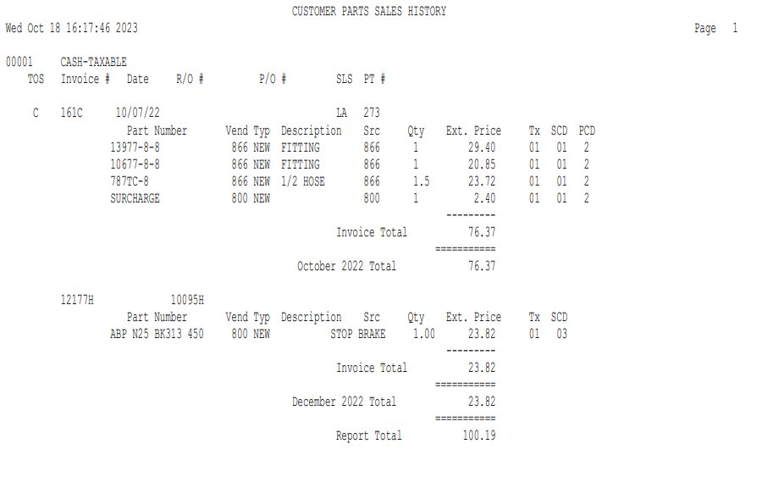

Detailed Report: The sample report pictured above shows all parts selected for the customer for the report period. This report contains the following information:

TOS: This column shows the Type of Sale:

C=Charge

$=Cash

F=Farm Plan

W=Warranty

I=Internal

A=American Express

V=Visa

M=MasterCard

D=Discover

E=Case

H=New Holland

G=Agri-Credit

L=Polaris

Invoice #: Here you will find the invoice number for the customer.

Date: The date shown is the invoice date.

R/O #: If the transaction was a repair order, the Repair Order Number will be shown here.

P/O #: If a Purchase Order Number was used on the invoice, it will be displayed here.

SLS: Here you will find the Salesperson’s initials or number.

PT #: This field will show the original Picking Ticket Number.

Part Number: Here you will see the part number(s) on this invoice.

Ven: This is the Vendor number for this part number.

Typ: This is the Part Type from the Part Master.

Description: This field shows the description of the parts sold.

Src: The Parts Source for each part number will show here.

Qty: This field holds the Quantity sold of the part number shown.

Ext. Price: This is the Extended Selling Price (Selling Price times quantity purchased).

Tx: This area shows the Tax Code used for this line of the invoice.

SCD: This area shows the Sales Code used for this line of the invoice.

PCD: This area shows the Price Code used for this line of the invoice.

Invoice Total: This is the total for the invoice listed.

Month Total: This is a total of all invoices for this customer for the month indicated.

Report Total: This is a grand total of all sales for the specified dates and part numbers.

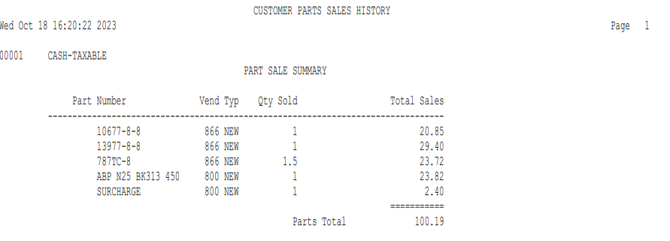

Summary Report Page: When you run the detailed version, a summary page is included which shows totals by part number, quantity sold, and total sales dollars. If you set the report to “Show Parts Summary,” you will receive only this page.

