CRM Dashboard (CRM)

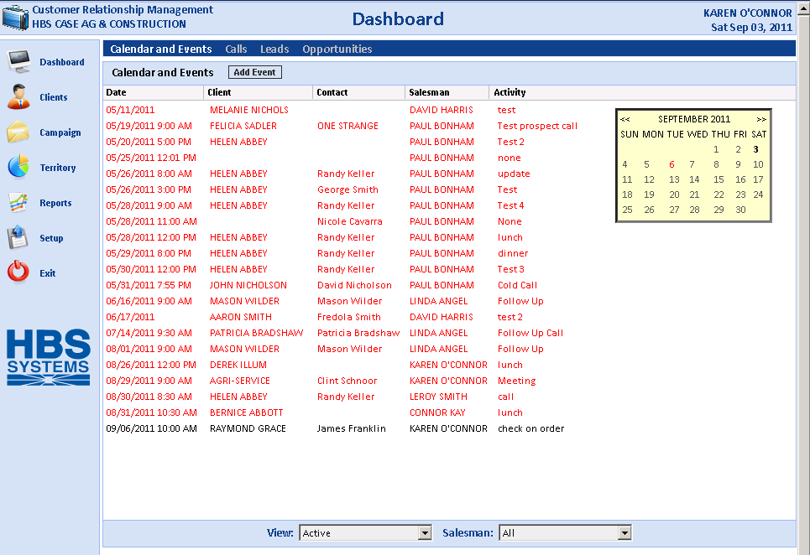

The Dashboard is the heart of the CRM product. It is the central hub that provides access to the Salesman's Calendar and Events, as well as other key features:

- Clients
- Campaigns
- Territories
- Reports

To access this function, you can either:

- Select “CRM” from the menu and click “CRM Dashboard.”
- Type “CRM” in the Shortcuts Bar.

The initial display is that of the salesperson's Event and Activity Calendar. Items in black are events that are for today or in the future. Items in red are those that are unfinished. The drop-down menus at the bottom control what events are displayed.

View: Choose from the following event types:

Active (those events that have not been completed)

Completed (events that are finished)

All (both Active and Completed events)

Salesman:

For an individual salesman, this defaults to that salesman's calendar and events.

For a sales manager, the dashboard can show the calendar and events for all salesmen, or for an individual one as selected from the drop-down.

