Cash Requirements Report (CRR)

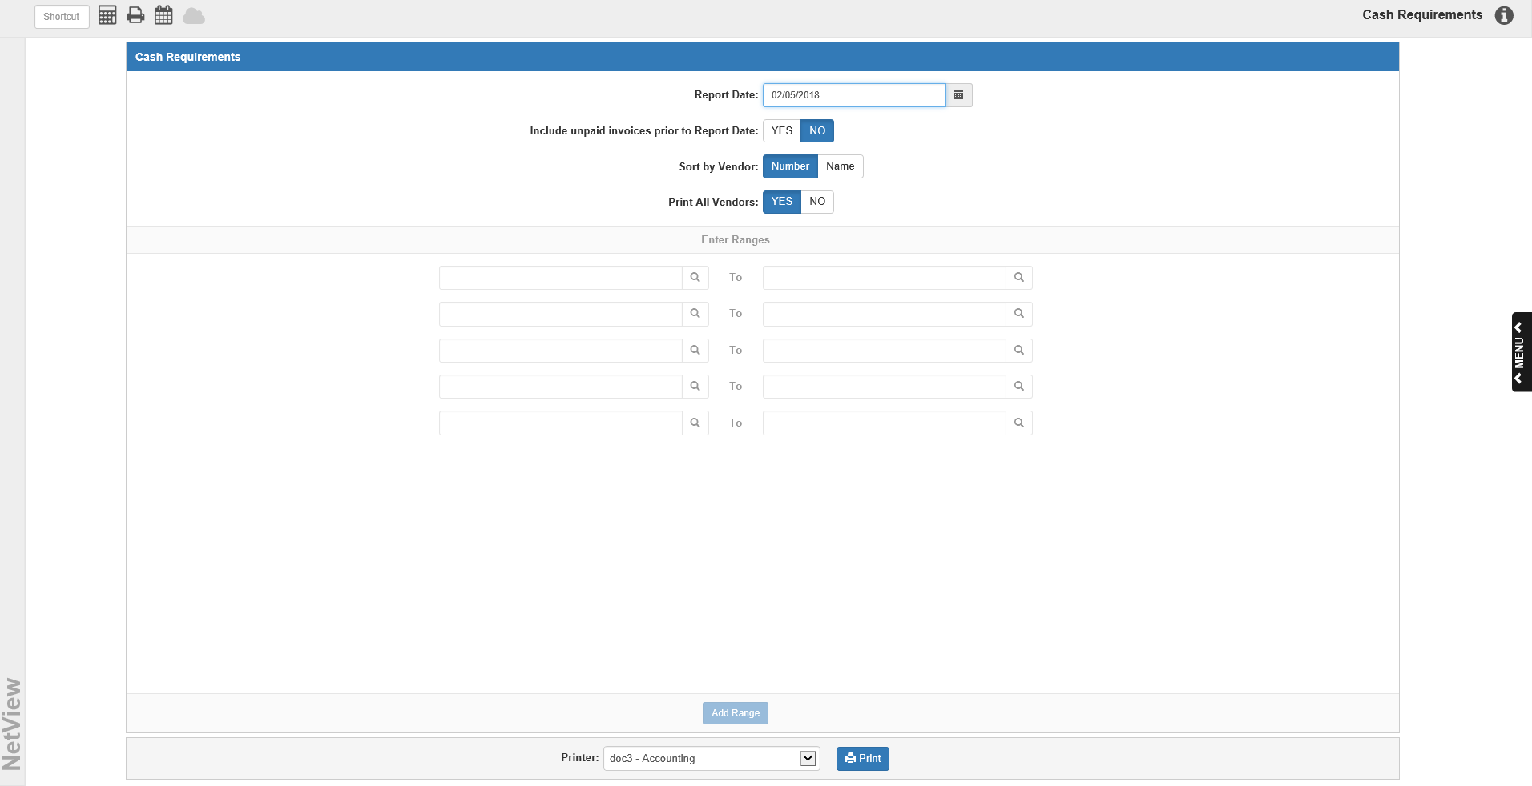

The Cash Requirements Report (CRR) project the total check amount needed to fully pay invoices with due dates within a four-week period. It lists all of the unpaid invoices for the selected vendors and calculates Vendor and Grand Totals for the report. The Cash Requirements Report also lists four columns that show payment due dates per each week within a month. Your selected report date determines these column dates.

To access this function, you can either:

- Select “Accounts Payable” from the menu and choose the “Memo Reports” submenu. Click on “Cash Requirements.”
- Type “CRR” in the Shortcuts Bar.

Field Descriptions:

Report Date: Enter the report’s starting date. The current date displays in this field by default. CRR includes all invoices that have a due date on or before this selected date, as well as all invoices that have due dates coming up within a four-week period of this date.

Include unpaid invoices prior to Report Date:

- Select Yes to have all unpaid invoices included on the report.
- Select No to have only unpaid invoices with due dates that fall into the four-week range of the report.

Sort by Vendor:

- Select Number to have the report sort by vendor number. This is the default selection for this field.
- Select Name to have the report sort alphabetically by vendor name.

Print All Vendors:

- Choose Yes to print invoice detail for ALL of your vendor accounts.
- Choose No if you are only interested in a single vendor account or in a range of accounts.

Enter ranges: You may enter ranges of vendors to include. Type a vendor number in the starting range field, or type all or part of the vendor name to search for it. Enter an ending vendor number in the ending range field to set the range. If you require more than 5 ranges for the report, click Add Range to add more ranges of vendors.

Printer: A default printer is pre-filled but you may change it as necessary. Use the pdf-Display printer to display the report on your screen. The report can also be directed to a spreadsheet. A sample is shown after the printed copy.

Press “Print” to generate the report.

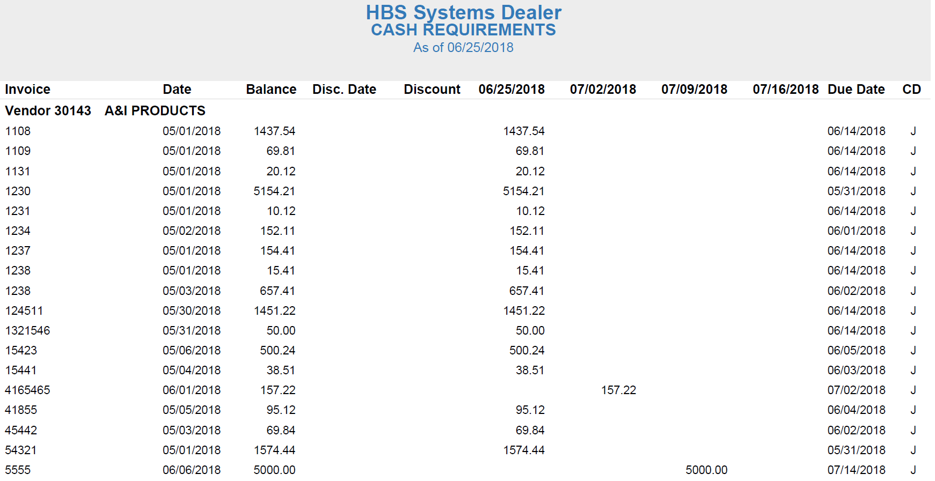

A/P Cash Requirements Printout: The Cash Requirements Report printout pictured above is sorted by vendor number. The vendor number and name are printed above a list of summary lines representing each of the vendor’s invoices.

Report Columns:

Invoice: The invoice number is printed under this column.

Date: The date that the invoice was written or received on is printed under this column.

Balance: This column prints the invoice’s remaining balance.

Disc Date: The date by which the invoice must be paid to receive a discount shows here.

Discount: This is the dollar amount of the discount if paid by the discount date.

Week 1 (The Report Date): This first column uses the report date as the starting point for separating out the remaining balances according to due date. The report reviews all open invoices. If an invoice has a payment due date before or on this date, or before the Week 2 date, the remaining balance prints in this column. The reason for including invoices with due dates several days beyond this column’s date is to help you pay the invoice on time. If the invoice amount printed under the next column, you might end up waiting for the Week 2 date to make the payment. The invoice would then be overdue making you liable for late and finance charges/fees.

Week 2: The second column shows all of the remaining balances for open invoices with a due date on this date or before the Week 3 date.

Week 3: The third column shows all of the remaining balances for open invoices with a due date on this date or before the Week 4 date.

Week 4: The third column shows all of the remaining balances for open invoices with a due date on this date or before a projected Week 5 date.

Due Date: This is the due date of the invoice.

CD (Code): The column displays the status of the invoice:

- E=Entered
- J=Journaled
- S=Selected
- P=Paid

Vendor Total Line: This line appears at the end of each vendor’s section on the report and calculates the total amounts due for this vendor account. It prints a total remaining balance, total discount amount (if applicable), and total weekly amounts (which is the distribution of the total remaining balance between Weeks 1, 2, 3, and 4).

Total Balance Line: This line appears at the end of the report, and calculates the total remaining balance, total discounts (if applicable), and weekly totals for the entire report by adding up all the vendors’ amounts.

Cash Requirements Report – Spreadsheet Sample: The report can be directed to a spreadsheet.

