Custom Stock Order (CSO)

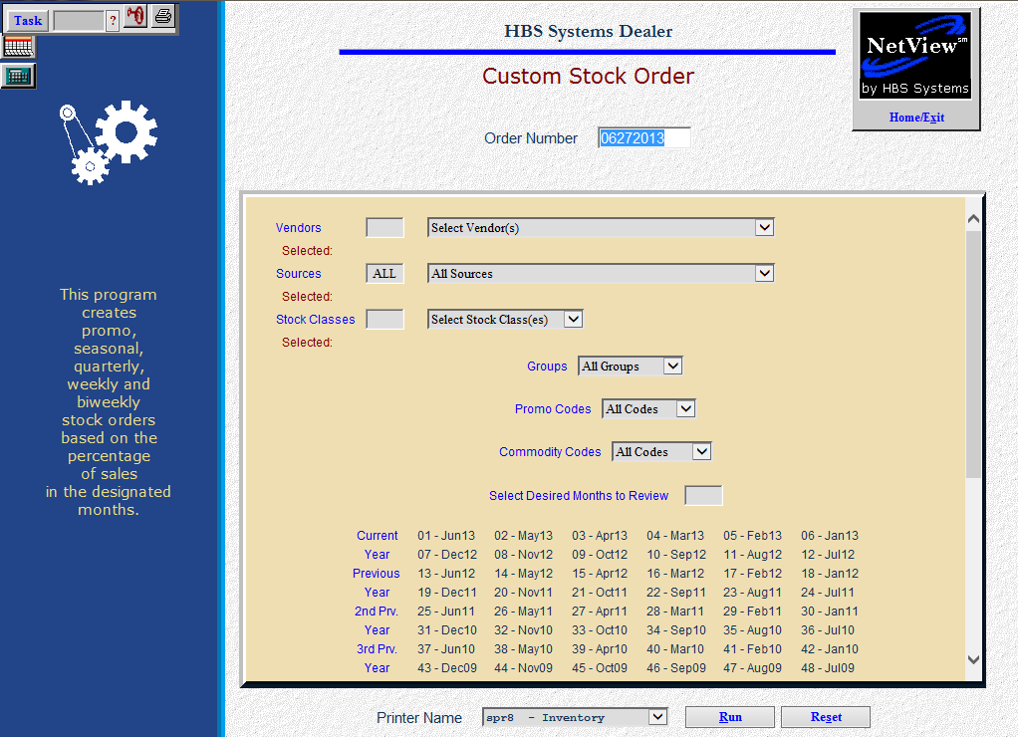

The Custom Stock Order program provides flexibility and control of the ordering criteria. This program does not use the calculated BSL and BRP figures, and does not update those fields in the part master. The formula bases order suggestions on the sales history of parts for the months of history that you select and the percentages you choose for generating quarterly, seasonal, promotional, annual, or weekly/biweekly orders. It provides the option to overstock (to take advantage of a promotional deal) or to under-stock (to conserve financial funds during slower periods).

- To access this function, you can:
  - Select “Inventory” from the menu. Choose the “Orders” submenu and click “Custom Stock Order.”
  - Type “CSO” in the Shortcuts Bar

Field Definitions

Order Number: The system will automatically pre-fill today’s date in this field. You can accept the provided order number or enter your own order number.

Vendors: Select “All Vendors” from the drop-down menu or choose/type up to 25 individual vendors. By including specific vendors, you can capture the parts for that vendor regardless of the source they are in. They will display on the screen as chosen.

Sources: Select “All Sources” or choose/type up to 25 individual sources.

Stock Classes: Choose which stock classes you want to examine. You can limit your order to specific stock classes or select ALL Stock Classes.

Common stock classes for ordering:
  - Stock Class 1=Fast moving parts or regular stocking parts
  - Stock Class 5=Seasonal parts
  - Stock Class 6=New parts with sales potential
  - Stock Class F=Dealer controlled or stocked by exception parts

Less frequently used stock classes for ordering:
  - Stock Class 7=Dealer-controlled or manually ordered parts
  - Stock Class 8=Non-stocking or slow moving parts
  - Stock Class 9=Slow moving or non-stocking parts
  - Stock Class U=Non-stocking parts ordered on emergency orders
  - Manual Stock Classes=2 3 4 B C D E G H I J K L M N O P Q R S TV W X Y Z

Never Used Stock Classes:
  - Stock Class A=Manufacturer use or “non-part” numbers

Groups: Here you can limit your order to specific Group ID codes. Some manufacturers provide ordering incentives with group codes. Select “All Groups” for ALL Group ID codes for the specified Vendor, Source, and Stock Class, or choose up to 25 ranges of individual Groups to limit the order.

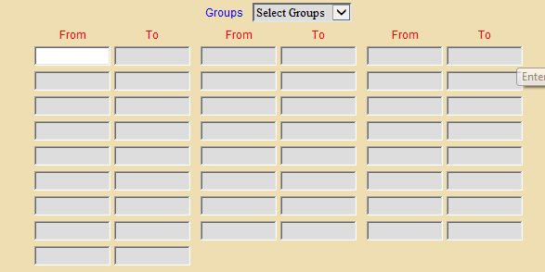

Promo Codes: Some manufacturers provide Promo Codes for ordering specials, incentives, etc. If you select “All Promo Codes” from the drop-down menu, the system will select the parts for ALL Promo Codes. Choose “Select Codes” and enter up to 25 ranges of Promo Codes. Case/New Holland dealers may use this field for generating orders from the PMC (Parts Market Codes), which is in the Promo Code 3 field.

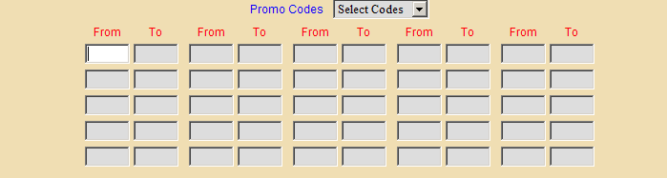

Commodity Codes: Some manufacturers provide Commodity Codes for ordering specials, incentives, etc. The Commodity Codes are added from the price file, if present. If you select “All Codes” from the drop-down menu, the system will select the parts for ALL Commodity Codes. You can select up to 25 ranges of commodity codes to consider.

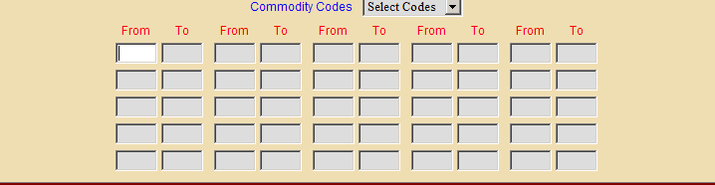

Select Desired Months to Review: This area shows all 48 months of detailed history from the part master. Type the number(s) of the months or click on their names to include them on the order. As you choose the months, they will display on the screen.

- Seasonal Orders – You may find it helpful to choose the months of the season for the prior years. Then, choose a percentage that matches the number of years (i.e. 50% for 2 years, 33% for 3 years, etc.). You can use this approach for seasonal orders as well as pre-season orders because you can choose the months to examine.
- Promotional Orders – You can choose the number of months to examine and then apply a percentage that matches your preference (i.e. 100% for the previous 12 months if creating a promo annual order).
- Quarterly Orders - The best way to prepare a quarterly order is to choose the months of the quarter for all of the years available. This approach uses current and past sales history only for the quarter you choose. Be sure to use an appropriate percentage (i.e. 33% for 3 years, 25% for 4 years, etc.).

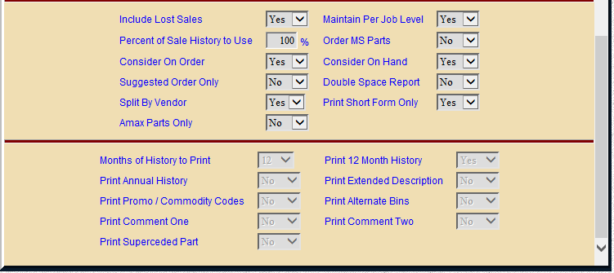

Include Lost Sales: This field lets you consider any identified Lost Sales for the parts selected.

Choose Yes and the lost sales hits for the months chosen will be added to actual parts sales quantities to arrive at the BSL, BRP, and ultimately the suggested order quantity.

Choose No here to exclude lost sales quantities from the calculation.

Maintain Per Job Level: This field works with the Per Job field in the part master. The Per Job field lists a preference for the quantity used for a particular shop job or sale.

Select Yes to use the Per Job field.

If the BSL and BRP quantities are less than the Per Job quantity, the system will recommend an order that will keep your quantity on hand in multiples of the Per Job quantity.

If you choose No here, the system will ignore the Per Job quantities and use only the recommended BSL and BRP levels.

Percent of Sales History to Use: The default for this field is 100% but you may use any percentage here. For example, you could use 100% if you want to order one-for-one based on the number sold in the months of history chosen. If you are generating an annual order and you have selected 36 months, then you might us 33% or one-third of the years selected (annual supply). Any suggested order quantities are then compared to On Hand, On Order, and Per Job Fields if you have selected these options. Here are some typical percentages to consider:

- Seasonal Stock Order (Use the seasons for each of past three years of history)
  - If you are anticipating a bumper crop season, use 37% (110% of average)
  - If you are expecting an average season, use 33% (equal to 100% of average)
  - If you believe it will be a below average season, use 30% (90% of average)
- Sixty Day Shelf Supply (use 13 months of history)
  - Use 15% to achieve a sixty day shelf supply

Order MS Parts: This field offers the option to order parts that are linked with the multiple super-session fields in the part master. If shelf quantities of these numbers are low, they may be placed on order.

Choose Yes to check the stocking levels of the parts listed as the multiple super-cession numbers. They are placed on order if they qualify for re-order.

Select No and the system will ignore the multiple super-session numbers listed in the part master.

Consider On Order:

- Choose Yes if you want the system to take into consideration other outstanding orders.
  - “Yes” in this field subtracts the on order quantity from the suggested order quantity.
- Choose No if you want to ignore them.

Consider On Hand:

- Choose Yes if you want the system to take into consideration the current on hand quantity.
  - “Yes” in this field subtracts the on hand quantity from the suggested order quantity.
- Choose No if you want to ignore them.

Suggested Order Only:

- Choose Yes to create the order for printout purposes only.
  - In this case, no order is created.
  - This can be useful if you want to experiment with several settings before making the final decision.
- Select No to generate a live order.

Double Space Report: This field lets you select single or double spacing for the printout.

Choose Yes to get a printout in double spaced format.

Choose No for a single spaced format.

Split By Vendor: This field lets you choose between page splits by vendor or all items sorted together.

Choose Yes to create the order split into pages by vendor.

Choose No for a printout of the order all together with no breaks by vendor.

Print Short Form Only: This option only prints the necessary information to place an order. This format is an easy-to-read, faxable printout.

It includes the following information:

Part Number

Qty

Mfr ID

Type

Amax Code

Description

Weight

Cost

Extended Cost

Choose Yes to receive this style of order printout.

Select No to continue making selections on the setup screen.

Amax Parts Only: If you are a CNH dealer, this prompt will be on the SSO screen to offer the options of only looking at AMAX parts.

- Choose Yes to limit the order to AMAX parts only.
- Leave it at No to include any parts.

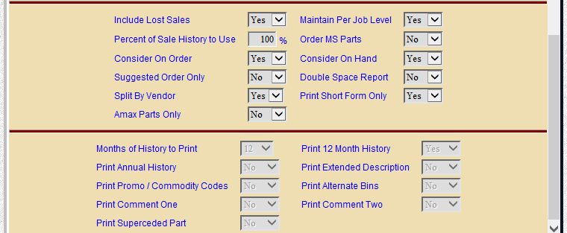

Months of History to Print: This field offers the choice of how much month-by-month sales history to include on your printout. Detailed sales history can be useful when evaluating the system’s suggested order quantity and to provide further insight for the person reviewing the order. For instance, if you have based the order on 12 months demand, you may find it helpful to have it display that year’s data plus the previous year’s data for comparison.

Answer 0 to print no detailed sales history.

Answer 12, 24, 36, or 48 to print that number of months of detailed sales history.

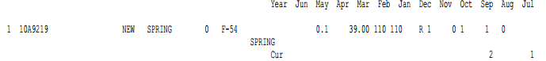

Print 12 Month History: This option lets you print totals only for 12 month sales history counts.

Select Yes here to receive a total for the last 12 months and a total for 3 more 12-month periods to cover the full 48 history months.

Choose No to leave these off.

Print Annual History: This option lets you print sales history count totals by year.

If you choose Yes here, you will receive a total for the current calendar year and the eight previous years.

Select No to leave these off your printout.

Print Extended Description:

- Select Yes to print the extended description.
- Select No to leave this description off.

Print Promo/Commodity Codes:

- Select Yes to include the promo and commodity codes.
- Select No to exclude this info.

Print Alternate Bins:

- Choose Yes to have the alternate bin 1 and 2 for this part number print on the order.
- Select No to leave this information off the printout.

Print Comment One: This field lets you print the first line of comments from the part master on the printout.

Choose Yes to have the first line of comments appear on the order printout.

Choose No to ignore any comment line 1 information.

Print Comment Two: This field lets you print the second line of comments from the part master on the printout.

Choose Yes to have the second line of comments appear on the order printout.

Choose No to ignore any comment line 2 information.

Print Superseded Part: Here you can have the old or superseded part number appear on the order printout. The program does make use of the sales history from the old part number when calculations for BSL and BRP are made.

Choose Yes to show the old part number on the order printout.

Choose No to leave off any “old” part number information if present.

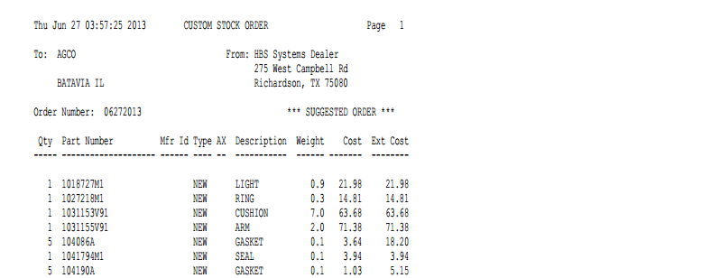

Short Form: The Custom Stock Order Short Form lists the vendor name and address, along with your dealership name and address. It includes the following information:

Order Number: This is the order number that was either assigned by you or provided by the system when the order was created.

Qty: Here you will find the suggested order quantity for the part.

Part Number: This is the part number to be ordered.

Mfr ID: This is the manufacturer ID of the part.

Type: This field shows the part type. This could be:

N=New

U=Used

R=Reman

C=Core

M=Memo

AX: This column shows the CNH Amax code, if any.

Description: Here you will see the description of the part number listed on the order.

Weight: This field shows the weight of the part number listed.

Cost: The cost is the manufacturers cost for this part.

Ext Cost: This is the Extended Cost for the part number (cost times suggested order quantity).

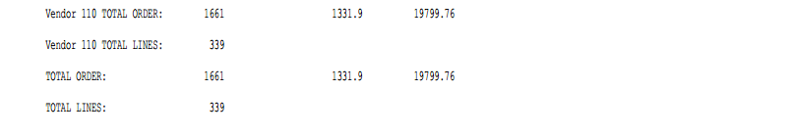

Totals: Totals on this version of the printout include:

Total piece count

Total line count

Extended weight

Extended cost

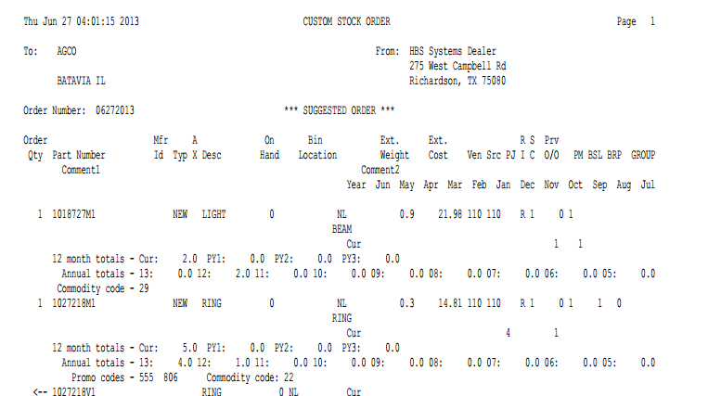

Long Form: The Custom Stock Order Long Form shows the vendor name and address that the order is issued to, the order number, and your dealership name and address. It can include the following detailed order information (depending on your selections):

Order Qty: Here you will find the suggested order quantity for the part.

Part Number: This is the part number suggested for the order.

Mfr ID: This is the manufacturer ID.

Typ: This field shows the part type from the part master. This could be:

N=New

U=Used

R=Reman

C=Core

M=Memo

Desc: Here you will see the description of the part number.

On Hand: This field shows the current quantity on hand.

Bin Location: Here you will find the primary bin location of the suggested part.

Ext. Weight: Here you will find the extended weight for the part number (weight times suggested order quantity).

Ext Cost: This is the extended cost for the part number (cost time suggested order quantity).

Ven: This is the vendor number for this part.

Src: This is the source code of the part number.

PJ: This is the per job quantity from the part master.

RI: This is the return indicator or return code from the part master.

SC: Here you will find the stock class for this part number.

Prv O/O: This field lists the previous on order quantity, which is the quantity on order prior to this order.

PM: This indicates the package multiple or package quantity from the part master.

BSL: The best stocking level is from the part master.

BRP: The best re-order point is from the part master.

Group: This shows the group ID from the part master.

Comment 1: This field lists any comments that are in the comment 1 field of the part master.

Comment 2: This field lists any comments that are in the comment 2 field of the part master.

Month History: This optional area may show up to four lines of monthly history by year, depending on the history you selected for the printout (0/12/24/36/48). They are titled by month names.

12 month totals: This optional area shows totals only for 12 month sales history counts. They are titled:

Cur

PY1

PY2

PY3

PY4

The columns are calculated from the date of the printout/order (the 1st shows the last 12 months, PY1 shows the 12 months prior to that, and so on).

Annual totals: This optional area shows totals by calendar year. Years are shown by the last two digits of the year (i.e. 13 for 2013, 12 for 2012, 11 for 2011, etc.).

Superseded: These “old” part numbers will print immediately below the number that has replaced them. They are shown with a left arrow <-- before their numbers.

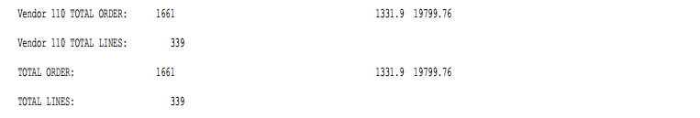

Vendor/Total Order: This line shows:

The total piece count

The total extended weight

The total extended cost on this order

Vendor/Total Lines: This is the total number of lines (unique parts numbers) on this order.

Recommendation: If you do not normally use the Standard Stock Order program, it recommended that at least once a month you run the following variation of the Standard program. This process will update the BSL and BRP fields in the event that you want to review what the system determines as the optimum levels.

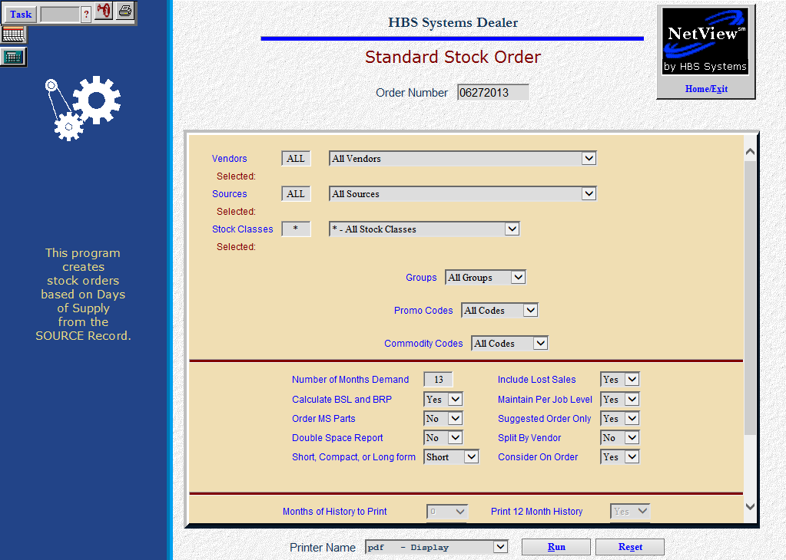

Be sure to select the all vendors, all sources, all stock classes, use 13 months of demand, answer Yes to suggested order only, and select the PDF printer!

