Customer Sales Ranking Report (CSR)

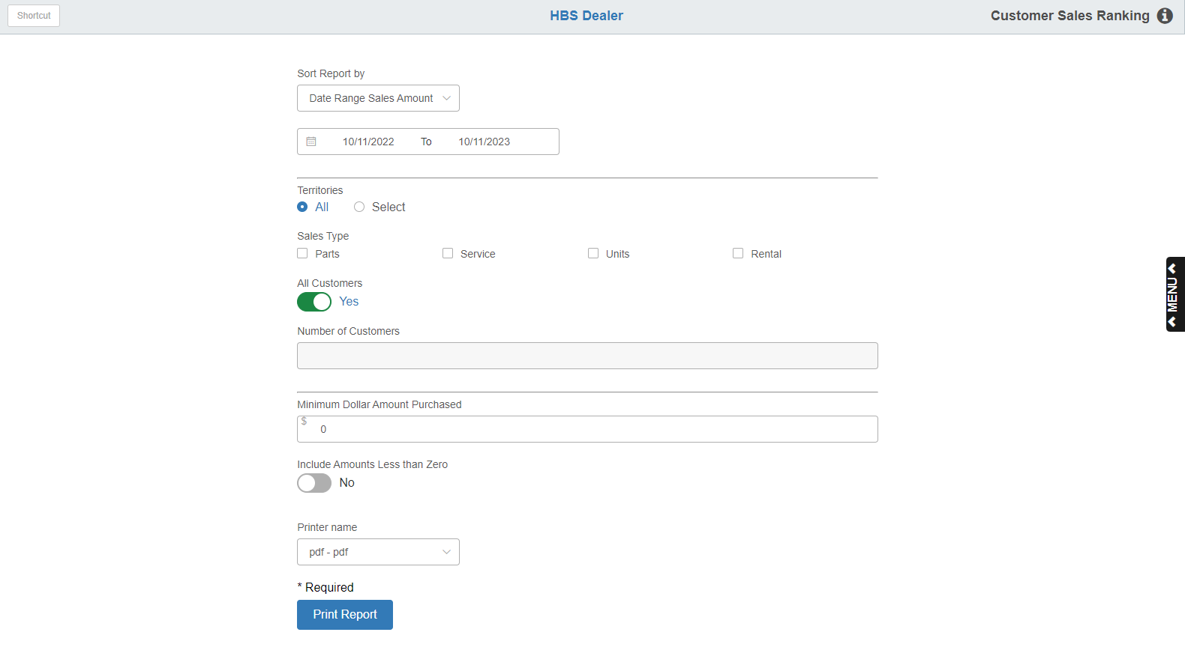

The Customer Sales Ranking Report prints a listing of your customers, ranking them according to their purchases. It gives you six years of sales activity.

To access the report, you can either:

Select “Inventory” from the menu. Choose the “Reports” submenu and click “Customer Sales Ranking Report.”

Type “CSR” in the Shortcuts Bar.

Field Definitions:

Sort Report By: Choose how to sort your report:

- Date Range Sales Amount
- Customer Name
- Total Sales

Report Date Range: Enter the starting and ending dates for your report, or select them from the calendar.

Territories:

- Choose All to include all territory codes on your report.
- Choose Select to enter up to 10 territory codes in the fields provided.

Sales Type: Select the type of activity to include on the report:

- Parts
- Service (POS, SMS, or NetView Service)
- Units

NOTE: The Rental category here refers to the original Rental package which is no longer in use.

All Customers: The field defaults to “Yes” but we recommend using “No,” as for most dealers including all their customers would produce a very long report.

- Select Yes to include all your customers on the report.
- Select No to specify a number of customers.

Number of Customers: This field only activates if you set “All Customers” to “No.” Type in how many of your “top” customers you want to include on the report. For example, if you want a report of your top 50 customers, put “50” here.

Minimum Dollar Amount Purchased: Enter a minimum dollar amount of purchases for the report.

Include Amounts Less Than Zero:

- Choose Yes to include all amounts for customers (including accumulated totals of less than zero).
- Choose No to include only amounts higher than zero.

Printer Name: Select the printer to receive the printout. A default printer name is pre-filled but can be changed as necessary. Use the pdf printer to view the report on the screen without printing a copy of it.

Print Report: Press this button to print your report.

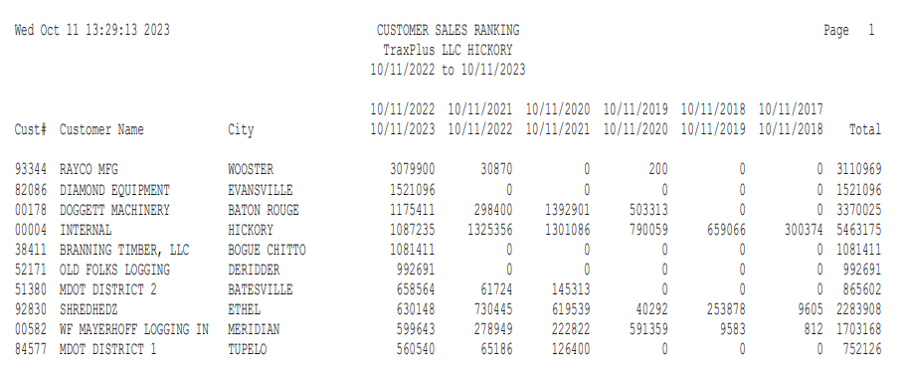

Report Columns:

Cust #: This is the Accounts Receivable number you have assigned this customer. If you have selected to print this report in Customer Order, these will be numerical sequence (the sample report above was printed in Date Range Sales Amount order).

Customer Name: This is the name associated with the customer number.

City: This is the city name from the customer’s address as recorded in the Customer Master.

Date Columns: The first date column is the range you selected when you ran the report. The remaining columns compare the previous years’ purchases for the same time period.

Total: This is the grand total of all the years’ purchases for this customer.

