POS—Customer Shop Tickets (Repair Orders)

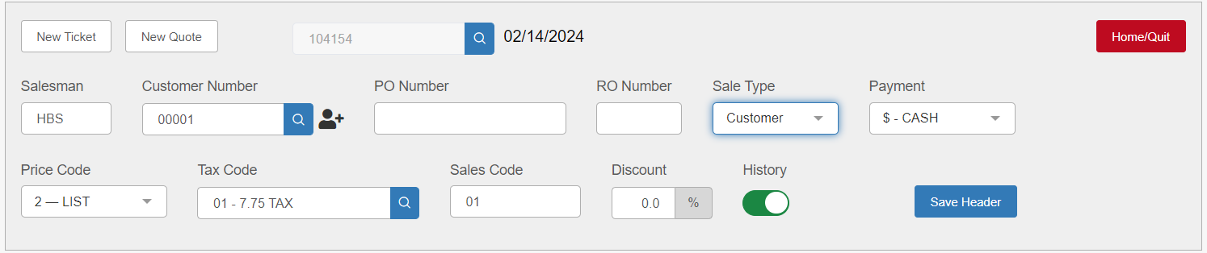

POS is able to handle shop tickets (repair orders), keeping up-to-the minute information about maintenance or repair work on units and the parts used.

Opening a New Shop Ticket: Start a new repair order ticket by typing in or selecting a customer account number from the “Customer Number” field. All of the customer’s open picking tickets, if any, will display.

If adding parts and labor to an existing open repair order, select the appropriate RO here.

If starting a new ticket, press Start New Ticket.

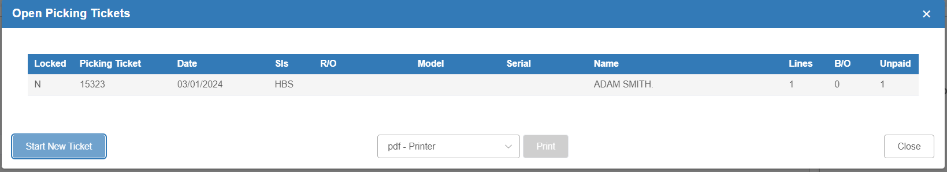

The header will populate and any Customer comments will be displayed.

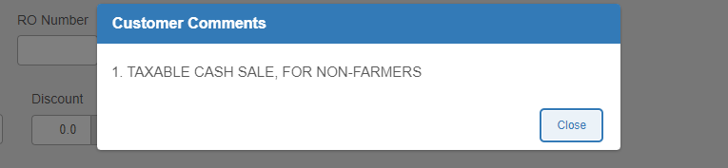

Close the pop-up and, if there is not a separate RO numbering system for the dealership, type the picking ticket number in the “RO Number” field. Click Save Header. NOTE: When filling out the header, a pop-up may appear to inform you that the customer requires a purchase order number.
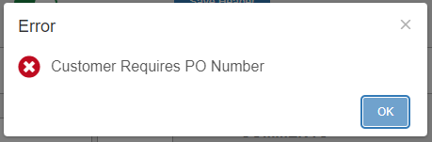

Make any needed changes to the shipping information in the Customer Info tab at this time.

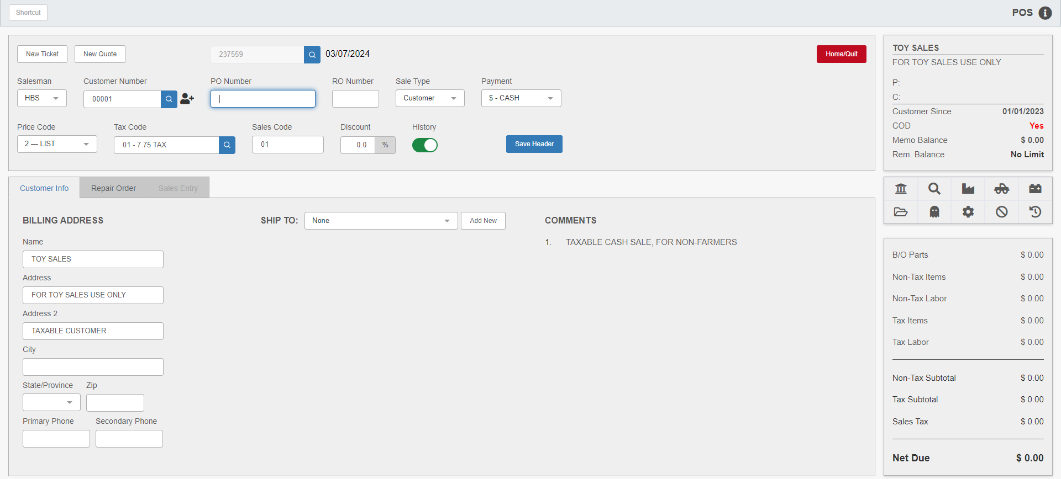

Open the Repair Order Tab to build the repair order.

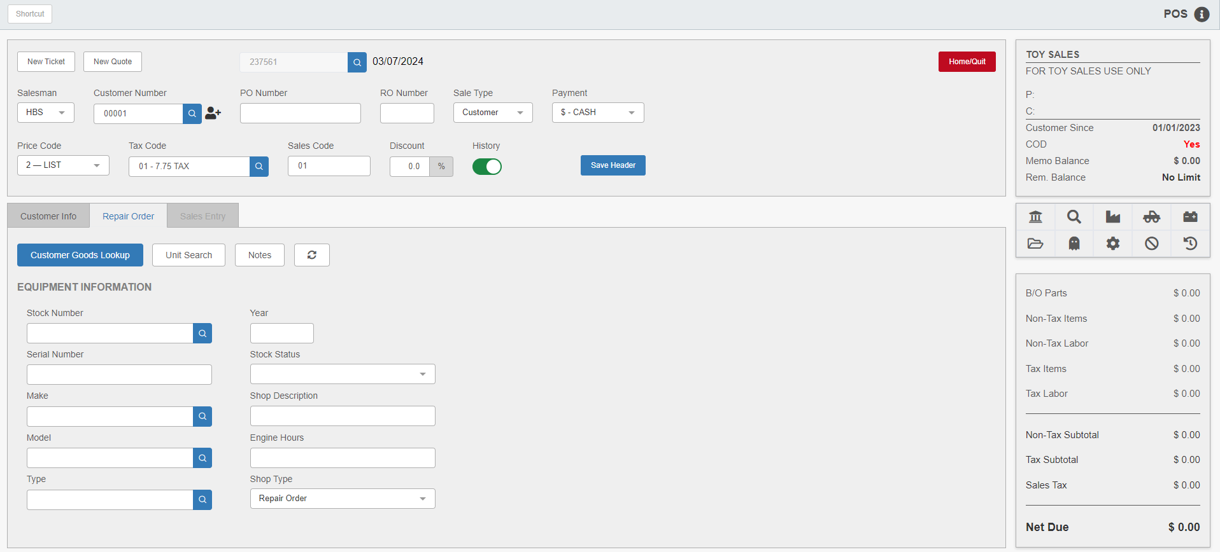

If the unit the customer brought in to be repaired is on file, type in the stock number or search for it by clicking the Customer Goods Lookup button to open Customer Equipment Maintenance (CEM). A list of the customer’s units on file will automatically display.
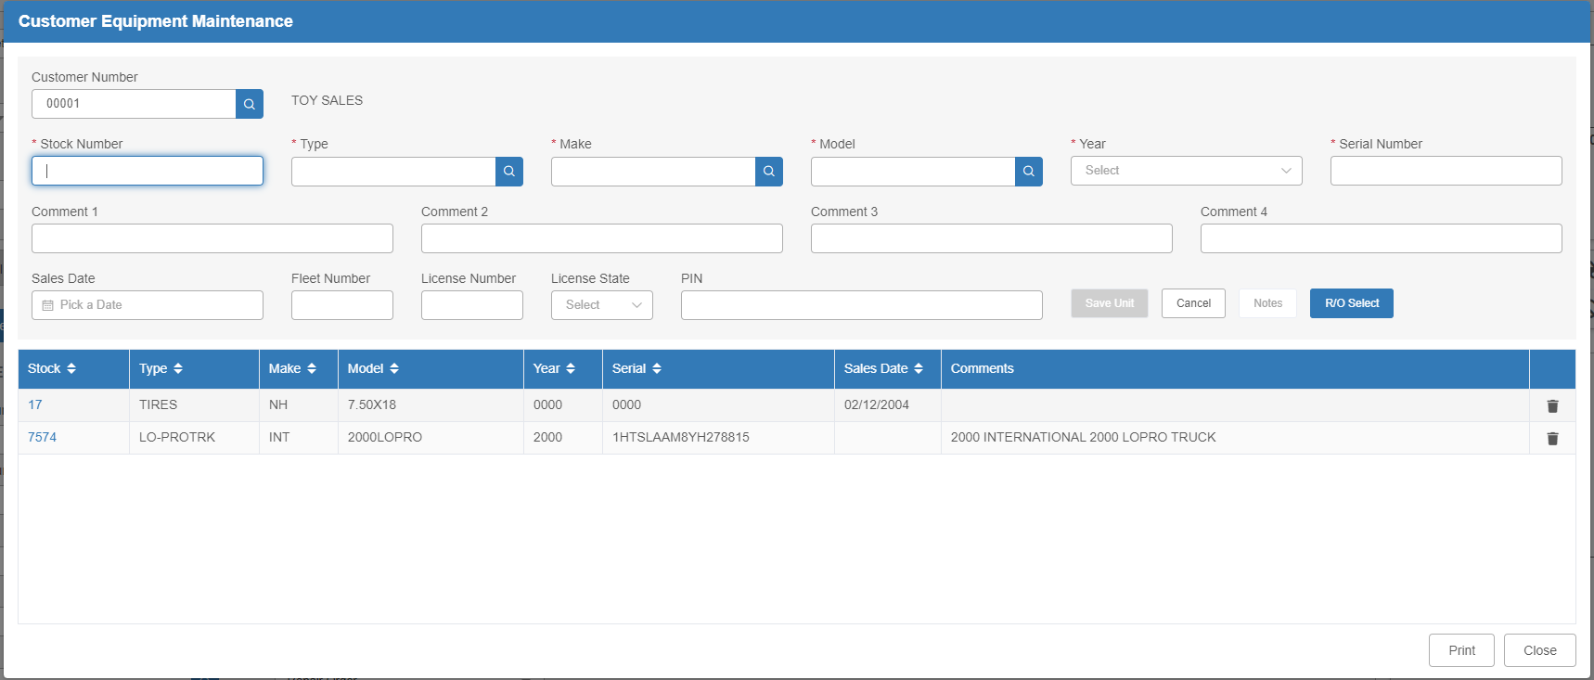

- If the equipment to be repaired is already included on the Customer Equipment screen (CEM), click on the unit to select it, then press RO Select to add it to the repair order.
- If the unit is not on file for the customer, it can be added here by completing the open fields. Comments relative to the piece of equipment can also be added at this time. After completing all pertinent fields, press Save to enter the equipment into inventory.

NOTE: An alternate way to find the unit from the Repair Order tab is by using the Unit Search button. This works well when the unit is on file at the dealership and may have previously been owned by someone other than the current customer.

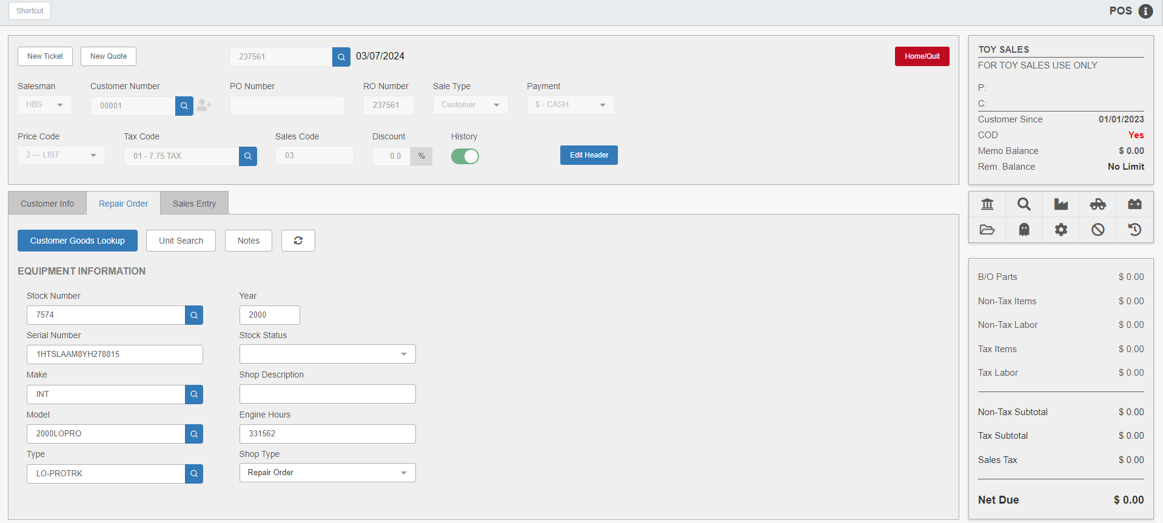

The Equipment Information fields will auto-fill with the selected unit’s information. Add additional information to this screen as needed. A shop description and shop type choice are recommended. Use the drop-down menu in the “Shop Type” field to select “Repair Order” or “Option.”

To begin adding charges and comments to the repair order, open the Sales Entry tab. On the first line, press “Enter” in the “Part Number” field to add a Comment line and type in a brief description of work to be done. Press “Tab” or “Enter” to save the line. Additional comment lines can be added as needed. Comments will appear on the sales invoice when printed. Enter any parts needed for repair as you would on a normal sales ticket.

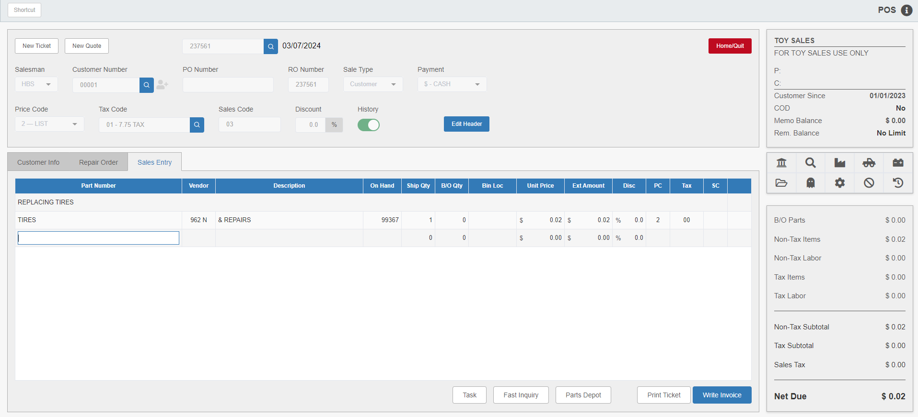

Labor Charges: To enter labor hours on a shop ticket, enter a labor part number as you would a normal part number. The system will display the cost of labor in the “Unit Price” and “Ext Amount” fields.

Miscellaneous Charges: Some dealerships may charge a percentage of the total customer ticket to cover miscellaneous services. For example, they might charge a shop supply fee to cover the incidental items used in the equipment repair. There are two override features used to add miscellaneous charges or miscellaneous supplies charges to customer tickets. They are identical except for the name and verbiage, and both add a percentage to the ticket total.

Task Code “M”: To add a miscellaneous charge to a customer ticket, place the cursor in the Part Number field. Type the percentage amount, press the spacebar, type the letter “M,” and press “Enter.”

The system will calculate the charge and add it to the ticket. The charges are calculated based on all detail lines ABOVE the miscellaneous charge.

Task Code “MS”: The system will calculate the charge and add it to the ticket. The charges are calculated based on all detail lines ABOVE the miscellaneous charge.

A miscellaneous shop supply percentage can also be added by using the letters “MS” in place of the “M.”

Result:

TIP—Adding Miscellaneous Charges/Miscellaneous Supplies Charge: The Miscellaneous field uses the lines above the miscellaneous charge to calculate the amount to be added to the invoice. When adding the miscellaneous charge after the labor entry, the labor is included in the calculation of miscellaneous charges. If adding the miscellaneous charges before the labor entry, the labor is excluded from the miscellaneous charges.

Printing the Ticket: A working copy of the picking ticket can be printed until all charges have been entered and an invoice is ready to be printed.

