POS—Customer Warranty Tickets

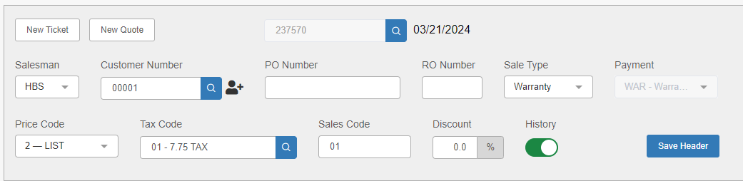

POS customer warranty tickets let you link warranty jobs to individual customers without charging the customer for those amounts. With a customer warranty ticket, you use the customer number instead of a warranty customer number. You will enter specific information in the header fields to ensure correct accounting.

With a customer warranty ticket, you must make manual changes to the ticket header. You must enter codes that identify this ticket as a warranty shop ticket and that post entries from this ticket to the Warranty Receivables account, which is usually 10800.

Start a new customer warranty ticket by entering or searching for the customer’s account number in the “Customer #” field. The system pre-fills the rest of the header fields with values from Enter Customer Information (ECI).

Header Fields:

RO#: Enter a repair order number in this field in accordance with your dealership’s RO numbering system. You can also just use the picking ticket number here.

Sale Type: Choose Warranty from the drop-down menu. This will also cause the “Payment” field to default to “Warranty” and be locked for editing, as that is the only method of payment that can be used for Warranty tickets.

Price Code: Most vendors reimburse warranty parts at cost or cost plus. The system pre-fills this field with the price code from the Customer Master for the customer. You must change the Price Code field to reflect the correct parts pricing, or utilize the “Discount” field in the Sales Entry tab (see under “Sales Entry Tab” below for more information).

Tax Code: This field holds the tax code, which defaults based on the customer. You must change it to hold the appropriate nontaxable code.

Sales Code: The Sales Code field is pre-filled with the sales code (parts sales, warranty, nontaxable) from the Customer Master.

R/O Info Fields: Once you’ve finished filling in the header fields, open the R/O Info tab to set up the repair order.

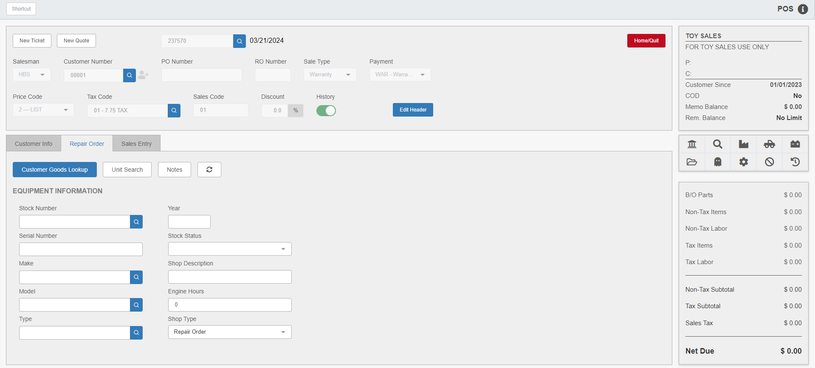

Stock Number: Here you will enter the unit stock number associated with this repair. If the customer has brought in the equipment for repair before, you can also use the Customer Goods Lookup button to find the equipment entry and auto-fill the remaining fields.

Shop Description: Enter a brief description of the repair ticket here.

Shop Type: The system pre-fills this field with Repair Order.

Sales Entry Tab: Open the Sales Entry Tab to begin adding parts and/or labor.

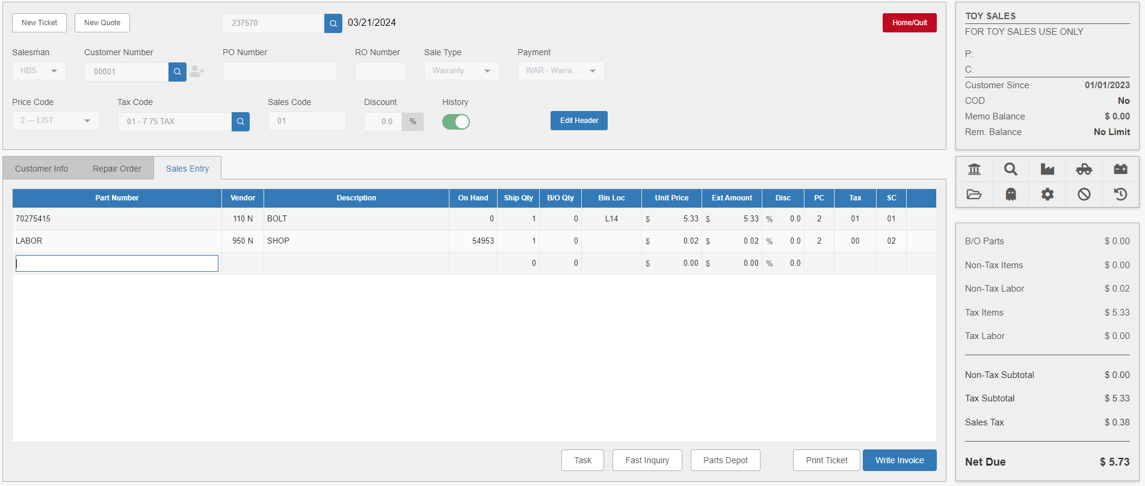

Disc: The system pre-fills this field with the discount rate from the Customer Master. You can use it to modify the pricing for the warranty job if needed.

Labor Charges: To enter labor charges on a warranty shop ticket, use the part number defined in the dealership’s unique system for warranty labor.

