Appendix D: Entering a Credit Invoice in Enter A/P Invoices (EAPI)

Follow these steps for entering a credit invoice:

Step 1: Entering a Credit Invoice: Use Enter A/P Invoices (EAPI) to enter the credit invoice.

A. Enter a Negative amount in the Amount field:

- Enter the following information:
  - Vendor account number
  - Invoice date
  - Invoice amount
- At the Amount field, type the amount as a NEGATIVE number. Example: Type “-250.00” for a credit invoice of $250.00.

B. Enter a Negative amount in the Offset Amount Field(s): Be sure to enter a NEGATIVE number on these lines.

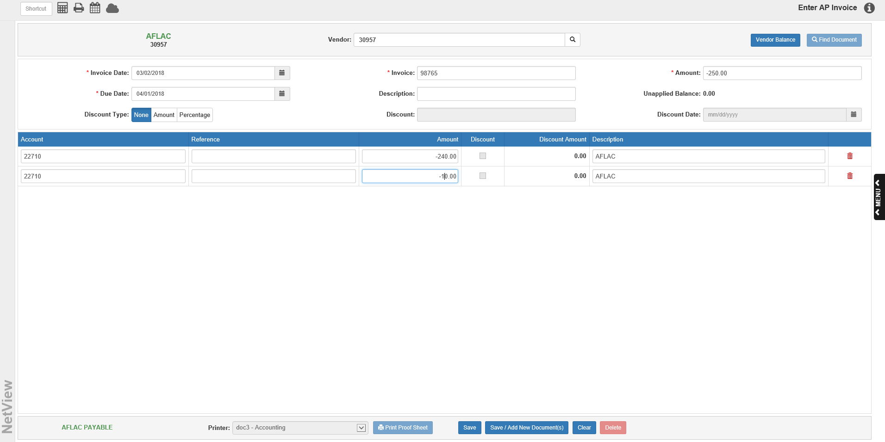

C. Save the Invoice:

- Press Save to save your invoice.
- Print the proof sheet to verify your entries.

Step 2: Posting the Credit Invoice: Post the entry in the A/P Purchase Journal (APPJ) or include it with the end of day posting activities.

