Daily Accounting Procedures

- Remove and replace daily backup tape.
- Review the nightly system backup and G/L Reconciliation Report.
  - Verify that the backup report contains no errors and that it ran through completion. If there are errors or if it did not complete, call HBS before proceeding with further use of the system.
  - Verify that the G/L Trial Balance is in balance from the G/L Reconciliation Report (GLRR), and that all subledgers and module totals (A/R, A/P, and Units) are in agreement with the G/L.
- Enter all daily activity.
  - Enter daily cash received on customer accounts. We suggest using Cash Applications (CA) for this process.
  - Enter any miscellaneous cash received. Use Accounting Document Entry (ARDI/GLED) for this. Your source document for this could be a check number or another number.
  - Enter any miscellaneous cash paid outs. Use Accounting Document Entry (ARDI/GLED) for this.
  - Enter equipment sales invoices. If you have the Units Module, use Unit Sales (US).
  - Enter daily bank deposit. Use Accounting Document Entry (ARDI/GLED) for this. Your source document for this could be your deposit stub or a journal entry form.
  - Reconcile cash accounts and/or cash clearing account (#10000 and #10100). The simplest method to do this is by printing all detail for each cash account for that day and then comparing the totals of the reports to your actual counts. To run this report(s), select the GL Detail Inquiry (GLDI) function from the G/L Menu.
  - Enter all A/P invoices. If you have the A/P Module, enter these invoices through Enter A/P Invoices (EAPI).
  - Print A/P checks. If you have the A/P Module, select the invoices you want to pay (SIP) and print the checks in A/P Print Checks (PC).
  - Enter Unit Purchases and Notes Payables. If you have the Units Module, enter these transactions in Unit Purchases (UP). Source document numbers may be purchase invoice, sales invoice, contract, or check numbers.
- Journal your entries. We suggest running your journals at the end of the day. This provides the opportunity to verify and possibly make corrections in the day’s work before you post them.
  - Journal the day’s A/P transactions for both Purchases and Disbursements. (APPJ and DJ).
  - Journal the day’s Units transactions (UPJ). Use ALL for the Journal Number to capture all types of Units transactions.
  - Journal the remainder of the day’s journal entries in the General Ledger and Accounts Receivable (GLPJ). Use ALL for the Journal Number to capture all types of entries.

TIP—Daily Procedures:

- Have your source documents account-coded with appropriate journal numbers on each to speed up the data entry process.
- Always enter a control number when entering data to an account which has a subledger established on it.

TIP—Posting when more than ONE accounting period is open:

- When posting journal entries for an open accounting period other than current month, you may use the last physical day of that month as the journal date. This will journal all unposted activity for that accounting period without having to journal each date that may have had activity.
- When posting journal entries for the current month, you may use the current date, if you like. This will journal all unposted activity for the current month up to the current date without having to journal each date that may have had activity.

Journals To Run:

A/P Purchase Journal (APPJ): Run the A/P Purchase Journal for today’s date.

- If there are unposted transactions for another month, you will get an Exception Report listing the unposted transactions. Run OIR for “E” (Entered invoices) to review these invoices BEFORE posting them.
- If you have unposted transactions that are from a prior month AND that month is still open, run APPJ for the last day of last month to post those entries.

A/P Disbursement Journal (DJ): Run the A/P Disbursement Journal for today’s date.

- If there are unposted transactions for another month, you will get an Exception Report listing the unposted transactions. Run OIR for “P” (Paid invoices) to review these transactions BEFORE posting them.
- If you have unposted transactions that are from a prior month AND that month is still open, run DJ for the last day of last month to post those entries.

Units Journal (UPJ): Run the Units Journal for today’s date. Choose ALL Journals.

- If there are transactions for another month, you will get a message that says “Documents from a prior period are waiting to be journalized.” Run PPS (Units proof sheet) to review these transactions BEFORE posting them.
- If they are from a prior month AND that month is still open, run UPJ for the last day of last month to post those entries.

General Ledger Journal (GLPJ): Run the General Ledger Journal for today’s date. Choose
ALL Journals.

- If there are transactions for another month, you will get a message that says “Documents from a prior period are waiting to be journalized”. Run DRAD (review G/L & A/R unposted transactions) to review these transactions BEFORE posting them.
- If they are from a prior month AND that month is still open, run GLPJ for the last day of last month to post those entries.

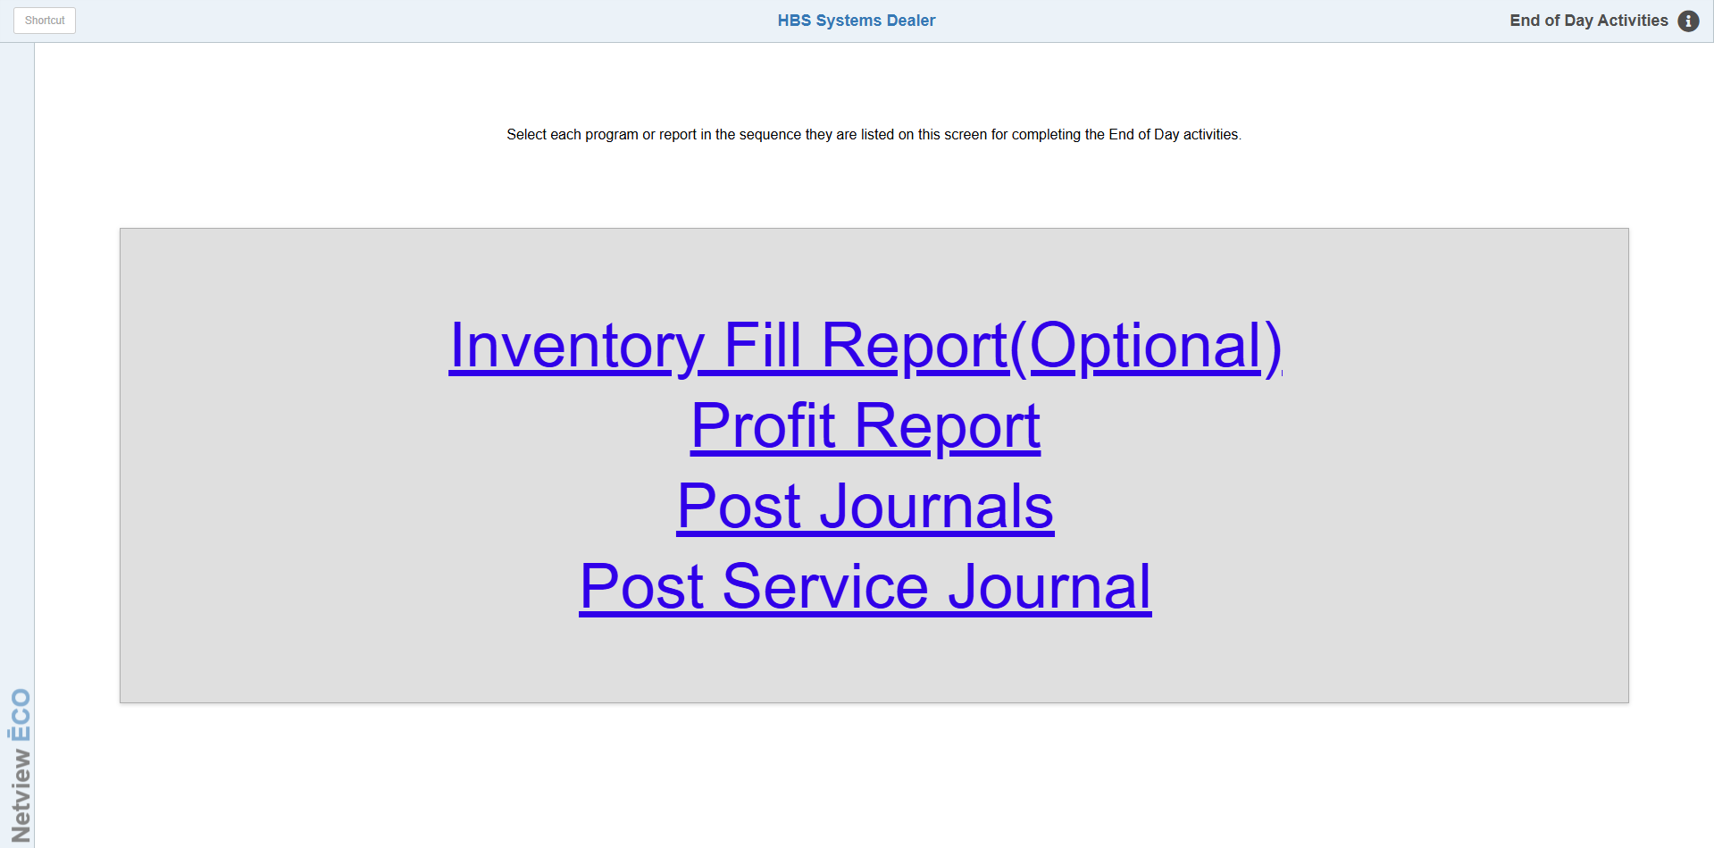

End-of-Day (EOD): Type "EOD" in the Shortcuts Bar to access the end-of-day menu for
the Parts Department. There are 3 selections on here. The first is optional, as
it indicates.

Profit Report (INPR): Run the Profit Report with the settings as shown. Press Exit
to leave the screen when the report is done.

Post Journals (INPJ):

- If you are posting the Journal for the current day, the selections on the screen are fine—just press Run.
- If you are running the report for yesterday’s business, you will need to change the date to that day.

Service Journal (SSPJ): Run the Service Journal for today’s date. Choose ALL Journals.

- If there are transactions for another month, you will get a message that says “Documents from a prior period are waiting to be journalized.” Run RDSS to review these transactions BEFORE posting them.
- If they are from a prior month AND that month is still open, run SSPJ for the last day of last month to post those entries.

