Detailed Equipment List: The Detailed Equipment List in Rental Reports (RR) shows a detailed list of all your dealership’s rental equipment, regardless of location. You can also run the report to only see equipment belonging to a specific make.

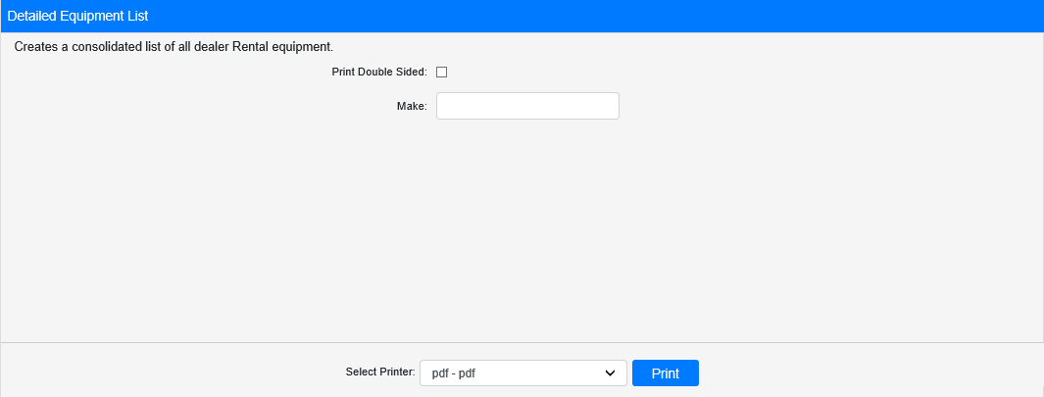

Field Definitions:

Print Double Sided:

- Check this box to print the report pages double-sided.
- Leave it unchecked to print the report pages single-sided.

Make: If you only want to run the report for a specific make, enter the 3-character make here.

Select Printer: Select the printer to receive the report. Use the pdf printer to preview the report.

Click “Print” to print the report.

Sample Report:

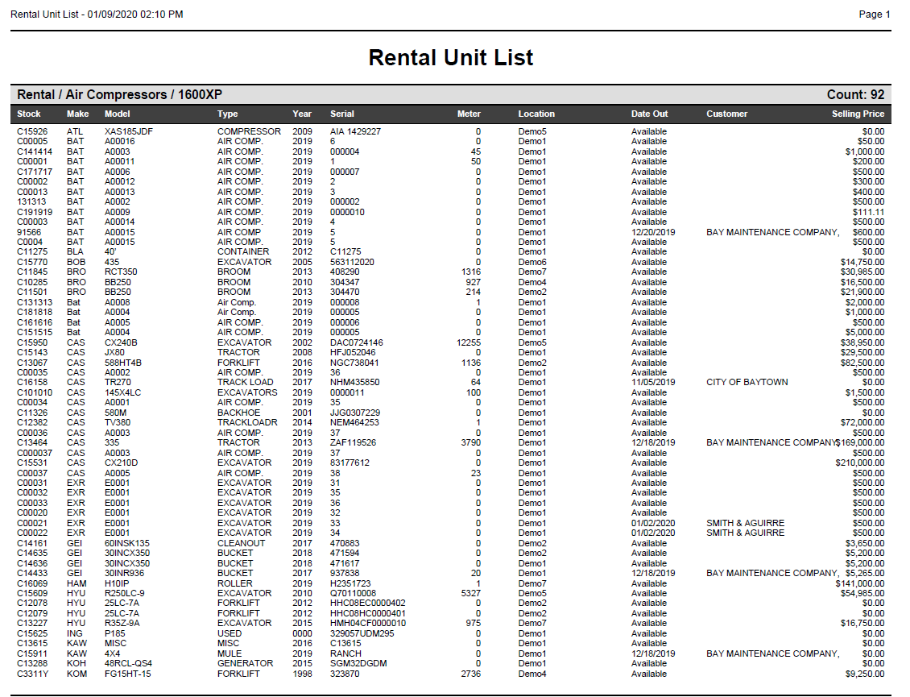

The report lists the units grouped by class and in alphabetical order by make. It shows the following information for each unit:

- Stock number
- Make
- Model
- Type
- Year
- Serial number
- Meter
- Dealer location
- Date Out (will show “Available” if the unit is not currently on rent)
- Customer currently renting the unit (if applicable)
- Unit selling price

