Disbursement Journal (DJ)

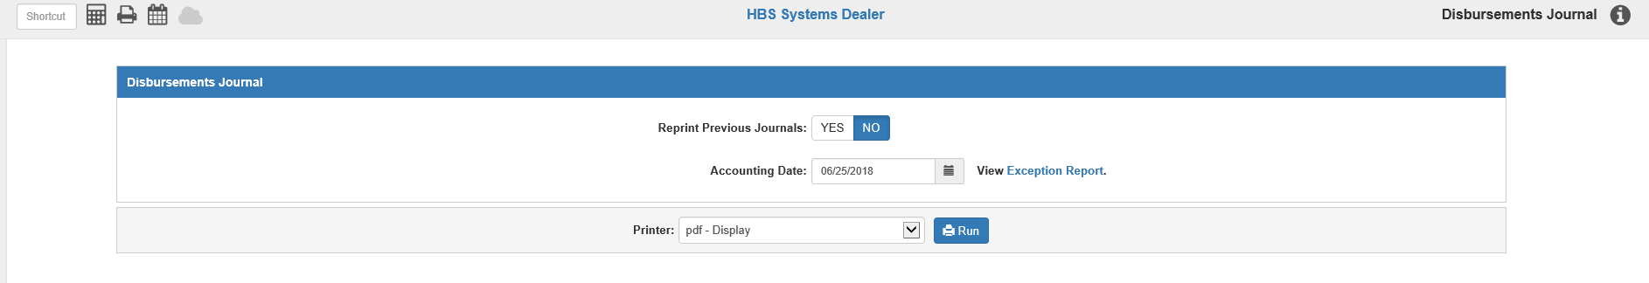

The Disbursement Journal (DJ) is the final step in the payment process. This is where the checks you printed or the payment/write off entries you made are posted to the General Ledger.

To access this function, you can either:

- Select “Accounts Payable” from the menu and choose the “Process Checks” submenu. Click on “Disbursement Journal.”
- Type “DJ” in the Shortcuts Bar.

Reprint Previous Journals: This defaults to No. Select Yes to reprint the last Disbursement Journal. You might use this option if the printer jams or prints the Journal incorrectly.

Accounting Date: This is the Journal’s posting date. Today’s date pre-fills but can be changed as needed. All pending documents for the accounting month will be posted, up to and including the date entered. You cannot post to a closed month.

View Exception Report: If you have any unposted invoices for a time period outside of the present (prior months or future-dated), an Exception Report will be available, containing a list of those invoices. Click on the link to view the report. You will also get a warning will also appear when you run the Journal:



Click on the link to view the report, which will appear at the beginning of the Journal printout. You will also get a warning will also appear when you run the Journal:

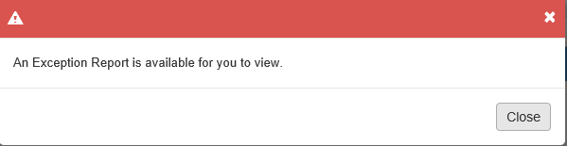

The Exception Report will appear as follows:

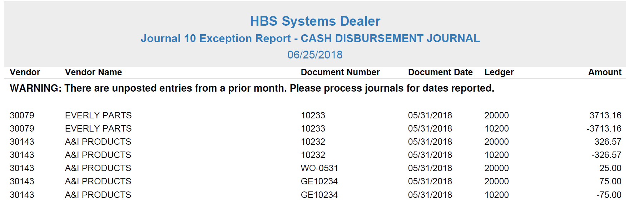

The report can be divided into three sections:

- Unposted future-date entries
- Unposted entries from a prior open accounting month
- Unposted entries from a closed accounting month.

Report Columns:

Vendor: This column shows the vendor number for the invoice.

Vendor Name: This column shows the vendor name.

Document Number: This column shows the unposted document number.

Document Date: This column shows the document’s payment date.

Ledger: This column shows the General Ledger account number for the unposted entry.

Amount: This column shows the dollar amount of the unposted entry, whether credit or debit.

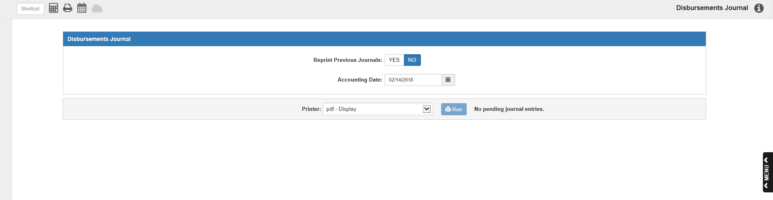

Printer Name: Identify which printer is to receive your printout. It pre-fills this field with a default printer name, but you can change it.

Click “Run” to run the Disbursement Journal and receive the Journal Printout.

NOTE: If there are no pending Journal entries, Run will be disabled and the following message will appear by the button:



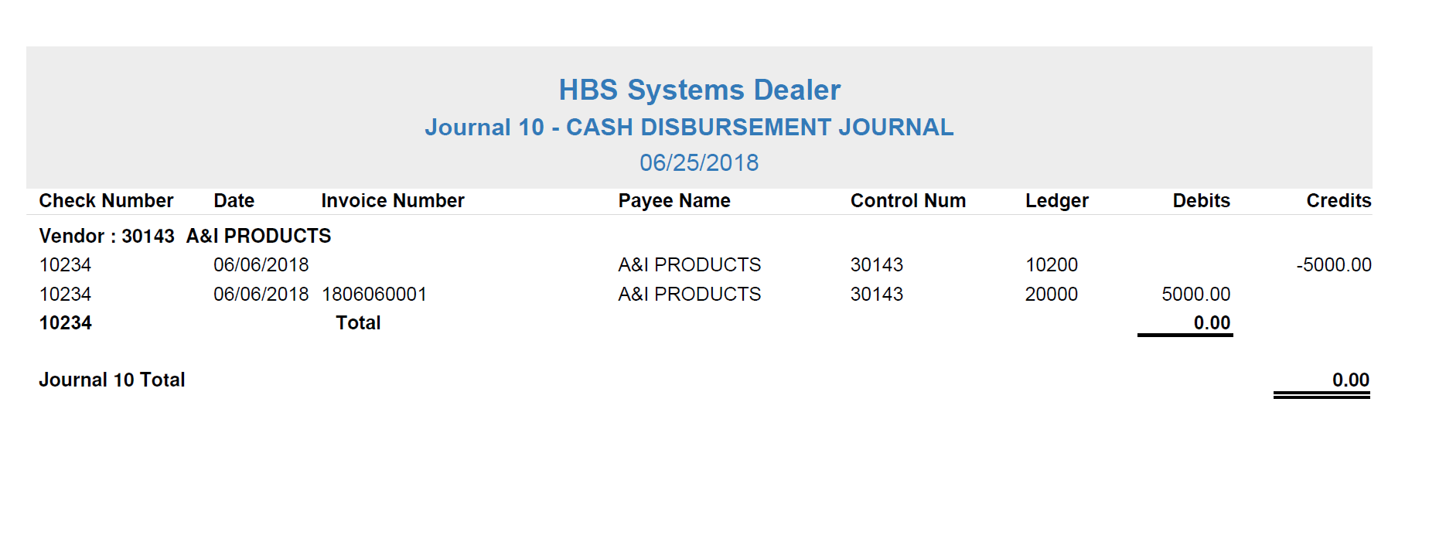

Disbursement Journal Printout: The Disbursement Journal printout is your permanent record for these payment/write-off entries. This should be kept with your other Journal printouts.

The Journal contains the following two sections:
- Document Detail
- Account Summary

Document Detail Section: Each payment is grouped into sections by Vendor that contain all line entries for each document number, listed in Check/Document Number order:

Vendor: This is the first row of each section. It shows the number and name for the A/P vendor you are paying.

Check Number: This shows the Document Number for this payment or write-off.

Date: This column shows the payment or write-off date.

Invoice Number: This column holds the invoice number affected by the payment or write-off.

Control Num: This column holds the control number for the payment or write-off, if applicable.

Payee Name: This column shows the name of the check’s recipient, i.e. who will get paid by the check.

Ledger: This shows the G/L account number for this line.

Debits: Most of the A/P account number line entries (20000) typically are debits (except credit invoices) and these amounts are printed in this column.

Credits: Usually, this column contains the entries for the checking account and any discounts. Also printed in this column might be the offsets for any write-off documents.

Check Total Line: At the end of each document section, you will see a total line that summarizes the entries for the document. It should be 0.00, as you can only save in-balance documents.

Journal 10 Total Line: The last line of detail to print at the end of the Document Detail is the Journal total. It should be 0.00, indicating the Journal is in balance.

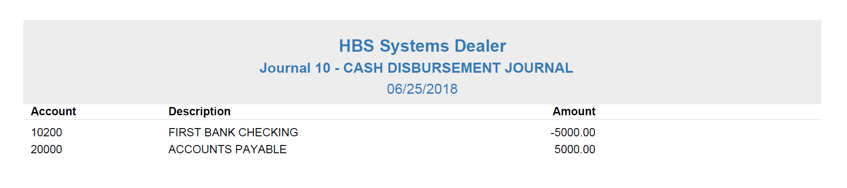

Account Summary Page: The last page of the Journal summarizes and prints all of the account numbers recorded for any documents in the Journal.

Account: This lists the G/L account number. These account numbers are sorted numerically.

Description: This shows the description of the G/L account number.

Amount: This column shows the net dollar amount for each of the account numbers listed on this page.

