Department Names (DNAM)

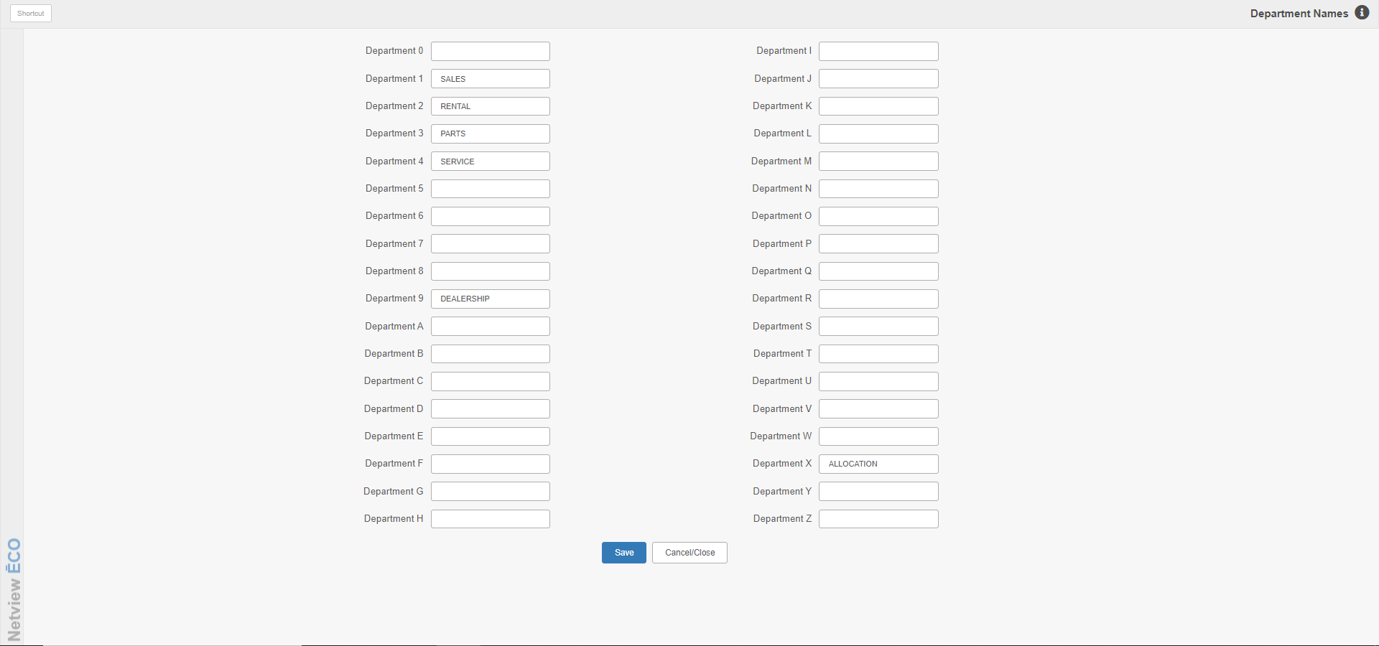

Department Names (DNAM) lets you define additional departments in the business.

To access this function, you can either:

- Select “System Maintenance” from the menu. Choose the “Company File” submenu and click “Department Names.”
- Type “DNAM” in the Shortcuts Bar.

Up to 35 departments may be defined with the first nine using numbers and the remainder with letters. These numbers and letters then become the last character of the standard 5-character account number. Example: If you wanted to create a department for Rental, you could define it as Department 2, and then any applicable accounts relating directly to that department would end in a 2.

Example Screen Fields: The above image gives you an example of a typical Department Names setup. Below are some example field definitions.

Department 1: Department 1 is defined as Sales.

Department 1: Department 2 is defined as Rental.

Department 3: Department 3 is defined as Parts.

Department 4: Department 4 is defined as Service or Shop.

Department 9: Department 9 is defined as Administration or Dealership.

Department X: Department X is defined as the “Allocation” department. You would use this if you set up expense allocation in the General Ledger.

The remaining department names are left undefined in this example.

