Daily Operating Control Report (DOC)

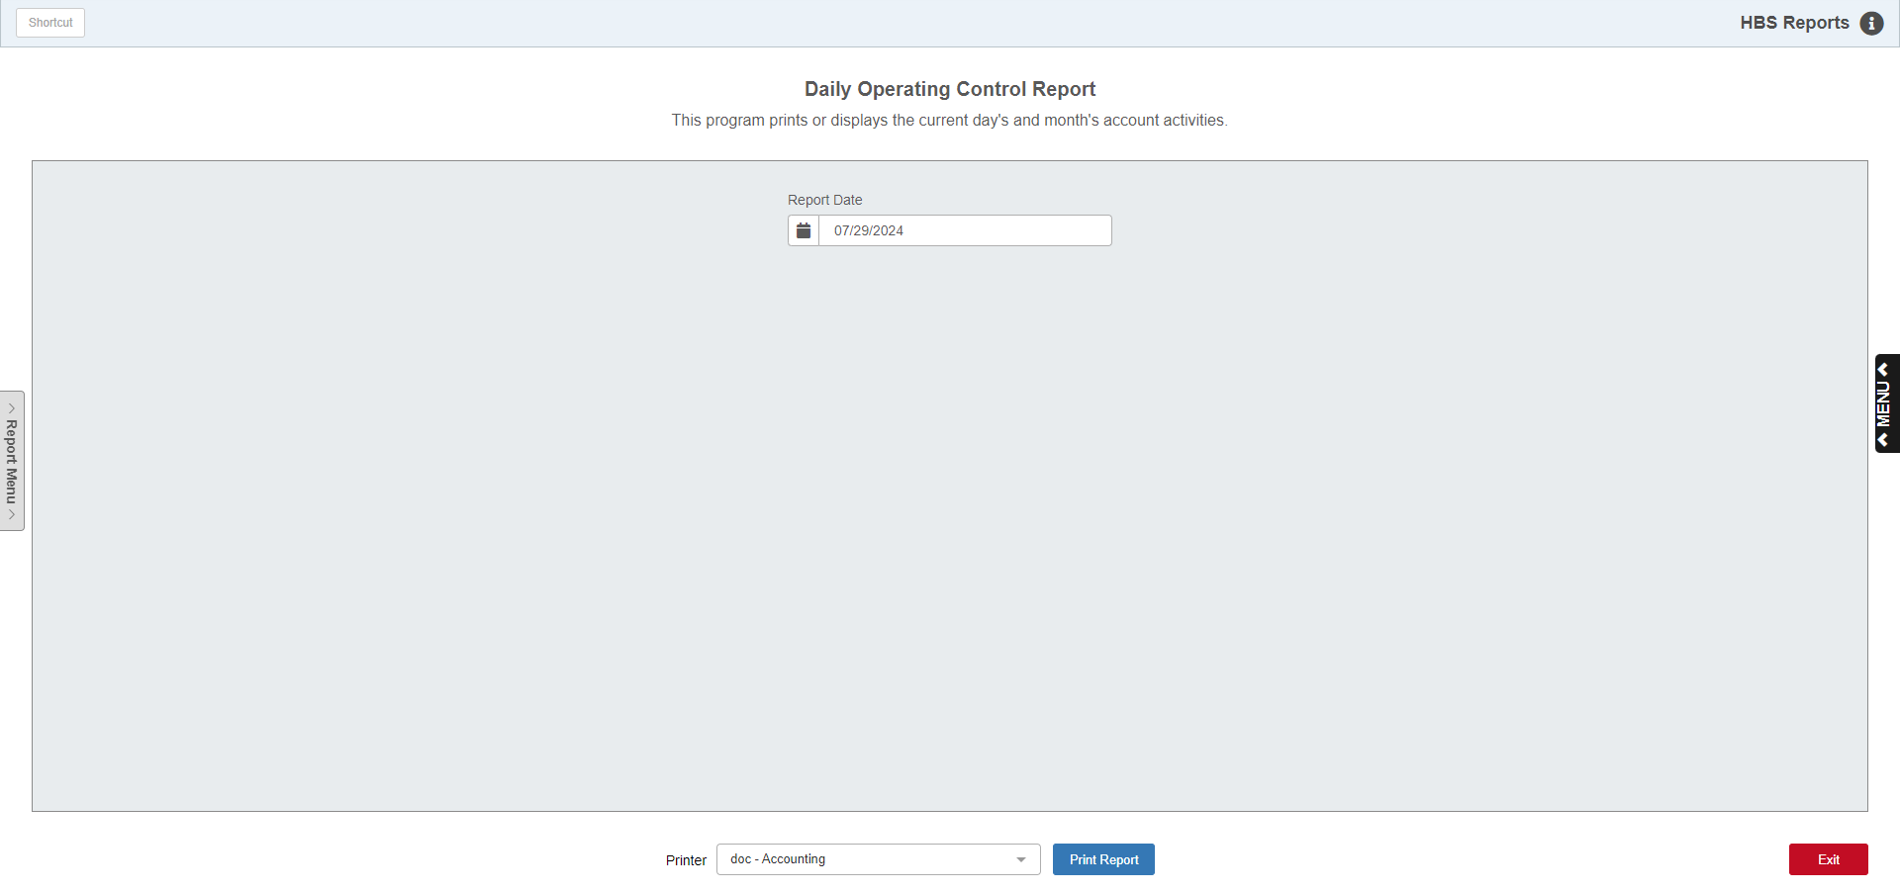

The Daily Operating Control Report (DOC) is a customized report of your company's daily, monthly, and year-to-date activity for the selected areas of interest. This report must be set up before using it.

The DOC report can be up to 50 lines long, and typically shows some key accounts and summaries that capture notable portions of the business. DOC typically does not show the entire financial picture, but rather highlights selected areas. It is customizable per dealership, so it may include any accounts and activity you choose.

DOC setup involves:

- Identifying the accounts to appear on the report
- Creating the titles for the report
- Coding the account numbers to show on the correct line of the report

To access this function, either:

- Select “General Ledger” from the menu. Choose the “Memo Reports” submenu and click on “Daily Operating Control Report.”
- Type “DOC” in the Shortcuts Bar.

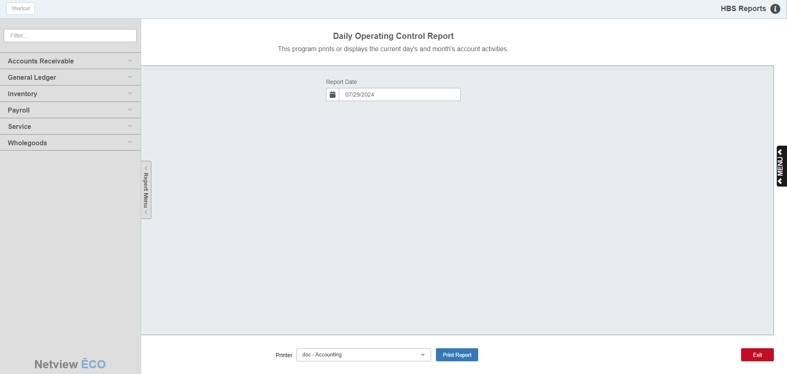

Reports Navigation Menu: This new menu appears on the left side of the screen for all reports and allows the user easy access to all report programs in the system. It is collapsable and can be easily hidden.

Screen Fields

Report Date: Select the report date you wish to see. The report will be generated “as of” the date you specify. The current date will pre-fill in this field, but can be changed as necessary.

Printer Name: Identify the printer to receive your printout. A default printer is pre-filled, but you may change it as necessary. Use the pdf-Display printer to display the report before printing.

Print Report: Click this button to print the report.

Daily Operating Control Report Setup: To create a DOC report (or examine your current DOC report setup) you will need to step through the following areas:

- Determine what (if anything) is currently printing on your DOC report. You can use the steps on the next couple of pages to run a report in its current format.
- Decide which areas to include on the report. Typically, dealerships may include areas like:
  - Cash
  - A/R
  - New Unit Sales and Gross Profit
  - Used Unit Sales and Gross Profit
  - Parts Sales and Gross Profit
  - Shop Sales
  - Gross Profit
  - Any other areas you may want to monitor on a daily basis
- Decide on how many report lines to include each General Ledger account. Each General Ledger account may be included on up to four lines of the DOC report. The lines of the report may be a single account number or a collection of account numbers to provide a total or a calculation. When more than one account is included on a single line, the balances for each are added together for the report. This can come in handy when you want to include a figure like Gross Profit. Since Gross Profit is the difference between what you sold it for (Sales) and what it cost you (Cost), you can simply include the appropriate Sale and Cost accounts on the same line and the net result will be the Gross Profit for the ones included.
- If you are setting up a new DOC report, you may want to see how many of your accounts already have references to a DOC report line. Print a Chart of Accounts (COA) and check the column that says “DOC Lines.” This column will show the report line references already in place.
- Taking your ideas of what to include on the report, now you need to code the desired account numbers to be included on the various lines of the report. These changes are done in Account Number Maintenance (ANM). Here you will put the line numbers for the DOC report in the fields labeled:
  - DOC Line 1 (1st time the account number will be included)
  - DOC Line 2 (2nd time the account number will be included)
  - DOC Line 3 (3rd time the account number will be included)
  - DOC Line 4 (4th time the account number will be included)
- There may be some pre-filled DOC lines in your report. Some of these may be some provided defaults. You can keep these pre-filled references if they suit your report or change any existing references to them. They primarily provide totals for Sales and Gross Profit in the major departments—Units, Parts, and Service. The default totals that could be present on your system are:

Daily Operating Control Report Setup

Standard Total Lines
Line # | Description
21 | Sales—New Units
22 | Gross Profit—New Units (New Unitss Sales & Cost Accounts)
23 | Sales—Used Units
24 | Gross Profit—Used Units (Used Units Sales & Cost Accounts)
25 | Sales—Parts
26 | Gross Profit—Parts (Parts Sales & Cost Accounts)
27 | Sales—Shop
28 | Gross Profit—Shop (Shop Sales & Cost Accounts)
29 | Total Sales
30 | Total Gross Profit (All Sales & Cost Accounts)

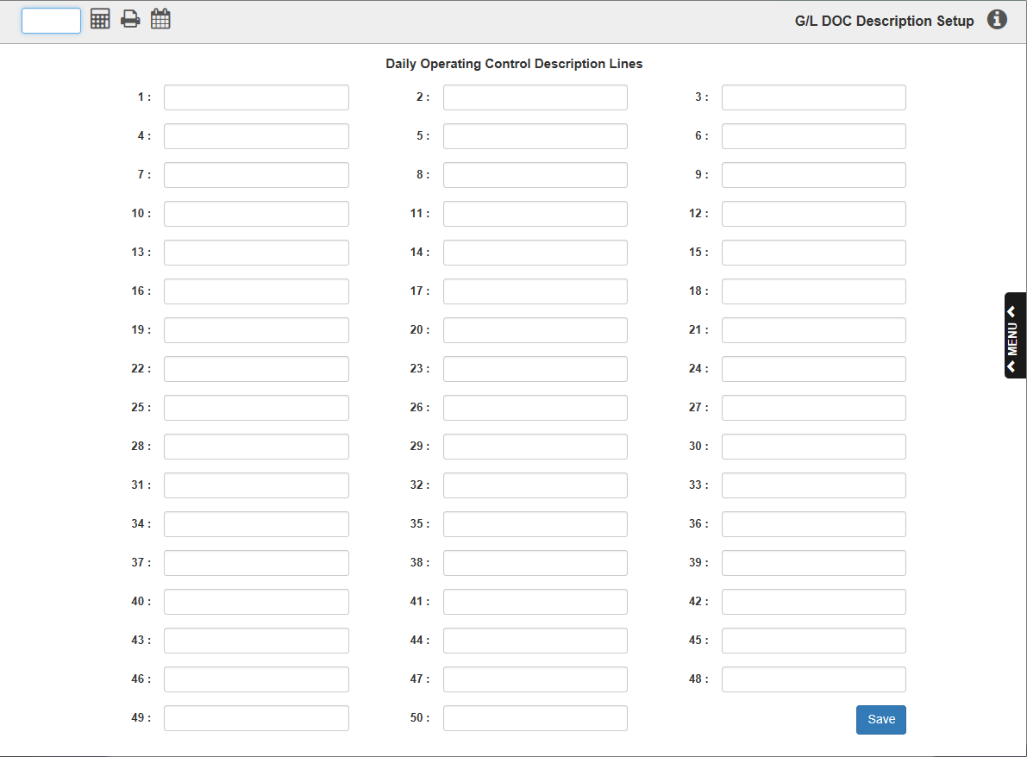

- Once you have coded the general ledger account numbers with the desired line numbers of the report, the actual descriptions of the categories themselves need to be entered. These are done in DOC Description Maintenance (GLDD). All fifty lines of the report can be “titled” here to fill out the body of your DOC report. Simply choose the line number to edit and make your entry.

Sample Daily Operating Control Report

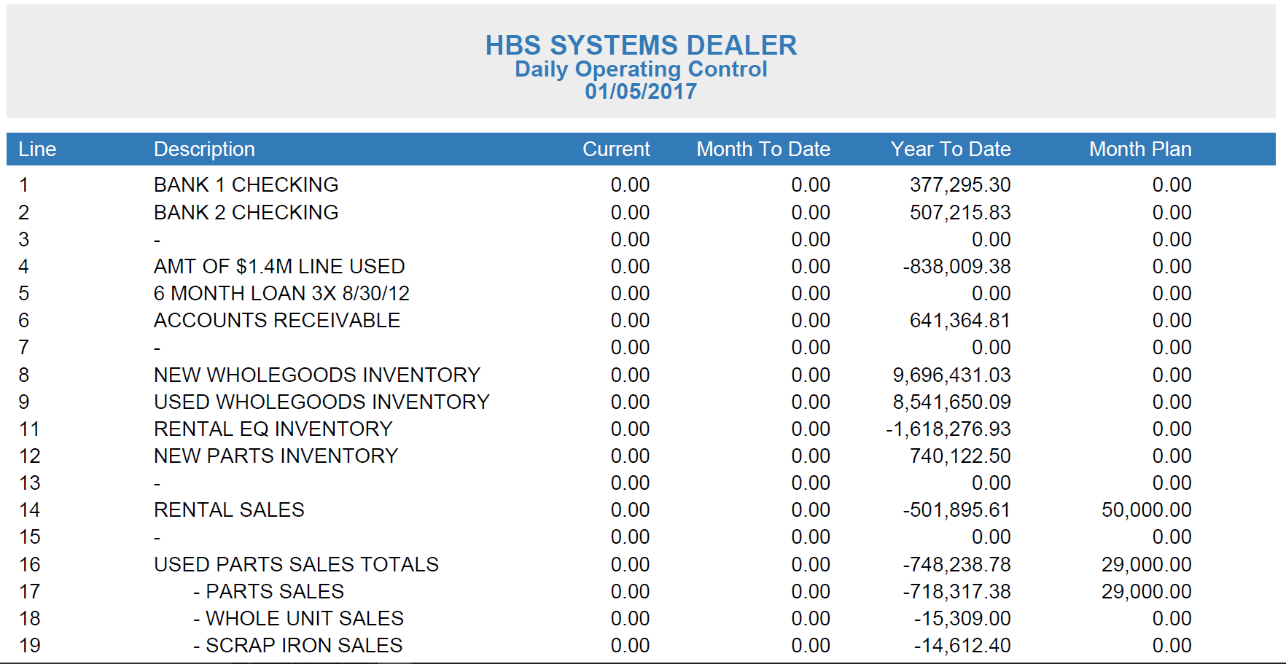

Line: This column shows the line number defined on the report. The report may have up to 50 lines defined. As you may see, the report prints each line sequentially and does not print line numbers that are not defined in the report set up.

Description: This field holds the entered description of the information defined on this line of the report. It can be as specific as the description of an account number (Checking Account) or the title of a summary (Parts Sales).

Current: This column shows the day’s business for the report date. If the report is dated January 5, the column shows the activity for that day.

Month To Date: This column shows the net activity for the month of the report date you selected. For example, if you enter April 10 as the report date, the month reported would be April of the current fiscal year.

Year To Date: This column shows the running YTD balance for the current fiscal year as of the report date. If your Fiscal Year runs January through December and you run this report on April 10, the amount in this column will be the YTD balance as of April 10.

Month Plan: This column will show the month’s plan or budget amount if it has been entered in ANM.

